Open

|  |  |
| --- | --- |
| **ABS cat.no.3412.0** | **23 April 2021** |
| **Migration Australia, 2019-20** | |
| This release presents detailed data on net overseas migration (NOM) for the 2019-20 financial year. It expands on the data presented in the latest National, state and territory population release on 18 March 2021 particularly around visa breakdowns and country of origin of migrants.  National NOM, which had been relatively steady over the previous 3 years, fell from 241,000 in 2018-19 to 194,000 in 2019-20, reflecting the early impacts of the COVID‑19 pandemic on migration in the latter part of the financial year. This fall was driven by a decline in arrivals and increased departures of international students, especially in NSW and Victoria. In NSW this exacerbated the trend of falling total NOM since its peak in 2017.  Despite the early impacts of COVID‑19, the share of overseas born residents rose slightly to 29.8 per cent of the population. This is up from 29.7 per cent in 2019 and 23.3 per cent in 1996. However, there were net outflows of migrants from China for the first time since this series began. | |
|

After ramping up in the 2000s, NOM peaked at around 316,000 in the year ending December 2008. Over the last 3 years, NOM has been relatively steady, averaging around 250,000. Underneath this overall trend, the number of arrivals and departures have both increased over the past two decades (Figure 1).

The steady NOM over recent years ended in March 2020 when international travel restrictions saw overseas arrivals limited to Australian citizens, permanent residents and New Zealand citizens usually resident in Australia while only temporary migrants (including New Zealanders) were permitted to depart. This led to decreased arrivals and increased departures, and a fall in NOM from 241,000 in 2018-19 to 194,000 in 2019-20.

**Figure 1: National NOM by arrivals and departures, year ended**

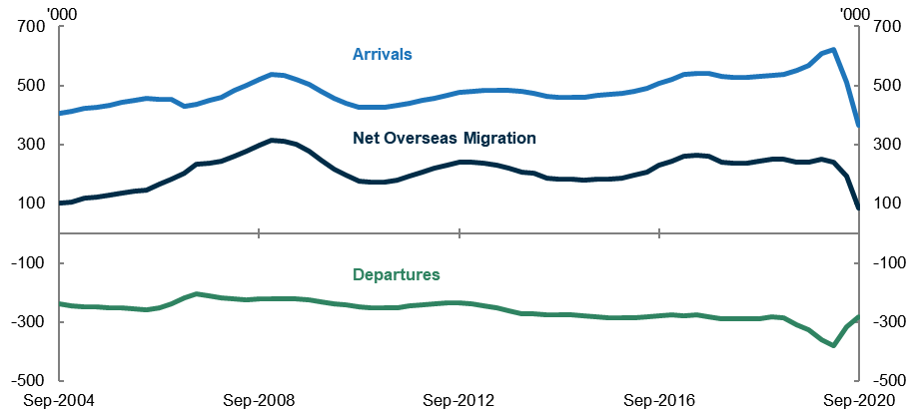 Source: ABS National state and territory population, September 2020 release

**The changing flows of international students accounted for the majority of the fall in NOM.** In 2019-20, the net inflow of international students was 12,800 people, around 84,000 fewer than in 2018-19 (Figure 2). This was driven by a 31.2 per cent decrease in student arrivals over the previous year to 113,000, and an almost 50 per cent increase in departures to 100,000. Permanent visa holders, temporary skilled visa holders and working holiday makers also experienced falls in NOM over 2019-20. All three experienced a decline in arrivals but, unlike student visa holders, departures in these visa classes continued around historical trends.

**In 2019-20, Australian citizens were net immigrants for the first time in this series.** Since records began, more Australians left the country than arrived. However, increasing global uncertainty due to the onset of the COVID-19 pandemic saw arrivals in Australian citizens rise by 25.7 per cent, as more Australians returned home. This, in conjunction with international travel restrictions in the last quarter of 2019-20, saw Australians make up almost 20 per cent of total arrivals, up from 14 per cent in 2018-19. Australians also historically constitute the majority of overseas departures, however travel restrictions meant student visa holders were the largest source of departures in 2019-20.

**Figure 2: National NOM by visa type, 2018-19 and 2019-20**



*Other includes all unclassified visa holders as well as migrants that crossed the border on visitor visas and likely transitioned to other visa types.

**In 2019-20, most states and territories experienced a decrease in NOM from the previous financial year.** New South Wales and Victoria account for the largest share of NOM and had the largest fall in 2019-20 (Figure 3). This was driven by large falls in students in these states. In NSW, NOM attributable to students had already been falling gradually since peaking in 2016-17.

**Western Australia and Tasmania were the only states to experience an increase in NOM from the previous financial year.** NOM for both states generally have a low dependency on student visa holders compared to other states and territories.

In recent years, NOM in WA and Queensland had been gradually increasing following large drop-offs at the end of the mining boom. NOM to Tasmania has been steadily increasing over the past five years.

**Figure 3: NOM by state and territory, year ended**



Source: ABS National state and territory population, September 2020 release

Migration also affects the ethnic diversity in the population as the **source countries for migration change over time**. Key countries of origin for NOM largely reflect the demand for higher education and both temporary and permanent employment from middle income countries. In recent years overseas born migrants were made up primarily from countries in Asia, particularly China and India. However, in 2019-20 the proportion of NOM from Asian born migrants fell from around 76 per cent in 2018-19 to 52 per cent as there were net outflows of migrants from China for the first time since this series began in 2004.

**Figure 4: Country of birth composition of NOM, 2019-20**



The **proportion of residents born overseas has increased** over the past two decades, growing from 23.3 per cent in June 1996 to 29.8 per cent in June 2020. This increase has been driven by migration from countries in Asia, particularly India and China. These two countries are now the second and third largest overseas born cohorts after England. New Zealanders, while growing as a share, have dropped from second in 1996 to fourth in 2020.

**Table 1: Top 10 countries of birth as at 30 June**

|  |  |  |  |  |  |  |
| --- | --- | --- | --- | --- | --- | --- |
|  | **1996** |  | **2020** | | | |
| **Rank** | **Country of birth** | **Share of population** | **Country of birth** | **Share of**  **population** | | **Median**  **age** |
| 1 | England | 5.2 | England | | 3.8 | 57.7 |
| 2 | New Zealand | 1.7 | India | 2.8 | | 34.7 |
| 3 | Italy | 1.4 | China | 2.5 | | 37.6 |
| 4 | Vietnam | 0.9 | New Zealand | 2.2 | | 44.3 |
| 5 | Scotland | 0.8 | Philippines | 1.2 | | 40.0 |
| 6 | Greece | 0.8 | Vietnam | 1.1 | | 47.3 |
| 7 | Germany | 0.7 | South Africa | 0.8 | | 44.3 |
| 8 | China | 0.7 | Italy | 0.7 | | 72.3 |
| 9 | Philippines | 0.6 | Malaysia | 0.7 | | 40.8 |
| 10 | Netherlands | 0.5 | Sri Lanka | 0.6 | | 41.4 |

**Table 2: Upcoming major population releases**

|  |  |  |
| --- | --- | --- |
| **Release** | **Former catalogue** | **Release date** |
| Regional Internal Migration Estimates, Provisional (PRIME), December quarter 2020 | NA | 4 May 2021 |
| Provisional Mortality Statistics | NA | Early May |
| National, state and territory population, December 2020 | 3101.0 | 17 June 2021 |