30 September 2021

Provisional Mortality Statistics, June 2021
Cumulatively in 2021 (until 27 June), the total number of doctor-certified deaths (69,200) was higher than the number of doctor-certified deaths in 2020 (67,000), and higher than the average over 2015-19 (64,800). The weekly number of doctor-certified deaths in June 2021 was higher than in June 2020, and above the 2015-19 average. Age standardised death rates in June were below the 2015-19 average, suggesting that the increase in the number of deaths (when compared to 2015-19) is largely driven by a change in the size and age structure of the population rather than an increase in mortality.

Weekly deaths
The number of deaths each week from January through to June was generally higher in 2021 than in 2020 or the 2015-19 average (Chart 1).

Doctor-certified deaths, COVID-19 infections, 2015-19 average compared with 2020 and 2021
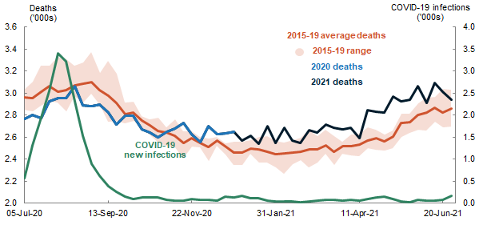

Cumulative deaths
In June 2021, the cumulative number of doctor-certified deaths was higher than the number of deaths in 2020 and was above the 2015-19 average.
Compared with the 2015-19 average, there have been slightly more doctor-certified deaths in 2021 for males and females aged over 65 years (an increase of 9.7 and 7.0 per cent respectively) (Chart 2).

Cumulative doctor-certified deaths by age and sex, 2015-19 average compared with 2020 and 2021

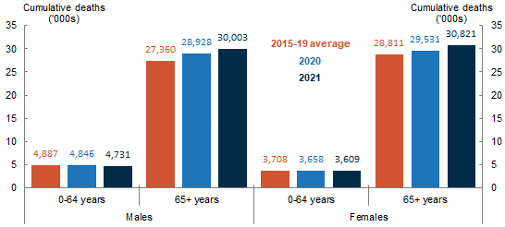

Cumulative doctor-certified deaths in 2021 were slightly higher in most states and territories when compared with 2020 and the 2015-19 average, but slightly lower in South Australia, the Northern Territory, and the Australian Capital Territory (Chart 3).

Cumulative doctor-certified deaths by state/territory of registration, 2015-19 average compared with 2020 and 2021
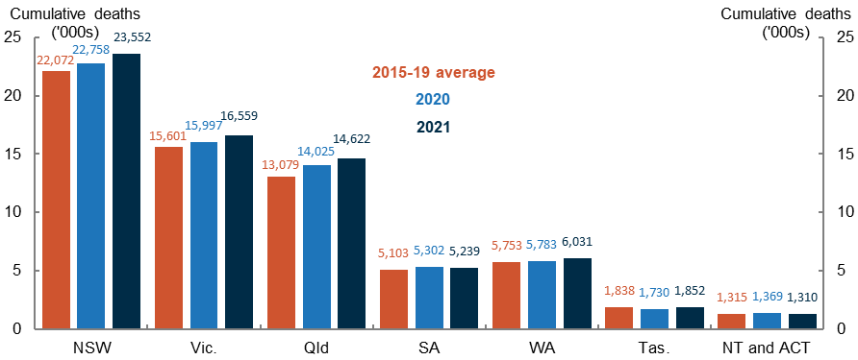

Cumulative doctor-certified deaths due to influenza and pneumonia in 2021 were 23.3 per cent lower than the 2015-19 average, while doctor-certified deaths due to dementia and diabetes in 2021 were 18.4 and 11.6 per cent higher respectively than the 2015-19 average (Chart 4).

Cumulative doctor-certified deaths by specified cause of death, 2015-19 average compared with 2020 and 2021
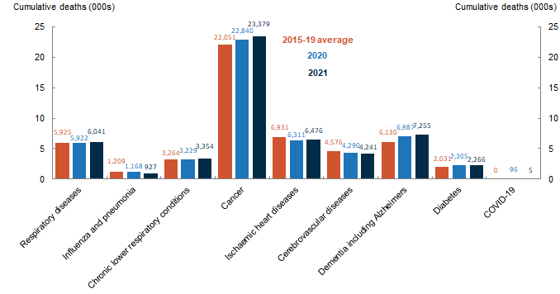
Note: Chart 4 shows the main causes of doctor-certified deaths and does not sum to total doctor-certified deaths for the period.

Age standardised death rates
Age standardised death rates (ASDRs) allow comparison of mortality trends across populations of different size and age structure. They are expressed as deaths per 100,000 population.
In the first half of 2021, ASDRs for total doctor-certified deaths have been lower when compared to the 2015-19 average (Chart 5).

Age standardised death rates, 2015-19 average compared with 2020 and 2021
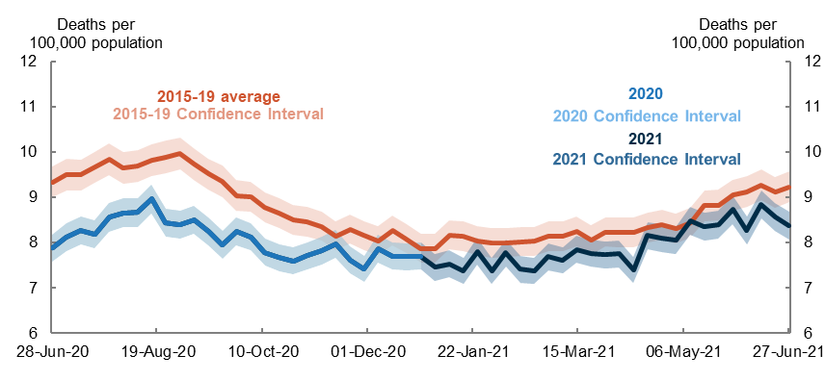
ASDRs for respiratory diseases in 2021 have also been generally lower than the 2015-19 average (Chart 6). This suggests that the decrease in respiratory related deaths is unrelated to changes in population size and ageing.

Age standardised death rates for respiratory disease, 2015-19 average compared with 2020 and 2021
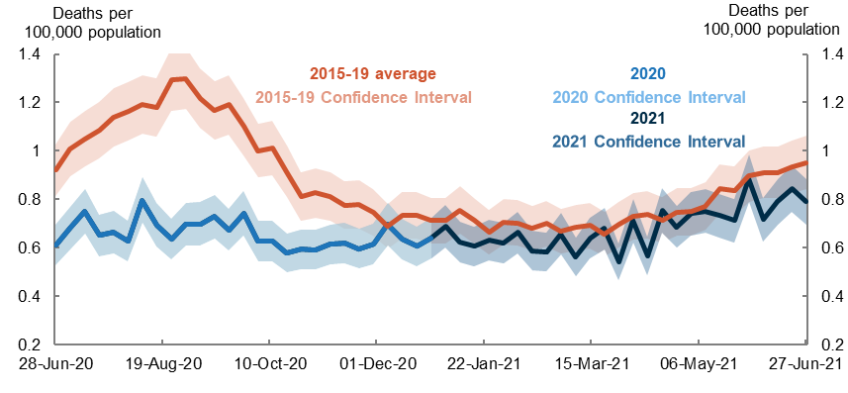
ASDRs for dementia for 2021 are close to the 2015-19 average (Chart 7). This suggests that some of the increase in cumulative dementia deaths compared to the 2015-19 average can be explained by an increase in population size, particularly at older ages.

Age standardised death rates for dementia, 2015-19 average compared with 2020 and 2021
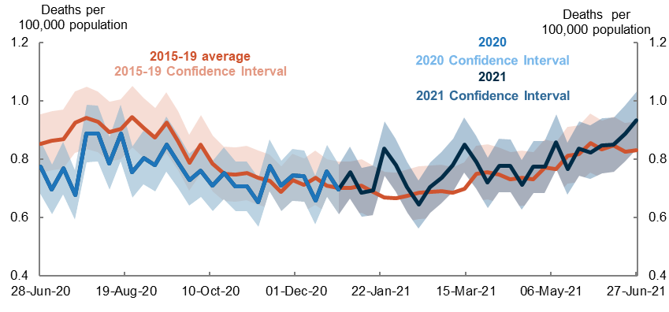

Upcoming major population releases
Release | Former catalogue | Release date
Provisional regional internal migration estimates, June 2021 | N/A | 28/10/2021
National, state and territory population June 2021 | 3101.0 | 16/12/2021

NOTES
Provisional data in this release only includes doctor-certified deaths, and therefore not comparable with the annual Deaths and Causes of Death data released by the ABS, which also include coroner-certified deaths. Each year just over 10 per cent of deaths in Australia are certified by a coroner. These include reportable deaths including suicides, drug overdoses and assaults.

Each new Provisional Mortality Statistics release will include those deaths that have been registered and reported to the Australian Bureau of Statistics since the previous release. As some of those deaths will have occurred in time periods covered in previous reports, the counts of deaths for those time periods will change from one report to the next. As a result, the cumulative numbers of deaths for the January-December period will change in future releases.

Provisional Mortality Statistics is released on a monthly basis by the Australian Bureau of Statistics. The Centre for Population prepares notes analysing these releases on a quarterly basis.

Further detail is available from the Australian Bureau of Statistics

