17 March 2022

National, state and territory population, September 2021

(Australian Bureau of Statistics)
The Estimated Resident Population (ERP) of Australia was 25.8 million people at 30 September 2021, around 12,100 people larger than at 30 June 2021. Population growth for the year ending 30 September 2021 was around 0.3 per cent (68,900 people), down from 0.8 per cent for the year ending 30 September 2020.
Quarterly net overseas migration (NOM) of -19,900 was around 16,800 lower than the previous quarter, the sixth consecutive quarter of negative NOM. NOM was -67,300 over the year ending 30 September 2021, an improvement compared to the year ending 30 June 2021. Natural increase over the year ending 30 September 2021 was relatively stable, with 7,700 more births and 4,900 more deaths compared to the year ending 30 September 2020.
Annual population growth was positive in most states and territories but was lower compared to the previous year in all states. Victoria recorded the largest decline in population of -0.5 per cent for the year ending 30 September 2021 after its sixth consecutive quarter of negative net overseas and interstate migration. Queensland had the highest growth rate of 1.1 per cent with net interstate migration being the major contributor to population growth for the year. The negative net interstate migration (NIM) in NSW and Victoria over this period largely corresponded with positive NIM to Queensland.

National Outcomes
Australia’s population grew by around 12,100 people in the September 2021 quarter (0.05 per cent). This was entirely due to natural increase of 32,000 for the quarter, offset by NOM of -19,900 (Chart 1).
- Quarterly national population growth and components, number of people
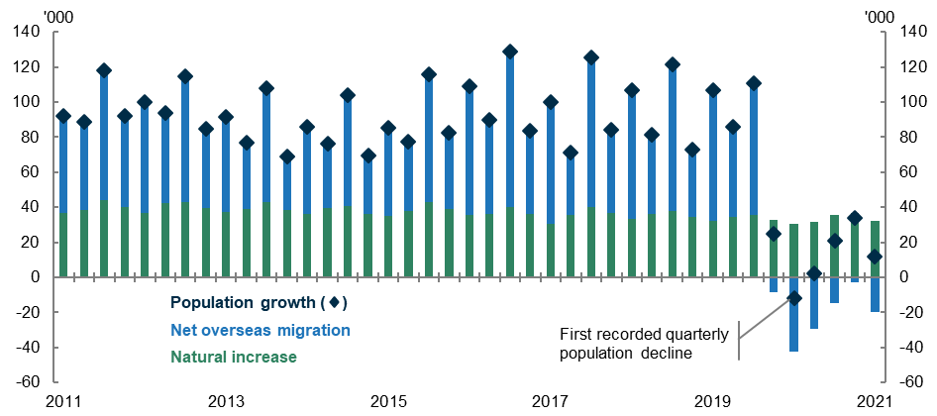
Quarterly NOM was around 16,800 lower than the previous quarter. This was the sixth consecutive quarter of negative NOM since the beginning of the COVID-19 pandemic.
In the September 2021 quarter, 55,700 people emigrated from Australia compared to 35,700 immigrants. Annual NOM over the year ending 30 September 2021 was -67,300. This was a decrease of 142,900 compared to the year ending 30 September 2020, but higher than NOM of -89,900 for the year ending 30 June 2021 (Chart 2).

Net overseas migration, year ending quarterly, number of people
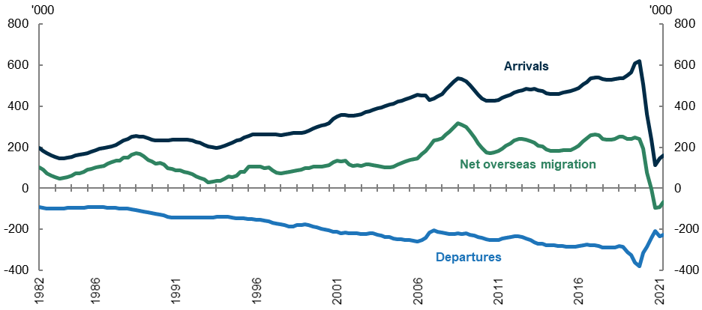
Natural increase over the year ending 30 September 2021 was 136,200 people, comprising 303,700 births less 167,500 deaths. Annual births increased by 7,700 from the year ending 30 September 2020. This is the third quarter where all births are the result of conceptions that would have taken place following the outbreak of the COVID-19 pandemic in Australia. The number of deaths in Australia increased slightly to 167,500 people in the year ending September 2021, this was 4,900 more deaths compared to the year ending September 2020 (also see analysis of the Australian Bureau Statistics’ Provisional Mortality Statistics, Jan 2020 - Nov 2021).
The number of total quarterly interstate moves in the September 2021 quarter increased substantially to 145,600 moves which was 23,900 more moves than the previous quarter. The NIM estimates have been revised for the past three quarters in this release. For more information on these revisions please see the Notes section below and also the ABS website.

State and territory outcomes
All states and territories recorded low but positive population growth over the year ending September 2021, except for Victoria, the Northern Territory and the Australian Capital Territory (Chart 3). Queensland had the highest annual growth (1.1 per cent), while Victoria had the lowest (-0.5 per cent). Victoria recorded its fifth consecutive quarterly population decline, falling by 6,000 people over the quarter. All states except NSW recorded negative NOM for the year ending September 2021. NSW recorded positive NOM of 5,100 people in the year ending September 2021.
- State and territory population growth (per cent), year ending quarterly

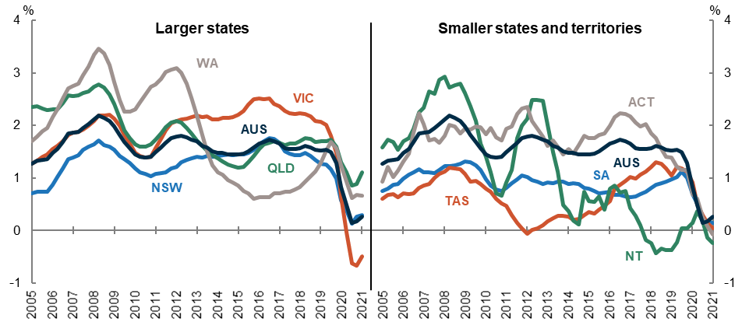
Following national trends, population growth for the quarter in all states and territories was mainly driven by natural increase, except in the case of Queensland, where population growth was driven by NIM. Compared to the September 2020 quarter, there were slightly more births in all jurisdictions except for Western Australia and more deaths over the same period in all states.

State and territory population growth (no. people), quarterly, September 2021
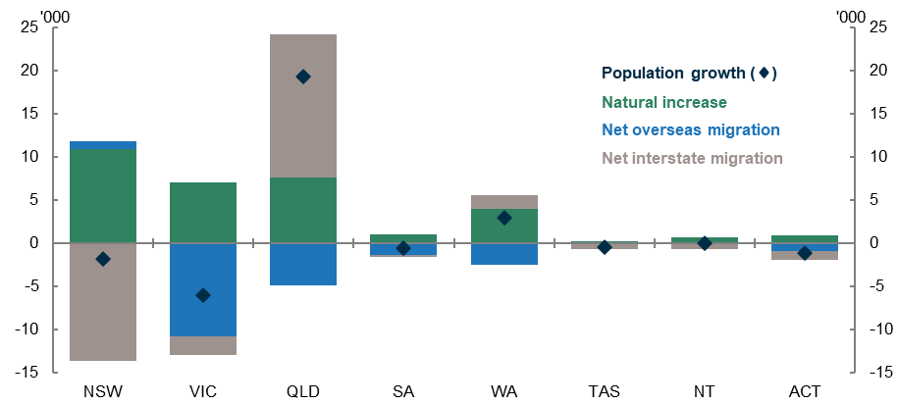
- Victoria’s annual population growth of -0.5 per cent is the fourth consecutive quarter of negative annual growth. Victoria remains the slowest growing state for the year ending September 2021. The state’s negative growth in the year ending September 2021 was caused by large net outflows of overseas migrants (-46,300) and smaller outflow of interstate migrants (-16,900), only partially offset by positive natural increase (30,500). Most significantly, NOM to Victoria was -46,300 over the year ending September 2021, a decrease of 60,300 compared to the year ending September 2020.
- New South Wales’ annual population growth fell to 0.3 per cent in the year ending September 2021 compared to 0.6 per cent in the year ending September 2020. The state’s lower population growth was driven by the lowest quarterly NIM since the beginning of the NSTP series in 1981, resulting in a net outflow of -26,200 in the year ending September 2021. NOM has continued to improve in the year-ending September 2021, recording a net inflow of 5,100.
- Queensland’s annual population growth slowed to 1.1 per cent in the year ending September 2021 compared to 1.3 per cent over the year ending September 2020. While Queensland recorded its sixth consecutive quarter of negative NOM, the state’s growth was supported by the highest quarterly NIM since the beginning of the NSTP series in 1981, resulting in a net inflow of 40,600 in the year ending September 2021. Queensland continues to be the fastest growing jurisdiction over the year ending September 2021, mainly due to continuing net inflows of interstate migrants.
- South Australia’s annual population growth dropped to 0.1 per cent from 0.7 per cent over the year ending September 2020. The state’s lower growth was due to negative NOM (-3,500), offset by slightly positive NIM (600) and natural increase (5,400).
- Western Australia’s annual population growth decreased to 0.7 per cent in the year ending September 2021 compared to 1.2 per cent in the year ending September 2020. The state’s growth was primarily driven by natural increase (17,800) and positive annual NIM (6,100).
- Tasmania’s annual population growth dropped to 0 per cent in the year ending September 2021, compared to 0.9 per cent over the year ending September 2020. While natural increase made a positive contribution to growth (1,200), this was offset by both negative NOM (-300) and NIM (-700).
- The Northern Territory’s annual population growth slowed from 0.2 per cent in the year ending September 2020 to -0.2 per cent in the year ending September 2021. This negative growth rate was primarily driven by negative NIM (-2,900) and negative NOM (-300) which more than offset the positive contribution of natural increase (2,600).
- The Australian Capital Territory’s annual population growth slowed from 0.7 per cent in the year ending September 2020 to -0.1 per cent in the year ending September 2021. The state’s negative growth was mainly due to negative NOM (-3,200) and to a much lesser extent negative NIM (-500), which more than offset the positive contribution from natural increase (3,400).

Population and population growth across Australia
State | ERP | ERP Increase | ERP Increase | Natural Increase | NIM | NOM
 | 30 September 2021 | Since 30 September 2020 | annual % | annual contribution | annual contribution | annual contribution
NSW | 8,186,789 | 24,214 | 0.30 | 45,359 | -26,204 | 5,059
VIC | 6,643,062 | -32,716 | -0.49 | 30,496 | -16,917 | -46,295
QLD | 5,240,520 | 57,764 | 1.11 | 29,808 | 40,619 | -12,663
SA | 1,772,787 | 2,551 | 0.14 | 5,448 | 561 | -3,458
WA | 2,685,165 | 17,794 | 0.67 | 17,786 | 6,051 | -6,043
TAS | 540,839 | 189 | 0.03 | 1,205 | -689 | -327
NT | 245,865 | -585 | -0.24 | 2,649 | -2,930 | -304
ACT | 430,469 | -308 | -0.07 | 3,428 | -491 | -3,245
Australia* | 25,750,198 | 68,917 | 0.27 | 136,185 | NA | -67,268
*Includes other territories comprising Jervis Bay Territory, Christmas Island, the Cocos (Keeling) Islands and Norfolk Island.

Upcoming major population releases
Reference period | Former catalogue | Release date
Regional population, 2020-21 | 3218.0 | 29/03/2022
National, state and territory population, December 2021 | 3101.0 | 28/06/2022
National, state and territory population, March 2022 | 3101.0 | 22/09/2022

NOTES
Further detail is available from the Australian Bureau of Statistics.
In this release, the ABS revised its NIM estimates for the past three quarters. For the June and September 2021 quarters, the revisions were due to the Medicare change of address data used to estimate internal migration. The change of address data showed an implausibly high number of moves because of widespread updating of Medicare records as people get vaccinated for COVID-19. Not all the address changes recorded in these quarters happened within this period. To treat for this, under-count adjustments in these quarters and those made in previous quarters have been revised.
The ABS is currently investigating a data quality issue with the source data for overseas migration, specifically the state and territory level data. Preliminary overseas migration is expected to be revised next quarter.
Chart 5 below shows the difference between June 2021 revised data and September 2021 revised data for the December 2020, March 2021 and June 2021 quarters. While the revisions to both interstate migration and overseas migration are quite significant, natural increase remains unchanged from the June 2021 release. More information can be found in Table 3 which sets out the revision schedule of the data.

Cumulative revisions for the December 2020 through June 2021 quarters
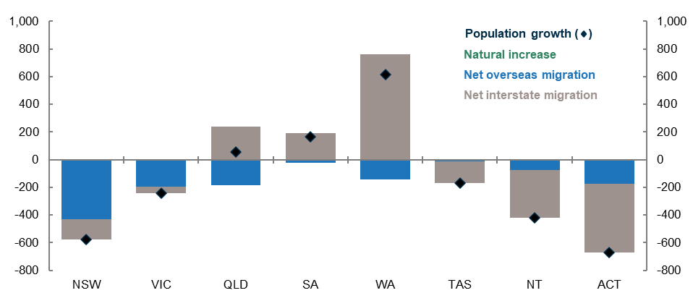

ABS revision schedule
Quarters | Births and deaths | Overseas migration | Interstate migration | Estimated resident population
Sep. 1991 – Jun 2016 | Final | Final | Final | Final
Sep. 2016 – Jun. 2020 | Revised | Final | Preliminary | Revised
Sep. 2020 | Preliminary | Final | Preliminary | Preliminary – updated due to revised component data
Dec. 2020 – Jun. 2021 | Preliminary | Revised | Preliminary | Preliminary – updated due to revised component data
Sep. 2021 | Preliminary | Preliminary | Preliminary | Preliminary

