30 March 2022

Mortality during the COVID-19 pandemic
This note draws on data from Provisional Mortality Statistics, Jan 2020 – Dec 2021 and from Measuring Australia’s excess mortality during the COVID-19 pandemic from the Australian Bureau of Statistics. It covers the period when infections and deaths from the Delta variant were most prevalent. While the Omicron variant was first detected in Australia in November 2021, deaths from the virus have been highest in early 2022.
In 2021, the total number of doctor-certified deaths (149,200) was higher than the number of doctor-certified deaths in 2020 (141,500), and higher than the average over 2015-19 (140,600).
Age standardised death rates for total doctor-certified deaths in 2021 were below the 2015-19 historical average, but higher than in 2020 (from May 2021 onwards). This suggests that the increase in deaths in 2021 (when compared to 2015-19) reflects a larger and older population, rather than an increase in mortality.
Excess mortality is an epidemiological concept defined as the difference between the number of observed and expected deaths in a period, with expected deaths modelled using data from the previous 5 calendar years.
In 2021, Australia had 5,100 more deaths than expected. However, only 5 weeks recorded excess deaths that were statistically significant, totalling 100 deaths above the weekly upper thresholds of statistical significance.
All states and territories except the Northern Territory experienced higher than expected deaths in 2021. Victoria experienced the highest number of statistically significant excess deaths (400 deaths above the threshold). New South Wales did not experience any weeks with statistically significant excess mortality.
Across the majority of 2020 and 2021, deaths due to respiratory disease (excluding COVID-19) were significantly lower than expected.

Weekly and cumulative deaths
The number of deaths each week from January through to December was generally higher in 2021 than the 2015-19 average (Chart 1). In 2021, there were a total of 149,200 doctor-certified deaths which was higher than the number of deaths in 2020 (141,500) and above the 2015-19 average (140,600).
Compared with the 2015-19 average, there were slightly more doctor-certified deaths in 2021 for males and females aged over 65 years (an increase of 9 and 6 per cent respectively). Doctor-certified deaths in 2021 were higher in all states and territories when compared with the 2015-19 average, and higher in all states except the Australian Capital Territory and Northern Territory when compared with 2020.
Doctor-certified deaths due to influenza and pneumonia in 2021 were 36 per cent lower than the 2015-19 average, while doctor-certified deaths due to dementia and diabetes in 2021 were 14 and 11 per cent higher respectively than the 2015-19 average. Doctor-certified deaths due to COVID-19 in 2021 were 43 per cent higher in 2021 than in 2020 despite new infections being 460 per cent higher over the same period in 2021.

Weekly doctor-certified deaths and COVID-19 infections, 2021
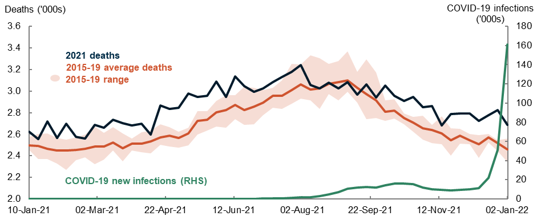

Age standardised death rates
Age standardised death rates allow comparison of mortality trends across populations of different size and age structure. They are expressed as deaths per 100,000 population.
In 2021, age standardised death rates for doctor-certified deaths have been lower when compared to the 2015-19 average (Chart 2). The age standardised death rate for 2021 was 431 deaths per 100,000 people, which was lower than the average for 2015-19 (459), but above the rate for 2020 (424.5). This suggests that an increase in the number of deaths observed in 2021 (when compared to 2015-19) reflects changes in the size and age structure of the population rather than an increase in mortality.

Weekly age standardised death rates for total doctor-certified deaths, 2020 and 2021
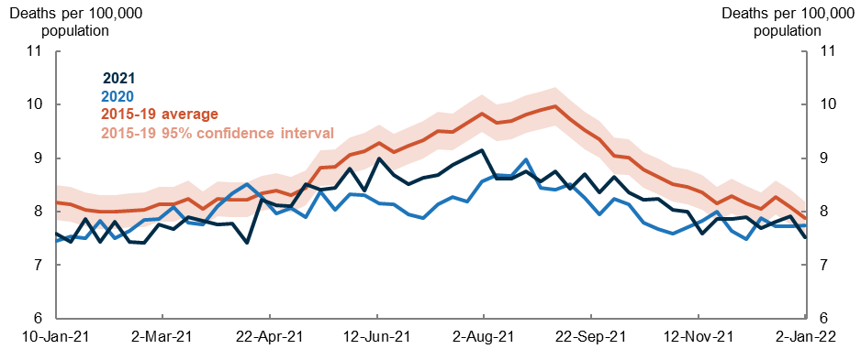Note: Data for 2020 refers to equivalent weeks in 2021

Measuring Australia’s excess mortality during the COVID-19 pandemic
Excess mortality is an epidemiological concept defined as the difference between the number of observed and expected deaths in a specified time period. Excess deaths account for deaths beyond natural variation such as deaths due to COVID-19, potentially undiagnosed COVID-19 deaths, and other mortality that may be indirectly related to the pandemic (e.g. relating to social isolation or changed access to health care).
While the number of deaths may be different from the expected number of deaths, it should fall within an expected range (that is, there is a 95% chance that the expected number of deaths would lie between the upper and lower bounds of the confidence intervals). When deaths exceed the upper threshold or drop below the lower threshold this indicates a statistically significant change in the pattern of mortality.

National
In 2021, there were 5,100 more deaths than expected, with a cumulative 100 deaths above the weekly upper thresholds of statistical significance (Table 1). In 2020 there were 1,700 fewer deaths than expected, though this includes periods where deaths were above (50 deaths in total) and below (200) the weekly thresholds of statistical significance. This compares with no statistically significant excess deaths in 2019, 20 fewer deaths in 2018, and 1,500 more deaths in 2017 (due to a severe influenza season that year).

Difference between expected and observed deaths
Year | Difference from expected | Total above weekly upper thresholds | Total below weekly lower thresholds
2017 | 3,630 | 1,501 | 0
2018 | -2,003 | 0 | -19
2019 | 1,277 | 0 | 0
2020 | -1,734 | 48 | -209
2021 | 5,090 | 108 | 0

At the national level, there were 5 weeks in 2021 where the number of deaths exceeded the upper threshold of statistical significance. These weeks were spread across the year in January, May, June, July, and December.
In 2021, deaths due to COVID-19 impacted all-cause mortality from July till the end of the year. In 2020, there was a period from July to September where deaths due to COVID-19 had a statistically significant impact on all-cause mortality (Chart 3), this time-period coincided with higher rates of COVID-19 infections.

Expected vs observed deaths - Australia

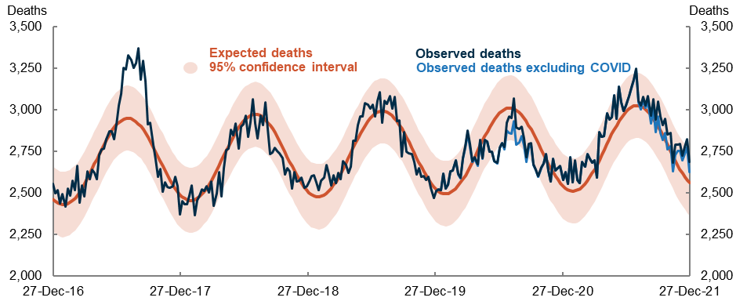

State and territory
States and territories were impacted differently by the pandemic, with those differences including COVID-19 infection rates, COVID-19 mortality and public health measures. However, there does not appear to be a clear relationship between levels of COVID-19 infections and statistically significant deaths.
In 2021 all states and territories (except the Northern Territory) recorded higher-than-expected deaths. However, only in Victoria, Queensland, South Australia and Tasmania did this include weeks in which deaths were statistically significant (Table 1).
Despite elevated rates of COVID-19 infection in 2020 and 2021, NSW experienced weeks with statistically significant lower mortality in 2020 and no weeks with statistically significant rise in deaths in 2021.

Difference between expected and observed number of deaths by state
Year | New South Wales | Victoria | Queensland | South Australia | Western Australia | Tasmania | Northern Territory | Australian Capital Territory
2020 | -1,292*  (-124) | 382*  (93) | -786*  (-55) | 102 | -63 | -68*  (-10) | 18 | 24
2021 | 13 | 2,782*  (394) | 853*  (52) | 891*  (70) | 804 | 366*  (28) | -96 | 102
Note: * notes years that have periods of statistically significant excess mortality or lower than expected mortality (2 weeks or more above or below the threshold). Other years fall within the expected range.
Numbers in () show the net statistically significant excess deaths.

In 2020 and 2021, Victoria experienced the highest number of deaths above the expected number, including the highest number of deaths exceeding the weekly upper thresholds. Deaths due to COVID-19 significantly contributed to all-cause mortality, and led to statistically significant weekly deaths during July and August 2020, and between October and December 2021 (Chart 4). In 2021, deaths in Victoria were above expectation in all but two weeks.

Expected vs observed deaths - Victoria
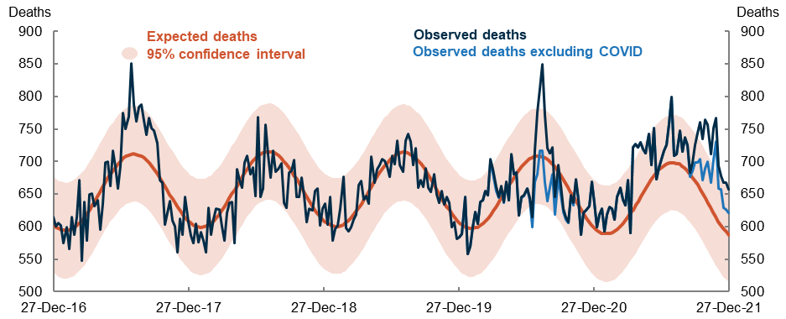

Cause-specific mortality
Deaths due to respiratory disease (excluding COVID-19) were most impacted during the pandemic, while deaths from other causes have been relatively unaffected.
Across 2020 and 2021 deaths due to respiratory disease (including influenza, pneumonia and chronic lower respiratory conditions) were 6,000 lower than expected. This includes 1,600 deaths below the weekly lower bound of statistical significance (Chart 5).
There were 40 deaths due to influenza in 2020, and only 2 in 2021. Sustained statistically significant excess mortality due to respiratory disease has not been recorded since 2017 (which occurred due to the influenza epidemic that year).

Expected vs observed deaths - respiratory diseases
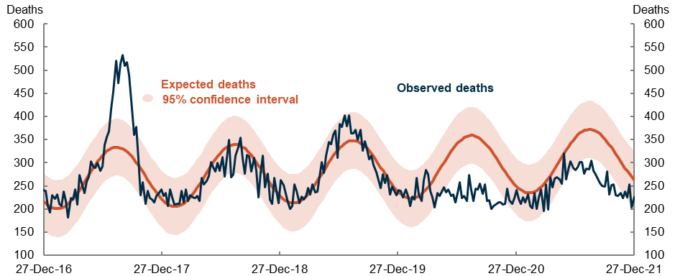

Upcoming major population releases
Release | Former catalogue | Release date
Causes of Death, Australia, 2021 | 3303.0 | 6/04/2022
National, state and territory population, December 2021 | 3101.0 | 28/06/2022
Deaths, Australia, 2021 | 3302.0 | 29/09/2022

NOTES
Data for this release includes doctor-certified deaths that occurred by 31 December 2021 and were registered by 28 February 2022. Provisional data in this release only includes doctor-certified deaths, and therefore not comparable with the annual Deaths and Causes of Death data released by the ABS, which also include coroner-certified deaths. Each year just over 10 per cent of deaths in Australia are certified by a coroner. These include reportable deaths including suicides, drug overdoses and assaults.
Each new Provisional Mortality Statistics release will include those deaths that have been registered and reported to the Australian Bureau of Statistics since the previous release. As some of those deaths will have occurred in time periods covered in previous reports, the counts of deaths for those time periods will change from one report to the next. As a result, the cumulative numbers of deaths for the January-December period will change in future releases. Provisional Mortality Statistics is released on a monthly basis by the Australian Bureau of Statistics (ABS). The Centre for Population prepares notes analysing these releases on a quarterly basis.
Care should be taken when comparing results from the ABS excess deaths analysis published in Measuring Australia’s excess mortality during the COVID-19 pandemic with excess deaths calculated elsewhere due to differences in methodology and source data. The ABS has adopted aspects of methodology used by New South Wales Health in its analysis, applying cyclical linear regression with a robust estimation procedure to produce an expected number of deaths and a range of expected deaths for 2021 all cause and cause-specific mortality. Further detail is available from the Australian Bureau of Statistics.

There is natural variation in patterns of mortality. While observed deaths may be different from that expected, it should fall within a range. When deaths are outside the range it indicates a statistically significant change in the pattern of mortality.
Daily new COVID-19 infection data sourced from Our World in Data.

