28 June 2022

National, state and territory population, December 2021
The Estimated Resident Population (ERP) of Australia grew by 0.2 per cent in the December 2021 quarter.
This is the first positive quarter of net overseas migration since the beginning of the pandemic, following a relaxation of international travel restrictions from 1 November 2021.
Queensland had the fastest growing population over 2021, followed by Western Australia and Tasmania. Population growth in New South Wales and the Northern Territory was slow, while the Victorian population declined.
There were large outflows of net interstate migration from New South Wales and Victoria, while Queensland and Western Australia received large inflows of interstate migrants.
The Australian Bureau of Statistics (ABS) has rebased Australia’s ERP to the 2021 Census of Population and Housing. For analysis of the rebased population estimates please see Rebasing of Australia’s population estimates using the 2021 Census, at population.gov.au.

Natural increase drove all of Australia’s population growth in 2021
- Australia’s population grew by 128,000 people over the year to December 2021, an increase of 0.5 per cent. This was higher than growth over the year to December 2020 at 112,000 people or 0.4 per cent.
- The December quarter 2021 was the first quarter with a net inflow of migrants (29,000) since international travel restrictions were introduced in March 2020 (see Chart 1).
  - As a result, population in the December quarter grew at the highest rate since the beginning of the COVID-19 pandemic, by 63,000 people or 0.2 per cent.

Quarterly national population growth and components, number of people
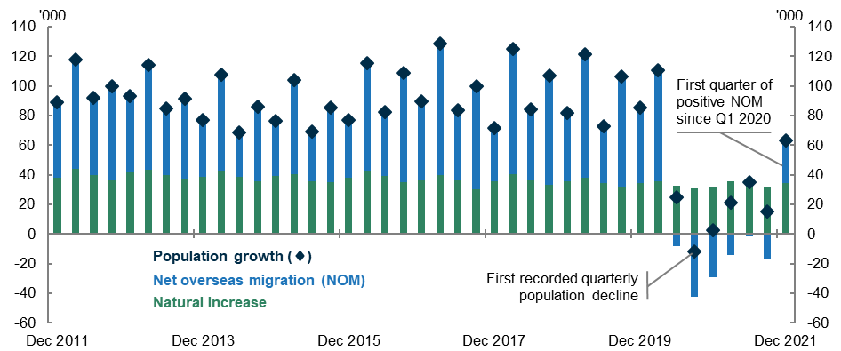

- Positive net overseas migration in this quarter was not enough to offset the previous three quarters of migration outflows, resulting in a net outflow of 4,000 migrants over the year to December 2021 (see Chart 2).
- Natural increase (births minus deaths) was entirely responsible for population growth over the year to December 2021, with births outnumbering deaths by 139,000.
  - There were 310,000 births over the year to December 2021, an increase of 6.2 per cent from 2020 and the highest annual births figure since 2016. Deaths increased by 6.6 per cent in 2021 to 172,000 (also see analysis of the ABS Provisional Mortality Statistics).
    - Victoria saw an increase in births in the December 2021 quarter, which is likely explained by a catch up in birth registrations following longer than usual delays in registrations in 2021 due COVID-19 restrictions.
- The number of interstate moves rose to a high of 484,000 over the year to December2021 (see Chart 3), with most states reaching historical records for interstate arrivals and departures.
  - However, it is unlikely that all these interstate moves were made in the December 2021 quarter. Driving these historic figures are changes to Medicare address data, which is used to calculate interstate moves. In 2021, there was an unprecedented increase in the number of address changes captured through Medicare because of the COVID-19 vaccination program.
Net overseas migration, year ending | Interstate migration, year ending

State and territory growth is concentrated in Queensland and Western Australia
- Record national interstate migration pushed annual population growth in Queensland and Western Australia above one per cent in 2021. New South Wales, the Northern Territory, and Victoria continued to be the slowest growing states through the net loss of migrants (see Chart 4).
- Annual population growth in South Australia, Tasmania, and the ACT increased following lows in the year to September 2021, suggesting these jurisdictions will continue to see improving growth.
- The Northern Territory was the only jurisdiction where annual population growth declined since the September quarter.
- Natural increase was the main driver of increased population in most states and territories, with only Queensland, South Australia, and Tasmania relying more heavily on migration for growth.
- Movement within Australia remains influenced by the pandemic with fewer residents choosing to move to jurisdictions during extended lockdowns.
  - Record net outflows from Victoria and New South Wales were driven by fewer interstate arrivals and record high departures. This led to record net interstate migration to Queensland and Western Australia.
- Flows of overseas migrants across the country were uneven as a result of interstate border closures which were removed in some jurisdictions throughout the December 2021 quarter.

State and territory population growth and Components
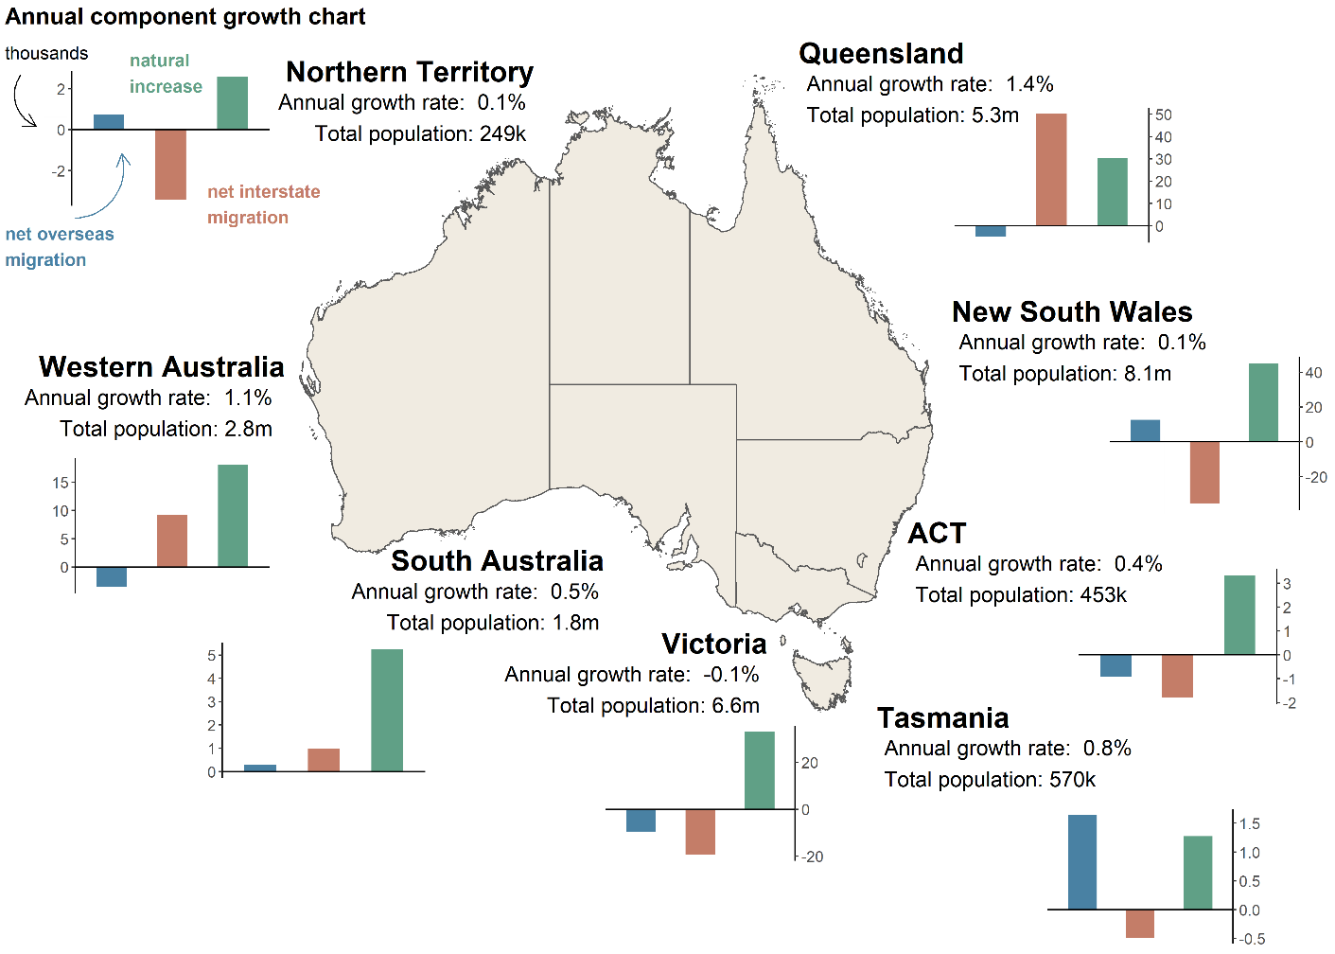
Note: Components of growth will not match the total growth due to the intercensal difference, notably for the Northern Territory. For further information on the intercensal difference please see Rebasing of Australia’s population estimates using the 2021 Census, at population.gov.au.

Population and population growth across Australia
State | ERP | ERP Increase | ERP Increase | Natural Increase | NIM | NOM
 | 31 December 2021 | Since 31 December 2020 | annual % | annual contribution | annual contribution | annual contribution
NSW | 8,095,430 | 11,238 | 0.14 | 44,809 | -35,337 | 12,608
VIC | 6,559,941 | -3,524 | -0.05 | 32,877 | -19,386 | -9,566
QLD | 5,265,043 | 73,689 | 1.42 | 30,255 | 50,162 | -4,838
SA | 1,806,599 | 9,644 | 0.54 | 5,260 | 980 | 295
WA | 2,762,234 | 30,505 | 1.12 | 18,150 | 9,288 | -3,578
TAS | 569,827 | 4,270 | 0.76 | 1,275 | -486 | 1,640
NT | 249,345 | 182 | 0.07 | 2,572 | -3,420 | 741
ACT | 453,324 | 1,893 | 0.42 | 3,335 | -1,801 | -921
Australia* | 25,766,605 | 127,953 | 0.50 | 138,539 | NA | -3,598
* Includes other territories comprising Jervis Bay Territory, Christmas Island, the Cocos (Keeling) Islands and Norfolk Island

Upcoming major population releases
Release | Former catalogue | Release date
Regional population | 3218.0 | 26/07/2022
Regional population by age and sex | 3235.0 | 30/08/2022
National, state and territory population, March 2022 | 3101.0 | 22/09/2022
Deaths, Australia, 2021 | 3301.0 | 29/09/2022

NOTES
Further detail regarding the latest population data is available from the ABS in National, state and territory population, December 2021.

