15 December 2022

National, state and territory population, June 2022
The Estimated Resident Population (ERP) of Australia grew by 0.3 per cent in the June 2022 quarter, to be 1.1 per cent higher than a year earlier.
Overseas migration continued to recover strongly with a net inflow of 58,000 in the June 2022 quarter. This saw net overseas migration contributing two-thirds of quarterly population growth, similar to quarters prior to the COVID-19 pandemic.
Deaths increased to 182,000 over the year to June 2022, 10.0 per cent higher than the year to June 2021. This more than offset a small increase in births, resulting in natural increase (births minus deaths) falling to 124,000.
Queensland had the fastest growing population over the year to June 2022, followed by Western Australia and Victoria. The Australian Capital Territory, Tasmania, and the Northern Territory were the slowest growing jurisdictions over the year to June 2022.
New South Wales and Victoria saw smaller net interstate migration outflows than the previous quarter, while Queensland continued to have the largest net inflow of interstate migrants.

Overseas migration drove most of the population growth in the June 2022 quarter
- Australia’s population grew by 291,000 people over the year to June 2022, an increase of 1.1 per cent. This was much higher than growth over the year to June 2021 of just 33,000 people (0.1 per cent).
- Population in the June 2022 quarter grew by 88,000 people or 0.3 per cent, driven mostly by strong net overseas migration.
- The June 2022 quarter was the second full quarter of data to incorporate the easing of international travel restrictions from November 2021. While net overseas migration was lower than the March 2022 quarter (98,000), it was the highest for a June quarter since 2008 (see Chart 1).

Quarterly national population growth and components, number of people
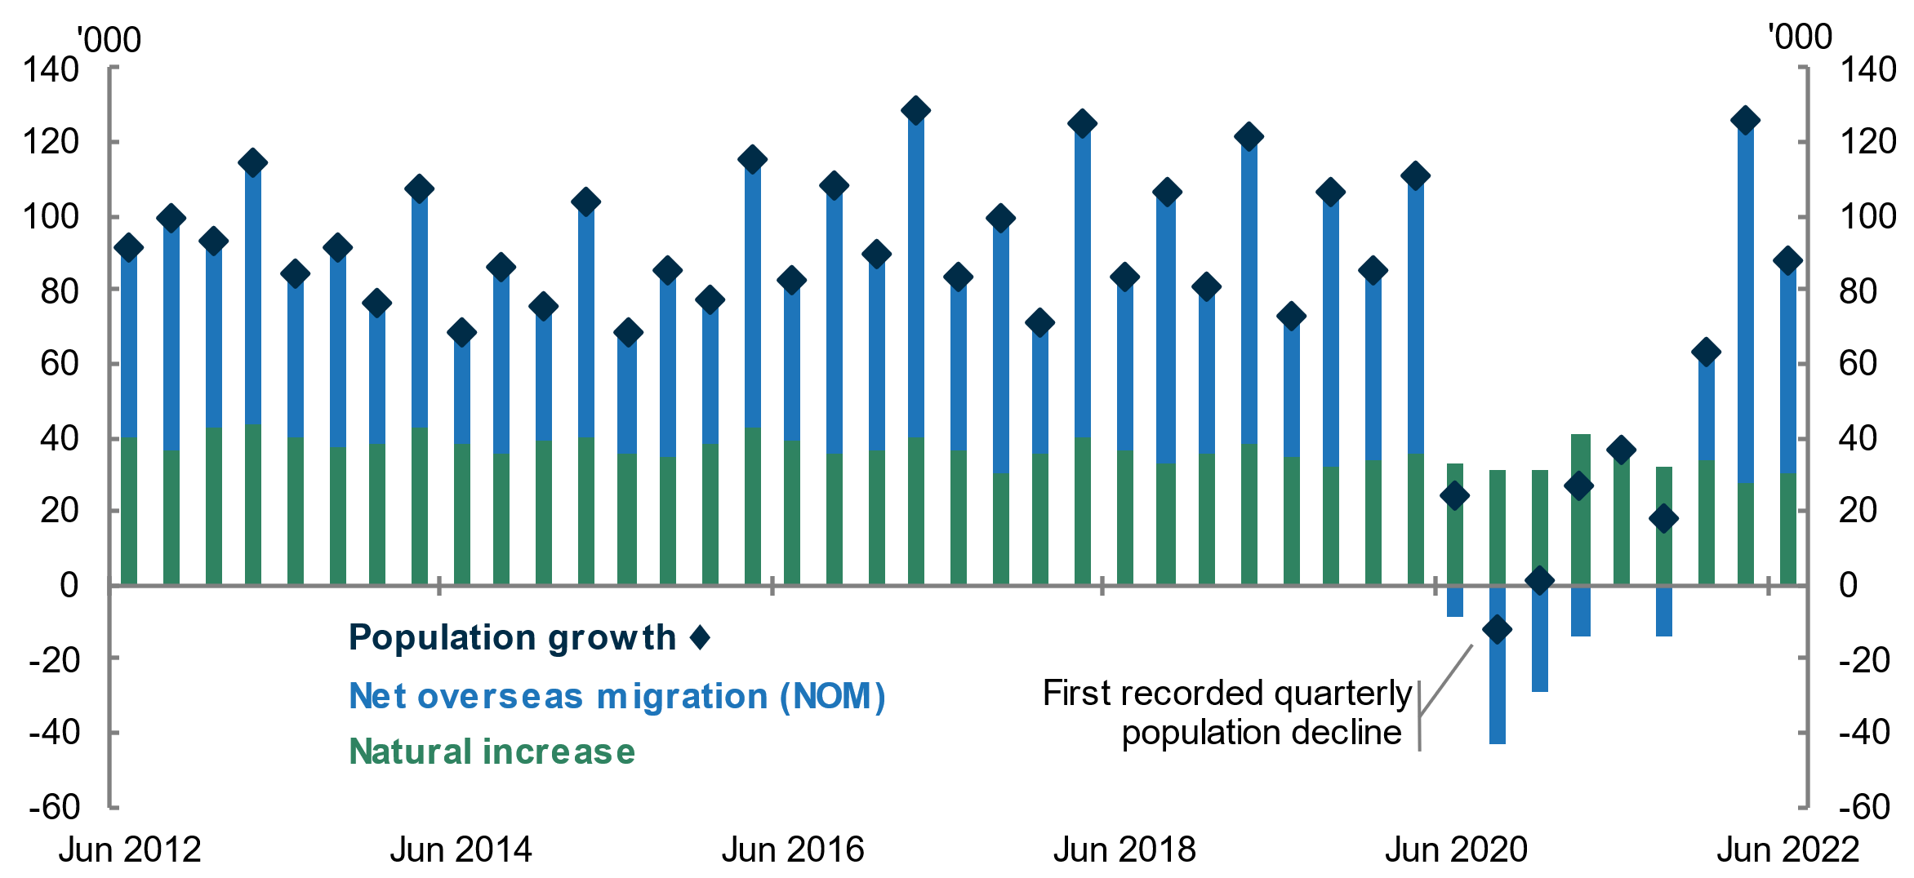
- Overseas migration grew to 171,000 and drove most of the population growth over the year to June 2022, the largest annual inflow of overseas migrants since June 2020 (see Chart 2).
  - This was due to continued growth in arrivals (119,000) and continued flat departures (61,000) in the June 2022 quarter (see Chart 2).
- Natural increase (births minus deaths) fell to 124,000 over the year to June 2022.
  - There were 306,000 births over the year to June 2022, an increase of 0.5 per cent from the previous year. Deaths in the year to June 2022 experienced an annual increase of 10.0 per cent, a period covering peaks in COVID-19 infections. Deaths associated with COVID-19 contributed to this increase (also see analysis of the ABS Provisional Mortality Statistics). This resulted in natural increase falling by 10.8 per cent over the year to June 2022.
- The number of interstate moves fell to 455,000 over the year to June 2022 (see Chart 3), down from a record high of 485,000 over the year to March 2022.
  - It is unlikely all recorded interstate moves were actually made in the year to June 2022. Interstate moves are estimated using change of address data captured through Medicare, which have seen an unprecedented increase because of the COVID-19 vaccination program.
  - Interstate moves in the June 2022 quarter fell to 92,000 from 95,000 in the March 2022 quarter. This was the lowest number of quarterly moves since the September 2020 quarter, and suggests that in future quarters annual interstate moves will likely return to levels seen prior to the COVID-19 vaccine rollout.
Overseas migration, year ending | Interstate migration, year ending

All states and territories experienced population growth in the year to June 2022
- Annual population growth increased in all states and territories, except for Tasmania and the Australian Capital Territory (see Chart 4).
  - New South Wales and Victoria saw an increase in annual population growth, driven by the continued recovery in overseas migration. However, growth remains below rates experienced prior to the pandemic.

State and territory population growth (per cent), year ending quarterly
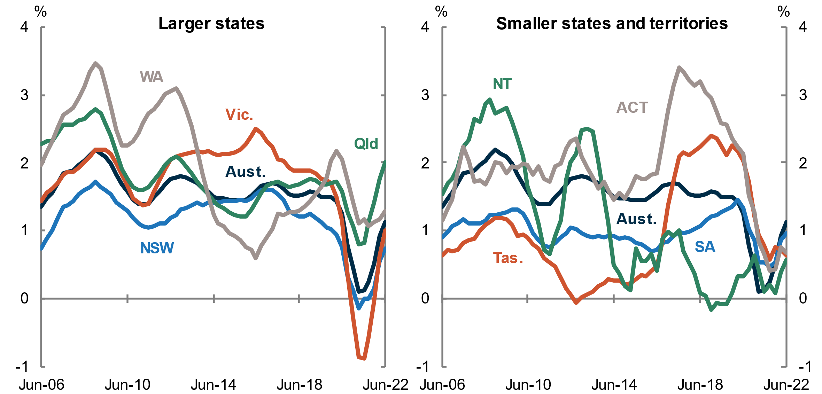

- Queensland and Western Australia continued to be the fastest growing jurisdictions in the year to June 2022. Tasmania, the Northern Territory and the Australian Capital Territory were the slowest growing jurisdictions due to interstate migration outflows and the comparatively smaller share of net overseas migrants they receive (see Chart 5).
- Queensland maintained the largest net inflow of internal migrants over the year to June 2022, followed by Western Australia and South Australia. All other states and territories had net outflows.

State and territory population growth and Components, annual

Population and population growth across Australia
State | ERP | ERP Increase | ERP Increase | Natural Increase | NIM | NOM
 | 30 June 2022 | Since 30 June 2021 | annual % | annual contribution | annual contribution | annual contribution
NSW | 8,153,584 | 59,769 | 0.74 | 40,378 | -43,451 | 62,213
VIC | 6,613,727 | 65,687 | 1.00 | 29,014 | -17,233 | 55,631
QLD | 5,322,058 | 104,405 | 2.00 | 27,647 | 55,418 | 23,430
SA | 1,820,530 | 17,338 | 0.96 | 4,560 | 1,025 | 12,077
WA | 2,785,312 | 35,448 | 1.29 | 16,179 | 10,791 | 9,502
TAS | 571,517 | 3,608 | 0.64 | 929 | -216 | 2,745
NT | 250,635 | 1,435 | 0.58 | 2,398 | -3,016 | 2,134
ACT | 456,652 | 3,094 | 0.68 | 3,252 | -3,318 | 3,117
Australia* | 25,978,935 | 290,856 | 1.13 | 124,360 | NA | 170,918
* Includes other territories comprising Jervis Bay Territory, Christmas Island, the Cocos (Keeling) Islands and Norfolk Island

Upcoming major population releases
Release | Former catalogue | Release date
Overseas migration, 2021–22 | 3407.0 | 16/12/2022
National, state and territory population, September 2022 | 3101.0 | 16/03/2023
Regional population, 2021–22 | 3218.0 | 20/04/2023

NOTES
Further detail regarding the latest population data is available from the ABS in National, state and territory population, June 2022.

