Components of Australia’s population since 1982

Over the last 35 years interstate migration has fallen by a third and natural increase has halved as a share of the total population.

**Chart 1. Australia’s natural increase and net overseas migration to interstate migration as a share of the total population**

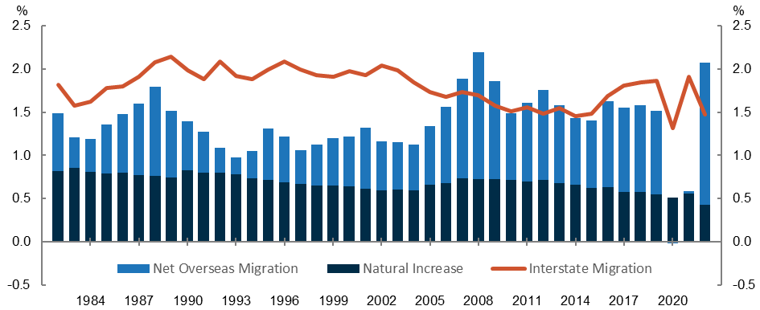

Source. Centre for Population analysis of [ABS National, State and Territory population data](https://www.abs.gov.au/statistics/people/population/national-state-and-territory-population/latest-release) (ABS, 2023a)

#### NOM has been a bigger contribution to population growth than natural increase

Since 2005, net overseas migration (NOM) has consistently been the largest contributor to Australia’s population growth due to increased levels of temporary migration (ABS, 2023c). NOM as a share of population peaked in 2008 and stabilised by 2011. This pattern persisted until the COVID-19 pandemic during which border closures disrupted migration. As Australia’s international borders reopened in 2022, NOM as a share of population has risen to above pre-pandemic levels. This increase has been primarily attributed to pent up demand for international study and a strong domestic labour market (Centre for Population, 2023).

Meanwhile, natural increase (NI) (defined as births minus deaths) has been steadily trending downwards as a percentage of the population since the 1990s, after remaining largely stable in the 1980s. Factors that contribute to the observed fertility decline include changing costs of having children, increased labour force participation and higher education amongst women, and changing social norms (Gray et al, 2022). In the 2000s, this trend temporarily reversed due to Australia’s increased fertility rate (Centre for Population, 2024). This fertility bump was also seen across developed English-speaking countries (Gray et al, 2022). This temporary fertility rate reversal ceased in 2009 and has since continued to decline to its lowest levels.

#### Interstate mobility has declined over the long term

From the late 1980s until 2004, interstate migration (IM) as a percentage of population tended to fluctuate at around 2 per cent of the population. From 2005 until 2015, IM as a percentage of population has seen a steady decline as a percentage of total population. The broad downwards trend in IM can be attributed to several factors, including an increasingly older population less likely to relocate, a higher share of dual income households that find it more difficult to leave established careers and networks, the increase in working from home, and adults moving out of their parents’ home later in life (CIE, 2023).

The measurement of IM was impacted by increased Medicare address changes during the pandemic, with the ABS noting that moves recorded in the second half of 2021 were implausibly high. Following the 2021 Census, the ABS revised total moves for 2016-2021. This is partially responsible for the increase in this period, particularly for the increase in 2021 (ABS, 2023b). In the post COVID-19 years, IM as a percentage returned to a trend that was similar to the 2010s.

#### References

ABS (Australian Bureau of Statistics) (2023a, December) National, state and territory population, <https://www.abs.gov.au/statistics/people/population/national-state-and-territory-population/latest-release>.

ABS (Australian Bureau of Statistics) (2023b, December) National, state and territory population methodology, <https://www.abs.gov.au/methodologies/national-state-and-territory-population-methodology/dec-2023>.

ABS (Australian Bureau of Statistics) (2023c, December) Overseas Migration, <https://www.abs.gov.au/statistics/people/population/overseas-migration/latest-release>.

CIE (Centre for International Economics) (2023) Internal Migration in Australia and the impact of government, levers <https://population.gov.au/sites/population.gov.au/files/2023-11/final-report-internal-migration-aus.pdf>.

Centre for Population (2023) 2023 Population Statement, <https://population.gov.au/sites/population.gov.au/files/2023-12/2023-population-statement.pdf>.

Centre for Population (2024) Fertility Decline in Australia: Is it here to stay?, <https://austreasury.sharepoint.com/:w:/r/sites/cenpop-function/_layouts/15/Doc.aspx?sourcedoc=%7B0D3D5564-130F-4290-B83B-77B4827AD716%7D&file=240418%20-%20FERTILITY%20DECLINE%20IN%20AUSTRALIA.docx&action=default&mobileredirect=true&wdsle=0>.

Gray E, Reimondos A, Lazzari E, Breunig R, Steinhauser R, Zhang J, Biddle N, and Gray M (2022) Impacts on policies on fertility rates, <https://population.gov.au/sites/population.gov.au/files/2022-03/ANU_Impacts-of-Policies-on-Fertility-Rates-Full-report.pdf>.