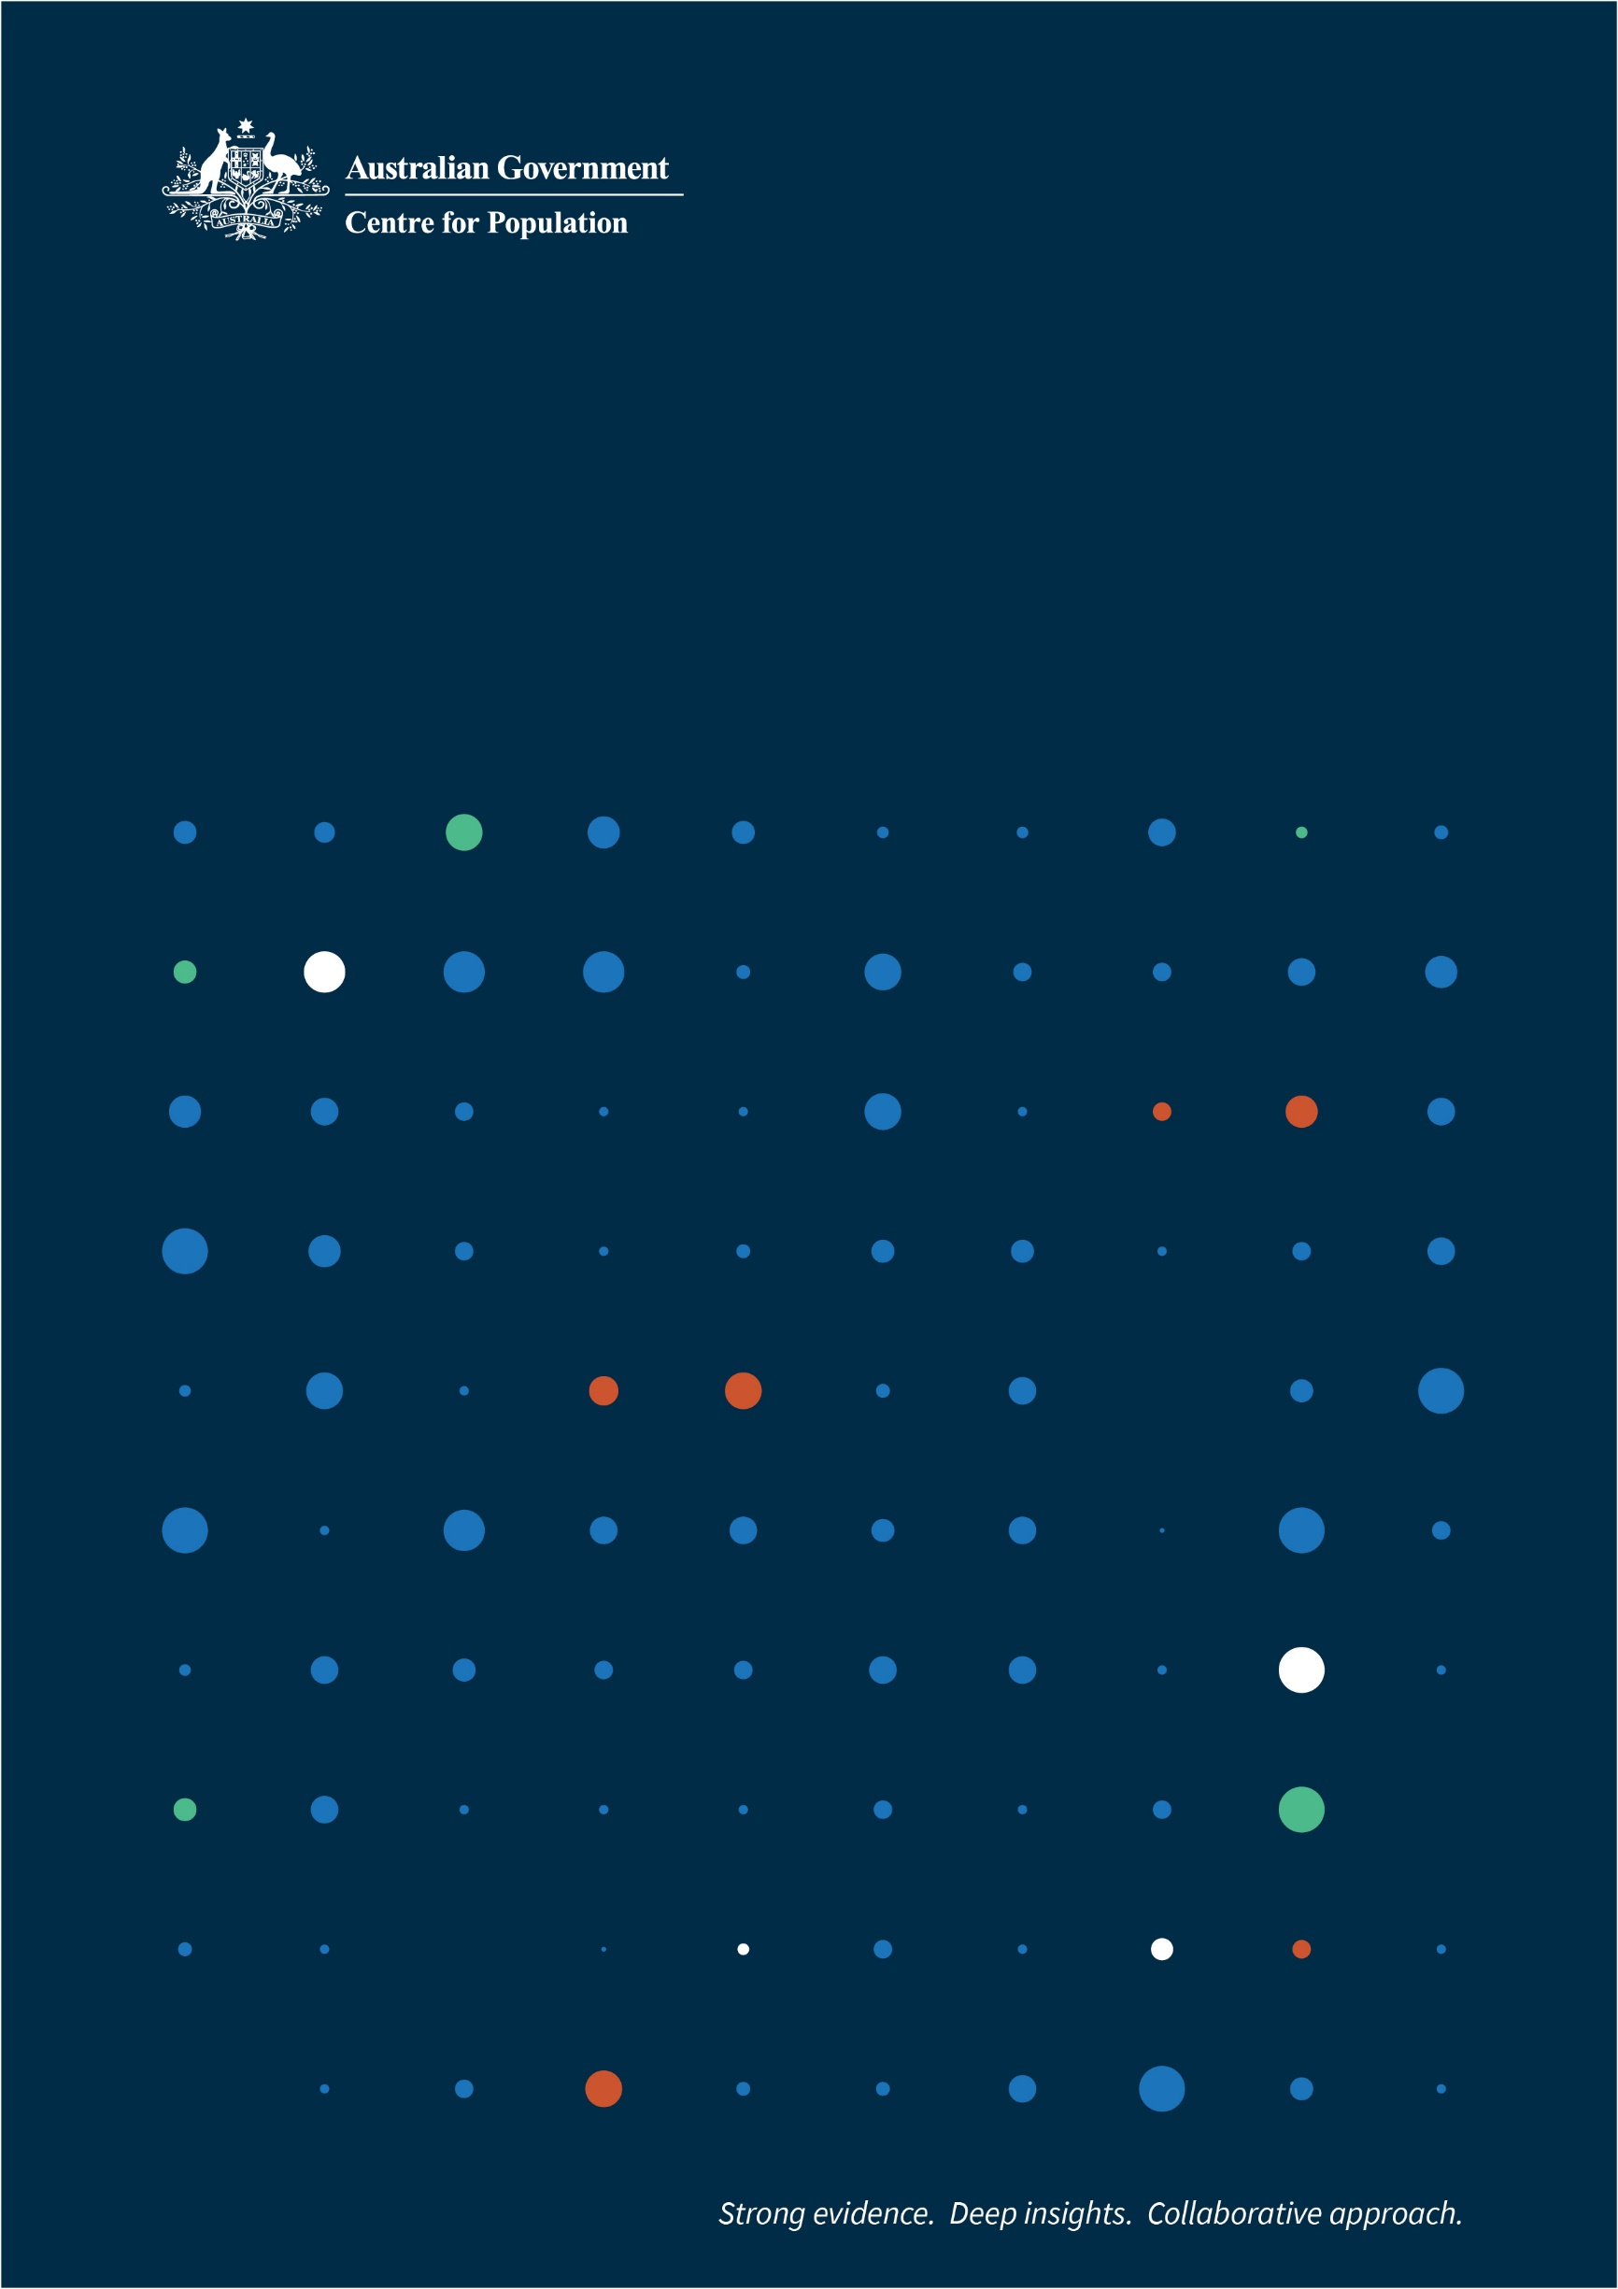

Submission to the inquiry into excess mortality

To the Senate community affairs References committee

Prepared by the Centre for Population

|  |
| --- |
| Key Points  Excess mortality since 2020 has corresponded with the prevalence of COVID-19 in the community and the timing of COVID-19 waves.  Deaths were slightly higher than expected in 2021. Excess mortality then peaked in 2022, before moderating in 2023.  The Centre for Population is forecasting excess mortality will continue to subside over 2023–24 to 2025–26.  Excess mortality has seen Australia experience a decline in life expectancy for the first time since the early 1990s, although the decline is smaller than in many other countries. |

# Introduction

The Centre for Population (the Centre) in the Australian Government Department of the Treasury welcomes the invitation from the Senate Community Affairs References Committee to make this submission to the inquiry into excess mortality.

In 2019, the Australian Government established the Centre to better understand Australia’s changing population. The Centre’s objectives are to: engage and collaborate, enrich the evidence base, and inform policy. To meet these objectives, the Centre produces data analysis, population forecasts and new research, which are regularly published on [population.gov.au](https://population.gov.au/).

The Centre analyses mortality data from the Australian Bureau of Statistics (ABS) and other sources to understand trends in mortality and its causes. Based on this analysis, and advice from the Australian Government Actuary, the Centre forecasts future mortality rates. This informs population projections in Australian Government Budget Papers, the Intergenerational Report and the Centre’s flagship annual publication, [the Population Statement](https://population.gov.au/publications/statements/2023-population-statement), which analyses recent and expected future changes in Australia’s population.

# Mortality in Australia

Australia has the third highest life expectancy in the world, behind only Monaco and Japan. Over the past 30 years, life expectancies at birth have increased, from 75.0 years for males and 80.9 years for females in 1993, to 81.2 years for males and 85.3 years for females in 2020–22. The five leading causes of deaths in 2021 were unchanged from 2012: ischaemic heart diseases, dementia including Alzheimer’s disease, cerebrovascular diseases, lung cancer, and chronic lower respiratory diseases.[1] While death rates have continued to decline, total deaths have gradually increased from 121,000 in 1992–93 to 166,000 in 2020–21 (Chart 1), in line with the increasing size and ageing of the population.

Total deaths climbed to 183,000 in 2021–22 and 190,000 in 2022–23, as COVID-19 became widespread from late 2021. To the end of 2023, there were 21,600 COVID-19 deaths, including 17,100 people who died due to the disease and a further 4,500 deaths where it was a contributing factor (Table 1).[2] Over 60 per cent of COVID-‍19 deaths were in 2022 (when it was the third leading cause of death), and 28 per cent were in 2023.[3] The vast majority (81.7 per cent) of deaths due to COVID-19 have been reported with other pre‑existing chronic conditions listed on the death certificate.[4]

Deaths, Year to June 1993 through year to September 2023

This chart shows total annual deaths for Australia from June 1993 to September 2023. Annual deaths began rising rapidly (significantly faster than the pre-pandemic trend) from the second half of 2021, peaking in the March quarter of 2023. In the two subsequent quarters, annual deaths have decreased sharply, but remain above the pre-pandemic trend.

Note: Shaded COVID-19 period is from the start of 2020.

Source: ABS, *National, state and territory population, September 2023*.

1. COVID-19 deaths

|  |  |  |  |
| --- | --- | --- | --- |
| Year | Deaths due to COVID-19 | COVID-19 related | All COVID-19 deaths |
| 2020 | 906 | 9 | 915 |
| 2021 | 1,355 | 65 | 1,420 |
| 2022 | 10,301 | 2,970 | 13,271 |
| 2023 | 4,525 | 1,444 | 5,969 |
| Total | **17,087** | **4,488** | **21,575** |

Source: ABS, *COVID-19 Mortality in Australia: Deaths registered until 31 January 2024.*

# Excess mortality since 2020

Excess mortality provides a measure of whether deaths are above their normal or trend level. It is measured as the difference between the number of actual and ‘expected’ deaths in a specific period. Expected deaths is the number of deaths that would be anticipated under ‘normal’ conditions (for example, in the absence of the COVID-19 pandemic). Expected deaths can be modelled in different ways, which can lead to varying estimates of expected, and hence excess, deaths. For example, the ABS’s methodology accounts for changes in the size and age profile of population, as well as seasonal factors like influenza season.[5]

In the 7 years prior to the pandemic, Australia’s excess mortality ranged from deaths being 2.7 per cent above expected in 2017 to mortality being 1.6 per cent lower than expected in 2018.[6] Over this period, excess mortality was typically concentrated in winter during virulent influenza seasons.

During the first two years of the pandemic, deaths were 3.1 per cent (5,300) lower than expected in 2020, and were 1.6 per cent (2,800) higher than expected in 2021 (Table 2). This period was marked by lockdowns and border restrictions, with limited spread of COVID-19 and other diseases.

Excess mortality peaked in 2022 (11.7 per cent or 19,900 deaths above expected), the highest rate in the series (which begins in 2013).[7] This coincided with the peak in COVID-19 deaths, as the virus became widespread in the community.

Excess mortality continued to be elevated in the first 8 months of 2023 (with deaths 6.1 per cent above expected), although this was lower than excess mortality recorded in the same period of 2022 (14.1 per cent).[8] The Actuaries Institute’s Mortality Working Group estimates that excess mortality was 5 per cent over the whole 2023 calendar year (8,400 deaths above expected).[9] This moderating excess mortality occurred alongside the easing of COVID-19 mortality in 2023.[10]

1. Excess mortality estimates, by year

|  |  |  |
| --- | --- | --- |
| Year | ABS | Actuaries Institute |
| 2020 | -5,250 (-3.1%) | -4,300 (-3%) |
| 2021 | 2,751 (1.6%) | 3,800 (2%) |
| 2022 | 19,945 (11.7%) | 19,300 (11%) |
| 2023 | 6,905 (6.1%)* | 8,400 (5%) |

*First 8 months (January to August)

Source: ABS, *Measuring Australia’s excess mortality during the COVID-19 pandemic until August 2023*; Actuaries Institute’s Mortality Working Group, *Excess mortality: Considerations in moving away from a pre-pandemic baseline.*

Excess mortality since the onset of the pandemic increases with age (Chart 2). Since the start of 2022, 99 per cent of excess deaths were experienced by those aged 55 and over, 95 per cent by those aged 65 and over, and 49 per cent by those aged 85 and over. In 2022, all age groups recorded excess mortality, although this was higher for those aged over 55; while in 2023, those aged 55 years and above have experienced excess mortality, with no excess mortality recorded for those aged under 55 years. In 2021, prior to COVID-19 becoming widespread, the overall level of excess deaths was lower, but they were similarly concentrated in older age groups.

Excess mortality as a percentage above/below expected, by age



Source: ABS, *Measuring Australia’s excess mortality during the COVID-19 pandemic until August 2023*.

COVID-19 was the main factor explaining the excess mortality over 2022 and 2023. COVID-19 deaths accounted for 66.6 per cent of excess deaths in 2022 and 64.4 per cent of excess deaths in 2023. Further, periods of excess mortality have coincided with COVID-19 waves (Chart 3). Over 2022 and 2023, 62.4 per cent of excess mortality occurred in weeks where there were over 200 COVID-19 deaths and 91.6 per cent occurred in weeks where there were over 100 COVID-19 deaths.[11]

Weekly deaths, with and without COVID-19



Source: ABS, *Measuring Australia’s excess mortality during the COVID-19 pandemic until August 2023*.

Although COVID-19 deaths increased during these waves, deaths without COVID-19 on the death certificate also increased. Potential reasons for this include: the waves leading to delays in emergency and routine care, deaths where COVID-19 was a contributing factor but not recorded on the death certificate, and COVID-19 increasing subsequent mortality risks.[12]

# Mortality forecasts

As discussed in the previous section, COVID-19 waves have resulted in excess mortality, particularly for older age groups, although this is moderating with subsequent waves.

Given this trend, the Centre is forecasting excess mortality to continue to be elevated over 2023–24 to 2025–‍26. During this period, excess mortality is forecast to decline from 5 per cent in 2023–24 to 3 per cent in 2024–‍25 and 1 per cent in 2025–26. Mortality is expected to return to the pre-pandemic trend from 2026–27. The forecast excess mortality is assumed to occur among those aged 50 and over, particularly those aged 65 and over.

As of the 2024–25 Budget, deaths are forecast to fall from the high of 190,000 in 2022–23 to 181,000 in 2024–‍25, reflecting this moderating excess mortality. Deaths are then projected to gradually rise to 218,000 by 2033–34 due to the growing and ageing population. They are not expected to return to 2022–23 levels until 2028–29. However, considerable uncertainty remains over the longer-term impacts of COVID-19 on mortality.

# Life expectancy

Although Australia has the third highest life expectancy in the world, continued excess mortality has temporarily lowered life expectancy. In 2020–2022, Australia recorded a decline in life expectancy for the first time since the early 1990s.[13]

Historical and projected life expectancies

This is a chart of male and female life expectancy at birth, with female life expectancy roughly four years higher than male life expectancy. There is a noticeable decline in life expectancy between 2019-20 and 2022-23 due to the impact of COVID-19. Life expectancy recovers to the historical trend of gradual improvement from 2026-27 onwards.

Source: ABS, *Life expectancy 2020–22*; Australian Government Actuary and Centre for Population projections.

Life expectancy at birth is forecast to be at its lowest in the Centre’s forward projections in 2022–23, down 0.2 years for males and 0.4 years for females from 2019–20 levels (Chart 4).[14] By 2023–24, life expectancy at birth for both males and females is projected to be above 2019–20 levels and return to pre-pandemic trends by 2026–27.

Australia’s decline in life expectancy has been lower than experienced by most other OECD countries.[15] This reflects Australia having lower excess mortality than many other advanced economies. The Economist estimates that since the start of the COVID-19 pandemic (to 29 January 2024) Australia has experienced 147 excess deaths per 100,000 people, whereas the United Kingdom, the United States and Canada have experienced 391, 420 and 214 excess deaths per 100,000 people respectively (Chart 5).[16] New Zealand experienced fewer excess deaths than Australia, with 19 excess deaths per 100,000 people. While measures of excess mortality can vary, other estimates tend to show Australia has experienced lower excess mortality than comparable countries.[17]

The submission from the Department of Health provides important information around the effectiveness of the COVID-19 response, including vaccinations, in protecting against COVID-19 death and ensuring that Australia had one of the lowest excess death rates globally.

Cumulative excess deaths per 100,000 persons, January 2020 to January 2024

This column chart shows cumulative excess deaths per 100,000 peoples between January 2020 and January 2024 for Australia, New Zealand, Canada, United Kingdom, and the United States. Canada, United Kingdom, and the United States experienced significantly more deaths than Australia and New Zealand. New Zealand’s excess deaths for the period remains significantly lower than the other selected countries. 

Source: The Economist – processed by Our World in Data, *Estimated cumulative excess deaths per 100,000 people during COVID*.

1. ABS, *Causes of death, Australia, 2022*.
2. ABS, *COVID-19 Mortality in Australia: Deaths registered until 31 January 2024.*
3. ABS, *COVID-19 Mortality in Australia: Deaths registered until 31 January 2024.*
4. ABS, *COVID-19 Mortality in Australia: Deaths registered until 31 January* 2024. Chronic cardiac conditions, dementia including Alzheimer’s, chronic respiratory conditions, cancer and diabetes are among the most commonly reported pre-existing chronic conditions that increase the risk of dying from COVID-19.
5. ABS, *Measuring Australia’s excess mortality during the COVID-19 pandemic until August 2023*.
6. ABS, *Measuring Australia’s excess mortality during the COVID-19 pandemic until August 2023*.
7. ABS, *Measuring Australia’s excess mortality during the COVID-19 pandemic until August 2023*.
8. ABS, *Measuring Australia’s excess mortality during the COVID-19 pandemic until August 2023*.
9. Actuaries Institute’s Mortality Working Group, *Excess mortality 5% higher than pre-pandemic expectations for 2023*.
10. Henceforward references to excess mortality in 2023 relate to ABS estimate for the first 8 months of 2023.
11. ABS, *Measuring Australia’s excess mortality during the COVID-19 pandemic until August 2023*.
12. For further discussion, see ABS, *Measuring Australia’s excess mortality during the COVID-19 pandemic until August 2023* and Actuaries Institute’s Mortality Working Group, *Almost 20,000 excess deaths for 2022 in Australia*.
13. ABS, *Life expectancy, 2020–22*.
14. Life expectancy for males reaches its lowest level in 2021–22 and remains at this level in 2022–23. The decline in life expectancy may seem modest relative to the level of excess deaths. This reflects the concentration of excess deaths amongst older age groups, with nearly half (49 per cent) of excess deaths since the start of 2022 amongst those aged over 85.
15. United Nations Population Division, *World Population Prospects 2022*.
16. The Economist – processed by Our World in Data, *Estimated cumulative excess deaths per 100,000 people during COVID*. The Economist’s publication is the most up-to-date estimate of excess mortality. The World Health Organization published excess mortality estimates over the period from 1 January 2020 to 31 December 2021, which excludes Australia’s increased mortality over 2022 and 2023.
17. For example, see Our World in Data and The Spectator*, Sweden, Covid and ‘excess deaths’*.