19 September 2024

National, state and territory population, March 2024
Australia’s population was 27.1 million on 31 March 2024, 2.3 per cent higher than a year earlier. Population growth has slowed from the peak of 2.6 per cent recorded in the September 2023 quarter, with declining net overseas migration (NOM).
NOM was 510,000 over the year to March 2024, and 134,000 in the March quarter. NOM has continued to decline (Chart 2), reflecting fewer arrivals in the March 2024 quarter compared to a year earlier. Nonetheless, NOM remains elevated, with arrivals still high despite some recent moderation, and departures remaining low. Low departures are due to both the relatively recent arrival of many temporary migrants and many onshore migrants seeking to extend their stay by applying for further visas.
Natural increase (births minus deaths) remained low at 106,000 over the year to March 2024, the same level compared to a year earlier. A fall in births over this period was offset by declining deaths post-pandemic. The total fertility rate for 2022-23 was a record low of 1.55 babies per woman (down from 1.58 in the previous release).
Since the recent peak in annual NOM in September 2023, population growth has been softening in all states and territories. Western Australia grew faster than any other jurisdiction over the year to March 2024 (3.1 per cent), followed by Victoria (2.7 per cent) and Queensland (2.5 per cent). Tasmania (0.4 per cent) and the Northern Territory (0.8 per cent) were the slowest growing jurisdictions.

National population growth
- Australia’s population grew by 615,000 people over the year to March 2024. The annual population growth rate of 2.3 per cent decreased slightly from the December quarter (2.4 per cent).
- The population grew by 165,000 people or 0.6 per cent in the March 2024 quarter. This was primarily driven by NOM, with student visa arrivals typically being higher in the March quarter (Chart 1).

Quarterly national population growth and components
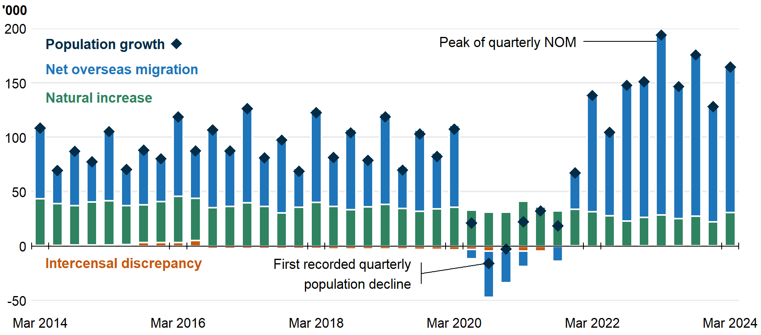
- NOM (Chart 2) was 510,000 over the year to March 2024. NOM was 134,000 in the March 2024 quarter, 32,000 lower than March 2023.
  - There were 718,000 arrivals and just 209,000 departures over the 12 months to March 2024, compared to 537,000 arrivals and 286,000 departures over the 12 months to March 2019.
  - The ABS revised down its estimates of NOM for the September and December 2023 quarters by almost 4,000.
  - The ABS revised down NOM for 2022–23 from 538,000 to 537,000. The final NOM outcome for 2022-23 will be published 12 December 2024.
  - The latest four quarters of NOM estimates are subject to future ABS revisions. The final NOM estimate for the March 2024 quarter will be published in September 2025 with the final NOM outcome for the 2023–24 financial year being published in December 2025.
- Interstate migration is below pre-pandemic levels, with interstate moves over the year to March 2024 (369,000) 21 per cent below the year to March 2019 (Chart 3). Interstate migration has remained around this level since September 2022.
  - There was a net flow of 31,000 residents moving from capital cities to regions over the year to March 2024, a decline from highs seen during the pandemic. This decline has been driven by increased arrivals to the capitals, which previously fell due to pandemic lockdowns.
- Natural increase over the year to March 2024 was 106,000, an increase of 2,300 (2.2 per cent) compared to the year to December 2023.
  - The quarterly rise was driven by more births, with 290,000 births (1.6 per cent increase) over the year to March 2024. This was partially offset by an increase to 184,000 deaths (1.3 per cent increase).
  - Despite an increase from the previous quarter, annual births are at the second lowest level since June 2007 (with the lowest level being in the December 2023 quarter).
  - However, preliminary birth estimates for Victoria continue to be affected by data issues, with longer than usual delays between birth and registration with the Victorian Registry.
  - Although annual deaths pick up in the most recent quarter, annual deaths have been declining since the peaking over the year to December 2022, reflecting declining COVID-19 mortality in the wake of the pandemic.
  - The total fertility rate for 2022-23 was revised down to a record low of 1.55 babies per woman from the previous record low of 1.58 in prior releases, as births were revised down by 5,000 (1.7 per cent) for the year.
Overseas migration, year ending | Interstate migration, year ending
International population growth
- Comparable English-speaking countries have also experienced significant increases in population growth following an easing of COVID-19 restrictions (Chart 4).
- Canada and New Zealand, which have similar migration programs to Australia, experienced population growth above Australia’s over the year to March 2024, at 3.2 per cent and 2.4 per cent respectively.
  - New Zealand’s growth subsequently fell sharply to 1.8 per cent in June 2024.
- Elsewhere, population growth in the UK was nearly double pre-pandemic growth, while US population growth recovered to near pre-pandemic levels.

Population growth in similar countries, year ending quarterly
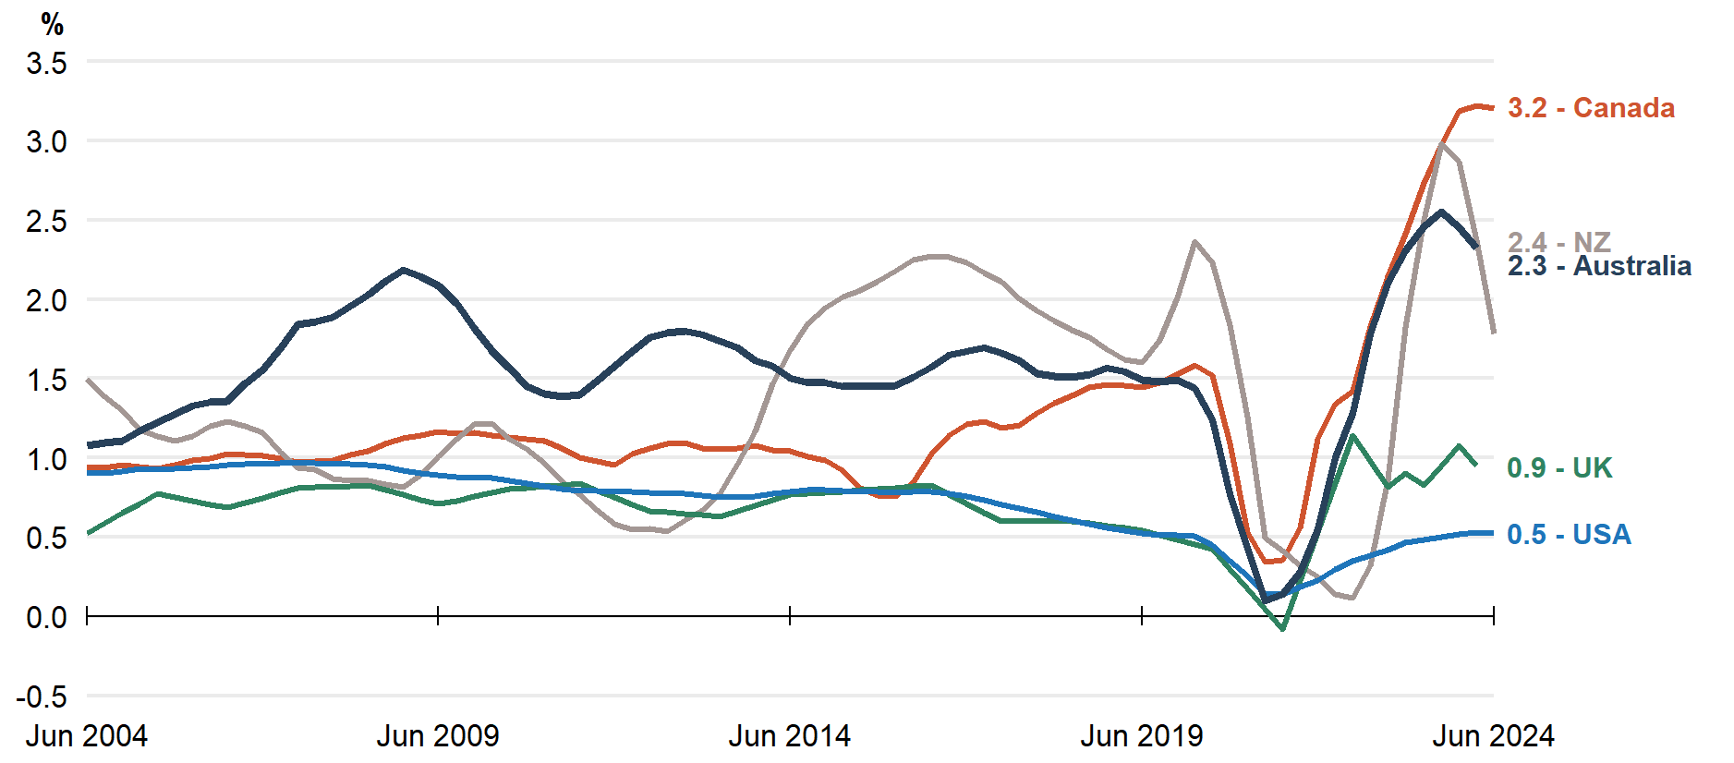
Note: Data callouts to the right of the plot reference 31 March 2024 for comparison to the latest Australian data. June 2024 data is included for international countries where available.
Source: ABS, Stats NZ, Statistics Canada, Office for National Statistics, Bureau of Economic Analysis.
State and territory population growth
- Western Australia was the fastest-growing state, with 3.1 per cent growth over the year to March 2024. This was driven by both NOM (65,000) and net interstate migration (NIM) (10,000), with levels above those seen during the mining investment boom around 2010.
- Victoria was the second fastest-growing state over the year to March 2024 (2.7 per cent). This comes after a population decline recorded during the pandemic, with the recovery driven by Victoria’s disproportionately large share of overseas migration (30 per cent in the year to March 2024).
- Tasmania was the slowest-growing state in March 2024 (0.4 per cent). The decline in growth was driven by a net outflow of interstate migration (2,900) and the low level of natural increase (300).

State and territory population growth (per cent), year ending quarterly

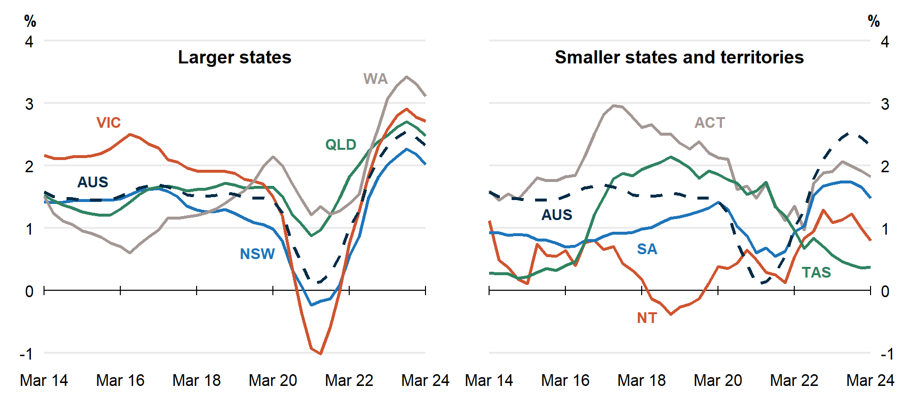

Population and population growth
State | ERP | ERP Increase | ERP Increase | Natural Increase | NIM | NOM
 | 31 Mar 2024 | Since Mar 2023 | Annual % | Annual | Annual | Annual
NSW | 8,470,000 | 168,000 | 2.0 | 31,000 | -31,000 | 168,000
VIC | 6,959,000 | 184,000 | 2.7 | 32,000 | 500 | 152,000
QLD | 5,560,000 | 135,000 | 2.5 | 21,000 | 31,000 | 83,000
SA | 1,874,000 | 27,000 | 1.5 | 2,900 | -1,700 | 26,000
WA | 2,952,000 | 89,000 | 3.1 | 14,000 | 10,000 | 65,000
TAS | 576,000 | 2,200 | 0.4 | 300 | -2,900 | 4,700
NT | 254,000 | 2,000 | 0.8 | 2,200 | -4,100 | 3,900
ACT | 473,000 | 8,400 | 1.8 | 2,700 | -1,700 | 7,500
Australia* | 27,122,000 | 615,000 | 2.3 | 106,000 | NA | 510,000
* Includes other territories comprising Jervis Bay Territory, Christmas Island, the Cocos (Keeling) Islands and Norfolk Island.

Upcoming population releases
Release | Release date
Deaths, Australia | 10/10/2024
Births, Australia | 16/10/2024
Life expectancy, 2021-23 | 8/11/2024
National, state and territory population, June 2024 | 12/12/2024

NOTES
Further detail is available from the ABS in National, state and territory population, March 2024.

