12 December 2024

National, state and territory population, June 2024
Australia’s population was 27.2 million on 30 June 2024, 2.1 per cent higher than a year earlier. Population growth has slowed from the peak of 2.5 per cent recorded in the September 2023 quarter, with declining net overseas migration (NOM).
NOM was 446,000 in 2023–24, and 63,000 in the June 2024 quarter. Annual NOM has continued to decline since its peak at the end of the September 2023 quarter (Chart 2). Annual NOM remains elevated compared with pre-pandemic levels. Departures have been low due to both the relatively recent arrival of many temporary migrants and some seeking to extend their stay by applying for further visas.
Natural increase (births minus deaths) was 106,000 in 2023–24, increasing by 3,500 from the previous year but remaining low overall. The small increase was driven by a decline in deaths over the year, partially offset by a slight fall in births. The total fertility rate fell to a record low of 1.49 babies per woman in 2023–24, following the previous record low of 1.55 in 2022–23.

National population growth
- Australia’s population grew by 552,000 people in 2023–24, with the annual growth rate declining to 2.1 per cent from 2.5 per cent in 2022–23.
- The population grew by 89,000 people or 0.3 per cent in the June 2024 quarter. This was primarily driven by NOM (Chart 1).

Quarterly national population growth and components
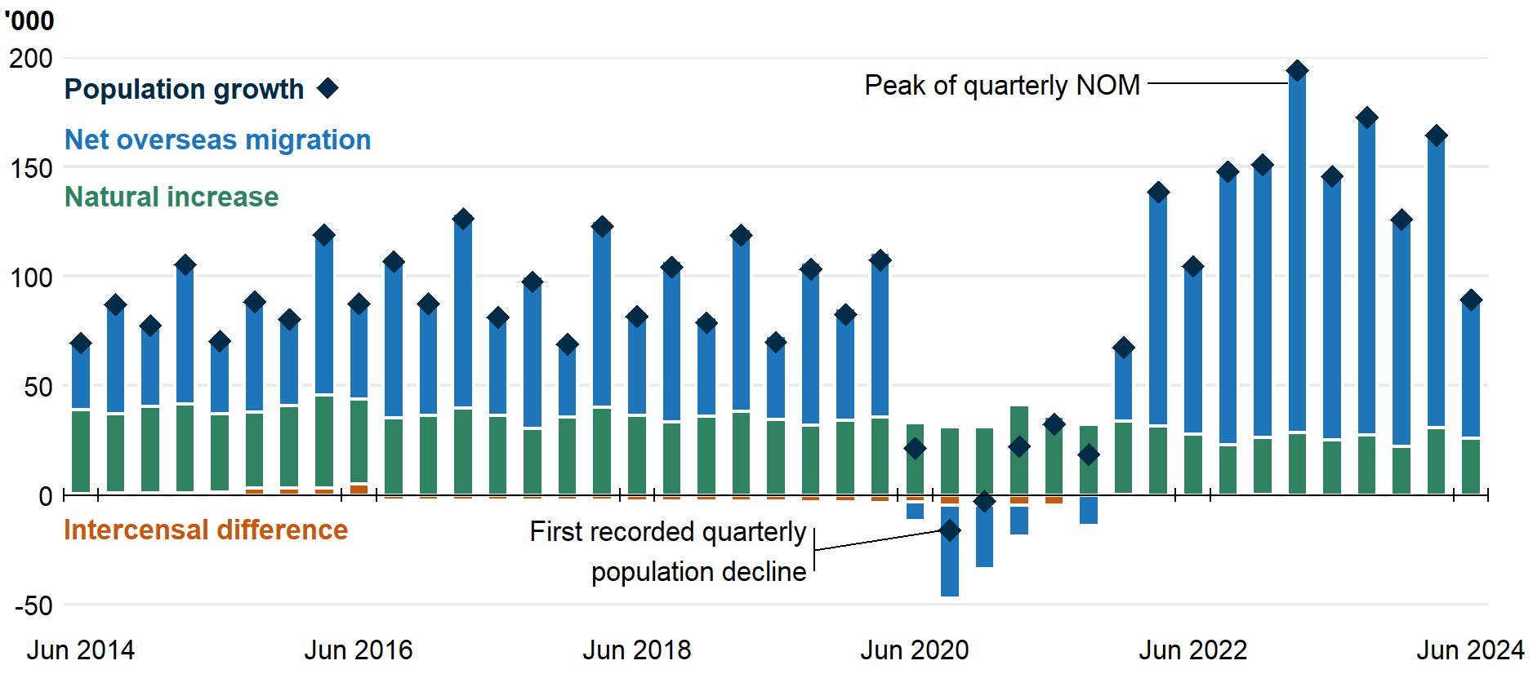
- NOM (Chart 2) was 446,000 in 2023–24, 90,000 lower than 2022-23. NOM was 63,000 in the June 2024 quarter, 57,000 lower than June 2023.
  - There were 667,000 arrivals and 221,000 departures over the 12 months to June 2024, compared to 739,000 arrivals and 204,000 departures over the 12 months to June 2023.
  - Annual NOM peaked at the end of the September 2023 quarter at 556,000. The Centre for Population will publish revised forecasts in the 2024-25 MYEFO and 2024 Population Statement.
  - The ABS revised down its estimates of NOM for the September 2023, December 2023 and March 2024 quarters by around 6,000 in total.
  - The final NOM outcome for 2022–23 was 536,000, revised down from 537,000 in the previous release.
  - The latest four quarters of NOM estimates are subject to future ABS revisions. The final NOM estimate for the June 2024 quarter will be published in December 2025, finalising the 2023–24 financial year.
- Natural increase was 106,000 in 2023-24, 3,500 (3.4 per cent) higher than in 2022-23, with 5,500 (2.9 per cent) fewer deaths, partially offset by a 2,000 (0.7 per cent) decrease in births.
  - Deaths declined to 183,000, reflecting moderating excess mortality from COVID-19. However, excess mortality persists. Although deaths have fallen from their recent peak in 2022–23, they remain significantly higher than pre-pandemic.
    - Between 2018–19 and 2020–21, there were on average 164,000 deaths annually. This has increased to 185,000 between 2021–22 and 2023–24, when COVID-19 became widespread.
  - The preliminary estimate of 289,000 births in 2023–24 is the lowest annual number since 2007–08.
    - This is in line with the Centre for Population's analysis of Medicare pregnancy ultrasound scan data as a leading indicator of births and fertility.
    - The preliminary total fertility rate for 2023–24 was a record low of 1.49 babies per woman, falling from the previous record low of 1.55 in 2022–23.
    - Most countries have recently reached historically low fertility rates. New Zealand recorded a record low of 1.53 babies per woman in 2023-24, while the UK and Canada recorded 1.44 and 1.26 respectively in 2023. The Republic of Korea, which has the lowest fertility rate in the world, set a new record low of 0.72 in 2023.
- Interstate migration is below pre-pandemic levels, with 368,000 interstate arrivals and departures in 2023-24, 107,000 (23 per cent) fewer than in 2018–19 (Chart 3). Interstate migration has remained around this level since the year to September 2022.
  - There was a net outflow of 33,000 residents moving from capital cities to regions in 2023–24, a decline from highs seen during the pandemic. This decline has been driven by increased arrivals to the capitals, which previously fell due to pandemic lockdowns.
Overseas migration, year ending  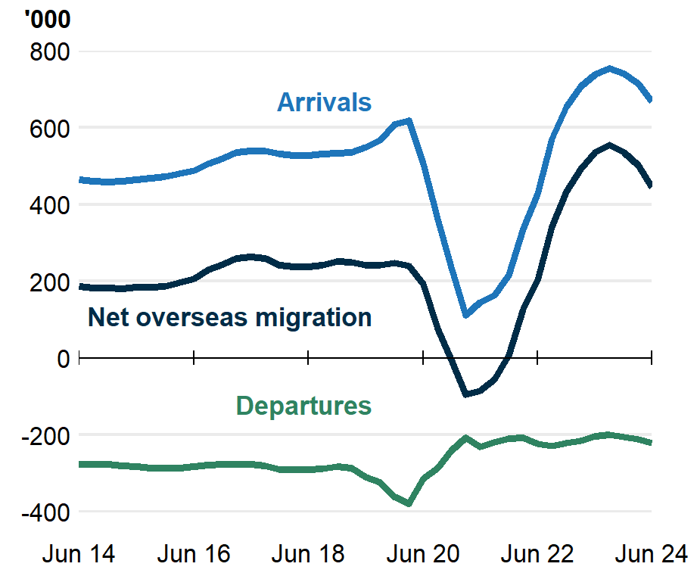 | Interstate migration, year ending  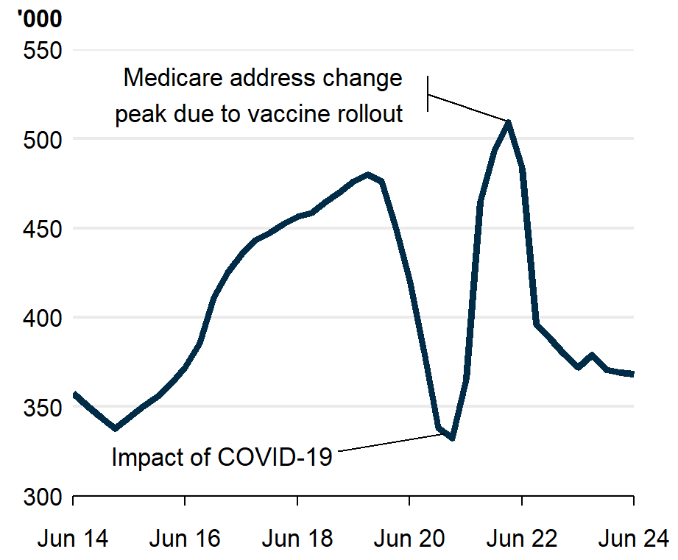
International population growth
- Other English-speaking countries also experienced increases in population growth following the easing of COVID-19 restrictions (Chart 4).
- Canada and New Zealand, which have comparable migration systems to Australia, have experienced similar trends in population growth to Australia’s. Canada’s growth (3.0 per cent) was higher than Australia’s over 2023–24, while New Zealand’s growth (1.7 per cent) fell below Australia’s for the first time since March 2023.
- Elsewhere, population growth in the UK was nearly double pre-pandemic growth, while the US population growth has nearly recovered to pre-pandemic levels.

Population growth in similar countries, year ending quarterly
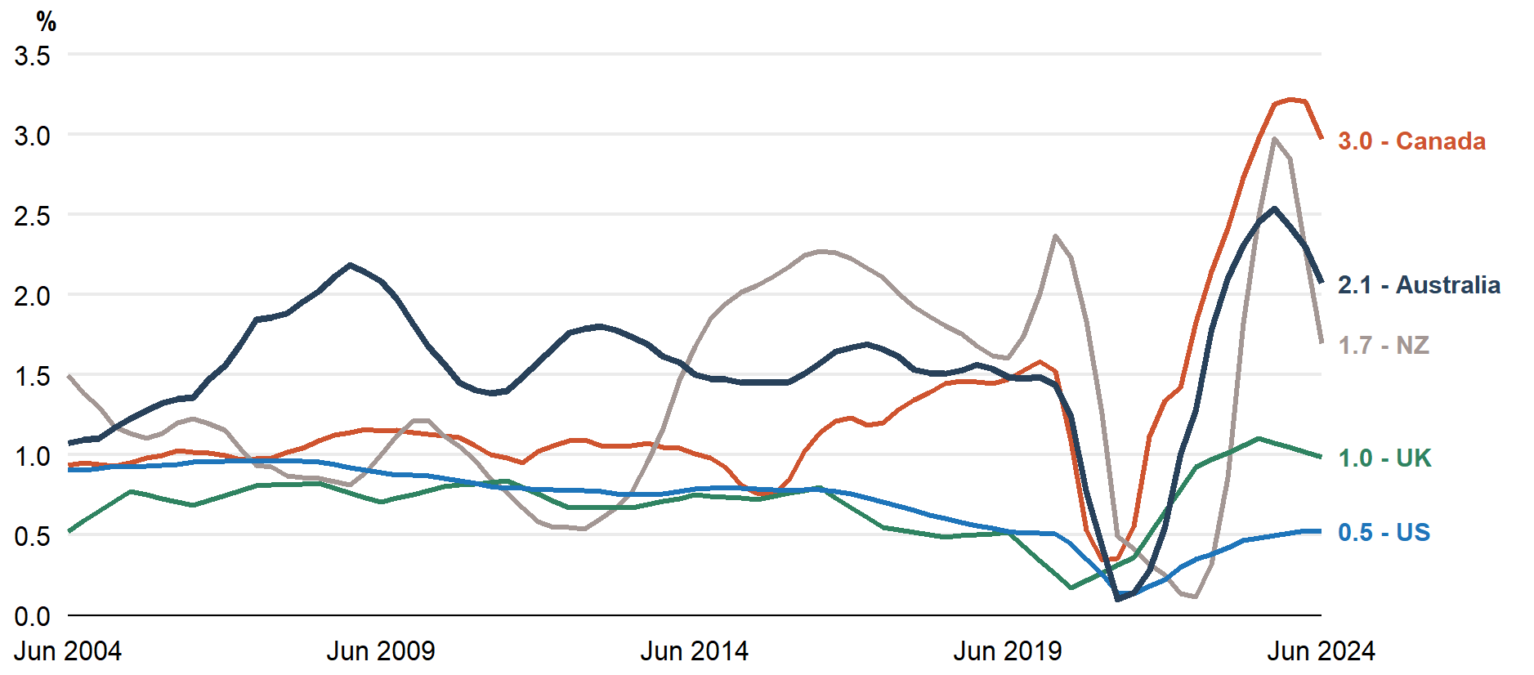
Note: Data callouts to the right of the plot reference 30 June 2024 for comparison to the latest Australian data.
Source: ABS, Stats NZ, Statistics Canada, Office for National Statistics, Bureau of Economic Analysis.
State and territory population growth
- Western Australia was the fastest-growing state, with 2.8 per cent growth in 2023–24. This was driven by both NOM (58,000) and net interstate migration (9,700), with levels above those seen during the mining investment boom around 2010.
- Victoria was the second fastest-growing state in 2023-24 (2.4 per cent), following a population decline recorded during the pandemic. This growth was underpinned by net overseas migration to the state (133,000). Outside of the pandemic, Victoria has consistently attracted a large share of NOM.
  - Victorian natural increase (32,000) increased by more than 10 per cent on the previous year, although this may be due to delays with birth registrations.
- Tasmania was the slowest-growing state in 2023–24 (0.3 per cent). This slow growth was driven by a net outflow of interstate migration (2,600) and a low level of natural increase (400).

State and territory population growth (per cent), year ending quarterly

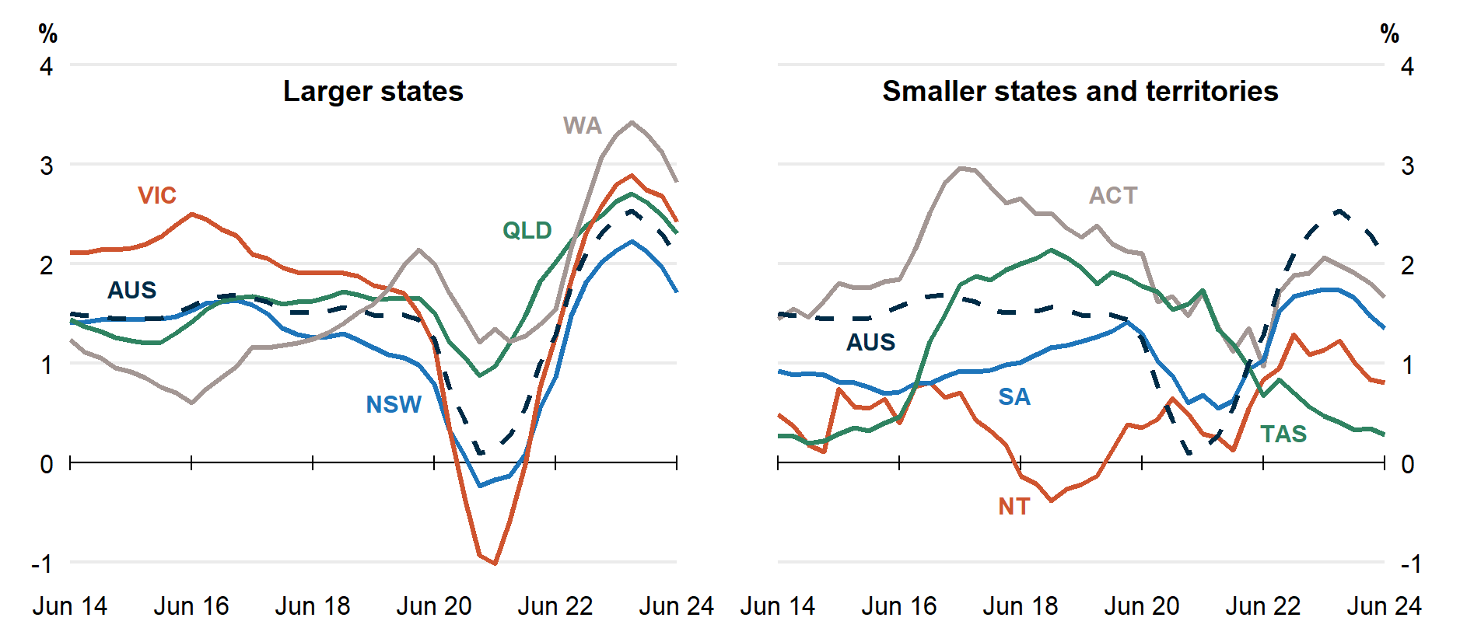

Estimated Resident Population (ERP) and population growth
State | ERP | ERP Increase | ERP Increase | Natural Increase | NIM | NOM
 | 30 June 2024 | Since June 2023 | Annual % | Annual | Annual | Annual
NSW | 8,484,000 | 143,000 | 1.7 | 32,000 | -31,000 | 142,000
VIC | 6,981,000 | 165,000 | 2.4 | 32,000 | 700 | 133,000
QLD | 5,586,000 | 126,000 | 2.3 | 21,000 | 30,000 | 75,000
SA | 1,878,000 | 25,000 | 1.4 | 3,400 | -1,600 | 23,000
WA | 2,965,000 | 81,000 | 2.8 | 14,000 | 9,700 | 58,000
TAS | 575,000 | 1,600 | 0.3 | 400 | -2,600 | 3,800
NT | 255,000 | 2,000 | 0.8 | 2,200 | -3,800 | 3,600
ACT | 474,000 | 7,800 | 1.7 | 2,800 | -1,600 | 6,500
Australia* | 27,205,000 | 552,000 | 2.1 | 106,000 | - | 446,000

* Includes other territories comprising Jervis Bay Territory, Christmas Island, the Cocos (Keeling) Islands and Norfolk Island.

NOTES

Further detail is available from the ABS in National, state and territory population, June 2024.

