**UN WORLD POPULATION projections:**

**21st century population decline**

Contents

|  |  |  |  |  |  |  |
| --- | --- | --- | --- | --- | --- | --- |
| World population to peak in 2084 | India’s population overtakes China | Lower income countries will drive growth as other areas decline | Lower income countries are also undergoing rapid demographic transition | Leading to world population aging | Almost all net migration is to high-income countries | UN projections vary significantly from the Centre for Population’s |

World population to peak in 2084

|  |  |  |
| --- | --- | --- |
| * On 11 July 2024, the United Nations published the *World Population Prospects 2024*, a biennial report providing comprehensive global demographic estimates from 1950 and projections to 2100. The release is available [**here**](https://population.un.org/wpp/). * Global population is estimated to be 8.2 billion in 2024, with the population to peak in 2084 at 10.3 billion and then decline to 10.2 billion by 2100 (Chart 1). * The world population growth rate has halved from 1.7 per cent in 1950 to 0.8 per cent over the 75 years to 2025. Population growth is projected to end in 2084 and be ‑0.1 per cent by 2100. * The 2024 projections continue a trend of population downgrades in subsequent revisions since 2015. The driver of the UN population projections downgrades is a faster-than-expected decline in global fertility rates. * From a historical perspective, the 20th century was defined by world population growth, from an estimated 1.7 billion people in 1900 to 6.2 billion by 2000. * The 21st century will be defined by population momentum and, eventual, population decline. The global total fertility rate is estimated to fall below replacement rate of 2.1 births per woman in 2050, which is the level required for a generation to replace itself.   + Population momentum is where population growth continues after the total fertility rate drops below the replacement rate. This occurs due to the youthful age structure created by the previous high fertility rate. |  | Chart 1. World population 1950 – 2100 This is a line chart showing the UN world population estimates and projections between 1950 and 2100 for each release from 2015, 2019, 2022, and 2024. For nearly all releases, there is a downgrade in the projected population in 2100.  Note: Projections from 2015, 2019, 2022 and 2024 UN World Population Prospects used. |

India’s population overtakes China

|  |  |  |
| --- | --- | --- |
| * The UN projects that Australia’s population will reach 43.1 million by 2100, up 16.4 million from today’s population of 26.7 million.   + A discussion on how these projections compare to Centre for Population projections can be found later in this note. * In 2025, Australia will become the 55th most populous country and projected to be 53rd by 2100. Australia was ranked as high as 39th in 1961, this was at the height of the baby boom and the UN estimated total fertility rate peaked in Australia at 3.5 births per woman. * Over time, there are significant changes in the relative sizes of countries and the population rankings. Notably, India is estimated to have overtaken China as the most populous country in 2022 with a population of 1.4 billion (Chart 2).   + India and China are projected to remain the first and second most populous countries at the end of the century. * By the end of next year, the United States will remain 3rd in the population rankings with 347 million people but is projected to fall to 6th with 421.3 million by 2100. Pakistan will move from 5th in 2025 to 3rd with 511 million people, while Nigeria will rise from 6th to 4th with 476.7 million people, and the Democratic Republic of the Congo will witness a large jump from 15th to 5th with 430.7 million people. * From a continental perspective, Europe’s populations were pre-eminent in 1950, with Asia rising by 2025 and Africa ascending by 2100.   + In 1950, 5 of the top 15 largest population nations were in Europe. By 2025, the only European country remaining in the top 15 is Russia. By 2100, no European countries are expected to be in the top 15.   + By the end of the 21st century, 7 African countries have moved into the top 15 reflecting the strong population growth projected for the continent.     - This contrasts with only one African country in the top 15 in 1950. |  | Chart 2. Country population rankings (Top 15) This is a bump chart showing the total populations of countries in the world for 1950, 2025, and 2100, ranked by largest population for each year. In 1950, many of the top 15 countries were in Europe, and by 2100, most countries in this list will be from Africa.  Note: Select country names have been abbreviated or contracted. |

Lower income countries will drive growth as other areas decline

* The UN *World Population Prospects 2024* includes projections for 237 UN defined countries/areas. This analysis aggregates the country based on World Bank 2022 Income Classifications, the classifications use gross national income per capita and is detailed [here](https://datatopics.worldbank.org/world-development-indicators/the-world-by-income-and-region.html) (Chart 3).

#### Chart 3. Countries by world bank income classifications

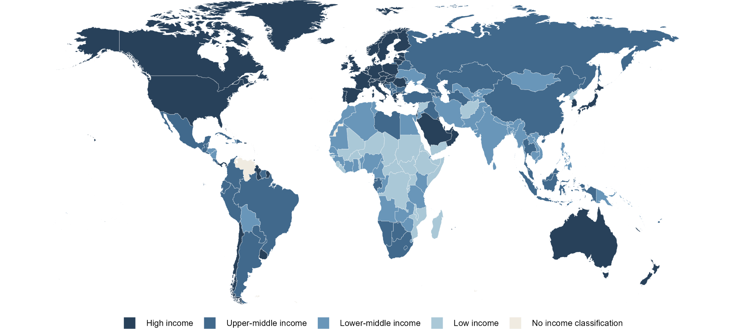

Note: The 2022 income classifications are consistently applied across the 1950 to 2100 period. For example, South Korea is classified as a high-income country in 1950 despite the impact of the Korean War on the country at the time.

|  |  |  |
| --- | --- | --- |
| * Countries with low to lower-middle income will drive population growth. * In 2025, the world population will be evenly split between the high to upper‑middle‑income countries (49.9 per cent) and the lower-middle to low‑income countries (50.1 per cent) (Chart 4). * This equal distribution contrasts with 1950, when two-thirds of the world population (66.9 per cent) lived in upper‑middle to high‑income countries (without accounting for income changes over time). * The UN projects that by 2100, the distribution will invert from that observed in the 1950s, with two-thirds of the world population (67.7 per cent) living in lower-middle to low‑income countries. * The population of upper-middle-income countries is projected to decline from 2.8 billion in 2025 to 2 billion in 2100. The dramatic decline is due to theprojected halving of the population in China.   + China’s population is projected to decline from 1.4 billion in 2025 to 600 million by 2100. * Population decline is preceded by population ageing, which causes deaths begin to outpace births. Population ageing and decline will be a demographic reality for many countries in the coming decades and a global reality by 2100. * This process of growth, ageing and decline is called the *demographic transition* and the UN data, due to its global breakdown and timeseries, is an excellent dataset to illustrate the transition. |  | Chart 4. World population by income classification 1950 - 2100 This is an area chart showing the total population of the world between 1950 and 2100 split by income group. The upper middle income group shows the most significant decline in population level between 2025 and 2100, reflecting the projected halving of the population of China. |

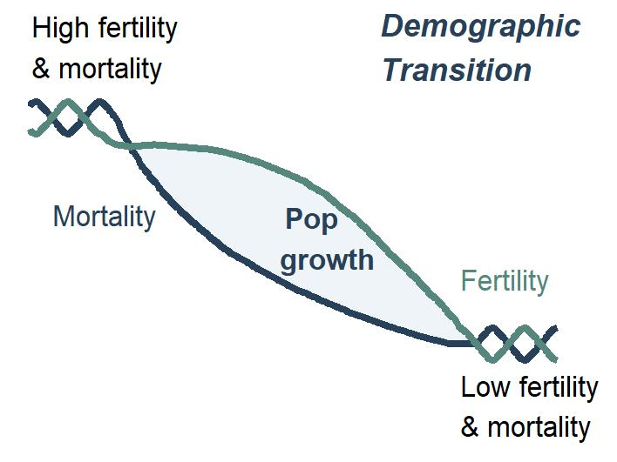Lower income countries are also undergoing rapid demographic transition

|  |  |  |  |  |
| --- | --- | --- | --- | --- |
| * 21st century world population growth, ageing and decline is the product of the demographic transition, a process where societies shift from a stable population level with high fertility and mortality rates to a society with low fertility and mortality rates. This transition occurs over decades and is an important part of economic development. * Mortality rates decline faster due to several factors, particularly lower infant mortality from increased access to basic public health care. In contrast, fertility rates decline more gradually, driven by cultural norms, economic development and female access to education and employment. * A simplified example of the demographic transition is illustrated in the accompanying sparkline (right) and observable in the scatter plots (below). | | |  |  |
| * In **1950**, a significantproportion of the world’s population experienced high fertility and mortality rates (Chart 5, right).   + Two-thirds of the world’s population lived in countries with a total fertility rate of over 4 births per woman (Chart 5 vertical density plot), and over 60 per cent of countries not in the high-income group had a rate over 6.   + Over 1.6 billion people (63.4 per cent) in the world had life expectancies under 50 years of age (Chart 5 horizontal density plot).     - There is clear delineation in life expectancy between the countries in the four income classifications, with over half of high-income countries with a life expectancy at birth of over 60 years. * By **2025** (Chart 5, below), life expectancies will have improved around the world, reflecting increased living standards and access to health care. The life-expectancy gaps between high-income and low-income countries will close from 30.6 years in 1950 to 16.4 years in 2025. These countries will experience population growth while their fertility rates remain high. * By **2100** (Chart 5, below right) the demographic transition will have concluded with global total fertility rates below the replacement rate of 2.1 resulting in a global population decline. People in most countries are projected to have a life expectancy at birth of over 70 years of age world life expectancy at 81.7. |  | Chart 5. 1950 fertility and mortality distributions These are three identical scatter plots for 1950, 2025, and 2100, showing how total fertility rates and life expectancies at birth of countries in the world change over time. The countries are split by their income groups. There are also density plots on the top and right side of each chart showing the dispersion of income groups for each year. In 1950, most countries in the world had relatively low life expectancies and high total fertility rates. By the end of the 21st century, most countries complete the demographic transition to have high life expectancies and low total fertility rates. | | |
| **2025 fertility and mortality distributions**  **These are three identical scatter plots for 1950, 2025, and 2100, showing how total fertility rates and life expectancies at birth of countries in the world change over time. The countries are split by their income groups. There are also density plots on the top and right side of each chart showing the dispersion of income groups for each year. In 1950, most countries in the world had relatively low life expectancies and high total fertility rates. By the end of the 21st century, most countries complete the demographic transition to have high life expectancies and low total fertility rates.** |  | **2100 fertility and mortality distributions**  These are three identical scatter plots for 1950, 2025, and 2100, showing how total fertility rates and life expectancies at birth of countries in the world change over time. The countries are split by their income groups. There are also density plots on the top and right side of each chart showing the dispersion of income groups for each year. In 1950, most countries in the world had relatively low life expectancies and high total fertility rates. By the end of the 21st century, most countries complete the demographic transition to have high life expectancies and low total fertility rates. | | |

**Leading to world population aging**

* Population ageing has seen the global median age increase from 22.2 in 1950, to 30.9 in 2025, and will increase to 42.1 in 2100. However, the rate of population ageing varies considerably across the income classification (Chart 6).
* High-income countries are the oldest populations in both 1950 and 2025, but the median age will increase by less than 5 years to 2100.
* In contrast, the median age of the other income groups is projected to increase by over 15 years, with the upper-middle-income group projected to have the highest median age of any income group by 2100.
* The slower ageing in high-income countries is due to migration of young adults and gradual increases in fertility projected by the UN.

|  |  |  |
| --- | --- | --- |
| Chart 6. Age Structure of the high-income population These are pyramid line plots showing the proportion of the world population by age between males and females for 1950, 2025, and 2100. Each graph includes a median age dot for both genders in each period. The proportion of the world population by age and gender are then split into four different income groups. The median age and shape of the pyramids in all income groups highlight the trend of an ageing population. |  | Upper-Middle-income These are pyramid line plots showing the proportion of the world population by age between males and females for 1950, 2025, and 2100. Each graph includes a median age dot for both genders in each period. The proportion of the world population by age and gender are then split into four different income groups. The median age and shape of the pyramids in all income groups highlight the trend of an ageing population. |
| Lower-middle-income These are pyramid line plots showing the proportion of the world population by age between males and females for 1950, 2025, and 2100. Each graph includes a median age dot for both genders in each period. The proportion of the world population by age and gender are then split into four different income groups. The median age and shape of the pyramids in all income groups highlight the trend of an ageing population.  Note: Points indicate median age. |  | Low-income These are pyramid line plots showing the proportion of the world population by age between males and females for 1950, 2025, and 2100. Each graph includes a median age dot for both genders in each period. The proportion of the world population by age and gender are then split into four different income groups. The median age and shape of the pyramids in all income groups highlight the trend of an ageing population. |

**Almost all net migration is to high-income countries**

|  |  |  |
| --- | --- | --- |
| * Since 1950, migration to high-income countries has increased, with a rise after 2000. This increase in mobility is due to an increasing number of educated people in lower-middle-income countries seeking economic opportunities abroad (Chart 7). * The main global flow across the income groups is from lower-middle-income countries into high-income countries.   + This is predominantly driven by migration out of India, Pakistan, and Bangladesh, which accounts for 65 per cent of all net migration out of lower-middle-income countries in 2030 (a year where projections are stable). * The emergence of COVID-19 dramatically impacted global migration. The net flow of migration into high income countries in 2020 fell to pre-2000 levels, a 66.4 per cent decline compared to 2019. * Global net migration to high income countries then spiked at 9.5 million in 2022, driven by a flow of almost 5.7 million people out of Ukraine, but also reflects the relaxing of pandemic-era travel restrictions. * The UN assume flat net migration in the future reflecting the difficulty in forecasting migration trends, though recent migration levels to high-income countries is not projected to continue. |  | Chart 7. World net migration by income classification 1950 - 2100 This is a line chart showing net migration flows by income group between 1950 and 2100. The UN projects people from low and lower middle-income countries to migrate to upper middle and high-income countries over the next century.  Note: Bold three-year average overlayed on single year values. |

UN projections vary significantly from the Centre for Population’s

|  |  |  |
| --- | --- | --- |
| * The Centre for Population (CPOP) is forecasting significantly higher growth in the Australian population (Chart 8). The Centre for Population forecasts a population of 40.7 million people by 2063, in comparison to 35.2 million in the UN series. * The Centre for Population and the UN fertility and mortality assumptions are nearly identical. * The large difference between the two series is due to different overseas migration assumptions, particularly in the 2020s. * The different migration assumptions quickly compound, with the Centre for Population projections being 1.3 million people higher than the UN projections by 2030, less than a decade into the projections.   + The resulting lower population size also leads to the UN forecasting fewer total births than the Centre for Population, despite the total fertility rate assumptions being similar (roughly 1.62 births per women). * The Centre for Population forecasts are best placed to understand the Australian population as they incorporate the latest available data, account for recent trends and account for non-demographic factors such as policy.   + The strength of the UN projections is they provide a consistent and coherent global perspective on population growth, rather than up-to-date national level projections. |  | Chart 8. Australian population growth rate - Comparison of UN and Centre for Population projections 1973 - 2063 This is a line chart showing Australian population growth rate estimates, and projections from the Centre for Population and the UN between 1973 and 2063. The Centre for Population projects significantly higher population than the UN over the entire projection period.  Note: CPOP projections to the medium term are from 2024-25 Budget, with assumptions beyond the medium term aligned with 2023 IGR. |