20 March 2025

National, state and territory population, September 2024
Australia’s population was 27.3 million on 30 September 2024, 1.8 per cent higher than a year earlier. Population growth has slowed from the peak of 2.5 per cent recorded in the September 2023 quarter, primarily due to declining net overseas migration (NOM).
NOM was 380,000 over the year to September 2024, and 90,000 in the September 2024 quarter. Due to declining migrant arrivals, annual NOM has eased since its peak of 556,000 in the year ending September 2023.
However, NOM remains elevated compared with pre-pandemic levels. The peak of temporary migrant arrivals is yet to be reflected in higher departures. This is due to both the relatively recent arrival of many temporary migrants and some seeking to extend their stay by applying for further visas.
Natural increase (births minus deaths) remained low at 104,000 over the year to September 2024, down 3,200 from one year earlier. The decrease was driven by more deaths over the year, offset by slightly higher births.

National population growth
- Australia’s population grew by 484,000 people over the year to September 2024, with an annual growth rate of 1.8 per cent, a decline from 2.5 per cent a year earlier.
- The population grew by 115,000 people (0.4 per cent) in the September 2024 quarter, driven by NOM.

Quarterly national population growth and components
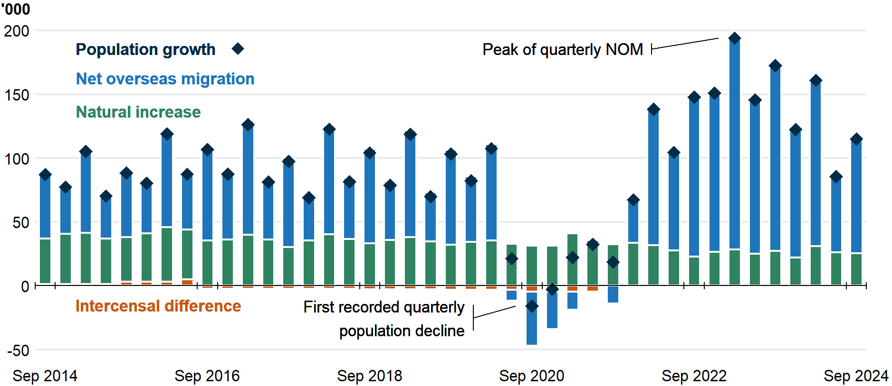
- NOM was 380,000 over the year to September 2024, 176,000 (32 per cent) lower than a year earlier. NOM was 90,000 in the September 2024 quarter, 55,000 (38 per cent) lower than September 2023.
  - September 2024 quarter NOM being higher than the 60,000 recorded for the June 2024 quarter is in line with the expected seasonal pattern of NOM.
  - While arrivals have dropped significantly, the number of departures is yet to reflect the post-COVID-19 peak in temporary migrant arrivals. There were 618,000 arrivals and 238,000 departures over the year to September 2024, compared to 755,000 arrivals and 200,000 departures twelve months earlier.
- Natural increase was 104,000 over the year to September 2024, 3,200 (3 per cent) lower than a year earlier. Natural increase was 25,000 in the September 2024 quarter, 2,000 lower than September 2023.
  - The preliminary estimate of births over the year to September 2024 was 291,000, a small increase from the recent low of 285,000 over the year to December 2023.
  - Deaths increased to 187,000 over the year to September 2024 from the recent low of 182,000 over the year to December 2023, primarily reflecting Australia’s growing and ageing population.
Overseas migration  NOM has been the main driver of population growth since 2005-06, accounting for 62.9 per cent of growth over the period.  Elevated NOM since the end of the pandemic has primarily been driven by increased arrivals of temporary migrants, particularly students. Annual NOM peaked in the September 2023 quarter at 556,000. Falling arrivals have driven the decrease in NOM, while the peak in temporary migrant arrivals is yet to be reflected in higher departures.  Overseas migration, year ending  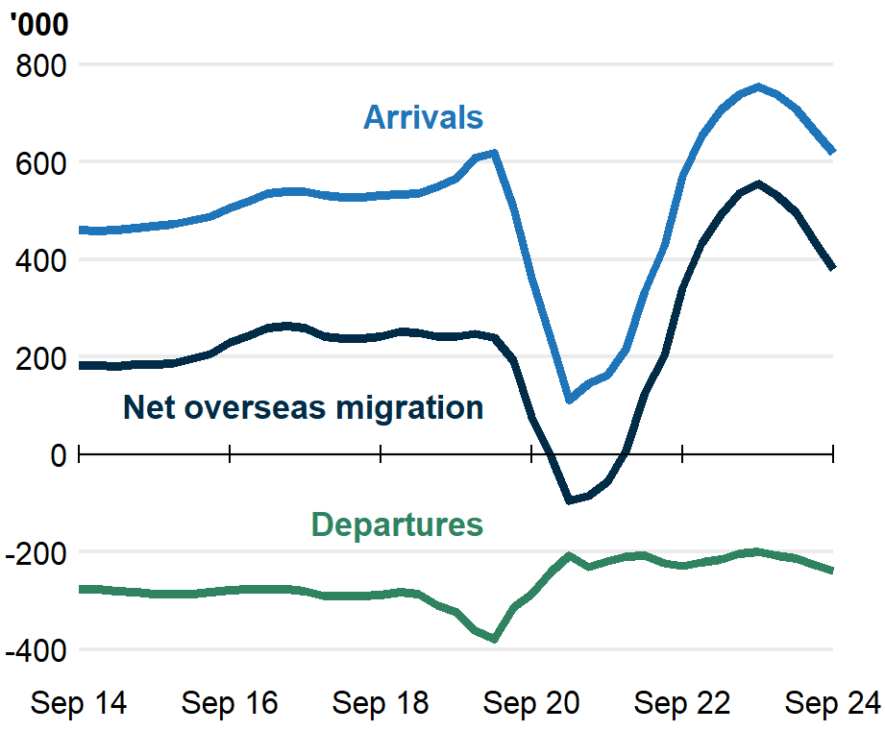 | Internal migration  Internal migration is below pre-pandemic levels (24 per cent lower than in 2018-19), with 364,000 moves over the year to September 2024. Internal migration continues to decline, with 15,000 (4 per cent) fewer moves than a year earlier.  There was a net outflow of 33,000 movers from capital cities to regions over the year to September 2024, a decline from highs during the pandemic. This was driven by increased arrivals to the capitals, which previously fell during pandemic lockdowns.  Interstate migration, year ending  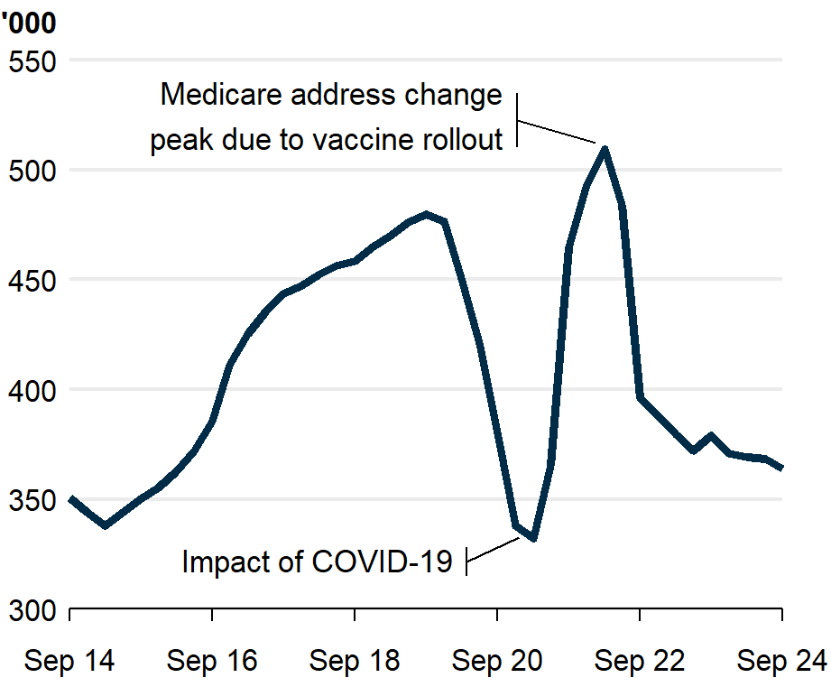
Fertility  Except for a ‘baby bump’ during the pandemic, fertility has consistently declined since 2008-09. The total fertility rate reached a record low of 1.49 in 2023–24, falling from the previous record low of 1.55 in 2022–23. The Centre for Population’s analysis suggests fertility will remain low in 2024-25.  Comparable countries recently also recorded historically low fertility rates. Canada and the UK respectively experienced record lows of 1.26 and 1.44 in 2023, with New Zealand at 1.56 in 2024.  Total fertility rate, babies per woman  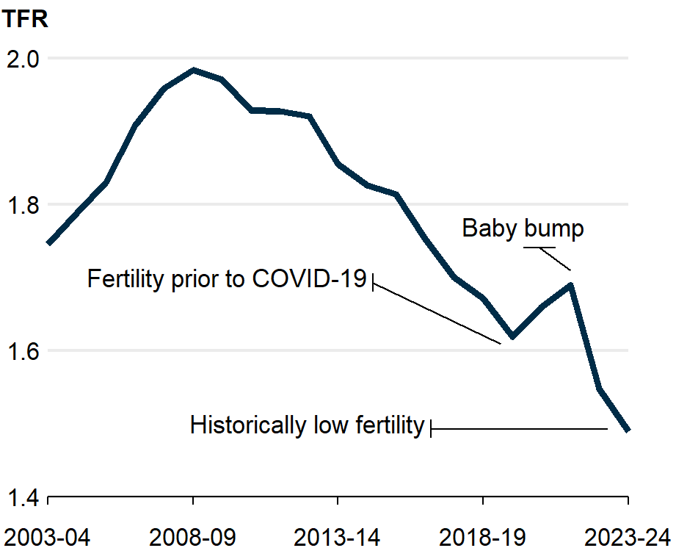 | Mortality  The standardised death rate, which adjusts for age structure, fell by half over the fifty years to 2023-24, reaching a record low of 4.9 deaths per 1,000 people in 2020–21 during the pandemic restrictions. The rate increased to 5.2 by 2022–23 as COVID-19 became widespread but fell once again in 2023-24 to 4.9.  Annual deaths have fallen since their peak in 2022, as excess mortality due to COVID-19 has declined in recent quarters. The Centre for Population expects excess mortality to continue to moderate in 2024-25.  Standardised death rate, deaths per 1,000  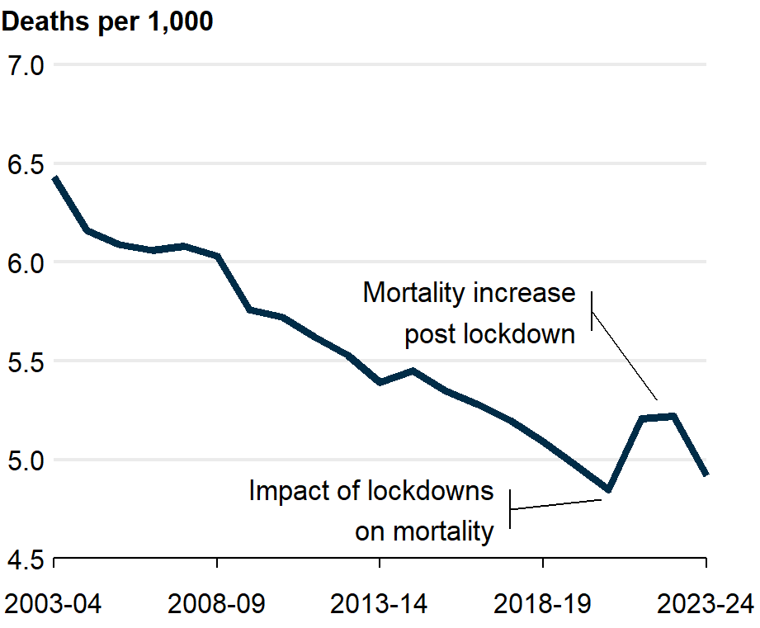

International population growth
- Similar to Australia, comparable English-speaking countries (Canada, New Zealand, the United Kingdom and the United States) also experienced increases in population growth following the easing of COVID-19 restrictions, that have since started to moderate.
- The latest data, which for Canada and New Zealand extends to 31 December 2024, shows that Canada is currently growing at 2.3 per cent, higher than Australia’s growth over the year to September 2024, and that New Zealand’s growth (1 per cent) has declined further since its peak in December 2023.
- UK and US population growth peaked later at 1.1 per cent in June 2024 and 1 per cent in March 2024 respectively, but now show signs of slowing.

Population growth in similar countries, year ending quarterly
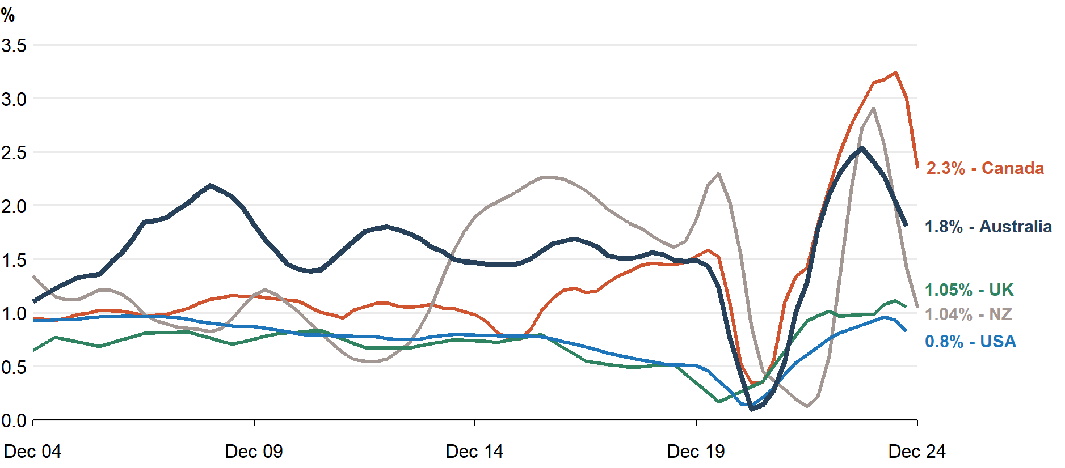
Note: Data callouts reflect the latest available data. Latest data for Australia, the UK and the USA reference the year to September 2024, while Canada and New Zealand reference the year to December 2024.
Source: ABS, Stats NZ, Statistics Canada, Office for National Statistics, Bureau of Economic Analysis.

State and territory population growth
- Western Australia was the fastest-growing state, with 2.5 per cent growth over the year to September 2024. This was driven by NOM (51,000), with levels comparable to those seen during the mining investment boom around 2012 but lower than the recent peak in the year to September 2023.
- Victoria and Queensland also grew faster than the national average, at rates of 2.1 per cent and 2 per cent respectively.
  - Victoria’s growth was driven by both NOM (112,000) and natural increase (33,000). Outside of the pandemic, Victoria has consistently attracted a large share of NOM.
  - Queensland’s growth was also mainly driven by NOM (64,000) and net internal migration (28,000). Queensland attracts a higher number of interstate arrivals than any other state.
- Tasmania was the slowest-growing state over the year to September 2024 (0.3 per cent). This slow growth was driven by a net outflow of interstate migration (2,000) and low natural increase (200).
  - Tasmania experienced natural decrease (where there are more deaths than births) in the September 2024 quarter, only the second time this has occurred in any state or territory since the series began in 1980-81.

State and territory population growth (per cent), year ending quarterly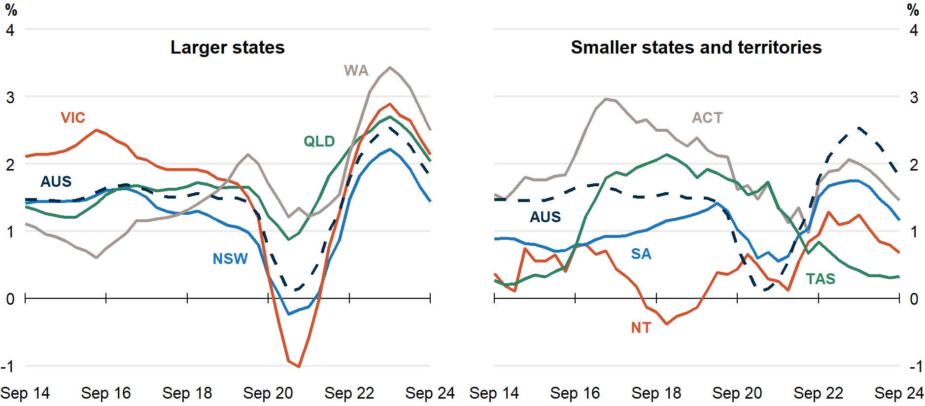

Population and population growth
State | ERP | ERP Increase | ERP Increase | Natural Increase | NIM | NOM
 | 30 Sept 2024 | Since Sept 2023 | Annual % | Annual | Annual | Annual
NSW | 8,511,000 | 121,000 | 1.4 | 30,000 | -30,000 | 120,000
VIC | 7,013,000 | 147,000 | 2.1 | 33,000 | 900 | 112,000
QLD | 5,609,000 | 112,000 | 2.0 | 20,000 | 28,000 | 64,000
SA | 1,883,000 | 22,000 | 1.2 | 3,000 | -1,600 | 20,000
WA | 2,982,000 | 73,000 | 2.5 | 13,000 | 9,000 | 51,000
TAS | 576,000 | 1,900 | 0.3 | 200 | -2,000 | 3,700
NT | 256,000 | 1,700 | 0.7 | 2,200 | -3,700 | 3,300
ACT | 476,000 | 6900 | 1.5 | 2,800 | -1,300 | 5,400
Australia* | 27,309,000 | 484,000 | 1.8 | 104,000 | NA | 380,000
* Includes other territories comprising Jervis Bay Territory, Christmas Island, the Cocos (Keeling) Islands and Norfolk Island.

Notes
- The latest four quarters of NOM estimates are subject to future ABS revisions.
  - Since the National, state and territory population, June 2024 data release, the ABS has revised down its estimate of NOM for 2023–24 by around 10,000 to 435,000.
  - The final NOM estimate for the September 2024 quarter will be published in March 2026.
Further detail is available from the Australian Bureau of Statistics.

