***27 March 2025***

|  |
| --- |
| Regional Population, 2023–24 |
| * Australia’s population grew by 2.0 per cent in 2023–24, but this picture varies widely at the regional level. * Capital city population growth fell to 2.4 per cent (428,000 people) in 2023–24, down from 3.0 per cent in the previous year (Chart 1). Nonetheless, growth remains above the pre-pandemic decade average of 1.8 per cent. * Perth (3.1 per cent), Melbourne (2.7 per cent) and Brisbane (2.7 per cent) were the fastest growing capital cities in 2023–24, while Hobart (0.4 per cent) and Darwin (0.9 per cent) were the only capital cities with a growth rate below 1 per cent. * Softening capital city growth reflects the slowing net inflow of overseas migrants to capital cities (373,000 in 2023–24, down from 461,000 in 2022–23). * Around 86 per cent of national net overseas migration (NOM) went to capital cities in 2023–24, similar to the previous year and the three years prior to the pandemic.   + Sydney and Melbourne received the majority of national NOM in 2023–24 (56 per cent). A further 22 per cent of NOM went to Brisbane and Perth.   + The inner city (SA4s) of these four cities accounted for around 15 per cent of national NOM, despite having just 5.9 per cent of the national population. * The net internal migration outflow from capital cities to regional areas increased to 35,000 in 2023–24. Outside of the pandemic affected years (when the net outflow reached 49,000 in 2020–21), this is the largest outflow since the beginning of the sub-state internal migration data in 2000–01. * Combined regional area growth remained near decade highs (1.3 per cent or 114,000 people).[1] Falling net overseas migration was partly offset by the increased internal migration. However, net overseas migration remained the primary driver of regional growth (68,000). * At the SA3 level, many regional areas are experiencing natural decrease (more deaths than births), reflecting their older age structure.[2] In most cases this is offset by net internal and overseas migration. However, some regions are experiencing population decline, reflecting net internal migration outflows. |

Contribution of components of population change to growth

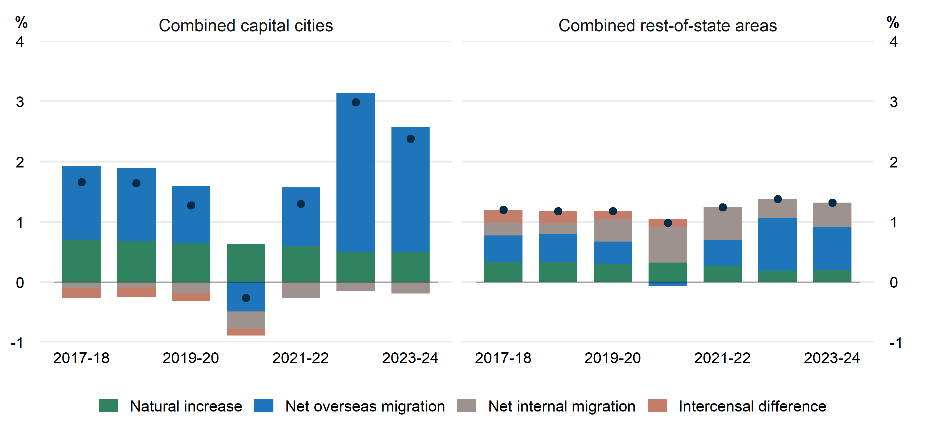

### Capital city population continues to be driven by net overseas migration

* Perth’s population grew by 3.1 per cent in 2023–24, the highest growth rate of all capital cities, followed by Melbourne (2.7 per cent), Brisbane (2.7 per cent) and Sydney (2.0 per cent).
  + Growth was down across Perth, Melbourne, Brisbane and Sydney from 2022–23 due to declining NOM (Chart 2). Net overseas migration fell by 23 per cent in Sydney, 19 per cent in Melbourne, 16 per cent in Brisbane and 13 per cent in Perth.
  + Despite the fall, NOM made the largest contribution to growth in all four cities, adding 121,000 to the populations of both Sydney and Melbourne, 53,000 to Perth and 44,000 to Brisbane. Brisbane and Perth had a net inflow of internal migrants (16,000 and 8,000 people respectively).
  + The highest growing SA4s[3] in each of the four cities were Melbourne Inner (3.9 per cent), Logan - Beaudesert (Brisbane, 3.8 per cent), Mandurah (Perth, 3.7 per cent) and Sydney - South West (2.9 per cent). Of the top 10 fastest growing SA4s in Australia, five were in Perth, two were in Brisbane, two were in Melbourne and one was in Sydney.
  + Growth in Sydney and Brisbane tended to be mostly concentrated in outer suburbs, with the highest growth areas being in Sydney’s west and in Brisbane’s south. The growth in Melbourne and Perth was more evenly distributed across the cities.
* Population growth was slowest in Hobart (0.4 per cent), Darwin (0.9 per cent), Adelaide (1.5 per cent) and the Australian Capital Territory (1.6 per cent). This lower growth primarily reflects a relatively smaller share of net overseas migration and negative net internal migration.
  + Hobart experienced its lowest population growth since 2001–02.
  + The SA3s of Hobart Inner and Hobart North-West were the only capital city SA3s to experience population falls in 2023–24. Hobart North-West has been experiencing population decline since 2021–22, while Hobart Inner had its first population decline since 2020–21.
  + Even in these cities, there were areas of high population growth. The highest growing SA3s in each of these cities were Molonglo (ACT, 12.5 per cent), Adelaide City (4.1 per cent), Litchfield (Darwin, 2.2 per cent) and Sorell – Dodges Ferry (Hobart, 1.4 per cent).

Contribution of components of population change to growth – Greater capital cities

These stacked bar charts compare the contribution that the components of population change had on population growth for every capital city in Australia from 2017–18 to 2023–24. The latest changes in 2023–24 are:
• Sydney’s components of growth consisted of 2.2 per cent NOM, –0.8 per cent NIM, and 0.5 per cent natural increase for a total of 2.0 per cent growth, down from 2022–23.
• Melbourne's components of growth consisted of 2.3 per cent NOM, –0.1 per cent NIM, and 0.6 per cent natural increase for a total of 2.7 per cent growth, down from 2022–23.
• Brisbane's components of growth consisted of 1.6 per cent NOM, 0.6 per cent NIM, and 0.5 per cent natural increase for a total of 2.7 per cent growth, down from 2022–23.
• Adelaide's components of growth consisted of 1.5 per cent NOM, –0.2 per cent NIM, and 0.3 per cent natural increase for a total of 1.5 per cent growth, down from 2022–23.
• Perth's components of growth consisted of 2.3 per cent NOM, 0.3 per cent NIM  , and 0.5 per cent natural increase for a total of 3.1 per cent growth, down from 2022–23.
• Hobart's components of growth consisted of 1.0 per cent NOM, –0.8 per cent NIM, and 0.2 per cent natural increase for a total of 0.4 per cent growth, down from 2022–23.
• Darwin's components of growth consisted of 1.8 per cent NOM, –1.8 per cent NIM, and 0.9 per cent natural increase for a total of 0.9 per cent growth, down from 2022–23.
• ACT's components of growth consisted of 1.3 per cent NOM, –0.3 per cent NIM, and 0.6 per cent natural increase for a total of 1.6 per cent growth, down from 2022–23.


Note: Intercensal difference is the difference between the change in population and the sum of the components for a given year.

### Regional population growth was led by growth in regional cities

* Regional Queensland was the fastest growing rest-of-state area in 2023–24 (1.8 per cent, Chart 3), followed by Western Australia (1.5 per cent), Victoria (1.2 per cent) and New South Wales (1.1 per cent).
  + Regional Queensland’s growth was driven by a combined inflow of overseas (28,000 people) and internal (14,000 people) migration. In contrast, NOM was the main driver of growth in the rest-of-state areas of New South Wales, Victoria and Western Australia.
  + Internal migration to regional Western Australia has been a positive inflow since 2021–22 after large outflows post-mining boom.
* Regional Tasmania (0.3 per cent), Northern Territory (0.6 per cent) and South Australia (0.7 per cent) were the slowest growing rest-of-state areas.
  + Regional Tasmania and South Australia continued to experience natural decrease (fewer births than deaths) in 2023–24, reflecting their older age structures.
  + Regional Northern Territory recorded high growth from natural increase and overseas migration but this was mostly offset by an outflow of internal migrants.
  + Regional Tasmania also recorded a net outflow of 600 internal migrants in 2023–24, well below its peak inflow of 1,600 in 2019–20.
* The regional cities of the Sunshine Coast (2.4 per cent), Geelong (2.3 per cent) and the Gold Coast (2.3 per cent) were the fastest growing areas in regional Australia in 2023–24.
  + Internal migration was the largest contributor to growth for the Sunshine Coast and Geelong, with net overseas migration also making significant contributions to growth. For the Gold Coast, the largest contributor to growth was net overseas migration, contributing 77 per cent of growth.
  + Over the past decade, population growth in regional Queensland has been driven by the Gold Coast and the Sunshine Coast, with both regions (SA4) growing at over 2.5 per cent annually since 2002 and accounting for just over half of regional Queensland’s growth in 2023–24.
  + Similarly, Geelong has been a focal point of growth in regional Victoria, accounting for 40 per cent of the state’s regional population growth in 2023–24.
* Murray River – Swan Hill in Victoria had the largest per cent fall in population for SA3s with population over 500, declining by 0.6 per cent (210 people, driven by a net internal migration outflow of 460 people). There were five SA3s with negative growth in regional New South Wales, four in regional Victoria, two in regional Tasmania, and one each in regional Queensland and South Australia. For all regional SA3s experiencing population decline, net internal migration outflows were the primary driver.
  + Many of these regions are experiencing sustained population decline, with falls in population of 28 per cent for Bourke - Cobar - Coonamble (New South Wales) and 18 per cent for Broken Hill and Far West (New South Wales) since 2000–01.

Contribution of components of population change to growth – Rest of state areas

These stacked bar charts compare the contribution that the components of population change had on population growth for every rest-of-state area in Australia from 2017-18 to 2023-24. The latest changes in 2023-24 are:
• Rest of New South Wales had 0.6 per cent NOM, 0.4 per cent NIM, and 0.1 per cent natural increase for a total of 1.1 per cent growth, up from 2022–23.
• Rest of Victoria had 0.6 per cent NOM, 0.5 per cent NIM, and 0.2 per cent natural increase for a total of 1.2 per cent growth, up from 2022–23.
• Rest of Queensland had 1.0 per cent NOM, 0.5 per cent NIM, and 0.3 per cent natural increase for a total of 1.8 per cent growth, down from 2022–23.
• Rest of South Australia had 0.4 per cent NOM, 0.4 per cent NIM, and -0.1 per cent natural increase for a total of 0.7 per cent growth, down from 2022–23.
• Rest of Western Australia had 0.8 per cent NOM, 0.3 per cent NIM, and 0.4 per cent natural increase for a total of 1.5 per cent growth, up from 2022–23.
• Rest of Tasmania had 0.5 per cent NOM, -0.2 per cent NIM, and -0.03 per cent natural increase for a total of 0.3 per cent growth, down from 2022–23.
• Rest of Northern Territory had 0.9 per cent NOM, -1.0 per cent NIM, and 0.8 per cent natural increase for a total of 0.6 per cent per cent growth, down from 2022–23.


Note: Intercensal difference is the difference between the change in population and the sum of the components for a given year.

### Major cities continue to grow faster than regional and remote areas

* Population growth in 2023–24 increased slightly for inner regional areas but decreased for all other remoteness area classifications (Chart 4).
  + Major cities (which includes most of the high population density parts of greater capital cities as well as larger cities such as Gold Coast, Newcastle and Geelong) grew at 2.4 per cent. This was down from 2.9 per cent, the largest decline in growth for any remoteness classification.
  + Remote and very remote region populations had slower growth than in 2022–23 but growth remains around its decade high. Over half of the 2023–24 growth was due to relatively strong population growth in remote parts of Western Australia.
  + The population of inner regional areas (which is largely made up of areas surrounding capital cities) have experienced similar population growth since at least 2016–17, despite the pandemic and the subsequent recovery.

Population growth by remoteness area classification

This chart shows the population growth rate of the five remoteness area classifications from 2001–02 to 2023–24. Growth in 2023–24 was 2.4 per cent for major cities, 1.4 per cent for inner regional, 0.9 per cent for outer regional, 0.7 per cent for remote and 0.7 per cent for very remote. Major cities have tended to grow faster than the other regions, although growth was slightly negative in 2020–21. Remote and very remote regions have had cyclical growth but have tended to grow slower than other regions, although very remote regions had similar growth rates to major cities over 2007–08 to 2010–11. Inner regional and outer regional areas have had more stable growth rates relative to the other regions. 

### Data notes

* Further detail, including data quality notes, are available from the [Australian Bureau of Statistics](https://www.abs.gov.au/statistics/people/population/regional-population/latest-release).
* Figures in this publication will not exactly match the data presented in the ABS publication *National, State and Territory Population*. Sub-state population data does not incorporate the ABS revisions published on 20 March 2025.

1. Regional areas include rest-of-state areas outside of capital cities, including non-capital cities such as the Gold Coast and Newcastle, but do not include ‘other territories’ such as Norfolk Island and Christmas Island.
2. There are 359 Statistical Area Level 3 (SA3s) in Australia. SA3s generally have populations between 30,000 and 130,000 people.
3. There are 108 Statistical Area Level 4 (SA4s) in Australia. In cities, SA4s tend to have populations of 300,000 to 500,000 people.