18 September 2025

National, State and Territory Population, March 2025
Australia’s population reached 27.5 million in March 2025. Population growth is slowing after the strong rebound that followed the COVID 19 pandemic. In the year leading up to March 2025, the population grew by 1.6 per cent. This is about the same as the average growth before the pandemic. Slower growth reflects slowing net overseas migration.
From March 2024 to March 2025, the population grew by 423,000 people. Of this growth:
• 107,000 came from natural increase (which means there were more births than deaths)
• 316,000 came from net overseas migration (which means more people came to live in Australia than left)
Even though natural increase was the highest since 2022, there are still fewer births and more deaths than before the pandemic. Net migration from overseas has gone down, but it is still higher than it was before the pandemic.

National population growth
- Australia’s population grew by 0.5 per cent in the March quarter 2025 to be 1.6 per cent higher in the year to March 2025 (Chart 1).
  - This is the sixth consecutive quarter of decline in annual growth since the peak of 2.5 per cent in September 2023. National population growth continues to decline towards the pre-pandemic decade average.
- Slowing population growth is not unique to Australia. Annual population growth across many advanced economies has moderated, including in Canada, New Zealand, the United Kingdom and the United States (Chart 1). This is driven by falling net overseas migration.

International population growth, annual
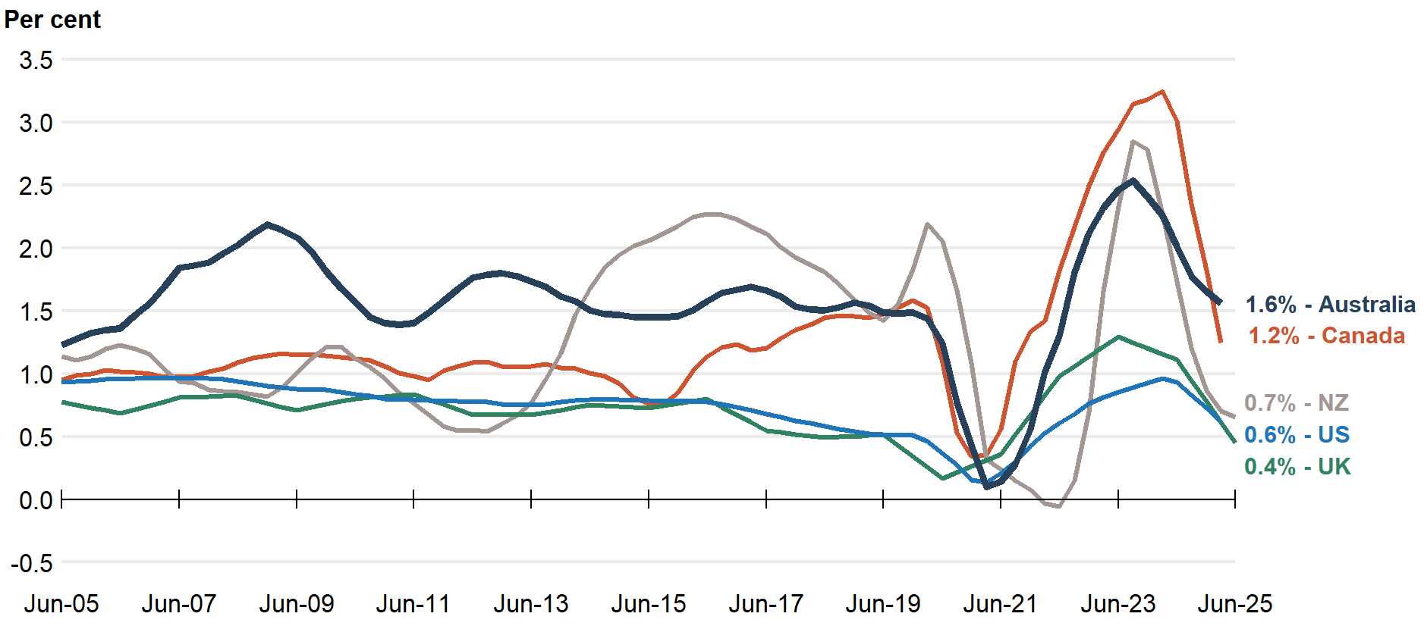
Note: Data callouts reflect the latest available data. Latest data for Australia, Canada and New Zealand reference the year to March 2025, while the United Kingdom and the United States reference the year to June 2025.
Source: ABS, Stats NZ, Statistics Canada, Office for National Statistics, Bureau of Economic Analysis.
- Despite net overseas migration moderating, it continues to be the main driver of Australian population growth, due to low levels of natural increase (Chart 2).
- Natural increase (NI) (births less deaths) was 107,000 people in the year to March 2025. While this was 1.9 per cent higher than the previous year, and the highest since 2022, the contribution of natural increase to population growth remained near record lows.
  - Births increased by 2.1 per cent (6,000 births) to 296,000 in the year to March 2025, the largest annual births figure since December 2022.
  - Of these, 78,000 were in the March quarter 2025, the largest quarterly result since September 2021 (Chart 3). However, the March 2025 figure is subject to revision and follows a low in December 2024.
  - Deaths increased by 2.1 per cent (4,000 deaths) to 188,000 in the year to March 2025.
  - In this release, the ABS has revised its natural increase data for 2023–24.
  - Births were revised up by 0.4 per cent to 290,000. The total fertility rate for 2023–24 was unchanged at 1.49 babies per woman.
  - Deaths were revised up by 1.4 per cent to 185,000.
- Net overseas migration (NOM) continued to decline and was 316,000 people in the year to March 2025, with 578,000 arrivals and 262,000 departures (Chart 4).
  - This was 36.0 per cent lower than the year to March 2024. Nearly three-quarters of the decline was due to decreasing arrivals (down 131,000 or 18.5 per cent), with the rest due to increasing departures (up 46,000 or 21.5 per cent).
  - Annual NOM has continued to decline since its peak of 556,000 in September 2023.
  - This is the lowest level of annual NOM since June 2022.

National population growth, annual
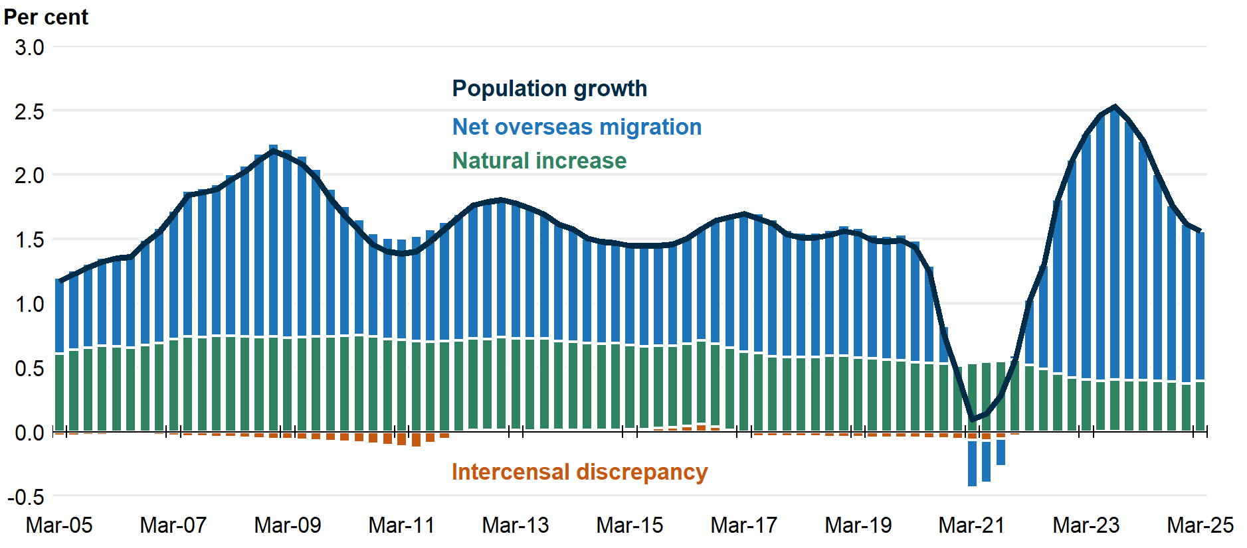

Births, quarterly
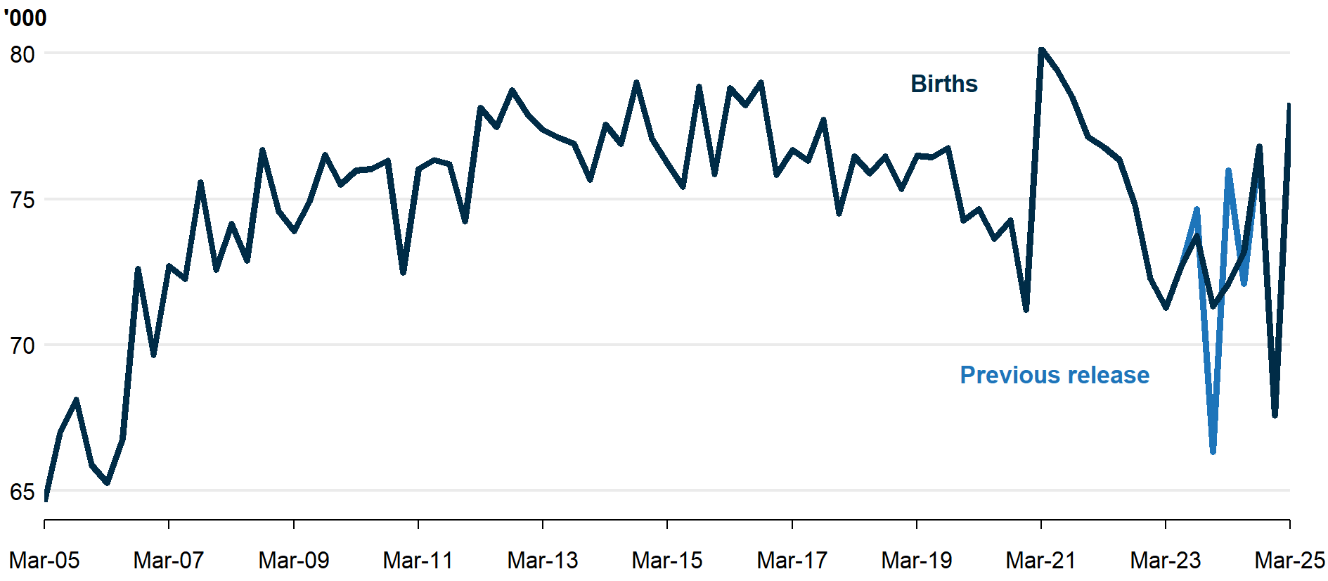

Overseas migration, annual | Interstate migration, annual

- Interstate migration continued to decline and remains below pre-pandemic levels (Chart 5). There were 371,000 interstate moves in the year to March 2025, 3.7 per cent lower than the previous year.
  - There was a net outflow of 31,000 residents moving from capital cities to regions in the year ending March 2025. This was a 4.5 per cent increase from the previous year. This reflected departures from rest-of-state areas to capital cities falling by more than movements in the opposite direction.

State and territory population growth
- Population growth over the year to March 2025 slowed in all states except the Northern Territory (NT), in line with the national easing of NOM (Chart 5). The NT’s growth increased due to fewer net interstate departures.
- Western Australia, Victoria, and Queensland had the fastest population growth, mostly driven by net overseas migration (WA at 2.3 per cent; VIC at 1.8 per cent; and QLD at 1.8 per cent). Victoria had positive quarterly net interstate migration (NIM) for the first time since the pandemic, while Queensland had its lowest quarterly NIM since 2016.
- The Northern Territory, the Australian Capital Territory, New South Wales and South Australia grew more slowly than the national average (NT at 1.3 per cent; ACT at 1.3 per cent; NSW at 1.2 per cent; and SA at 1.1 per cent).
- Tasmania grew well below the national average (at 0.2 per cent). Its population has grown at less than 0.3 per cent since the June quarter 2023.

Interstate population growth, annual
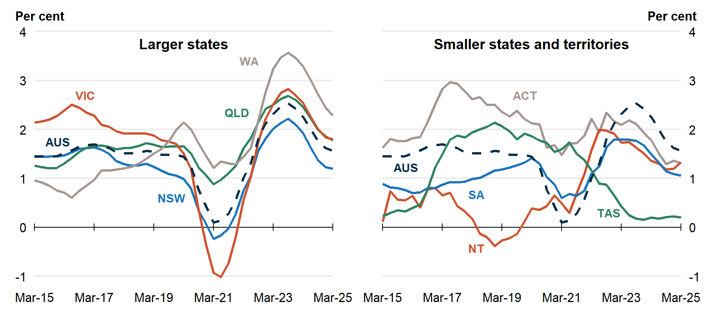

National, state and territory population
State | ERP | ERP Increase | ERP Increase | Natural Increase | NIM | NOM
 | 31 Mar 2025 | Since Mar 2024 | Annual % | Annual | Annual | Annual
NSW | 8,579,000 | 102,000 | 1.2 | 32,000 | -27,000 | 97,000
VIC | 7,053,000 | 125,000 | 1.8 | 34,000 | -2,300 | 93,000
QLD | 5,647,000 | 99,000 | 1.8 | 20,000 | 24,000 | 55,000
SA | 1,899,000 | 20,000 | 1.1 | 2,700 | -1,500 | 19,000
WA | 3,030,000 | 68,000 | 2.3 | 14,000 | 12,000 | 41,000
TAS | 576,000 | 1,100 | 0.2 | 200 | -2,200 | 3,200
NT | 263,000 | 3,500 | 1.3 | 2,100 | -1,900 | 3,300
ACT | 484,000 | 6,200 | 1.3 | 2,700 | -1,300 | 4,800
Australia* | 27,537,000 | 423,000 | 1.6 | 107,000 | NA | 316,000
Note: Absolute figures above 10,000 are rounded to the nearest thousand, and the nearest 100 otherwise.
* Includes other territories comprising Jervis Bay Territory, Christmas Island, the Cocos (Keeling) Islands and Norfolk Island.

