19 June 2025

National, State and Territory Population, December 2024
Australia’s population has reached 27.4 million, as population growth continues to slow following the post-pandemic rebound. Population growth has fallen from its peak of 2.5 per cent in the year to the September quarter 2023 to be 1.7 per cent in the year to the December quarter 2024. This result was driven by a decline in net overseas migration.
For the year ending December quarter 2024, the population grew by 445,900 people, with natural increase contributing 105,200 and net overseas migration contributing 340,800. Natural increase remains subdued with low births and elevated deaths post-pandemic. NOM remains elevated compared to pre-pandemic levels, largely due to lower departures, which have now begun to pick up. This reflects the relatively recent arrival of many temporary migrants, with some people seeking to extend their stay by applying for further visas.
The ABS has implemented methodology changes, leading to revised estimates of state population growth rates since 2021. The changes have led to higher population estimates for the Northern Territory (up 1.8 per cent as at June 2024), the Australian Capital Territory (1.0 per cent), and Western Australia (0.4 per cent), with a downgrade to Victoria’s estimated population (0.4 per cent lower).

National population growth
- Australia’s population grew by 0.3 per cent in the December quarter 2024 to be 1.7 per cent higher in the year (Chart 1).
  - This was the fifth consecutive quarter of decline in annual growth since the peak of 2.5 per cent in the September quarter 2023. National population growth is closer to, but still above, its pre-pandemic decade average.
  - This experience has not been unique to Australia. Population growth across many advanced economies has moderated, driven by a fall in net overseas migration, including Canada, New Zealand, the United Kingdom and the United States.

International population growth
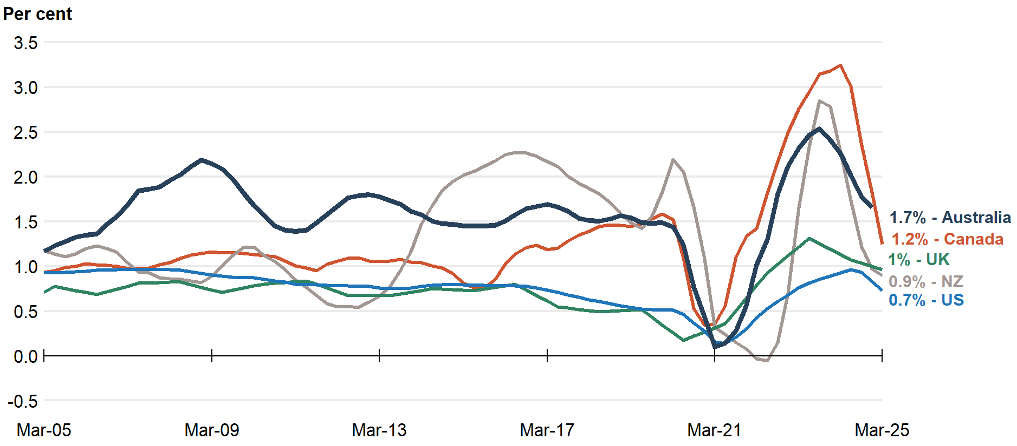
Note: Data callouts reflect the latest available data. Latest data for Australia and Canada reference the year to December 2024, while the United States, United Kingdom and New Zealand reference the year to March 2025.
Source: ABS, Stats NZ, Statistics Canada, Office for National Statistics, Bureau of Economic Analysis.
  - Despite net overseas migration moderating, it continues to be the main driver of Australian population growth, due to low levels of natural increase (Chart 2).
- Natural increase (NI) (births less deaths) was 105,200 people in the year to the December quarter 2024. While this was 1.9 per cent higher than the previous year, natural increase’s contribution to population growth remained near record lows.
  - Births increased by 2.6 percent (7,500) to 292,400 in 2024.
  - Deaths increased by 3.0 per cent (5,500) to 187,300 in 2024.
- Net overseas migration (NOM) continued to decline and was 340,800 people in 2024.
  - This was 35.8 per cent lower than 2023. Decreasing arrivals (19.5 per cent or 144,100 people) and increasing departures (22.0 per cent or 45,700 people) drove the decline. (Chart 3).
  - Annual NOM peaked at the end of the September 2023 quarter at 555,800.

National population growth
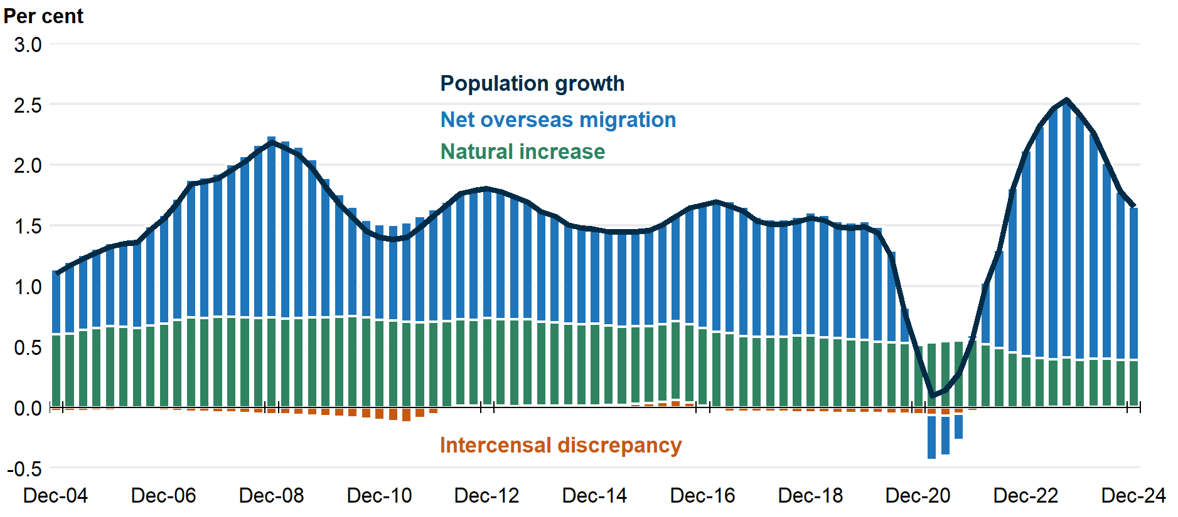
Overseas migration | Interstate migration

- Interstate migration (IM) continued to decline and remains below pre-pandemic levels (Chart 4).
  - There were 377,800 interstate moves in the year to the December quarter 2024. The ABS has reviewed the methodology for estimating interstate migration (refer to ABS net interstate migration review below), which has resulted in fewer moves in late 2021 but more moves over 2022 to 2024.
  - There was a net outflow of 31,000 residents moving from capital cities to regions in the year ending December 2024. This is a slight decline from the previous quarter, reflecting departures from capital cities falling by more than departures from rest-of-state areas.

State and territory population growth
- All states and territories continued experiencing positive population growth in the December quarter 2024 (Chart 5). Growth softened in most states, except for Tasmania, the NT and ACT, although these were among the slower growing states.
- Western Australia, Victoria, and Queensland were the three states with the fastest population growth, and all recorded population growth rates above the national level, driven by net overseas migration (WA at 2.4 per cent; VIC at 1.9 per cent; and QLD at 1.9 per cent).
- New South Wales, South Australia, Tasmania, Northen Territory and Australian Capital Territory recorded population growth rates below the national level (NSW at 1.3 per cent; SA at 1.1 per cent; TAS at 0.3 per cent; NT at 1.2 per cent; and ACT at 1.4 per cent).
- Methodology changes caused revisions to estimated state population growth rates since 2021 (refer to ABS net interstate migration review below).

Interstate population growth
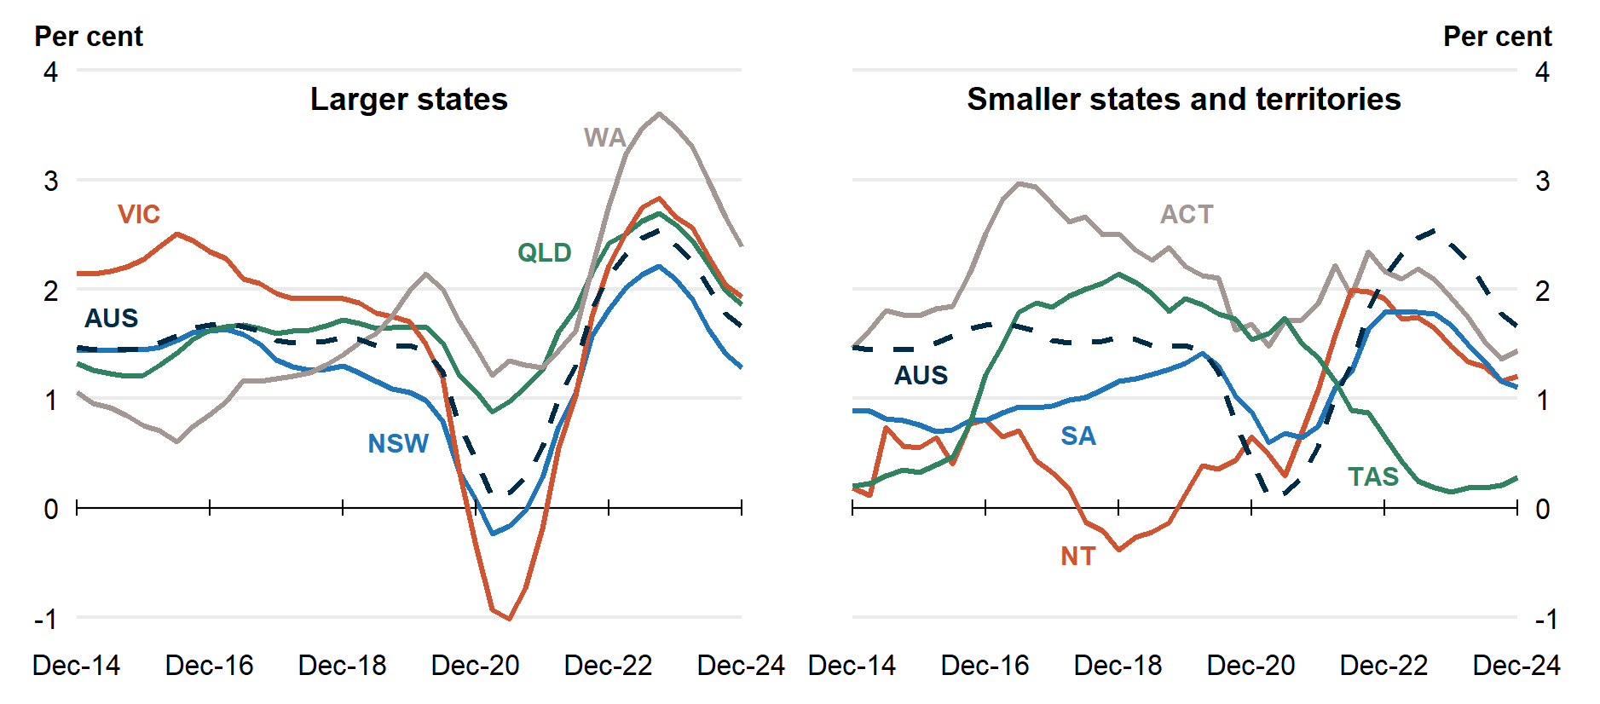

National, state and territory population
State | ERP | ERP Increase | ERP Increase | Natural Increase | NIM | NOM
 | 31 Dec 2024 | Since Dec 2023 | Annual % | Annual | Annual | Annual
NSW | 8,545,000 | 108,000 | 1.3 | 29,000 | -28,000 | 107,000
VIC | 7,011,000 | 133,000 | 1.9 | 35,000 | -3,200 | 101,000
QLD | 5,619,000 | 103,000 | 1.9 | 20,000 | 26,000 | 57,000
SA | 1,892,000 | 21,000 | 1.1 | 2,700 | -1,600 | 20,000
WA | 3,009,000 | 70,000 | 2.4 | 13,000 | 13,000 | 45,000
TAS | 576,000 | 1,600 | 0.3 | 200 | -2,400 | 3,900
NT | 262,000 | 3,100 | 1.2 | 2,300 | -2,200 | 3,100
ACT | 482,000 | 6,800 | 1.4 | 2,800 | -1,000 | 5,000
Australia* | 27,400,000 | 446,000 | 1.7 | 105,000 | NA | 341,000
Note: Absolute figures above 10,000 are rounded to the nearest thousand, and the nearest 100 otherwise.
* Includes other territories comprising Jervis Bay Territory, Christmas Island, the Cocos (Keeling) Islands and Norfolk Island.

ABS Net Interstate Migration Review
- The ABS has revised their estimates for net interstate migration in this release, following a methodology review. The changes are designed to improve the accuracy of state and territory population estimates.
- The changes have redistributed population from Victoria, Queensland and Tasmania to the other states, particularly New South Wales and Western Australia (Table 2). This has contributed to population increases for the Northern Territory (1.8 per cent higher population in June 2024), the Australian Capital Territory (1.0 per cent higher) and Western Australia (0.4 per cent higher), with a downgrade to Victoria’s population (0.4 per cent lower). The change for other states is within ¼ of a per cent of their respective populations.
- The number of interstate moves in 2023–24 has been revised up by 4.4 per cent from 368,000 to 385,000.
  - The number of interstate moves in the September 2021 quarter, which were affected by the COVID-19 vaccine rollout, has been revised down to 100,000 from 164,000 (Chart 4).

Change in state population due to NIM revisions, June 2024
 | NSW | VIC | QLD | SA | WA | TAS | NT | ACT
Change | 13,800 | -25,100 | -12,700 | 4,300 | 11,200 | -1,000 | 4,600 | 5,000
Per cent of population | 0.2 | -0.4 | -0.2 | 0.2 | 0.4 | -0.2 | 1.8 | 1.0

Background
- The review follows the high intercensal difference (the difference between the population estimate based on a new Census, and the previous population estimate) observed for some states following the 2021 Census.
  - The previous NIM methodology used Medicare change-of-address data, scaled by Census-based ‘expansion factors’ and supplemented with moves of members of the defence forces.
  - The Medicare change-of-address data has issues with underreporting, particularly for younger adults.
- As part of this review, the ABS examined the expansion factor methodology and investigated alternative data sources. The review concluded that Medicare is still the best single data source for estimating quarterly interstate migration due to its population coverage and availability. However, it suggested methodology improvements, including leveraging tax data.
- Revisions to NIM apply from the September 2021 quarter and are based on:
  - Corrections for the timing of moves during the COVID-19 vaccination program, which impacted different states in different quarters.
  - Using tax return change-of-address data to help derive new adjustment factors (renamed from expansion factors). The adjustment factors are applied to ages 20 to 39 as the tax data provides most benefit for capturing additional moves for these ages.
  - Removing the prior caps on expansion factors, which could not be less than 1 or greater than 2, and applying them to a wider age range than previously.
  - Adjusting for scaling moves of 15- to 19-year-olds and correcting for new defence force members.
- The ABS plans to apply annual updates to the NIM estimates in 2024–25 and 2025–26. Future reviews will consider additional data sources and population estimates below the state and territory level.

