18 December 2025

National, State and Territory Population, June 2025
Australia's population reached 27.6 million in the June 2025 quarter. Population growth continues to slow after the strong rebound that followed the pandemic. Growth has fallen to 1.5 per cent in the year to June 2025 and is slightly below the pre-pandemic decade average. This reflects slowing net overseas migration.
Over the year to June 2025, the population increased by 420,000 people. Of this, natural increase (births minus deaths) added 115,000, while net overseas migration added 306,000. Although annual natural increase reached its highest level since 2022, there are still fewer births and more deaths than prior to the pandemic. Net overseas migration has fallen but is still higher than the years before the pandemic.

National population growth
- Australia’s population grew by 0.3 per cent in the June 2025 quarter to be 1.5 per cent higher over the year to June 2025 (Chart 1).
  - Annual population growth has been slightly below the pre-pandemic decade average for two quarters. This follows a downward revision to growth for the March 2025 quarter.
- Slowing population growth is not unique to Australia. Annual population growth across many advanced economies has moderated, including in Canada, New Zealand, the United Kingdom and the United States (Chart 1). This is driven by falling net overseas migration.

International population growth, annual
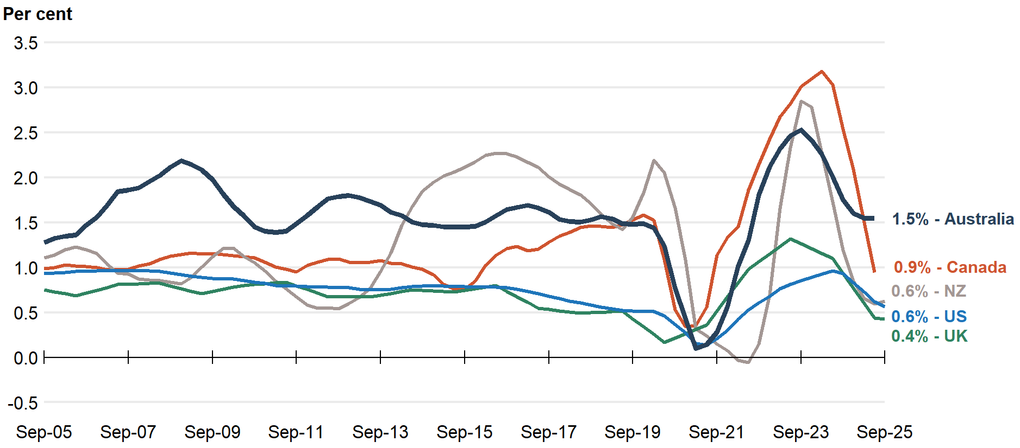
Note: Data callouts reflect the latest available data. Latest data for Australia and Canada reference the year to June 2025, while the United Kingdom, New Zealand and the United States reference the year to September 2025.
Source: ABS, Stats NZ, Statistics Canada, Office for National Statistics, Bureau of Economic Analysis.
- Despite net overseas migration moderating, it continues to be the main driver of Australian population growth, due to low levels of natural increase (Chart 2).
- Net overseas migration (NOM) continued to decline and was 306,000 people in the year to June 2025, with 568,000 arrivals and 263,000 departures (Chart 3).
  - This was 28.8 per cent lower than the year to June 2024. This decline was due to decreasing arrivals (down 93,000 or 14.1 per cent) and increasing departures (up 31,000 or 13.2 per cent).
    - Despite the increase in the number of departures, temporary migrants are departing at slower rates than before the pandemic.
  - Annual NOM has continued to decline since its peak of 556,000 in September 2023.
  - This is the lowest level of annual NOM since June 2022.
  - NOM remains higher than in the years immediately before the pandemic but is now around the level it was in the year to June 2009 (300,000).
- Natural increase (births less deaths) was 115,000 people in the year to June 2025. While this was 8.9 per cent higher than the previous year, and the highest since 2022, the contribution of natural increase to population growth remained near record lows.
  - Births increased by 3.4 per cent (10,000 births) to 300,000 in the year to June 2025, the largest annual births figure since September 2022.
  - Deaths increased by 0.4 per cent (700 deaths) to 186,000 in the year to March 2025.

National population growth, annual
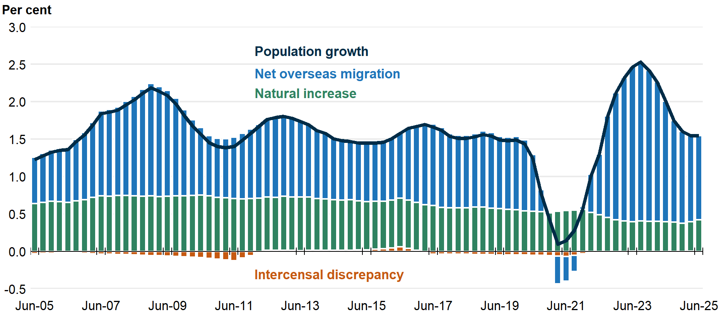

Overseas migration, annual | Interstate migration, annual
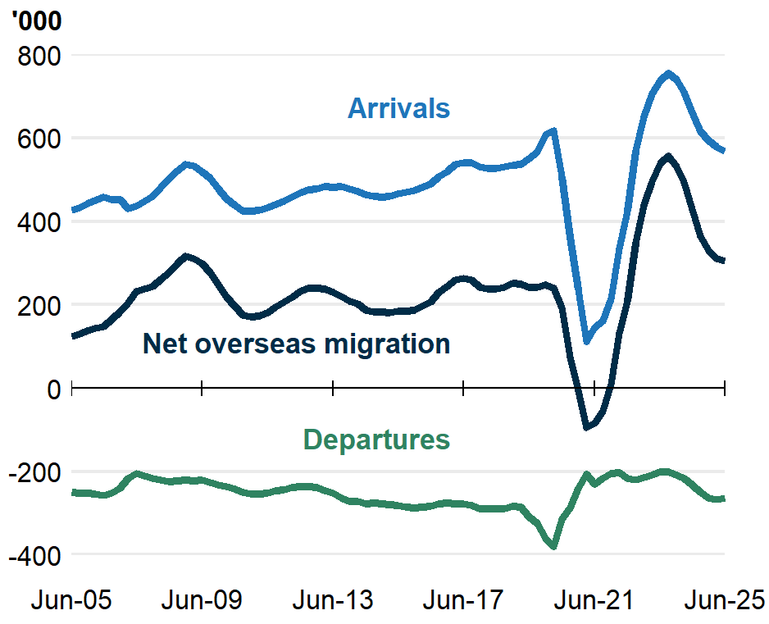 | 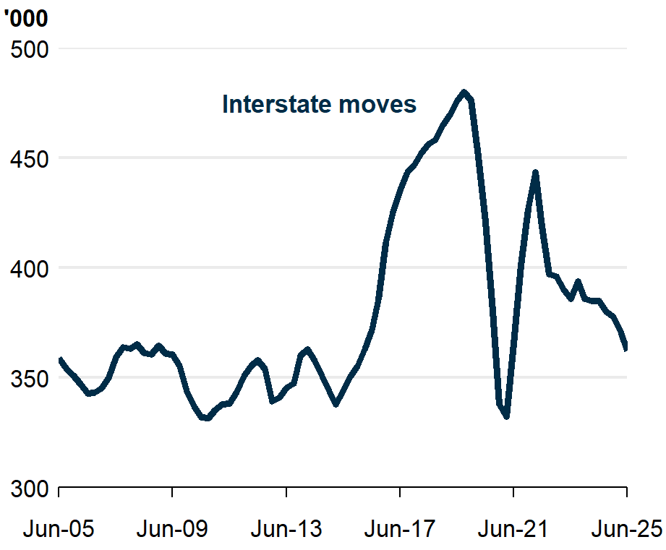

- Interstate migration continued to decline and remains below pre-pandemic levels (Chart 4). There were 362,000 interstate moves in the year to June 2025, 5.9 per cent lower than the previous year.
  - There was a net outflow of 30,000 residents moving from capital cities to regions in the year ending June 2025. This was a 5.1 per cent decrease from the previous year. This reflected departures from capital cities to rest-of-state areas falling by more than movements in the opposite direction.

State and territory population growth
- Population growth over the year to June 2025 increased slightly in the Australian Capital Territory and Tasmania and decreased slightly in Western Australia and the Northern Territory (Chart 5).
- Western Australia, Victoria, and Queensland had the fastest population growth, mostly driven by net overseas migration (Western Australia at 2.2 per cent; Victoria at 1.8 per cent; and Queensland at 1.8 per cent). Victoria had its lowest quarterly NOM since 2021, Queensland had its lowest quarterly net interstate migration (NIM) since 2016 and Western Australia had its lowest NIM since 2020.
- The Northern Territory, the Australian Capital Territory, New South Wales and South Australia grew more slowly than the national average (Northern Territory at 1.4 per cent; Australian Capital Territory at 1.3 per cent; NSW at 1.2 per cent; and SA at 1.1 per cent).
- Tasmania grew well below the national average (at 0.2 per cent). Its annual population growth has been at less than 0.3 per cent since the June quarter 2023.

Interstate population growth, annual
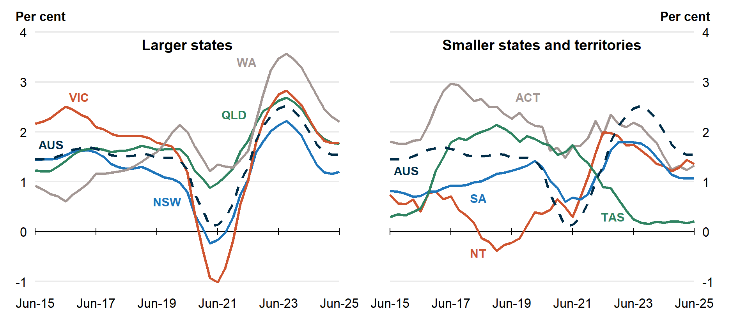

National, state and territory population
State | ERP | ERP Increase | ERP Increase | Natural Increase | NIM | NOM
State | 30 Jun 2025 | Since Jun 2024 | Annual % | Annual | Annual | Annual
NSW | 8,594,000 | 102,000 | 1.2 | 35,000 | -24,000 | 92,000
VIC | 7,074,000 | 124,000 | 1.8 | 37,000 | -800 | 88,000
QLD | 5,670,000 | 98,000 | 1.8 | 21,000 | 22,000 | 56,000
SA | 1,902,000 | 20,000 | 1.1 | 2,700 | -1,300 | 19,000
WA | 3,044,000 | 66,000 | 2.2 | 15,000 | 10,000 | 40,000
TAS | 576,000 | 1,200 | 0.2 | 400 | -1,900 | 2,700
NT | 264,000 | 3,500 | 1.4 | 2,000 | -2,100 | 3,600
ACT | 485,000 | 6,400 | 1.3 | 2,900 | -1,500 | 5,000
Australia* | 27,614,000 | 420,000 | 1.5 | 115,000 | NA | 306,000
Note: Absolute figures above 10,000 are rounded to the nearest thousand, and the nearest 100 otherwise.
* Includes other territories comprising Jervis Bay Territory, Christmas Island, the Cocos (Keeling) Islands and Norfolk Island.

