19 March 2026

National, State and Territory Population, September 2025
Australia's population reached 27.7 million in the September 2025 quarter. Population growth has moderated to the pre-pandemic decade average of 1.6 per cent, following the strong rebound post-pandemic.
Over the year to September 2025, the population increased by 424,000 people. Of this, natural increase (births minus deaths) added 113,000, while net overseas migration added 311,000. Although annual natural increase is near its highest level since 2022, there are still fewer births and more deaths than prior to the pandemic. Annual net overseas migration increased for the first time in September 2025 since peaking in September 2023, but remains well below that peak.

National population growth
- Australia’s population growth has remained steady at around 1.6 per cent over the year to September 2025, having been around this level for the past four quarters. This is broadly in line with the decade prior to the pandemic, where annual growth varied between 1.4 and 1.8 per cent.
- Population growth in the United Kingdom and New Zealand picked up in recent quarters, while it continued to slow in the United States and Canada (Chart 1). Notably, Canada’s population growth fell to 0.2 per cent in September 2025, the lowest recorded since the pandemic (December 2020).

International population growth, annual
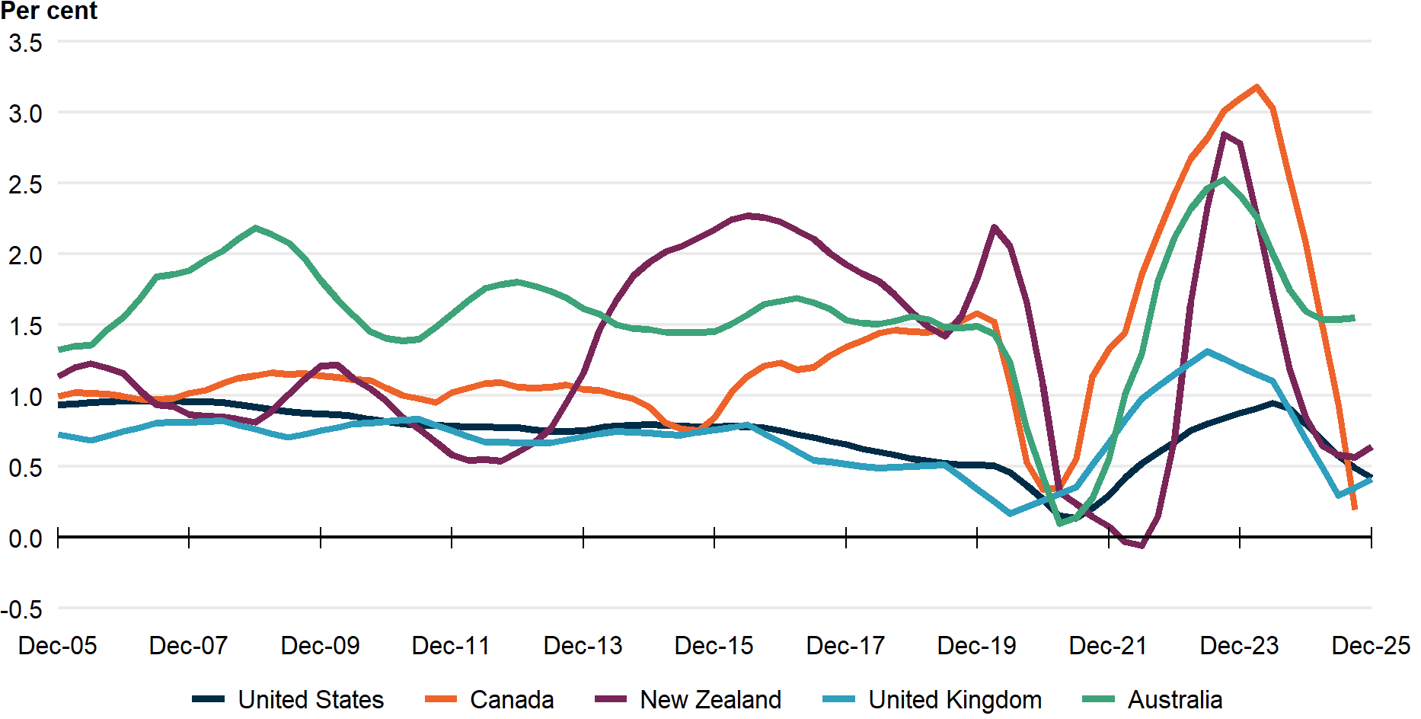
Note: Latest data for Australia and Canada reference the year to September 2025, while the United Kingdom, New Zealand and the United States reference the year to December 2025.
Source: ABS, Stats NZ, Statistics Canada, Office for National Statistics, Bureau of Economic Analysis.
- Net overseas migration remains the main driver of Australian population growth, due to low levels of natural increase (Chart 2).
- Net overseas migration (NOM) was 311,000 people in the year to September 2025, with 572,000 arrivals and 261,000 departures (Chart 3).
  - This was 6,000 (2 per cent) higher than the year to June 2025. The increase was due to arrivals increasing by 2,000 and departures decreasing by 4,000.
    - This outcome partly reflected the fact that temporary visa holders were departing at slower rates than before the pandemic.
- This is the first time that annual NOM has increased since peaking in September 2023.
  - Despite the increase, annual NOM was 245,000 lower than its historical peak of 556,000 in September 2023 and is around the level it was in the year to March 2009 (311,000).
- Natural increase (births less deaths) was 113,000 people in the year to September 2025. This was 7.9 per cent higher than the year to September 2024.
  - Births increased by 1.9 per cent (5,600 births) to 299,000 in the year to September 2025, remaining close to the 3-year high reached in the year to June 2025.
  - Deaths decreased by 1.4 per cent (2,600 deaths) to 186,000 in the year to September 2025, reflecting a halving of the number of COVID-19 deaths compared with the year to September 2024.
  - However, on a quarterly basis, natural increase was the third lowest on record since the 1980s. This reflects higher quarterly deaths in September 2025, in part due to a worse flu season.

National population growth, annual
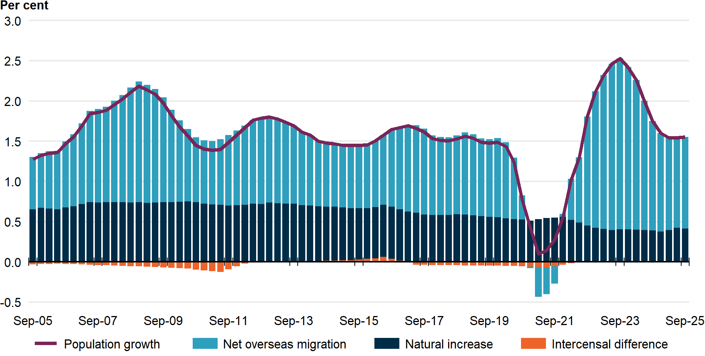

Overseas migration, annual | Interstate migration, annual
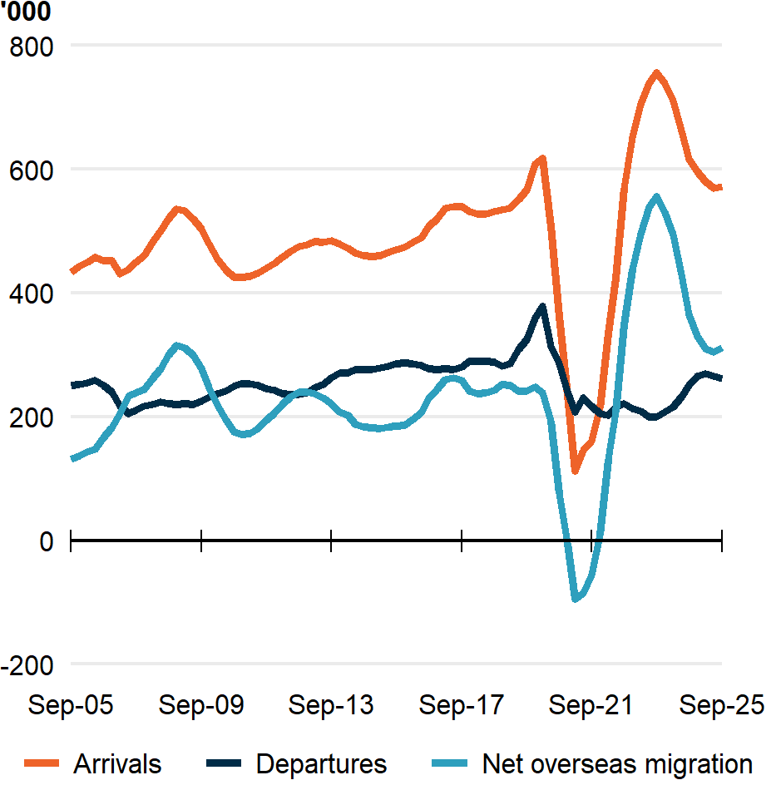 | 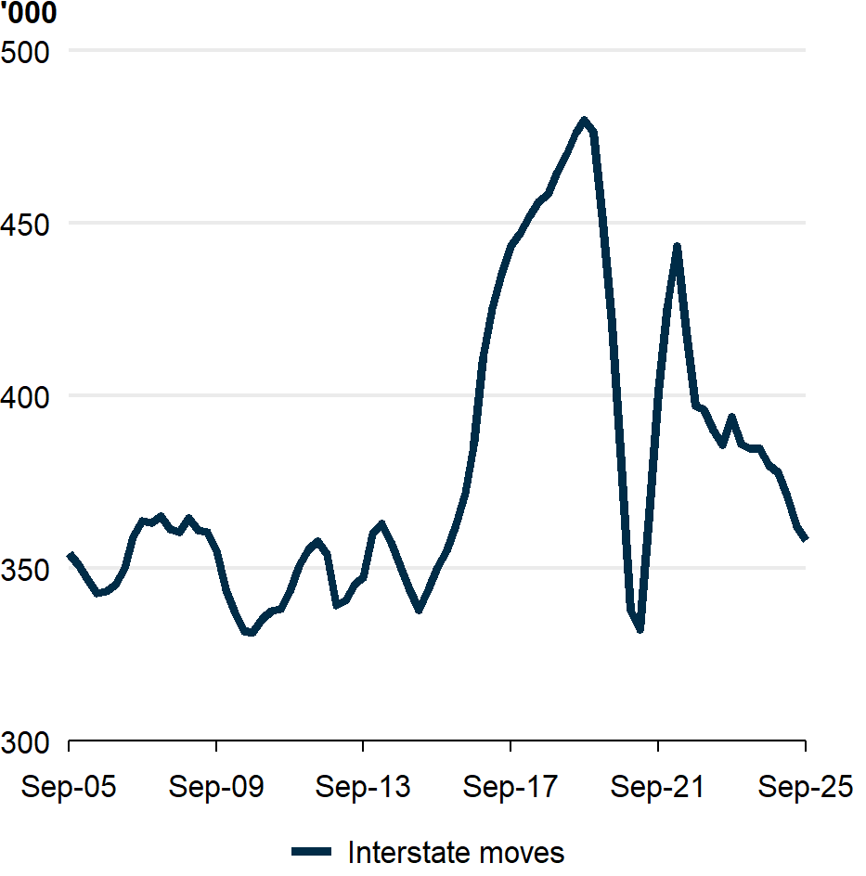

- Interstate migration continued to decline and remains below pre-pandemic levels (Chart 4). There were 358,000 interstate moves in the year to September 2025, 5.7 per cent lower than the previous year.
  - There was a net outflow of 28,000 residents moving from capital cities to rest-of-state areas in the year ending September 2025. This was a 12.7 per cent decrease from the previous year. This reflected departures from capital cities to rest-of-state areas falling by more than moves in the other direction.

State and territory population growth
- Western Australia, Victoria, and Queensland had the fastest population growth over the year to September 2025, mostly driven by net overseas migration (Western Australia at 2.2 per cent; Victoria at 1.7 per cent; and Queensland at 1.7 per cent) (Chart 5). For these states, population growth continued to moderate from their post-pandemic peaks. Queensland recorded its lowest quarterly net interstate migration (NIM) since September 2015 and Western Australia had its second lowest NIM since June 2022.
- The Northern Territory, Australian Capital Territory, New South Wales and South Australia grew slower than the national annual growth rate of 1.6 per cent (Northern Territory at 1.4 per cent; Australian Capital Territory at 1.3 per cent; New South Wales at 1.2 per cent; and South Australia at 1.1 per cent). However, annual population growth rates increased relative to the year to June 2025 for these four states, albeit only slightly for the Northern Territory and South Australia.
- Although Tasmania’s annual population growth has gradually increased since December 2023, its growth remained well below the national average annual growth rate (at 0.3 per cent) and the growth rates of all other states and territories. Tasmania was the only state or territory to record a natural decrease (more deaths than births) in the September 2025 quarter.

State and territory population growth, annual
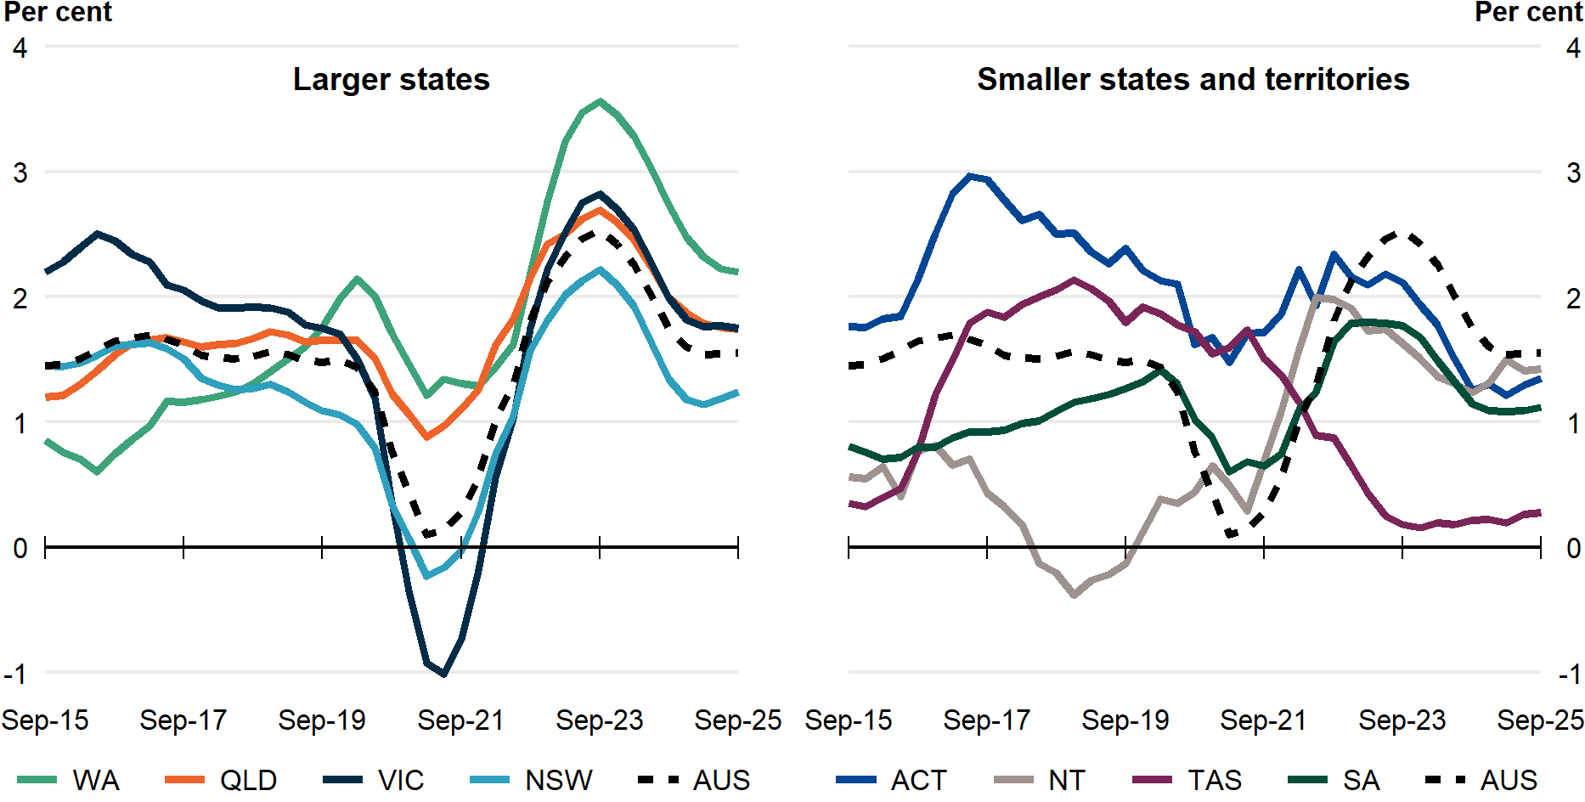

National, state and territory population
State | ERP | ERP Increase | ERP Increase | Natural Increase | NIM | NOM
State | 30 Sept 2025 | Since Sept 2024 | Annual % | Annual | Annual | Annual
NSW | 8,625,000 | 106,000 | 1.2 | 36,000 | -23,000 | 93,000
VIC | 7,104,000 | 122,000 | 1.7 | 33,000 | 400 | 89,000
QLD | 5,693,000 | 97,000 | 1.7 | 21,000 | 19,000 | 57,000
SA | 1,908,000 | 21,000 | 1.1 | 2,800 | -1,000 | 19,000
WA | 3,062,000 | 66,000 | 2.2 | 15,000 | 10,000 | 41,000
TAS | 577,000 | 1,600 | 0.3 | 300 | -1,600 | 2,900
NT | 265,000 | 3,700 | 1.4 | 1,900 | -2,100 | 3,900
ACT | 486,000 | 6,500 | 1.3 | 2,900 | -1,700 | 5,300
Australia | 27,725,000 | 424,000 | 1.6 | 113,000 | NA | 311,000
Note: Absolute figures above 10,000 are rounded to the nearest thousand, and the nearest 100 otherwise.
* Includes other territories comprising Jervis Bay Territory, Christmas Island, the Cocos (Keeling) Islands and Norfolk Island.

In the National, State and Territory Population release, births and deaths data are initially counted on a registration basis, meaning events are counted according to the date they are registered, rather than the date they occurred. This approach is used because early data based on the date of occurrence can be incomplete, due to delays between an event occurring and being registered. In the March release (published in September), the ABS revises data for the previous financial year to an occurrence basis, assigning events to when they occurred. Estimates for all 4 quarters of 2024-25 are preliminary and will be revised in September 2026. Estimates for the September 2025 quarter will be revised with other quarters of 2025-26 in September 2027.

