Regional Population, 2024–25 31 March 2026
- Australia’s population grew by 1.5 per cent in 2024–25, slightly below the pre-pandemic average of 1.6 per cent, but this picture varied at the regional level.
- Capital city combined population growth fell to 1.8 per cent (325,000 people) in 2024–25 in line with the growth rate observed prior to the pandemic.
  - This was down from 2.3 per cent in the previous year, reflecting the slowing net inflow of overseas migrants to capital cities (258,000 in 2024–25, down from 368,000 in 2023–24). Darwin was the only capital that grew faster (1.7 per cent) than the previous year (1.5 per cent).
  - Perth (2.4 per cent) was the fastest growing capital city in 2024–25, while Hobart (0.2 per cent) was the only capital city with a growth rate below 1 per cent.
- Around 85 per cent of net overseas migration (NOM) went to capital cities in 2024–25, similar to the previous year and the three years prior to the pandemic.
- Net internal migration outflow from capital cities to rest-of-state areas was approximately 30,000 in 2024–25, lower than the 2023-24 high of 34,000.
- Combined rest-of-state areas growth aligned with the pre-pandemic trend (1.1 per cent or 95,000 people), slightly lower than 2023-24 (1.3 per cent).
  - Although net overseas migration had fallen compared to 2023-24 levels, it remained the primary driver of rest-of-state growth (47,000).
  - Many rest-of-state areas experienced natural decrease (more deaths than births), due to their older age structure. In most cases this was offset by net internal and overseas migration (e.g. Mid North Coast of New South Wales and Wide Bay of Queensland). However, some regions (such as Launceston) experienced population decline that primarily reflected net internal migration outflows.
Chart 1. Combined capital city and rest of state growth, 2002 -03 to 2024-25  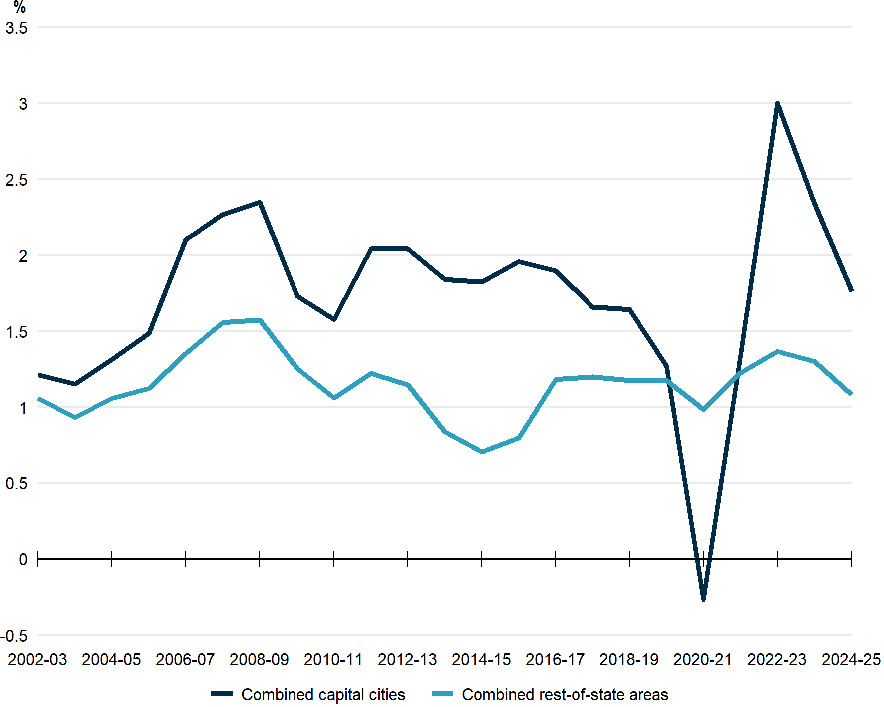 | Chart 2. Contribution of components to growth  Combined capital cities  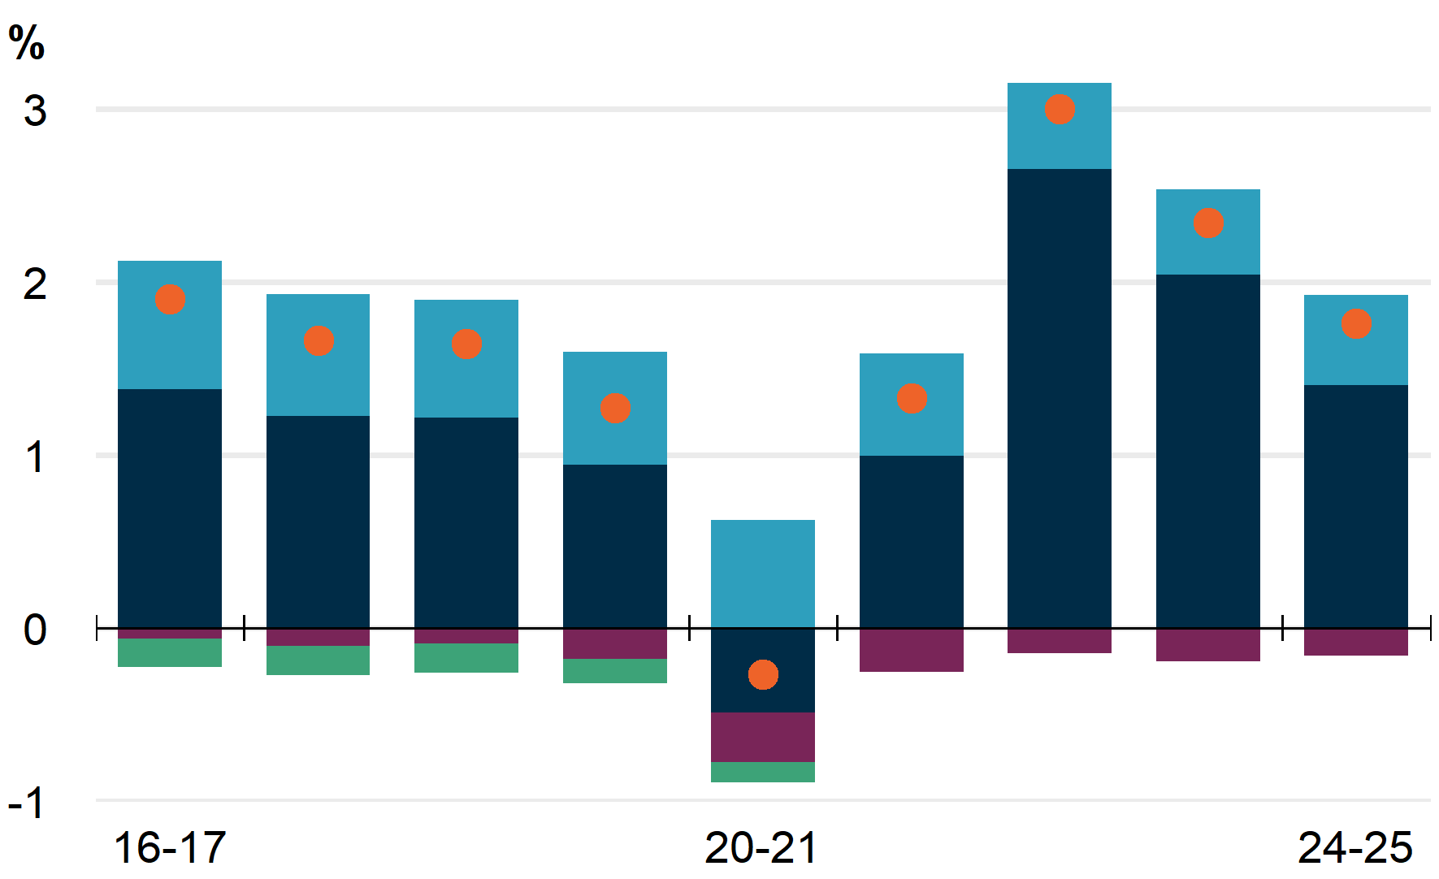  Combined rest-of-state areas
 | 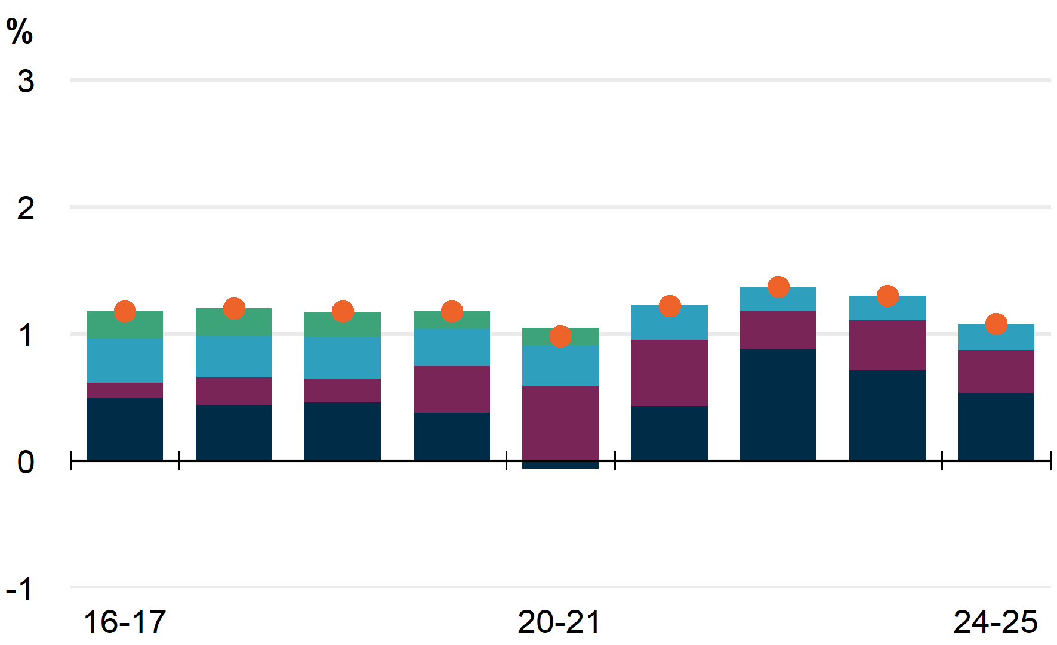

Capital city growth continues to be driven by overseas migration  - Population growth in Sydney, Melbourne, Brisbane and Adelaide has largely returned to the level of population growth seen before the pandemic. However, Perth, and Darwin are establishing growth levels higher than pre-pandemic trends. Hobart and the ACT’s pre-pandemic growth was driven by intercensal revisions, with current growth much lower.  - Despite falling, NOM made the largest contribution to growth in all capital cities in 2024-25, adding 81,000 people to Melbourne, 78,000 to Sydney, 37,000 to Perth and 34,000 to Brisbane.  - Sydney and Melbourne received the majority of national NOM in 2024–25 (52 per cent), with a further 23 per cent received by Brisbane and Perth. The inner city (SA4s) of these cities accounted for around 24 per cent of national NOM, despite having just 13 per cent of the national population.  - Brisbane and Perth were the only capital cities to have a net inflow of internal migrants (11,000 and 8,000 people respectively).  - Growth tended to be concentrated in outer suburbs for Sydney and Brisbane, with Melbourne and Perth’s growth more evenly distributed.  - Population growth was slowest in Hobart (0.2 per cent), primarily reflecting a smaller share of net overseas migration and negative net internal migration. This is the lowest population growth Hobart has experienced since 2001–02. | Chart 3. contribution of components to growth – greater capital cities  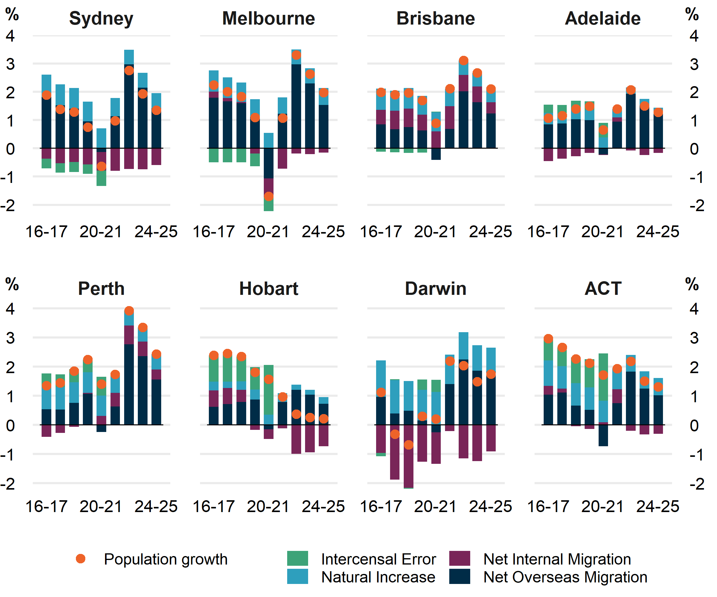

Growing lifestyle destinations offset areas of inland decline  - Rest-of-state (i.e. regional) areas in NSW, Victoria, Queensland and South Australia have largely returned to population growth levels seen before the pandemic. However, in Western Australia and the Northern Territory regional areas are experiencing elevated growth levels. While regional Tasmania has experienced much lower growth rates since the end of the pandemic.  - Regional Queensland was the fastest growing rest-of-state area in 2024–25 (1.4 per cent, Chart 4). This is the second year in a row that regional Queensland was the fastest growing rest-of-state area.  - Caloundra in the Sunshine Coast was the fastest growing area (SA3) in rest-of-state areas in 2024–25, growing by 3 per cent. This was followed closely by the Sunshine Coast Hinterland (2.7 per cent).  - Regional Tasmania (0.3 per cent) was the slowest growing rest-of-state area in 2024-25, largely due to lower net overseas migration as well as natural decrease (fewer births than deaths) that reflects Tasmania’s older age structure.  - 15 SA3s experienced negative growth in 2024-25, which is the same as 2023–24. Most of them are in New South Wales (six SA3s), particularly in the state’s west.  - Regional Victoria and South Australia each had 3 SA3s with negative growth.  - New South Wales’s Lord Howe Island was the only SA3 which experienced negative growth of more than 1.0 per cent, with a 1.1 per cent decline driven by internal migration outflows and zero natural increase. | Chart 4. Contribution of components to growth – rest of state areas  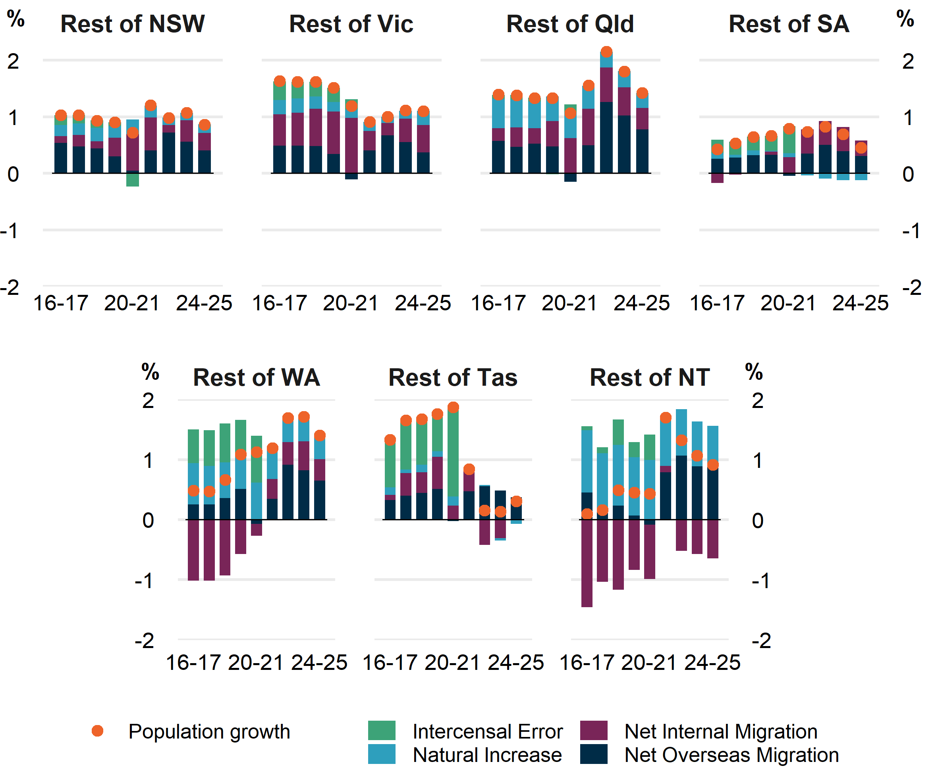

Australian cities are substantially less dense compared to international counterparts
- Australian cities are some of the least dense globally, especially compared to European cities. Due to their age, European cities developed before the mass production of cars, so European cities prioritise denser and more walkable cities. However, American cities are generally less dense than Australian cities because cities in the United States are often more orientated to suburban development, prioritising private cars over centralised public transport.
- Sydney is Australia’s most densely populated city, with 6.4 per cent of its population living in areas with over 10,000 persons/km², though most Sydney residents (39.7 per cent) live in areas with 3,000-6,000 persons/km². Melbourne’s population density is slightly lower than Sydney, with 2.3 per cent concentrated in areas with over 10,000 persons/km² and 36.4 per cent living in areas with 3,000-6,000 person/km².
- Sydney and Melbourne are substantially less dense than London, where 36.4 per cent of its population is concentrated in over 10,000 persons/km². However, Australia’s two largest cities are denser than Houston, which has over 70 per cent of its population is concentrated in under 3,000 persons/km². Whilst state and territory governments have presented plans to increase the density of Australian cities and benefited from centralised infrastructure orientated development, density-levels comparable to London are unlikely in the future.⁴

Chart 5. city population density, by 1km² grid
Sydney | Melbourne | London | Houston
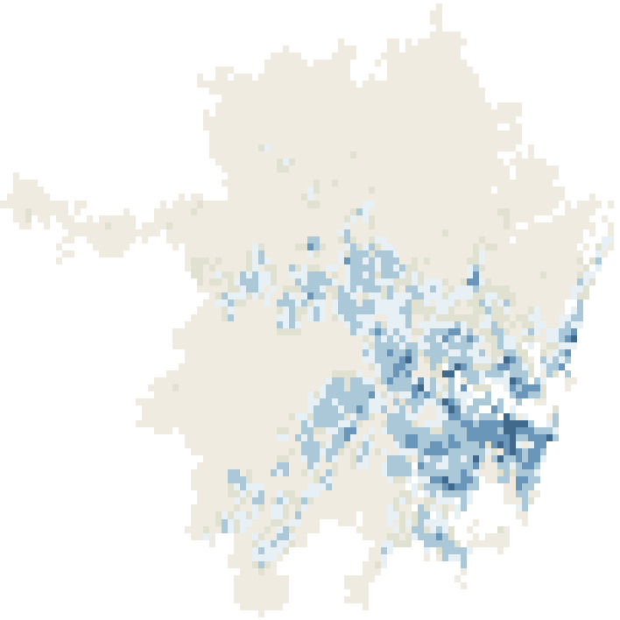 | 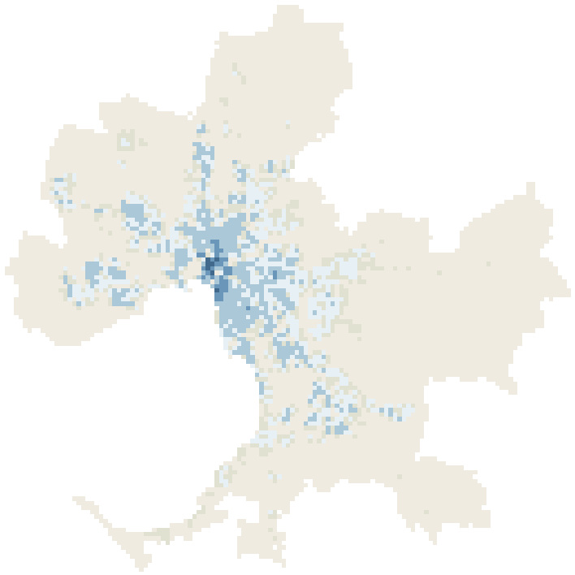 | 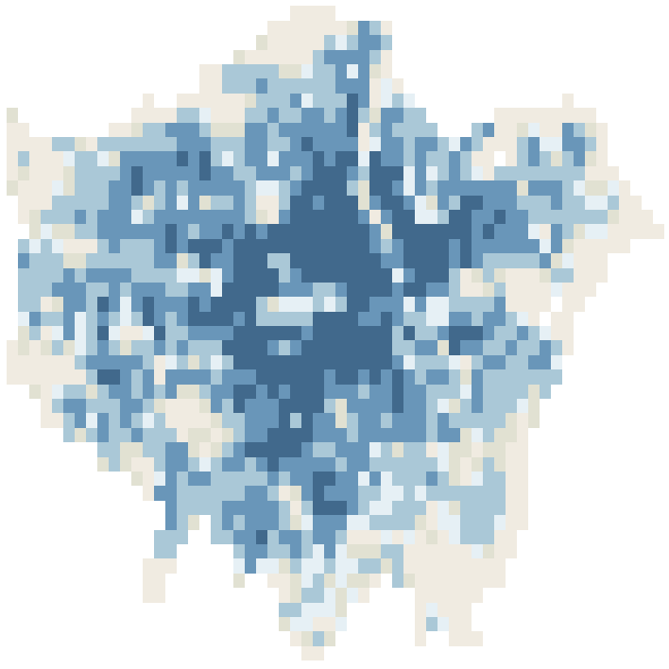 | 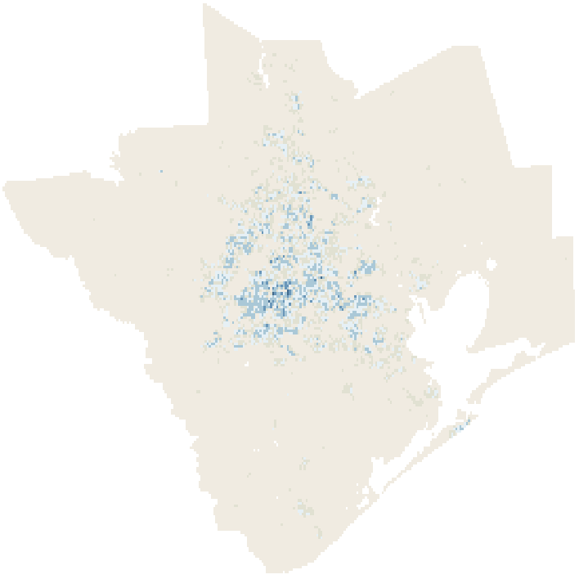

Chart 6. Proportion of population, by 1km² density
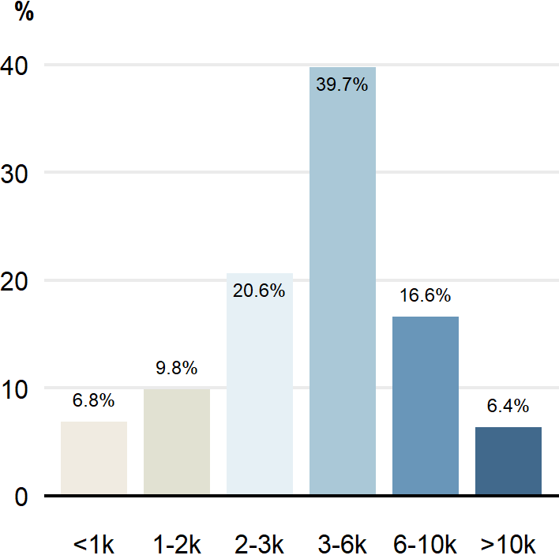 | 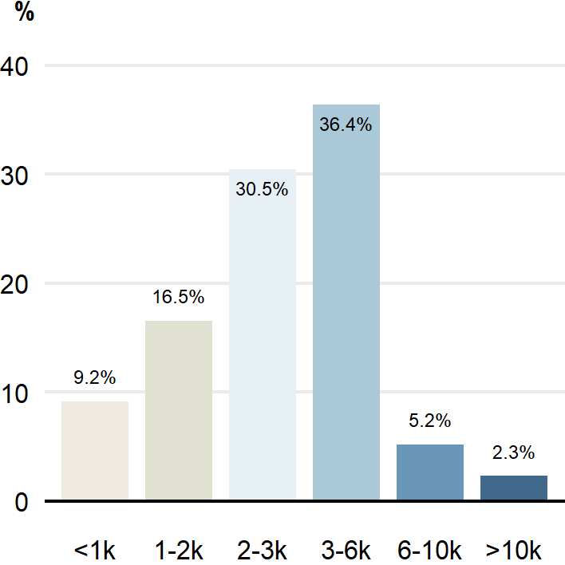 | 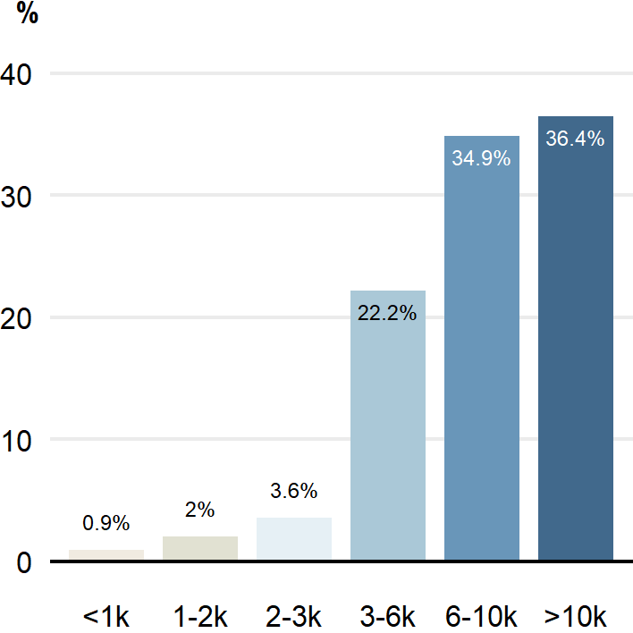 | 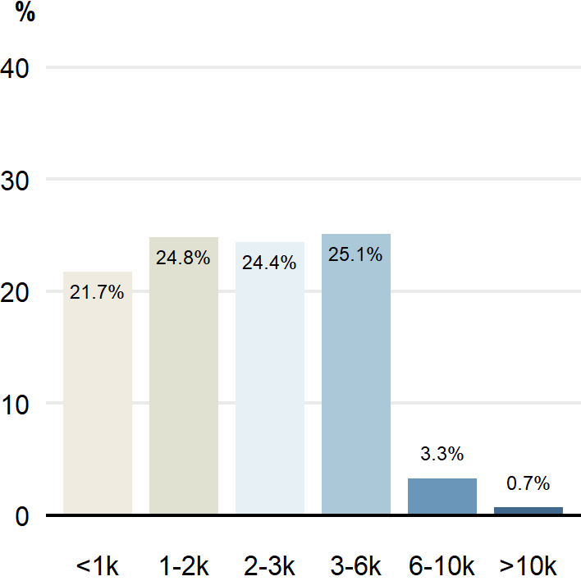
Chart 5 and Chart 6 utilise 1km² population density grids, increasingly available from various countries, which allow for density comparisons across cities on a consistent basis: Sydney and Melbourne use 2025 1km grid data with city defined by ABS 2021 Significant Urban Area definitions. London uses 2021 1km grid population data with city defined by the Greater London Authority. Houston uses 2020 1km grid data with city defined by the US Census Bureau as the Houston-The Woodlands-Sugar Land Metropolitan Statistical Area.

Data notes
- Further detail, including data quality notes, are available from the Australian Bureau of Statistics.
- Figures in this publication will not exactly match the data revisions in the ABS publication National, State and Territory Population (19 March 2026).

Pre-pandemic decade average is calculated using 2009-19 compound average annual growth rates.
Regional areas include rest-of-state areas outside of capital cities, including non-capital cities such as the Gold Coast and Newcastle, but do not include ‘other territories’ such as Norfolk Island.
There are 359 Statistical Area Level 3 (SA3s) in Australia. SA3s generally have populations between 30,000 and 130,000 people.
See The Sydney Plan, NSW Department of Planning, Housing and Infrastructure; Plan Melbourne 2017-2050, VIC Department of Transport and Planning

