Past trends and potential futures – projecting Australian fertility
MAIN REPORT

A research report prepared for the Centre for Population, Australian Treasury.
Authors: Edith Gray, Anna Reimondos, James Raymer and Natalie Nitsche
School of Demography
Research School of Social Sciences
Australian National University
© Australian National University 2026
ISBN: 978-1-923278-59-2
This publication is available for your use under a Creative Commons Attribution 4.0 International licence, with the exception of photographs, images, third party materials, materials protected by a trademark, signatures and where otherwise stated. The full licence terms are available from https://creativecommons.org/licenses/by/4.0/legalcode.

Use of Australian National University material under a Creative Commons Attribution 4.0 International licence requires you to attribute the work (but not in any way that suggests that the Australian National University endorses you or your use of the work).
Australian National University material used ‘as supplied’
Provided you have not modified or transformed Australian National University material in any way including, for example, by changing the Australian National University text; calculating percentage changes; graphing or charting data; or deriving new statistics from published Australian National University data – then the Australian National University prefers the following attribution:
Source: Gray, E., Reimondos, A., Raymer, J. and Nitsche, N. Past trends and potential futures – projecting Australian fertility, Australian National University.
Derivative material
If you have modified or transformed Australian National University material, or derived new material from those of the Australian National University in any way, then the Australian National University prefers the following attribution:
Based on Australian National University analysis.

Contents
Glossary of Terms vi
Executive Summary vii
1. Introduction 1
2. Australian fertility trends in a global context 3
3. Historical Fertility Trends in Australia 9
4. Drivers of fertility 17
5. Challenges of projecting fertility 22
6. Fertility Projections Methods 26
7. Sources of Data 31
8. Deterministic fertility projection 32
9. Probabilistic fertility forecast 38
10. Comparison of models 43
11. Conclusion 46
Acknowledgements 47
References 48
Technical Appendix 56

Figures

Figure 1: Total Fertility Rate (TFR) in Australia and selected countries, 1960–2023 4
Figure 2: Completed Cohort Fertility (CCF) at age 44, by birth cohort, Australia and selected countries 4
Figure 3: Mean age of women giving birth in Australia and selected countries, 1960–2023 6
Figure 4: Normalised age-specific fertility rate (ASFR) curve for 2019, Australia and selected countries 7
Figure 5: Standard Deviation of Mean age of mothers at birth, Australia and selected countries, 1960–2023 7
Figure 6: Total Fertility Rate and Completed Cohort Fertility in Australia 1935–2024 10
Figure 7: Completed cohort fertility in Australia, by year of birth 11
Figure 8: Age-specific fertility rates in Australia by 5-year age groups, 1921–2023 12
Figure 9: Historical evolution of age-specific fertility rates in Australia, by year 13
Figure 10: Historical evolution of age-specific fertility rates in Australia,
by birth cohort 13
Figure 11: Age-specific fertility by age group and number of
children already born (parity) 16
Figure 12: Women aged 20–24 – Trends in percentage enrolled in study and age-specific fertility rates by year 18
Figure 13: Women aged 20–24 – Trends in percentage not living with a partner and
age-specific fertility rates by year 19
Figure 14: Predicted probability of a high desire for a child, among childless respondents aged 25–39 (by sex) with 95% confidence intervals (HILDA) 20
Figure 15: Total Fertility Rate- Historical trend and select past fertility projections for Australia, by source 23
Figure 16: Total Fertility Rate – Historical trends and projections for Canada,
Germany and Sweden 24
Figure 17: Age-specific fertility rates - Observed in 2023–24 and projected in 2065–66, under high, medium and low scenario 36
Figure 18: Completed cohort fertility at age 44, by birth cohort projected under high, medium and low scenario 36
Figure 19: Total Fertility Rate – Historical trend and projected to 2065–66 under high, medium and low scenario and including variable trend 37
Figure 20: Age-specific fertility rates – Observed in 2023–24 and projection to 2065–66, model average and underlying models 40
Figure 21: Total Fertility Rate – Historical trend and projection to 2065–66,
model average and underlying models 41
Figure 22: Age-specific fertility rates – Observed in 2023–24 and
projected to 2065–66 43
Figure 23: Total Fertility Rate – Historical trend and projection to
2065–66, by model 44
Figure 24: Total Fertility Rate – Historical trend and projection to 2031–32, comparison of deterministic model with McDonald (2020) projection 45

Glossary of Terms
Age-specific Fertility Rate (ASFR): The age-specific fertility rate represents the birth rate at a particular age. It can be expressed in its original scale or per 1,000 women. It is typically calculated for single years of age, or five-year age groups, by dividing the number of babies born in a particular period (usually 1 year) to mothers at a given age, by the total number of women of that age at that time (often approximated by the mid-year population).
Total Fertility Rate (TFR): The total fertility rate in a year is the sum of the ASFRs in that year. It represents the hypothetical number of babies a woman could expect to have in her lifetime given the fertility patterns prevailing in that year. For example, the total fertility rate in 2023 is the number of children a synthetic cohort of women would have if from every age from 15 to 49 they experienced the exact age-specific fertility rates of 2023. One of the benefits of the TFR is that it is age-standardized, which makes it comparable across time and place. It can fluctuate from year to year or trend up or downwards if the age pattern of childbearing is shifting or the completed family size is changing.
Completed Cohort Fertility (CCF): Completed cohort fertility is a measure of the number of children born, usually to women, at the end of their reproductive years. CCF can be taken as a distribution of the number of children ever born (0, 1, 2, 3, etc.), or as an average for the cohort. Both are useful. The distribution shows if there are increases or decreases in the number of children that families are having – e.g. an increase in those not having children, or a decrease in having larger families. The average shows the most accurate measure of fertility for a cohort. The disadvantage of the measure is that the fertility has been completed by the time the measure is fully available.
Parity: The number of live births a woman has had. It is a retrospective measure of a woman’s reproductive history of live births up to a certain age or time. A woman who has never had a live birth has parity 0, which is also sometimes referred to as ‘nulliparous’. A woman who has had two live births has parity 2.
Replacement Level of Fertility: The concept of replacement fertility is often used to describe how many children are needed to replace the population, i.e. the average number of births needed to replace the population of reproductive age. It is often approximated as 2.1 births – 2 children for each parent – and a small fraction to account for standard mortality rates, specifically those who don’t survive to reproductive age. The measure ignores the role of migration, of differences in sex ratios, and of high levels of mortality, particularly child mortality. These settings can mean that the replacement level of fertility needed to ‘replace’ the population would be lower or higher depending on these factors.

Executive Summary
Understanding long-term fertility trends is crucial for policymaking, particularly in areas such as workforce planning, childcare, education, and social services. This report presents long-term fertility projections for Australia up to 2065–66. It examines past fertility trends, both globally and nationally, and analyses the key factors influencing fertility patterns. The projections provide insights into future fertility trajectories, incorporating both deterministic and probabilistic approaches to account for different methodological perspectives and uncertainties.

Background: Fertility trends and past projections

Fertility Trends and Underlying Factors
Over the past few decades, Australia has experienced a gradual decline in fertility, with a significant shift towards later childbearing. This aligns with trends observed in other high-‍income countries. Fertility decline has been primarily driven by social and economic factors, including increased participation in higher education, changing gender roles, and evolving partnership patterns.

Cohort vs. Period Fertility
Completed cohort fertility (CCF) has shown a more stable decline over time compared to period-based total fertility rates (TFR) which can be quite volatile. As such, period fluctuations in TFR should be interpreted with caution, as they may reflect changes in the timing of births rather than long-term fertility levels.

Challenges in Projecting Fertility
Fertility projections are inherently uncertain due to their dependence on social, economic, and behavioural factors, which can change unexpectedly. Delayed childbearing, shifts in family formation patterns, and economic conditions all contribute to this uncertainty.

Previous fertility projections
Previous fertility projections have often faced challenges in anticipating short-term fluctuations and long-term trends. For example, projections made in the early 2000s did not foresee the temporary rise in fertility in the mid-2000s, while later projections tended to overestimate fertility levels. These discrepancies highlight the inherent difficulty in forecasting fertility, as trends are influenced by unpredictable factors such as economic cycles, policy changes, and shifts in social behaviour. This report acknowledges these challenges and incorporates a range of projection methods to better capture the uncertainty surrounding future fertility trends.

Projection Methods
Projecting fertility is inherently complex due to the interplay of social, economic, and demographic factors that shape childbearing behaviour. To provide a comprehensive assessment of future fertility trends in Australia, this report employs both deterministic and probabilistic approaches to project fertility rates over the next 4 decades. The deterministic method relies on expert judgment and historical trends to establish a range of plausible fertility scenarios, while the probabilistic approach incorporates multiple statistical models to quantify uncertainty and capture a broader spectrum of possible outcomes.

Deterministic Approach
A deterministic projection, incorporating expert judgement and historical trends, estimates a medium total fertility rate (TFR) of 1.34 by 2065–66, with low and high scenarios of 1.10 and 1.67, respectively. Projections of completed cohort fertility (CCF) results in 1.40 (medium), 1.25 (low), and 1.63 (high).

Probabilistic Approach
A model-averaged probabilistic projection, using seven component models, provides a wider range of possible fertility outcomes. The individual models project fertility rates ranging from 1.18 to 1.96 by 2065–66, with a model-averaged TFR of 1.43. The divergence between the expert-driven deterministic projection and the probabilistic model reflects differences in methodology and assumptions.
The deterministic projection represents what the authors consider the most likely fertility trajectory, while the probabilistic approach helps demonstrate the diversity of potential fertility outcomes.

Future Fertility Trends
The authors recommend the results of the deterministic approach (medium scenario) in future projections of the Australian population, noting that the results for the probabilistic approach are similar. The recommendation is based on the weight given in the deterministic approach to recent observed trends in the age-schedule of childbearing, in Australia and other countries.
In the near term, fertility is expected to continue declining, driven primarily by lower fertility rates among women under 30 and ongoing postponement of childbearing.
Fertility levels may stabilise at a lower rate, although uncertainty remains about the potential for future shifts, such as changes in economic conditions, social policies, or medical advancements that may influence reproductive behaviour.

1. Introduction
The size and age structure of a population is determined by three key components: the number of children born (fertility), the number of people who die (mortality), and the net number of people who move into its boundaries (migration). As the rates of these components shift over time, they directly influence the population’s growth and demographic makeup. For instance, a decline in the number of children per woman leads to fewer people being added to the population, particularly at younger ages. In contrast, a decline in mortality – meaning that people live longer – increases the number of individuals in older age groups, especially those beyond retirement age. Similarly, positive net migration predominantly adds people to the working-age population. By examining these three components and making assumptions about their future trends, we can project the future size and age structure of the population.
Population projections are important for policymaking, population planning, and economic forecasting because they provide insights into possible future demographic trends. The Australian Government uses projections to anticipate changes in population size and age structure, which directly affect long-term planning for services like healthcare, education, and pensions. For example, in the Intergenerational Report (Commonwealth of Australia 2023), projected population estimates show ageing of the Australian population, and this information can be used to assess the sustainability of public finances and social programs and informs policy decisions on immigration, workforce participation, and family support.
Fertility projections are an essential component of population projections which use assumptions about fertility, mortality, and migration to project the future population size by age and sex. Fertility projections are crucial in these models as they determine the size of future birth cohorts, shaping the population's age structure and growth. Furthermore, the effect of fertility on predicted population structures is cumulative over time. As an example, the number of births in 2066 will depend on the birth rate of women aged 15–49 in that year, but also on the number of women in those reproductive age ranges which itself is determined by the level of fertility in the coming 25 years. Hence, most of the people who will give birth in 2066 are not born yet. Fertility projections are also useful for anticipating demand for related services such as maternity care, childcare, and schooling (Petropoulos et al. 2022).
In this report, we use the terms ‘projection’ and ‘forecast’ interchangeably, although the terms have historical differences in their application to future predictions (Goldstein, et al. 2011; Booth 2006). We aim to present our view of the most probable development of future fertility. However, the future is inherently uncertain, and the further ahead we look, the higher the uncertainty. The analysis presented is based on a 40-year projection horizon from 2023–24 to 2065–66, representing a relatively long timeframe for a fertility forecast.
A unique feature of childbearing in human populations is our ability to control reproduction. Today this is typically done using modern contraceptives. However, even before the availability of these measures, there is evidence that people used various practices to limit and control the timing of reproduction (Szreter and Garrett 2004). In Australia, most pregnancies are planned. Pregnancy intention is associated with several factors including age, parity, geographical residence, and socio-economic status (Hewitt et al. 2010; Rassi et al. 2013; Shankar et al. 2023). The high degree of planning and intendedness in childbearing reflects that people generally have children if they are ready, willing, and able.
The ability of humans to control their reproduction allows fertility patterns to change gradually, reflecting slow shifts in socio-economic factors such as partnering, housing, work, and education, which influence the costs and benefits of childbearing. However, fertility can also change more abruptly as people respond to more immediate changes in conditions around them. This is evident in the temporary falls in fertility rates that are evident during recessions, military conflicts, or famines (Comolli 2017, Sobotka et al. 2011, Zhao and Reimondos 2012).
Over the next 40 years, social, political, technological, environmental, or medical changes could significantly impact childbearing patterns. These changes might include one-off events, such as the development of new contraceptives, the outbreak of war, a pandemic, or a major environmental catastrophe. Alternatively, longer-term trends may emerge, such as shifts in social attitudes or changes to work patterns driven by technological advancements. While the exact nature of these changes is impossible to predict, their influence on fertility could be substantial, potentially leading to fertility levels far higher or lower than those presented here.
To inform predictions about the future level and pattern of fertility in Australia, this analysis explores how Australia's fertility levels compare to those of other countries and examines the diversity of patterns and trajectories observed internationally. Australia’s current and past fertility, along with the primary drivers of recent changes to fertility patterns, are also closely examined. Over the last 40 years, there have been significant societal changes which have led to a gradual decline in the number of children that people have, and a shift in the timing of childbearing at the national level.

2. Australian fertility trends in a global context
This section examines recent Australian fertility trends in a global context, highlighting the similarities and differences between the patterns of childbearing in Australia and in other high-income countries. This process allows us to identify what fertility trends are common to all countries, and which ones are more country specific. It also provides an opportunity to consider different trajectories that Australia might take based on the experience of other countries.
Two dominant trends in recent Australian fertility are that Australians are having fewer children, and they are having them later. However, in a global context these trends are not unique to Australia and overall Australia has maintained somewhat higher fertility compared to other high-income countries. This is evident when looking at childbearing data across time (period data) as well as across different generations of women (cohort data).
The primary indicator demographers use to track fertility levels over time, and to compare across countries, is the Total Fertility Rate (TFR). The TFR is an age-standardised measure which measures the average number of children born in a year. Figure 1 shows the pattern in the TFR between 1960–2023 for selected countries, including Australia. While Australia’s TFR trajectory has followed the global pattern of declining fertility over this period, it remains higher than many other European countries, and Japan. Between 1977 and 2019, Australia’s TFR has fluctuated between 2.01 and 1.67 children (ABS 2024a). During the COVID-19 pandemic, fertility declined to 1.59 in 2020. In 2023, Australian TFR was recorded as 1.5, which is the lowest TFR ever recorded for Australia. While a TFR of 1.5 in 2023 was a historic low for Australia, a handful of countries have had fertility rates of 1.5 or below for many years, even before COVID-19. As an example, among European countries there are many countries including Spain, Italy, Greece, Poland, Germany, Austria, Hungary who have experienced a TFR of 1.5 or less for 10 or more years in the two decades between 2000 and 2019 (Eurostat 2025).
Australia’s relatively high fertility is also evident when taking a generational perspective and looking at another fertility indicator known as Completed Cohort Fertility (CCF) (Figure 2). CCF measures how many children women have at the end of their reproductive lives, typically at a cut-off age such as 44 (or 49), and is useful for examining generational changes in childbearing. The most recent completed cohort data are for women born in the late 1970s who are reaching their mid-40s and the end of their reproductive life spans. Again, the trend has been one of declining fertility over time. In Australia, women born in 1978 (aged 44 in 2022) had an average of 1.96 children. Other countries have considerably lower CCF, although some such as Germany, Japan and the United Kingdom have experienced recent upturns. ‘Very low’ CCF is defined as 1.75 children per woman (Zeman et al. 2018), a level which Australia has to date never dropped below.
In comparing Figure 1 (period fertility) and Figure 2 (cohort fertility), we can see that period fertility can fluctuate considerably, but when averaged out over a cohort as measured by CCF, it shows that societal changes in childbearing patterns occur in a relatively stable and predictable pattern over time.
Figure 1: Total Fertility Rate (TFR) in Australia and selected countries, 1960–2023
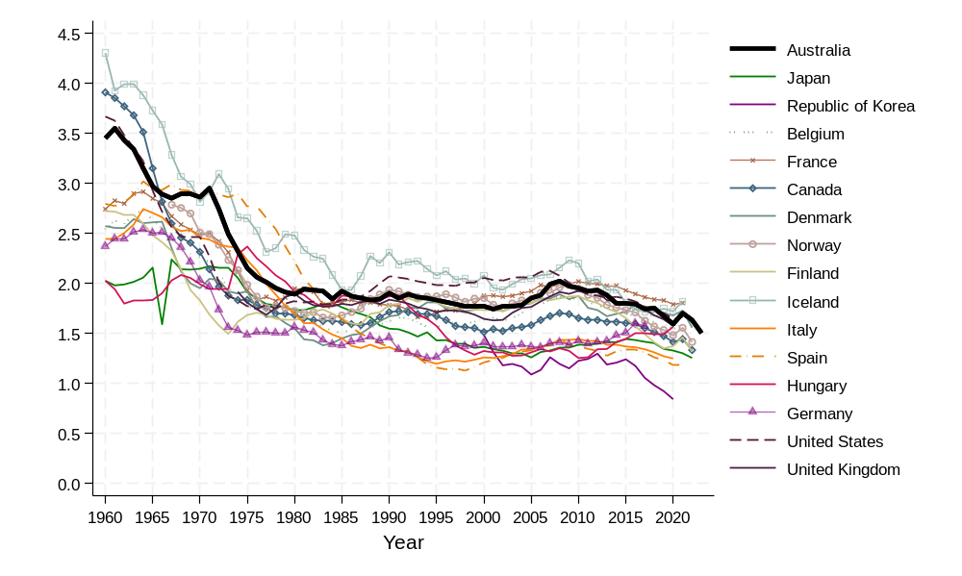
Note: Fertility data up to 2023, or last available year.
Source: Data for Australia from Australian Bureau of Statistics (2024a); data for other countries from Human Fertility Database (2024).

Figure 2: Completed Cohort Fertility (CCF) at age 44, by birth cohort, Australia and selected countries
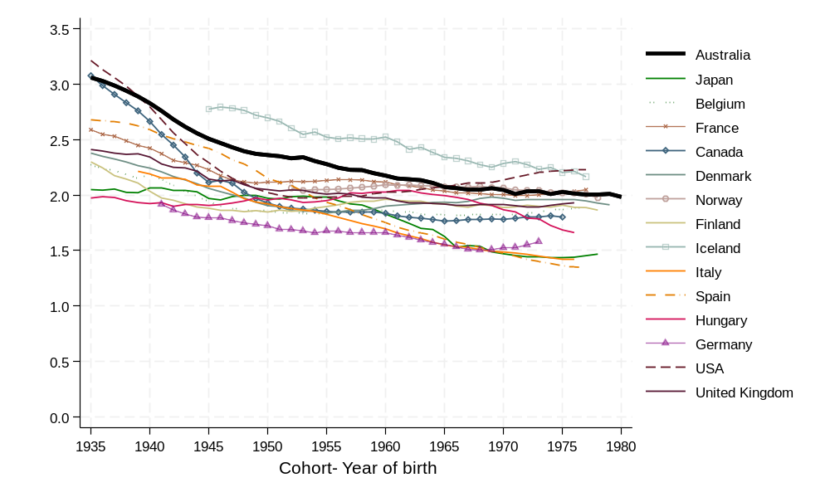
Source: Data for Australia from the Human Fertility Collection (2024); data for the United Kingdom from Office of National Statistics (2024); data for all other countries from Human Fertility Base (2024).

Comparison of age patterns
In addition to the overall level of fertility, it is important to consider the timing or age pattern of fertility. Whether people have children at young ages, or later in life, is shaped by social, economic, and cultural factors. Two countries with the same overall level of TFR may have very different underlying patterns of childbearing by age. At the country-level the timing of fertility can be measured in different ways, with different indicators elucidating different dimensions of the age-pattern of childbearing.
At the individual level, a later age at first birth is associated with lower overall fertility, as a delayed start to parenthood leaves less time to have large families. However, this negative association between age at first birth and fertility does not necessarily hold at the country level. Hence, when comparing lower fertility countries, the degree to which they have experienced an increase in age at birth is not necessarily correlated with their overall fertility (Beaujouan and Toulemon 2021).
A common measure of timing is the average age of all mothers giving birth in a certain year or period. Typically, this average is represented by the mean age at birth (MAB) or mean age at childbearing (MAC), but occasionally it is calculated using the median age at birth. The Australian Bureau of Statistics traditionally publishes data on the median age of mothers, rather than the mean age.
Figure 3 shows the evolution of the mean age at birth in Australia and other selected countries since 1960. For Australia, data on MAB was available from 1998 from statistics published by the Australian Institute of Health and Welfare. To extend the historical period for comparison we supplemented this with our own calculation of MAB. The trend for median age, as published by the ABS, has also been included, although care should be taken to note that when the age distribution of fertility is left-skewed the mean will be lower than the median.
Figure 3 shows that Australia has exhibited the same general pattern as seen in other countries, with a declining average age at birth during the 1960s and 1970s followed by a steady increase since 1980. In 2022, the MAB in Australia was 31.2 (AIHW 2024). In most countries with fertility levels similar to Australia the average age at which women give birth is around 30–32 years of age. While an average age at birth at age 30–32 is common in many countries, few countries have reached 33 or higher so far. Although not shown on the graph, examples include South Korea, where the average age of women giving birth in 2023 was 33.6 years old, having increased from 31.8 in 2013 (Statistics Korea 2024), and Ireland with an average age of mothers of 33.2 years in 2022 (Central Statistics Office 2024).
Figure 3: Mean age of women giving birth in Australia and selected countries, 1960–2023
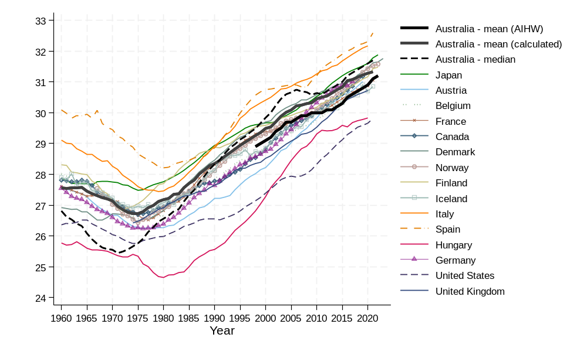
Note: Data up to 2023, or last available year.
Source: Australia mean values are from Australian Institute of Health and Welfare (2024) and National Perinatal Statistics Unit (1994,1995), Australia mean values (calculated) are based on author calculations from ABS fertility rates (2024b); Australia median values from Australian Bureau of Statistics (2024b); for all other countries data are from Human Fertility Base (2024).
Although comparing a single indicator such as MAB between Australia and other countries can tell us whether Australia has a similar age at which childbearing is most concentrated, this comparison does not give us any additional information. Two countries may have the same mean age at birth but very different age patterns of childbearing.
When fertility rates are calculated for each age, they are known as age-specific fertility rates (ASFRs). When ASFRs are plotted by age on the x-axis they form a curve, known as the age-specific fertility rate (ASFR) curve. The mean age at birth is closely related to the peak of this curve, or the age at which there is the highest intensity of childbearing. To understand more about how Australia compares we can look at the peak of the curve, and additionally, compare the shape of the whole ASFR curve.
Curves may vary over time, and between countries, in terms of their skewness, height, and overall distribution. Figure 4 shows the ASFR curves of selected countries. For comparison purposes, the ASFRs have been scaled to a TFR of 1.0 for each country, meaning that only the shape or distribution of the fertility curve is demonstrated. The curve shows that the fertility age pattern for Australia has a slight bulge at younger ages (which is larger than many countries), a somewhat lower level in the mid-20s to 30, and is relatively high in the early to mid-30s, relative to other countries. That is, Australia has a comparatively high level of fertility in both younger and older age groups.
The relatively large ‘spread’ of the Australian ASFR curve means that it has a relatively high value for the Standard Deviation of the MAB (SDMAB), which is another measure sometimes used to compare the age pattern of fertility. Countries that have a more concentrated distribution of childbearing in the peak years tend to have a smaller SDMAB. As seen in Figure 5, which shows the same countries as before we see that Australia has a relatively high standard deviation.
Figure 4: Normalised age-specific fertility rate (ASFR) curve for 2019, Australia and selected countries
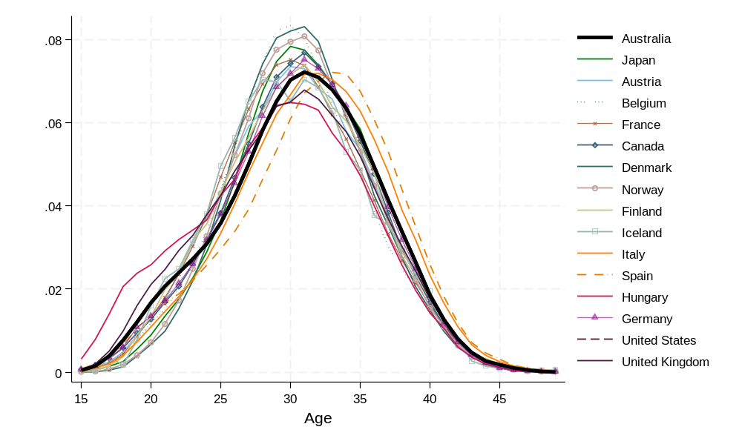
Source: Data from United Nations (2024).

Figure 5: Standard Deviation of Mean age of mothers at birth, Australia and selected countries, 1960–2023
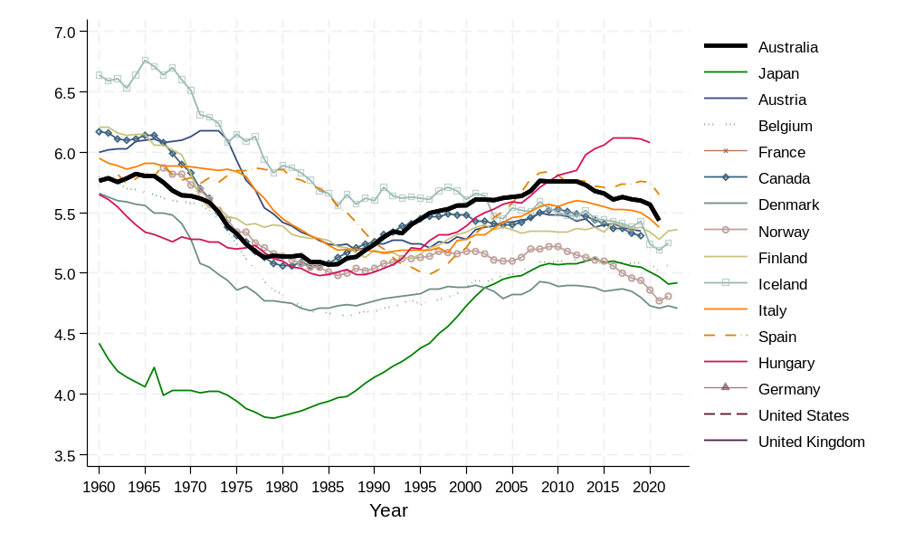
Note: Data up to 2023, or last available year.
Source: Data for Australia from Australian Bureau of Statistics (2024b); data for other countries from Human Fertility Database (2024).
In terms of numbers, Table 1, compares Australian age-specific fertility rates in 5-year age groups to selected other countries. These numbers help to inform the comparisons seen in earlier the graphs.
As noted earlier, Australia has relatively high childbearing at ages 15–19 and 20–24 (Table 1). It has similar values to other English-Speaking countries such as Canada and the United Kingdom. Other countries have significantly lower values. For example, while in 2019 the birth rate for women aged 20-24 was 40 children per 1,000 women in Australia, in Denmark it was 29 children per 1,000 women. At the other end of the age range, at age 40–44 the values are similar to other countries. After age 40 there is generally little variation across the countries, with the exception of Ireland which has the highest rate of childbearing at older ages.

Table 1: Age-specific fertility and TFR, selected countries (2019)
Country | 15–19 | 20–24 | 25–29 | 30–34 | 35–39 | 40–44 | 45–49 | TFR
Australia | 8.8 | 40.1 | 84.3 | 115.6 | 69.3 | 15.5 | 1.3 | 1.67
Canada | 6.2 | 31.9 | 81.0 | 105.5 | 57.3 | 12.4 | 0.8 | 1.48
United Kingdom | 11.2 | 48.4 | 88.3 | 104.7 | 61.9 | 16.5 | .. | 1.66
United States | 16.7 | 66.6 | 93.7 | 98.3 | 52.8 | 12.0 | 0.9 | 1.71
Denmark | 2.0 | 28.9 | 107.0 | 127.8 | 60.7 | 12.5 | 0.8 | 1.70
Italy | 2.5 | 23.7 | 89.4 | 125.6 | 61.9 | 11.3 | 0.5 | 1.57
Spain | 6.0 | 23.9 | 49.8 | 84.3 | 64.1 | 16.7 | 1.5 | 1.23
Hungary | 21.1 | 48.4 | 82.8 | 94.0 | 51.5 | 11.4 | 0.6 | 1.55
Ireland | 5.4 | 31.7 | 69.4 | 119.3 | 92.3 | 22.1 | 1.9 | 1.71
Republic of Korea | 0.8 | 7.1 | 35.7 | 86.2 | 45.0 | 7.0 | 0.2 | 0.91
Colombia | 56.6 | 88.0 | 76.3 | 55.3 | 32.1 | 8.8 | 0.7 | 1.59
OECD- Average | 11.7 | 45.0 | 88.4 | 101.7 | 57.5 | 13.4 | 1.0 | 1.59
Note: For United Kingdom, the ASFR at age 40–44, is for ages 40+.
Source: OECD Family Database (2025).

3. Historical Fertility Trends in Australia
In this section the historical fertility trends in Australia are examined in greater detail. Significant trends in the overall level of fertility, as well as the underlying age pattern of childbearing, are highlighted using different indicators from both a period and cohort perspective.

Overall level of fertility

Period perspective using the Total Fertility Rate (TFR)
Australia’s fertility levels have changed substantially over the 20th and 21st centuries. As discussed previously, the most used measure of fertility is the TFR, which measures the number of children born to a synthetic, or theoretical, cohort. The TFR calculation includes all women alive from age 15 to 49, at a point in time, and derives the TFR based on their fertility patterns at that specific year or time point. It is useful because it is age-standardised, meaning that we can use it to compare the fertility levels across different populations over time and place, even if those populations have different age structures. While the TFR is an intuitive and widely available measure, it does have some important shortcomings that should be considered when interpreting it (Bongaarts and Feeney, 1998).
Most important of these shortcomings is that fluctuations in period TFR may be due to a change in the timing of childbirth. This is called a tempo effect, whereby there has been a change in the age at which women have children, but the number of children that they have (or will have) overall may not have changed. Hence, a decline (or increase) in TFR, may be because people are delaying (or bringing forward) when they have children. Many countries have had, or are experiencing, an increase in age at birth, and this will lower the TFR. Once the delay has stabilised, so too will TFR. If women ‘catch up’ on those delayed births, this may increase the TFR, an effect referred to as ‘recuperation’. However, changes in TFR can also be the result of an increase (or decrease) in the number (quantum) of children being born. This makes a change in TFR somewhat difficult to interpret: Is it due to a change in the timing (tempo) of births? Is it due to a change in the quantum (number) of births? Or is it due to both tempo and quantum?

Cohort perspective using Completed Cohort Fertility (CCF)
As mentioned previously, looking at how fertility has changed over birth cohorts or generations with measures such as Completed Cohort Fertility (CCF) can often give us a more stable picture of past trends in fertility. A disadvantage of the CCF is that we can only measure completed fertility for women who are already aged in their forties.
Figure 6 shows both the TFR for Australia from 1935 to 2023, and CCF at age 44 for matching generations. The figure applies the CCF (at age 44) of women at the time of their peak childbearing age of 28. For example, the CCFS figure for the year 1995 represents the CCFS (44) of women who were 28 years old at that time (born in 1967). The figure provides author calculations of CCFS from period age-specific fertility rates, and CCFS estimates published by the Australian Bureau of Statistics. The CCFS data ends in the mid-2000s as this is the last year where we can observe the CCFS at age 44 from the data (for women born in the late 1970s).
From both a period and cohort perspective we see a similar trend, although the period TFR naturally has more fluctuations.
There are periods of stability, but also periods of variability. Some periods show very steep declines or increases. The large increase in TFR from the early 1940s is often termed the post-war ‘baby boom’. Research has shown that the baby boom resulted from two key factors: childbearing occurring at younger ages than in previous years (tempo) and an increase in the number of children born to women overall (quantum). These trends were driven by younger and higher rates of marriage following the 1930s Depression (Ruzicka and Caldwell, 1982).
Those who had children during the peak childbearing years of the baby boom did have larger families; however, the recorded Total Fertility Rate (TFR) was higher than the completed cohort fertility due to the influence of the tempo effect.
Figure 6: Total Fertility Rate and Completed Cohort Fertility in Australia 1935–2024
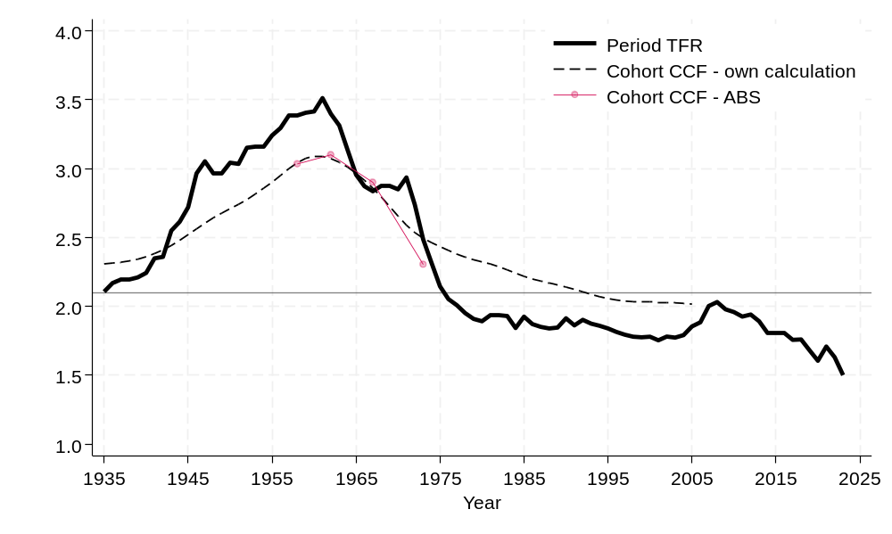
Note: Cohort CFS (age 44) shown at cohort age 28 to provide a comparison with TFR.
Source: Period TFR and cohort CCF own calculations based on data from Australian Bureau of Statistics (2024b). Cohort Completed Family Size estimates from Australian Bureau of Statistics (1998a).

Fertility then fell dramatically from the early 1960s, stabilised, and then continued downwards in the early 1970s. Notably, the oral contraceptive pill was introduced on 1st February 1961 in Australia, allowing women to control their reproduction for the first time in a safe and reliable way. The introduction of the oral pill at this time also occurred in the context of general changes in gender roles and social attitudes taking place at this time (Bryson et al. 1999). In 1972, the pill was placed on the Pharmaceutical Benefits Scheme, making it more affordable across Australian society.
From around 1980 the TFR was quite stable, with small ups and downs until the early 2000s when it hit a low point. This downturn was predominantly due to a delay in the age of having children and resulted in a smaller catch-up baby boom in the mid-2010s, as births were recuperated at older ages. From 2008, the TFR has continued its downward trend, with a slight catch-up in 2021 post the onset of COVID. In 2023, TFR hit a record low point of 1.50 children (ABS 2024a). Again, the CCFS had a much more stable pattern, although the general trend and direction of the fertility trajectory was the same.
The overall fertility level by cohort is shown from a different perspective in Figure 7. The figure displays the cumulated number of children had by specific ages. Taking the 1960 birth cohort as a starting point, the average completed fertility at age 44 is 2.2. This dropped to 2.1 for the 1965 birth cohort. It again fell to just over 2 for the 1970 and 1975 birth cohorts. The figure also shows the decline in the average number of children born before age 30 for women in these cohorts. Incomplete cohort fertility is available for the 1980, 1985 and 1990 birth cohort. All of them are below the 1975 birth cohort line, and it appears that they will have lower completed fertility if there is no substantial recuperation at later ages. Of note is that the 1990 cohort has substantially lower average number of children born by age 30.
Figure 7: Completed cohort fertility in Australia, by year of birth
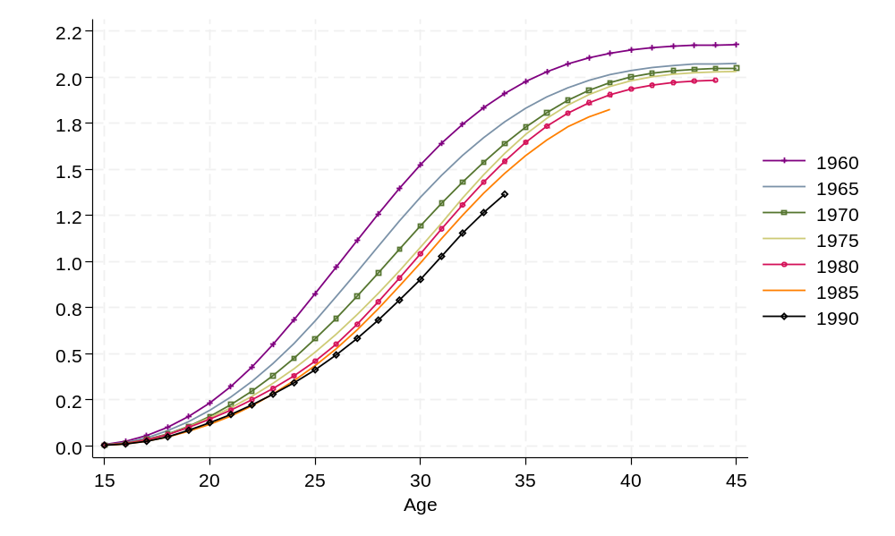
Source: Data from Australian Bureau of Statistics (2024b) and provided by Centre for Population.

Age pattern: Period and cohort age-specific fertility rates
These patterns by tempo and quantum for total fertility are also evident when looking at more detailed ASFR (Figure 8). In the peak baby boom years (approximately 1940–1960), fertility at ages 20–24, 25–29 increased substantially, and ages 30–34 increased to a lesser extent. Fertility in the 20s age groups then declined substantially from the 1960s, and it has never returned to the peak level seen in 1961. This decline in the 20s age groups led to an increase in fertility at ages 30+ from around 1980, demonstrating a shift in the age profile of childbearing. The increase in fertility in the 30s age groups is associated with the upturn in TFR in the first decade of the 2000s. Over the last 5 to 10 years there has been a continued decline in fertility at all ages except 35–39, 40–44 and 45–49, although fertility in the 40s only makes a small contribution to overall TFR.
Figure 8: Age-specific fertility rates in Australia by 5-year age groups, 1921–2023
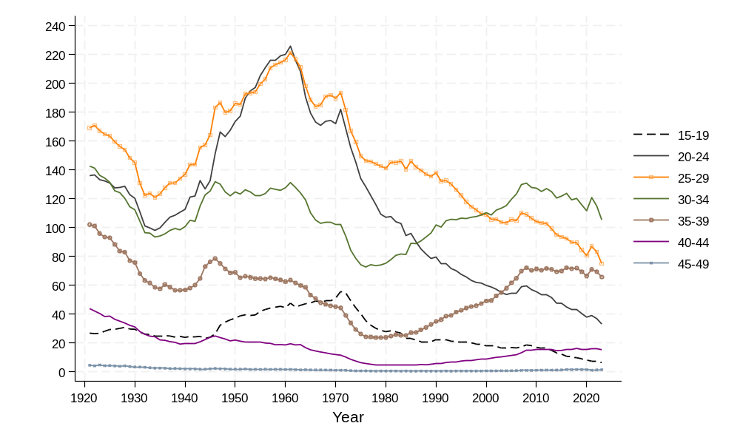
Source: Data from Australian Bureau of Statistics (2024a and 2024b).

In Australia’s past, there have been times when the level of fertility at older ages was significantly higher than what we observe today. In 1921, it is estimated that the fertility rate at age 40–44 was 43.6 children per 1,000 women, compared to 15.1 in 2023 (ABS 2024b). However, a higher level of fertility at older ages is typically associated with higher overall levels of fertility, that is, when childbearing at older ages was associated with higher parity births. This was also before the widespread availability of modern contraceptives. Based on our analysis of a large series of historical fertility rates from the Human Fertility Database, fertility rates of 40+ children per 1,000 women at ages 40–44 are rarely observed when the overall TFR is 2 or below.
The shift in the age profile of childbearing since the 1980s can be seen more clearly when looking at ASFRs plotted for each year, against age, as evident in Figure 9 (Period) and Figure 10 (Cohort). The curves demonstrate how the peak age at childbearing has moved from the mid-to-late-20s in the 1980s to the early 30s in the last decade. Childbearing below age 25 has dropped dramatically, and the main peak of childbearing has shifted to the right. Overall, the age at childbearing has increased to later ages, although this pattern has slowed in recent years, particularly the rate of fertility from 35+ which has largely stalled.
Figure 9: Historical evolution of age-specific fertility rates in Australia, by year
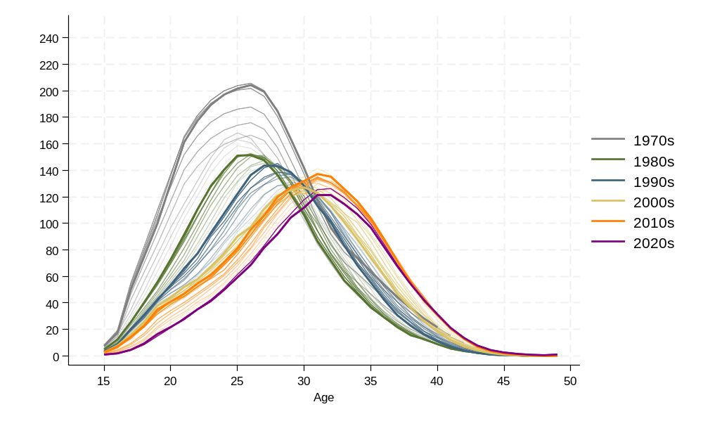
Source: Data from Australian Bureau of Statistics (2024b) and provided by Centre for Population.

Figure 10: Historical evolution of age-specific fertility rates in Australia, by birth cohort
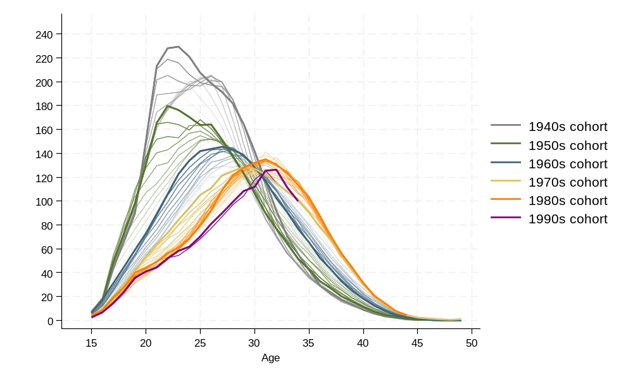
Source: Data from Australian Bureau of Statistics (2024b) and provided by Centre for Population.

A bimodal pattern
In the most recent childbearing cohorts, a small bulge or ‘shoulder’ of childbearing at younger ages (<20) is evident. In more extreme cases this presents as a bimodal pattern of fertility, which typically occurs when there are two distinct populations with differing age schedules of childbearing. Most research to date, has focused on a concept known as ‘reproductive polarization’ (Ekert-Jaffé et al. 2002; Sullivan 2005; Rendall et al. 2010) where sub-populations with low- and high- socio-economic status have different childbearing patterns. However, bulges or bimodal patterns may also be tied to other factors including ethnicity, geographic location, or religiosity. For many populations the existence of a bulge or bi-modal pattern may be a transitory phase, however, for others, it may be a more permanent feature of the population’s fertility (Burkimsher 2017). A bulge may make a transitory appearance if there are general societal trends towards childbearing at older ages but where some sub-groups transition faster than others towards older ages. However, in other cases there may be entrenched differences in childbearing behaviour by socio-economic status, religion or geographic location. As the pattern has emerged for recent cohorts, it is possible that there are some people for whom childbearing at younger ages is still prominent, but it is unclear what contributes to this bulge at younger ages in Australia. Below we provide a possible explanation by considering education and childbearing.
Education is a proxy measure of socio-economic status. Around 80% of women aged 18–‍24 have completed secondary education (high school) (Table 2). Women aged 18–24 who have not completed high school are much more likely to have had a child by that age than women who finished high school (10% of those with year 11 and 23% with year 10). This correlation suggests that having a child at younger ages is selective, and much more likely for those with incomplete secondary education or to impact education continuation. This is consistent with other studies that find a bimodal pattern by socio-economic status.

Table 2: Women aged 18–24 by whether they have ever had a child, column %
Highest level of schooling completed | No children (%) | At least 1 child (%) | Total N
Year 12 or equivalent | 96.3 | 3.7 | 40,320
Year 11 or equivalent | 89.7 | 10.4 | 3,892
Year 10 or below | 76.8 | 23.2 | 3,664
Not stated | 99.5 | 0.5 | 2,821
Total | 94.6 | 5.4 | 50,697
Source: Data from 2021 Census, 5% microdata, Australian Bureau of Statistics (2023a).

Parity
Another key dimension of recent fertility trends in Australia is how the number of children, also known as parity, has changed. Examining trends in parity can help us understand more about the underlying drivers of fertility change. A change in overall fertility might be due to an increase in the proportion of women who are childless, or it might be due to change in the proportion who go on to have a second birth, or the proportion who have large families of four children or more. These illustrative trends in parity distribution would likely be caused by different social and economic processes (de Beer 2000), and therefore important to understand in predicting how childbearing patterns might change in the future.
There are several different approaches to examining parity, which can be useful to provide insights into recent childbearing trends and include examining the distribution of the number of children born, and the progression from having X to X+1 number of children. This information is important for explaining why fertility is falling or increasing. For example, is fertility falling because many people are having no children, or because everyone is having fewer children overall?
Excluding survey data, there are three usual sources for these data: birth registration, perinatal statistics collection, and the Australian Census.
Unfortunately, detailed data on parity from birth registration data is limited in Australia. Parity information is now recorded in the birth registration systems of all Australian states and territories. However, the quality of these data varies, and at the national level only available for 2022 and 2023, excluding Queensland. The collection in Queensland differs, because parity counts only include children born to the same father as the child being registered (ABS 2024c). Until recently, similar issues existed in other states and territories (ABS 2024c).
The AIHW publishes parity-related measures from the perinatal statistics collection. It includes the proportion of mothers who are first-time mothers, second-time mothers, or have previously had two or more children. As fertility rates have declined, the proportion of births to first-time mothers has gradually increased. For example, in 1995, first-time mothers accounted for 39% of the 250,000 births (AIHW 1997). By contrast, in 2022, an estimated 44% of the 293,000 women who gave birth were first-time mothers (AIHW 2024). While the share of first births is partly influenced by the age structure of the population – because a higher proportion of younger women increases the proportion of first births (ABS 1995) – there has been a steady increase in first-time motherhood across all age groups. This broader trend reflects ongoing declines in fertility.
One of the main sources of data that can be used to understand trends in fertility by parity is ‘Number of children ever born’ asked in the Australian Census. It is one of the most useful collections of parity data, due to its ability to compare across time and for different subgroups of Australia’s population. Unfortunately, the question is not asked at each Census.
Author analysis of children ever born to women from 2006 through 2021, shows that there has been an increase in those who have no child in all age groups, an increase in those who have one child in age groups from 25–29 and above, a decrease in those who have 2 children from 30–34 and below, and a decline in those who have three or more children in all age groups.
This type of information on the distribution of women by parity plays a significant role in helping us interpret and predict fertility levels because a woman’s parity strongly influences her patterns of childbearing. A woman with one child has a much higher probability of giving birth in the near future, compared to a woman who has no children, or who already has 2 children (Kippen 2003).
This pattern is evident in Figure 11, which shows the age-parity-specific fertility rate based on the 2021 Census. The rates were calculated using the ‘own-child-method’ which is an indirect fertility estimation method, the details of which are outlined in the Technical Appendix. At all ages, women with one child had the highest fertility. The fact that young women aged 20–24 with two children already had a high childbearing rate is not surprising, given that this is a selective population.
Figure 11: Age-specific fertility by age group and number of children already born (parity)
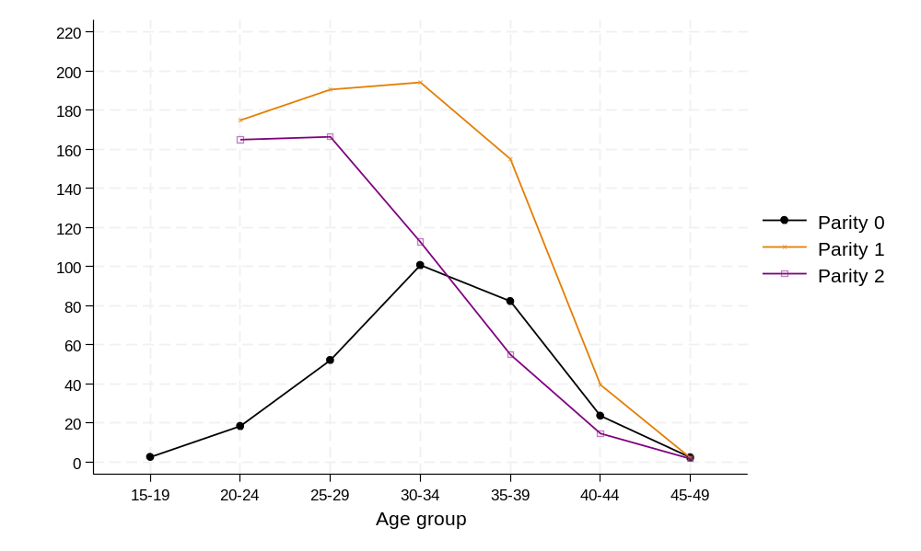
Data from 2021 Census, 5% microdata, Australian Bureau of Statistics (2023a).

4. Drivers of fertility
To anticipate how fertility might evolve in the future, it is essential to understand the underlying drivers of recent fertility changes and how these drivers may shift over time. For instance, if educational expansion has influenced childbearing at younger ages, then a stabilisation in the rate of educational participation could suggest a similar stabilisation in its effect on the timing of fertility.
The causes of changes in fertility behaviour are complex and can be analysed at different levels (Gray et al. 2022). At the individual level, both background factors – such as the size of a person's family of origin, ethnicity, and educational history – and dynamic characteristics like employment patterns and relationship formation influence how many children individuals have and when. Moreover, childbearing itself affects various domains of life, including work and relationships.
At the macro level, societal or population-level drivers also play a role. These include trends such as increasing educational participation, shifts in gender role attitudes, and fluctuations in unemployment rates.
Drivers of fertility change can also be distinguished by how directly they influence fertility. For example, changing gender role attitudes may indirectly affect fertility by influencing women’s labour force participation or altering couples’ relationship dynamics. In contrast, innovations in contraceptive methods may have a more direct or ‘proximate’ impact on fertility.
This section provides a brief overview of key trends over the last 40 years of two factors strongly associated with fertility: education and partnering.

Education
The expansion of education is often cited as a primary driver of fertility decline. The expansion of mass education has been attributed as one of the most important reasons for fertility decline. Once fertility declines to low levels, the difference in fertility by education is relatively small compared to countries where there are still large gaps between those with high levels of education and those with very little education. Still, education gaps remain.
For Australia in the last 40 years, the expansion of education encompasses significant increases in tertiary or post-school enrolment, particularly during the 1980s and 1990s. The significant increase in educational participation during this time can be seen in Figure 12 which shows the percentage of women aged 20–24 enrolled in study, along with the ASFR in this age group. The relationship between education and fertility can vary considerably, depending on the specific measures of fertility and education being examined. The link between education and fertility is complex and causality can be hard to establish at both the micro and macro-level. Nevertheless, there is mounting evidence that education has played an important role at the macro level, in driving the timing of fertility to later ages in recent decades (Ní Bhrolcháin and Beaujouan 2012). Neels et al. (2017:685) outline three main ways that education can lead to a postponement or delay in this process:
- The direct impact of enrolment in full-time education itself on inhibiting fertility. This effect can operate through social expectations of the ‘student role’, economic dependency, and peer effects.
- The displacement to later ages of the timeline of transition to adulthood; major ‘adult’ life transitions such as a first full-time job, establishing a long-term relationship, or purchasing a house often occur after leaving education and the longer time is spent enrolled in education, the longer these other transitions are delayed.
- Broader effects of educational participation on factors such as earning power, labour force participation, attitudes, values and preferences, social learning, and on knowledge.
Figure 12: Women aged 20–24 – Trends in percentage enrolled in study and age-specific fertility rates by year
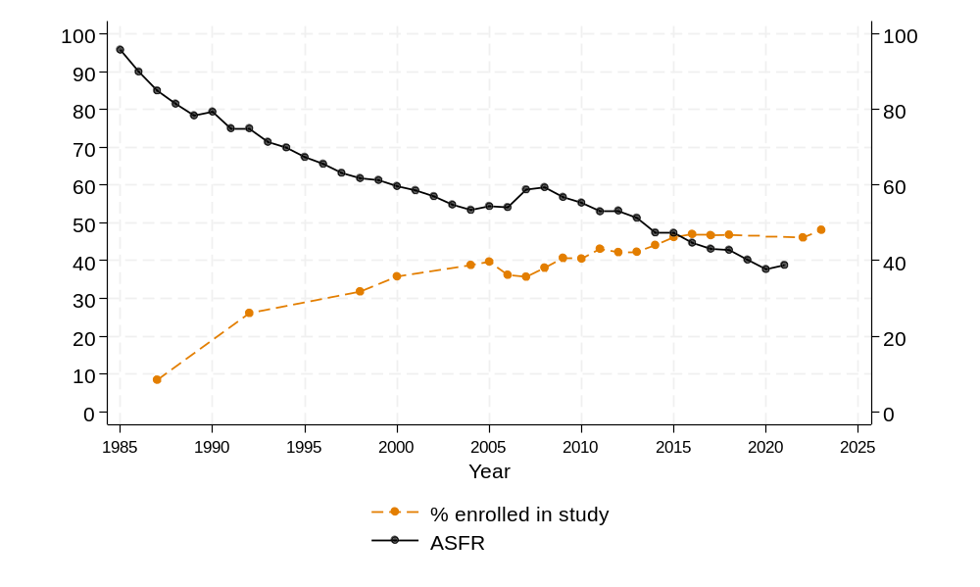
Source: Data on age-specific fertility rates from Australian Bureau of Statistics (2024a); data on percentage of women aged 20–24 enrolled in study are from Education and Work surveys (Australian Bureau of Statistics 1988; 1992; 1998; 2018a; 2024d).
The period from the mid-1980s to the mid-2000s saw a rapid increase in educational participation among young people. In the last decade, the participation rate in education for women in their early 20s has largely stabilised, potentially stalling the impact of education on delaying childbearing. However, among young people we are likely to see a continued decline in fertility due to the continuation of a general extension in the transition to adulthood. How young people transition to adulthood has become increasingly diverse and complex (Brückner and Mayer 2005). It has also been extended over increasingly older ages, and this can be seen in Australia where young adults are spending longer periods living in the parental home, with traditional ‘markers’ of adulthood such as independent living in rental accommodation or home ownership being delayed (Atalay et al. 2022).

Partnering trends
The delay in the transition to adulthood is also evident when looking at partnering. An often overlooked yet significant determinant of fertility at the macro level is the prevalence and stability of relationships. In Australia, most births occur within a couple relationship. Therefore, trends in partnership formation and duration have a strong and direct impact on fertility. Over the last few decades, there has been an overall decline in partnership rates, measured as the percentage of people who are living with a partner either in a cohabitation or marriage. We can see that for 20–24-year-old women, the percentage who did not live with a partner increased from 66% in 1991 to 78% in 2021 (Figure 13). For 25–29-year-old women there was also an increase in the percentage who were not living with a partner, from 34% to 47%, and for 30–34-year-olds from 23 to 30%.

Figure 13: Women aged 20–24 – Trends in percentage not living with a partner and age-‍specific fertility rates by year
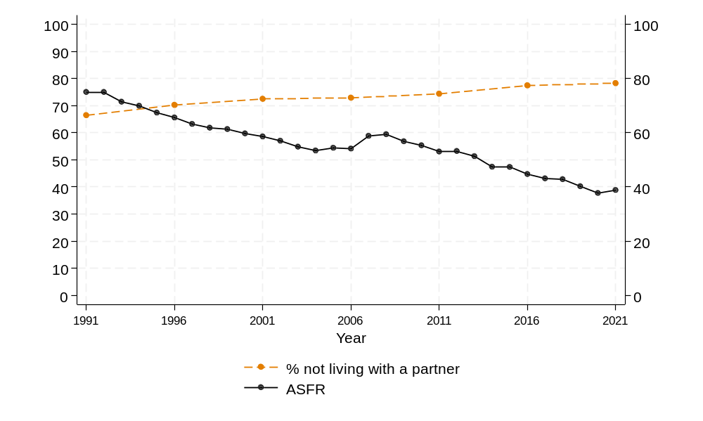
Source: Data on age-specific fertility rates from Australian Bureau of Statistics (2024a); data on percentage not living with a partner from Australian Bureau of Statistics Census data (1991, 2006, 2011, 2016,2021). ASFR data from Australian Bureau of Statistics (2024b).

If we assume that these trends in relationship formation will continue, then this would have a small but negative impact on fertility levels, particularly for those in their 20s.

Fertility desires
For the timing of fertility, based on the above trends we predict that there will be a continued decline in fertility at younger ages. Referring again to the concept of being ‘ready, willing, and able,’ the more challenging aspect to predict is whether, once individuals are ‘ready’–having met perceived prerequisites such as securing a partner, stable employment, and housing–they will also be ‘willing’ to have a child and at what levels compared to recent historical trends. Many factors affect childbearing desires and the perceived costs and benefits of children. In the Household, Income and Labour Dynamics in Australia (HILDA) survey respondents are asked how much they would like to have a child in the future, on a scale from 0 (no desire) to 10 (would very much like to have a child). When the sample is restricted to individuals who are ‘ready’ – defined as those living with a partner – the predicted probability of childless respondents expressing a strong desire for children has mirrored overall fertility trends, showing a slight decline in recent years. However, these differences are not statistically significant (Figure 14).

Figure 14: Predicted probability of a high desire for a child, among childless respondents aged 25–39 (by sex) with 95% confidence intervals (HILDA)
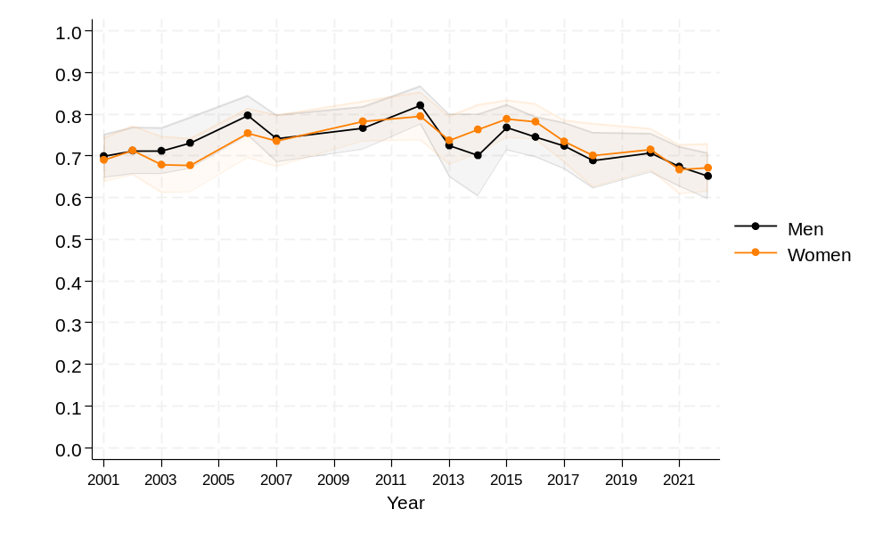
Note: Predicted probabilities based on logistic regression modelling whether respondents stated a high desire for children measured as 8 or above on the scale of 0–10 Predicted probabilities presented above also control for age, and are weighted. Waves 5, 8, 11, 15, 18 which correspond to years 2005, 2008, 2011, 2015 and 2018 are not used due to differences in the question filtering on fertility desires at these waves.
Source: Authors’ analysis of data from the Household Income and Labour Dynamics in Australia (HILDA) data.

It is harder to make assumptions about the overall level of future fertility than the timing. However, even without explicit assumptions about the overall level we can predict that the level will fall if first births are increasingly experienced later in life. This is due to increased sub-fecundity with age, making it more difficult to conceive and carry a pregnancy to term. Additionally, spending more time childless or child-free earlier in life may increase the likelihood of individuals becoming accustomed to a certain lifestyle or deeply invested in careers that are less compatible with starting a family.

Broader-level social changes
In Western-Industrialised countries, social changes have been linked to changes in family formation and can be further explained by several theories, including the second demographic transition (SDT) theory (Van de Kaa, 1999; and Lesthaeghe 2010) and the gender equity theory (McDonald 2000a, b).
The SDT proposes that after the First Demographic Transition, societies undergo a series of transformations characterised by declining fertility rates, delayed marriage, increased cohabitation, higher rates of divorce, and a rise in non-traditional family forms. Fertility levels fall to below-replacement level. This occurs because of broader societal and cultural attitude changes driven by increasing wealth and education. These include increased individualism, women's empowerment, and access to contraception. Under the SDT theory, individuals prioritise personal fulfilment, career development, and autonomy over traditional family roles. This leads to a decrease in the importance of marriage and childbearing, as well as an increase in diverse family structures such as single-parent households, same-sex couples, and cohabiting couples without marriage.
The gender revolution (GR) theories argue that the ongoing changes in the family are essentially the result of the alteration in women's lives (Sobotka and Berghammer 2021). Authors such as McDonald (2000a, 2000b), Esping-Andersen and Billari (2015) and Goldscheider et al. (2015), argue that the trend towards lower fertility and declining marriage is a result of the conflict between women's increasing labour force participation and women's traditional family roles. In many countries, women have opportunities to study, participate in the labour force, and pursue careers. However, this gender equality in the public sphere is at odds with the private sphere, where women are still expected to perform the traditional roles of taking care of the house and children. These theories show how cultural and social shifts can impact fertility.

5. Challenges of projecting fertility
There are several reasons why projecting fertility is challenging. As Schmertmann et al. (2014) succinctly noted: ‘Unlike death, childbearing is both optional and repeatable’. One fundamental challenge in projecting fertility arises because childbearing in modern societies is largely ‘optional’: it is primarily governed by choices and behaviours that are shaped by economic and social trends, which are also hard to predict. More specifically, fertility trends are hard to measure and therefore to project because fertility rates in a particular year are made up of the childbearing experiences of women across approximately 35 ages, from menarche to menopause, who may be experiencing different generational trends.
McDonald noted that ‘Statistical agencies around the world have a very poor record of projecting fertility, even in the short term’ (2020, p.6). In fact, many fertility forecasters lament these challenges, their reasons, and the implications.
- Fertility forecasting is remarkably difficult. No country has succeeded in predicting future changes in fertility rates. (Goldstein et al. 2011)
- Fertility has proved stubbornly difficult to predict accurately (Wilson 2024a).
- The difficulty in fertility forecasting stems from structural change, seen in the trajectory of total fertility (quantum), changing age patterns (tempo) and the complex association between the two. Forecasting success has been limited. (Booth 2006)
Bacon (2000) argues that both the expert-assumptions approach driven by experiences of Australia and other countries, and methods that try to draw on past functional forms of fertility, have limitations. Wilson states that there is a ‘clear need to develop more reliable fertility forecasting methods’, and recommends a cautious approach to forecasting, arguing it is better to over-estimate than under-estimate for policy purposes (2023, p.15–‍16). However, over-estimates can also cause planning problems. For example, when planning for public schools, local governments need to know how many teachers they should recruit in the future; often past fertility data are used to inform these estimates. Good estimates help to ensure public monies are spent wisely and used efficiently.
Figure 15 provides examples of previous projections of fertility in Australia. Some commonalities are evident in these projections. Firstly, many of the projections have a short-term forecast of declining or increasing fertility, followed by holding the level constant. This reflects the uncertainty inherent in projection assumptions. It is noticeable that none of the projections conducted in the early 2000s captured the increase that occurred from 2005 to 2008. Other projections, conducted since that increase, performed quite well for a short period, but then over-estimated fertility. This is the usual pattern for projections, where they perform well in the short term, and not as well in the long term. One projection goes against this trend. Bacon (2000) incorporated discrete cubic splines to project fertility levels for a 20-year horizon. In the short term, the estimates completely underestimated fertility but performed well in the long term, as it captured the fertility levels nearly perfectly towards the end of the projection horizon.
Figure 15: Total Fertility Rate- Historical trend and select past fertility projections for Australia, by source
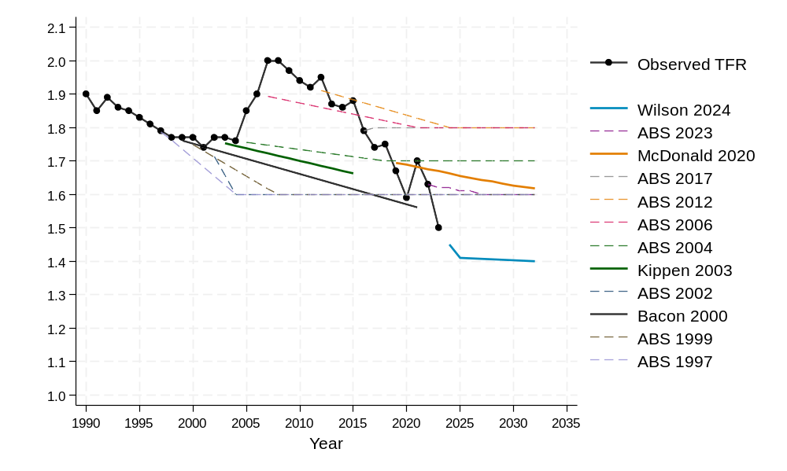
Note: For projections that included a high, medium, and low scenario, the medium scenario is shown. For Kippen (2003), scenario/assumption 4 is shown.
Source: Australian Bureau of Statistics (1998b; 2000; 2003; 2006; 2007; 2013; 2018b; 2023b), Bacon (2000); Kippen (2003) McDonald (2020); Wilson (2024b).

Projections, particularly expert-based ones, may be impacted by cognitive biases. Four of the main cognitive biases which are relevant to research that projects future scenarios are: assumption drag, recency bias, commonality, and optimism. Assumption drag refers to the tendency to cling to assumptions about trends in fertility, for example, that it will increase or decrease, even when these trends are not evident in recent data. On the other hand, recency bias refers to the tendency to be overly influenced by the most recent data or trends and ignore long-running historical trends. Bell et al. (2011) note that assumption drag, and recency bias, are evident in previous Australian population forecasts. Commonality refers to following the lead of others (Nardi et al. 2022) and taking a research-oriented approach will often result in the use of commonality because following peer-reviewed methods usually results in the best practice. In the case of projections, this usually means that researchers use the technique of freezing projections after a certain amount of time because the future is unknown.
The further out in time that is projected, the more uncertainty is associated. Usually, it is much easier to project what the fertility rate will be in two years, compared to in 20 years. Demographers often feel uncomfortable making projections with a forecast horizon of more than a few decades into the future because uncertainty grows with the time horizon, and increases substantially beyond 30–40 years, when most of the population will be made up of people not yet born (O’Neill et al. 2001:205).
Optimism is also potentially of concern when using a deterministic approach with expert assumptions. Optimism is a key feature of human cognition (Sharot 2011) and when thinking of the future, optimism bias means that we tend to over-estimate the chance of positive outcomes. In the context of forecasting, optimism bias has been widely studied in macroeconomic forecasts (Gatti et al. 2024), but less is known about the extent to which it is a feature of assumption based demographic forecasts. Here, a researcher providing an expert opinion may ‘err on the side of caution’ (Wilson 2023), resulting in an overestimation of fertility levels in the future.
The contrast between an optimistic and pessimistic approach can be seen in the fertility projections recently published by national statistical offices. Figure 16 provides a snapshot of projections from selected countries. Under its medium variant the National Statistics Office of Germany is projecting an increase of fertility to 1.55 by 2070. In comparison Canada, which has had higher fertility on average than Germany in the last two decades, is predicting only a small increase to reach around 1.37 in 2070.
In this report, we carefully consider these issues when deriving assumptions and deciding on the projection methods.

Figure 16: Total Fertility Rate – Historical trends and projections for Canada, Germany and Sweden
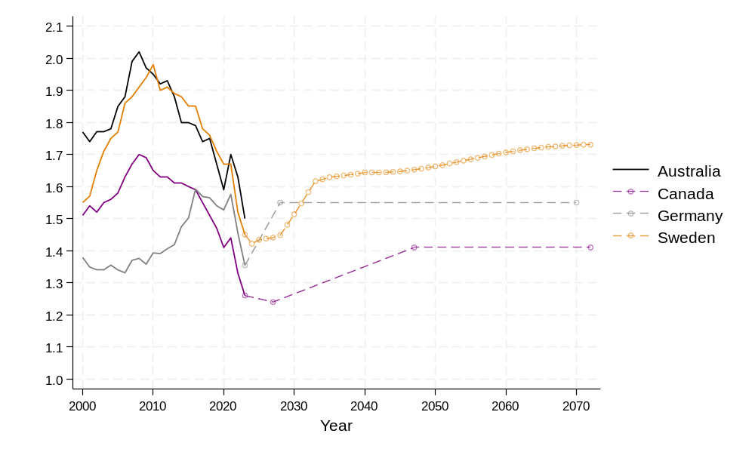
Source: Data for Australia are from Australian Bureau of Statistics (2024a); for Canada from Statistics Canada (2024a; 2024b); for Germany, variant G2 is shown from DeStatis (2024); for Sweden data are from Statistics Sweden (2024a; 2024b).

Predictable and unpredictable factors
There are many factors associated with fertility behaviour. Future fertility will be influenced by both predictable and unpredictable events. The predictable events include social and cultural shifts are related with fertility decline in all high-income countries and a large and growing number of middle-income countries. But it can be hard to foresee what might be ahead. For example, how might technical or medical advancements change fertility patterns? Advancements in medically assisted reproduction have resulted in slightly higher overall childbearing in Australia, particularly for childbearing at ages 40 and above (Lazzari et al. 2021). In comparison, future availability and uptake of advancements like long-acting reversible contraceptives would likely reduce unwanted pregnancies (Mazza et al. 2017).
Although a woman's reproductive lifespan is generally considered to be between 15 and 49 years of age, most childbearing occurs between the ages of 20 and 40. In 2024, women in this key reproductive age range were born between 1984 and 2004. Despite being only 20 years apart, these birth cohorts have vastly different life experiences. For instance, a woman born in 1984 would have witnessed the early rise of the internet and entered adulthood during a time when views on gender roles, work, and family were rapidly evolving. In contrast, a woman born in 2004 grew up fully immersed in the digital age and may experience delays in starting her career and family life due to shifting social norms and economic pressures.
As discussed, fertility is closely tied to various life factors such as education, work, partnering, and housing. Therefore, when projecting future fertility, we must consider how these aspects of life may change. The further into the future we project, the more uncertain the predictions become, especially given the rapid pace of technological and social change. Fertility in 2032 will primarily be the result of people who are currently 12 to 32 years old, born between 1992 and 2012. While we can reasonably imagine what life will be like for a 12-year-old girl in the coming years, projecting fertility in 2042– which will be driven by people who are currently 2 to 22 years old – is far more uncertain. By 2062, most childbearing will be to people who are not yet born.
‘Shocks’ have also been found to impact fertility, at least in the short term, due to the uncertainty and disruption that they cause. Examples are numerous, and include recessions (Comolli and Vignoli 2021, Testa and Basten 2014, Comolli 2017, Rodin 2011, Sobotka et al. 2011), war and conflict (Ahmed et al. 2023), famines (Zhao and Reimondos 2012), climate events (Nobles et al. 2015), and pandemics (Lazzari, et al. 2024).

6. Fertility Projections Methods
There are many methods available to project cohort and period fertility. Bohk-Ewald et al. (2019) identified 20 main methods, with hundreds of variants between them. The choice of method may be influenced by the purpose of the projection, whether the forecast is needed for the short term or for far into the future, as well as the availability and quality of data.
There are several different ways to categorise the plethora of methods, but the main distinction is between deterministic and probabilistic approaches.

Deterministic
Deterministic projections are most commonly used, and they provide a single, fixed forecast of future fertility. These projections are based on specific assumptions and parameters, which may have been derived from models or expert judgement. The defining characteristic of deterministic projections is that they do not convey the inherent uncertainty in the assumptions and parameters underlying the forecast. They are termed ‘deterministic’ because they follow a pre-set path, without incorporating variability or randomness. However, uncertainty can be illustrated by adding variants to the baseline model to show alternative trajectories – such as scenarios where fertility might decline further or increase more than the baseline forecast – but these scenarios lack any quantified likelihood or probability of occurrence. Deterministic fertility projections with variants are commonly used by National Statistics Offices, including the Australian Bureau of Statistics. For example, in its latest Population Projection (2022–2071) report, the ABS has set three long-term assumptions for fertility, reflecting their assumptions for medium (TFR 1.6), high (TFR 1.75), and low (TFR 1.45) scenarios.

Probabilistic
In contrast to deterministic projections, ‘probabilistic’ or ‘stochastic’ approaches, can quantify uncertainty, or the probabilities for a range of possible fertility outcomes. As Keilman notes ‘there are many different possible futures, and some are more likely to come to pass than others’ (2018, p15).
How certain or uncertain we are that a possible future trajectory will occur can be expressed through the addition of error terms to create stochastic probabilistic projections, or by using a Bayesian framework where the model parameters themselves are viewed as random variables (Costemalle 2020). Many stochastic projections only account for model and projection uncertainty. In comparison, Bayesian methods can account for, and combine different sources of uncertainty, including the underlying historical data, expert views in the form of prior distribution assumptions, model parameters, and the underlying demographic processes (Dunstan and Ball 2016).
Expert judgments on the expected probability distribution surrounding projected rates may also be used (Graziani 2020, Lutz et al. 1996).
Following Costemalle (2020) we can use the example of a weather forecast to illustrate difference between the deterministic and probabilistic approach. A deterministic weather forecast states that it will rain 20mm tomorrow. A probabilistic forecast might state there is a 60% chance of rain tomorrow. Deterministic and probabilistic approaches each have their own advantages and disadvantages. The former is easy to interpret but may give a false sense of precision by not exhibiting the underlying uncertainty in fertility trends (Vanella et al. 2020). Probabilistic approaches may give a more realistic view of the range of possible future fertility trajectories; however, they may be harder to produce and interpret.

Expert judgement
It is important to note that the distinction between deterministic and probabilistic projections is not between a purely subjective or judgment-based projection and an objective, data-driven, or model-based one. Many deterministic projections rely on statistical models to project future fertility rates, and similarly probabilistic projections involve a range of assumptions and human judgements. Probabilistic projections may even incorporate target fertility levels, as in the case of the probabilistic fertility projection produced by the National Statistics Office of New Zealand which has a target TFR of 1.65 by 2042 (Stats NZ 2022).
While historically, human judgement in data-driven models was seen as a negative interference, there has been a gradual shift to recognise that human assumptions and judgements pervade every aspect of forecasting (De Baets and Harvey 2020) and that adjustments based on domain-specific knowledge about the subject of the forecast can help improve accuracy (Perera et al. 2019). In fertility forecasting, a simple example of this is the fact that fertility data is often transformed before being modelled, or constrained during the modelling process, in order to avoid negative fertility values. In this case the forecaster has the specific knowledge that women cannot have negative births. Depending on the purpose of the projection and the quality of the data, more or less adjustment may be needed. As such we can think of human judgement in forecasting as being on a continuum, rather than a binary behaviour.

Country approaches
Gleditsch et al. (2021) recently provided a review of which population projection method was used by different National Statistics Offices in Europe. As seen in Table 3, deterministic models were more frequently used than probabilistic ones, with only a handful of countries such as Italy, the Netherlands and Iceland employing probabilistic models which portray uncertainty.

Period or cohort forecasts
Another distinction in fertility projections is the choice of fertility indicator being projected and the method used to project it. Fertility projections may be based on cohort fertility or period fertility. In the academic literature on fertility forecasting, cohort fertility measures have recently been favoured as cohort trends tend to be more gradual and easier to forecast compared to period trends (Ellison et al. 2024). An increased use of cohort approaches in fertility projections has also been aided by the availability of high-‍quality cohort fertility data from databases such as the Human Fertility Database (Schmertmann et al. 2014).
In these cases, the fertility forecast is the end product. However, when fertility forecasts are produced by National Statistics Offices or policy planners, the purpose of the fertility forecasts is to be used as inputs for further projections of the population. In cases where fertility projections are being integrated into cohort-component models to estimate future population by age and sex, they typically require ASFR by period. For this reason, period-‍based projections are the most common in these settings.
Table 3: Broad type of fertility projection method used by selected countries
Country/Organisation | Model-based, deterministic | Model-based, probabilistic | Expert opinion | No projection
Austria | X | – | – | –
Belgium | X | – | X
Bosnia and Herzegovina | – | – | – | X
Cyprus | – | – | – | X
Czech Republic | X | – | X | –
Denmark | X | – | – | –
Estonia | – | – | X | –
Finland | X | – | X | –
France | X | – | X | –
Germany | X | – | X | –
Greece | – | – | – | X
Hungary | X | – | X | –
Iceland | – | X | X | –
Ireland | – | – | X | –
Italy | – | X | X | –
Latvia | – | – | – | X
Lithuania | – | – | – | X
Luxembourg | – | – | X | –
Netherlands | – | X | X | –
Norway | – | – | X | –
Poland | X | – | X | –
Portugal | X | – | X | –
Romania | X | – | – | –
Slovakia | – | – | X | –
Slovenia | – | – | – | X
Spain | X | – | X | –
Sweden | – | – | X | –
Switzerland | – | – | X | –
Türkiye | – | – | X | –
Ukraine | X | – | X | –
UK | X | – | X | –
Eurostat | X | – | – | –
United Nations | X | X | – | –
Source: Adapted from Gleditsch et al. (2021).

Whether projecting cohort or period fertility, most methods typically involve trying to reduce the number of elements or dimensions that need to be forecast. As noted above, if the aim is for it to be used in cohort-component projections, projected fertility typically needs to be in the format of single-year ASFR. This means that the task is to forecast 35 separate univariate, but correlated, time-series (one for each age between age 15 and 49). In addition, because forecasts at different ages can follow different trends, once all the separate univariate datasets are combined, they may not resemble a typical ASFR curve (de Beer 2000). To avoid working with such high-dimension data, several different models and approaches have been developed. The different approaches typically have the same aim of reducing the data into a smaller number of elements. Regardless of the method used the process typically involves three main steps:
- Reduce fertility rates (e.g. 35 ASFRs per year) into a smaller number of dimensions/components
- Examine how these components vary over time and forecast them into the future, typically using a time-series method.
- Translate the forecasted components into a full schedule of predicted single-year ASFRs.
One way to reduce the dimensionality of ASFRs is through a parametric approach, which represents the ASFR curve using a small number of parameters defined by mathematical functions such as the Hadwiger function, Beta and Gamma functions, Skew Normal models, and others (Gaire et al. 2024). Over time, a wide range of functions have been developed, with ongoing refinements and adaptations frequently published. While parametric methods are straightforward, they may lack the flexibility to accurately capture different fertility curve shapes over time. An alternative to parametric methods is to avoid assuming a specific mathematical form and instead use techniques such as splines, allowing the data to define the curve more freely.
In period projections, the TFR is often projected first, using time-series models (Wilson 2005; Wilson and Bell 2004) or extrapolation of historical trends, and usually supplemented with expert opinion. From these projections, ASFRs can be provided by assuming various proportional age distributions over time. Alternatively, both the age distribution and level of fertility may be forecast together, using approaches such as functional data analysis (e.g., Principal Component Analysis) or by modelling the ASFR distribution as a function of parameters based on parametric or non-parametric relational models. Whether PCA, parametric or non-parametric methods are used, the output is values that can be forecasted before being translated back into ASFRs. In practice, fertility projections often use a combination of methods and approaches.
As noted by Shang and Booth (2024) many of the models used in fertility forecasting are not designed for long-term projections of fertility. Instead, they were originally produced with the simpler aim of smoothing age-specific curves or ‘complete’ cohort age-fertility schedules in the near future.

Assessment of methods
Recently Bohk-Ewald et al. (2018) undertook an extensive study which compared the forecast accuracy of twenty different fertility projection methods. They investigated accuracy for cohort fertility, testing the extent to which a model was able to accurately predict the fertility of a cohort from a cut-off age until age 40. Using data from over 200 countries, they found that in terms of overall rankings, two ‘simple’ methods were rated first and third, and two ‘complex’ hierarchical Bayesian methods were rated second, and fourth. The four top-performing methods for cohort fertility were:
- Myrskylä et al. (2013). This model fits and forecasts fertility by age and time using a model that describes ASFR as a function of a baseline fertility schedule and two decomposed components that describe changes in age and time, respectively. The time component is then extrapolated with a random walk with drift term for 5 years into the future, after which it is frozen.
- Schmertmann et al. (2014). Bayesian model that uses information from a large database of fertility patterns by age and over time to forecast incomplete cohort fertility for individual countries.
- de Beer (1985, 1989). De Beer’s method uses a CARIMA model to fit and forecast fertility by age and cohort simultaneously with two integrated ARIMA(p,d,q) time series models. It accounts for changes in the level and timing of cohort fertility.
- Ševčíková et al. (2016) use a hierarchical Bayesian model to project age patterns of fertility based on past national trends combined with a global model age pattern of fertility trend.
The results of Bohk-Ewald et al. (2018) support the argument of Green and Armstrong (2014) that there has been a trend for forecasting to become more complex and incomprehensible, and that simple methods often perform better and have the advantage of being more transparent and easier to understand.

A rapidly evolving field
Fertility forecasting is a rapidly evolving field with new methods and approaches being developed to provide better estimates of the future. For example, ‘model averaging’ or averaging the results of a combination of different models, has frequently been used in other fields to improve forecast accuracy, and Shang and Booth (2024) have illustrated that it can be used to improve fertility forecasts. Another promising approach is the renewed interest in using more information about fertility to inform models, in particular information about parity. Childbearing is a sequential process, and the childbearing behaviour of people is strongly influenced by how many children they already have, or do not have.
As with any sequential process, knowing how many people are at a certain stage, at a given point in time, can greatly improve our predictions about future outcomes. Demographers recognised the importance of parity in understanding fertility dynamics around fifty years ago (Das Gupta 1976; Park 1976). In Australia, McDonald and Kippen (2011) demonstrated that having additional information, beyond just age, about the population at ‘risk’ of having a birth, can also improve fertility forecasts. Most forecasters work with simple input data using the number of women by age, and past fertility rates by age. They argue that three additional parameter inputs: age at first birth, parity, and duration since last birth, can improve forecasts because of their importance in shaping childbearing patterns.
Of the three parameters, the use of parity information has been the focus in recent years. Research has shown an improvement in the plausibility and reliability of fertility projections that can be gained when taking a parity-specific approach (Ellison et al. 2024a; 2024b). While many countries, including Australia, collect parity information, these data are often not widely available (Corr and Kippen 2006). As discussed in Section 3, parity data collected within the birth registration data is limited by state and territory variations in historical collections.

7. Sources of Data
The ideal data to inform fertility projections is a long time series of period-specific fertility rates, preferably by single year of age. As noted earlier; fertility rates are calculated by dividing the number of births by mother’s age by the number of women in the population by age. At the national level, data on number of births come from the Australian Bureau of Statistics (ABS) which compiles data from each state and territory’s Registry of Births, Deaths and Marriages. Birth data is also available separately from the Australian Institute of Health and Welfare (AIHW) based on births reported in the National Perinatal Data Collection (NPDC). For the denominator of women by age, the Estimated Registered Population (ERP) from the ABS is typically used.
The ABS provides three different series of birth data: by calendar year of registration, calendar year of occurrence, and financial year. The main source of birth and fertility statistics is the Births, Australia report published annually by the ABS, which reports on births by calendar year of registration. This is not necessarily the year the birth occurred in, as there is a delay between the occurrence of a birth and the registration, there will always be some births born at the end of a calendar year that will not be registered until the next. Beyond this, procedural changes, processing issues (e.g. delays in registration due to COVID-19), and subsequent processing of backlogs all contribute to fluctuations in birth registrations, particularly in recent years, which may not necessarily reflect actual changes in birth patterns (ABS 2024c). The Births, Australia data on registrations by calendar year are final after publication and not updated.
Additional data on births by year of occurrence are published separately and updated as new data is processed. The ABS also produces quarterly estimates of births quarterly, in its reporting of the National, State and Territory population. These birth estimates are also based on registration counts; however, they are adjusted to account for registration lags (ABS 2024e). They, therefore do not correspond to the birth counts in Births, Australia. For example, for 2021 the AIHW (2024) reported 315,705 births based on the perinatal database, the ABS reported 309,996 in the Births, Australia, and 315, 200 in the estimates for calculating the ERP (ABS 2024a, 2024f).
Between 2002 and 2018 the annual difference in live birth count between the ABS and the AIHW has varied between -2.6% and 4% (ABS 2020). At the State and Territory level the difference in birth counts across the different sources are more noticeable (Wilson 2017). Differences in birth data across sources or could lead to different observed fertility patterns in the short term which may or may not reflect ‘true’ fertility trends.
In the following sections historical patterns of fertility are reported based on calculations for data by financial year. These statistics may therefore not match figures reported by other publications based on calendar year.

8. Deterministic fertility projection
A series of fertility projections were produced at the national and state levels. As previous projections of Australian fertility have not distinguished fertility patterns of Indigenous Australians or people of migrant backgrounds, nor by geographical area, as requested, these are included in this report. All projections in this section are based on expert judgement about the level and timing of future childbearing behaviour based on anticipated long-term social trends. The projections are classified as deterministic as they do not include any quantifiable measures to illustrate the uncertainty of the projected values.

National projection
The national projections provide overall (TFR) and single-year-of-age ASFR fertility rates, annually by financial year, over 40 years from 2023–24 through to 2065–66 for Australia.
Several possible variations of a ‘medium’ projection scenario, which targets a TFR of 1.34 births per woman by 2065–66 are presented. In addition to the medium scenario, a low and a high scenario are included showing plausible alternative future trajectories in fertility trends.

Assumptions
Informed by current fertility theories (Section 3), the assumptions were developed using expert judgement, considering the fertility trends outlined in Sections 2 and 3, as well as the broader societal context discussed in Section 3:
- Detailed analysis of fertility internationally, particularly TFR and ASFR
- Detailed analysis of fertility trends in Australia, particularly TFR and ASFR
- Comparison of Australia’s fertility patterns in comparison with similar countries
- Analysis of change in mean age at childbearing across countries
- Consideration of the context of change in overall fertility behaviour
- Consideration of factors affecting fertility behaviour change for specific age groups.
The following outlines the assumptions underlying the medium projections, with the low and high projections representing variations on these assumptions, as detailed in Table 3.
Australia’s TFR has been trending downward since 2008, despite occasional small upward fluctuations. This decline has been primarily driven by decreasing fertility rates among women aged 25–29, and, to a lesser extent, those aged 30–34. In contrast, there has been a slight increase in fertility rates at ages 35–39 and 40–44, reflecting a shift toward later childbearing. Our analysis assumes that this trend will continue, albeit at a slower pace.
Historically, Australia’s fertility, like other English-speaking countries, has remained relatively high compared to non-English-speaking high-income countries such as Germany and Italy, where fertility has been below 1.7 for over two decades (McDonald and Moyle, 2010).
There have been some small increases in fertility in a very small number of high-income countries in the last 10-15 years, but the gains are small and often short-lived. The trend of later fertility and smaller family size shows no sign of abating in high-income countries. Hence, we assume that fertility in Australia is likely to continue to decline to a TFR value of 1.34 by 2065–66.
As discussed, the underlying shape of fertility patterns has dramatically shifted to a later age profile of childbearing. We consider the main patterns that have been observed, and from which we base some of the main assumptions regarding the overall shape of fertility for the medium projection. These are outlined in Table 4.

Results of projected fertility scenarios
Our medium deterministic projection reflects the assumptions about the most likely trajectory of fertility based on historical trends and the social and economic drivers of those trends. This can be termed the ‘medium’ scenario. In addition, a low and high scenario provide alternative possible scenarios, as described here.
For the medium scenario we predict a continuing shift of childbearing to later ages, and an overall decline of the Total Fertility Rate (TFR) to 1.34 births per woman by 2065–66.
In the low scenario, fertility falls further to 1.10. The low scenario models the situation where fertility keeps declining at a rapid rate over time. The distribution of childbearing by age becomes more concentrated as the standard deviation of the mean age of childbearing decreases. In this scenario, Australia could be caught in a ‘low fertility trap’ (Lutz et al. 2006) where low fertility becomes self-reinforcing through a series of social, demographic, and economic mechanisms.
In the high scenario fertility patterns remain fairly similar to recent history and the result is an increase to a TFR of 1.67 in 2065–66. The TFR under the different scenarios, along with some additional fertility indicators are shown in Table 5.
In all the scenarios, we assume that the mean age at childbearing will increase over time, although at different rates. In the medium scenario, the mean age at childbearing would increase to 32.6. This is a relatively high mean age for childbearing by today’s standards but follows Australia’s current trend and is in line with the mean age observed in some other countries.
Table 4: Assumptions regarding fertility by age group
Assumption | Justification | Certainty
Peak age at childbearing will increase from 31.4 to 32.6 | The peak age at childbearing, and related measures such as the median age at birth and the mean age at birth, have seen continuous increases in Australia like other high-‍income countries.  It is unlikely to reach much higher given that to date, across a range of countries with very low fertility it is exceptional to observe peaks of 33 years of age. | High
Fertility at ages 15–19 will decline | Fertility under age 20 is still relatively high in Australia, like other English-speaking countries such as the UK and the US, compared to many countries (McDonald and Moyle 2010). This leaves room for further declines.  Yet despite higher fertility in English-speaking countries, teenage pregnancy rates have declined in recent years due to the use of more effective contraception such as IUDs and implants, as well as declines in sexual activity at younger ages, as seen in the United States (Scott et al. 2020; Lindberg et al. 2021). | High
Fertility at ages 20–24 will decline | The 20–24-year age group has experienced an almost linear decline in fertility since 1985. The activities of 20–‍24-‍year olds have changed substantially during this period, including increased participation in education, and living in the parental home.  We do not anticipate that there will be a major reversal in these social trends or other observed delays in the transition to adulthood and assume that the declining trend in fertility in this age group will therefore continue. | High
Fertility at ages 25–29 will decline | Fertility in the 25–29-year age group has also seen a downward trend. Lesthaeghe and Zeman (2024) argue that fertility postponement at this age may have to do with the delayed formation of stable partnerships and job and housing challenges. There is no sign in the trend, nor the current socio-economic climate, that fertility will stabilise or rise in this age group. We have fertility continuing to decline in the future. | Medium
Fertility at ages 30–34 will largely stabilise | In recent years fertility in this age group has been stable or declining. With the potential for some recuperation in this age range, we assume that fertility at these ages will remain largely stable with some continued decline as overall fertility falls. | Medium
Fertility at age 35–39 will increase | For the 35–39 age group, there have been very small changes in recent years. The trend is increasing ASFR for this age group, and the projections assume some recuperation of fertility forgone at earlier ages will occur which will lead to continued small increases in ASFR. | High
Fertility at ages 40 and over will increase | We predict that there will be technological advancements in medically assisted reproduction (MAR) and the use of frozen eggs. Further, while there are age-related physiological limits to fertility, past ASFR has been higher in Australia and other countries from age 40. We note caution on the potential of MAR as it is not a solution for age-related infertility. However, in recent years, MAR has increasingly contributed to births from age 40 (Lazzari et al. 2021). As such, we assume small increases in this ASFR. | High

Table 5: Total Fertility Rate in 2065–66 and related fertility indicators, under different projection scenarios
Scenario | 2023–24 | 2065–66 Medium | 2065–66 Low | 2065–66 High
Total Fertility Rate | 1.48 | 1.34 | 1.10 | 1.67
Mean age at childbearing | 31.6 | 32.6 | 33.6 | 32.4
% contribution to TFR of childbearing at ages <=25 years | 16.0 | 11.5 | 7.0 | 13
% contribution to TFR of childbearing at ages >=35 years | 27.8 | 33.8 | 40.1 | 33.1
Completed cohort fertility (at age ~44) of women born in 2022 | - | 1.40 | 1.25 | 1.63

The overall shift to later childbearing can also be seen in the change in the percentage contribution to TFR of fertility at ages 25 and under. This shifts from its current level of 16% in 2023–24 to 11.5% in 2065–66. Conversely, the percentage contribution of fertility at ages 35 and over increases substantially.
From a cohort perspective, these scenarios suggest that young women born in 2022 – who will experience their prime reproductive years (ages 15–44) in the 2050s – would have an average of 1.40 children under the medium scenario.
The resulting difference in the shape of the ASFR distribution is at Figure 17.
For specific age groups, we project a continued decline in fertility rates. Among women aged 15–19, fertility is expected to decrease to 3.2 births per 1,000 women by 2065–66, aligning with rates observed in several other countries (see Table 1). For ages 20–24, we anticipate a decline from 31 births per 1,000 women in 2023–24 to 20 per 1,000 by 2065–‍66. A similar trend is projected for women aged 25–29, with fertility declining from 71 births per 1,000 women in 2023–24 to 47 per 1,000 by 2065–66.
As a result of delayed fertility in the 20s, there will be some recuperation at later ages. As such, fertility rates at ages 30 and over are in some cases projected to increase but with varying degrees depending on age
Figure 18 demonstrates the effect of the different scenarios on completed fertility. The 1995 cohort will be aged 44 around 2039–40. Under the medium scenario, their completed family size at this age will be 1.61, with minimal difference for the low scenario (also 1.61) and only slightly higher at 1.64 for the high projection. In contrast, as we go further in the future the completed family size drops, and the variation between scenarios increases. For those born in 2020, and aged 44 around 2065–66 we have their completed family size at 1.40 for the medium scenario, 1.25 for the low scenario, and 1.63 for the high. As projected, the difference between each 10-year cohort’s completed fertility becomes progressively larger. This is due to the later start to childbearing with only slight recuperation at later ages.
Figure 17: Age-specific fertility rates - Observed in 2023–24 and projected in 2065–66, under high, medium and low scenario
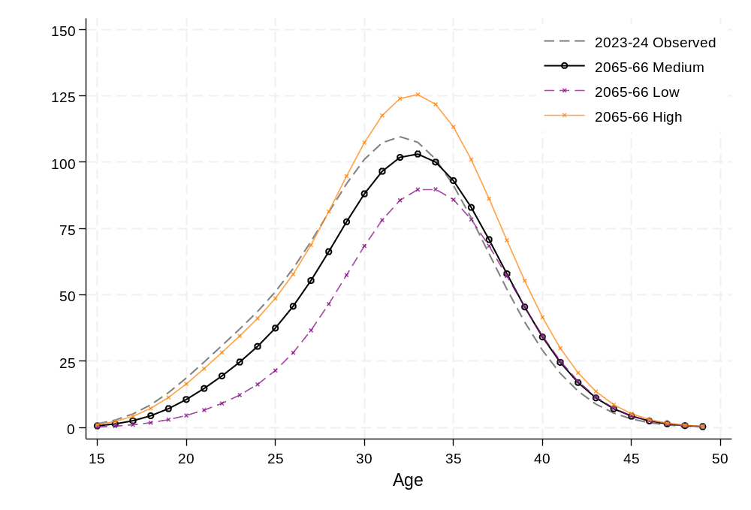
Figure 18: Completed cohort fertility at age 44, by birth cohort projected under high, medium and low scenario
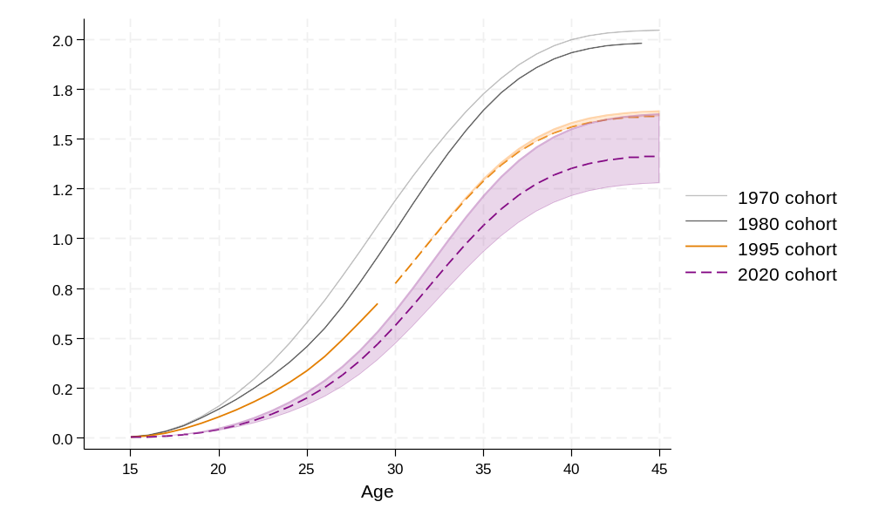
Note: Dashed lines indicate projected values.

Projection 1B: Variation on medium projection
The following variation is included in this report for demonstration purposes. It illustrates that fertility patterns have rarely followed a straight trajectory which then levels off. Typically, fertility levels follow a trend, but may have periods of reversal, as a result of changes in the tempo and quantum of fertility. However, fertility projections rarely consider these fluctuations. This supplementary medium scenario incorporates both delay and subsequent recuperation in the TFR to demonstrate a more realistic trend. While the long-term target TFR remains 1.34, the trajectory includes temporary variations, with an increase during the 2030s, peaking at approximately 1.50 in 2039–40 (Figure 19).
This mid-2030s ‘bump’ reflects postponed childbearing among individuals who initially delay having children due to unfavourable economic conditions or other factors but later ‘catch up’ as circumstances improve.

Figure 19: Total Fertility Rate – Historical trend and projected to 2065–66 under high, medium and low scenario and including variable trend
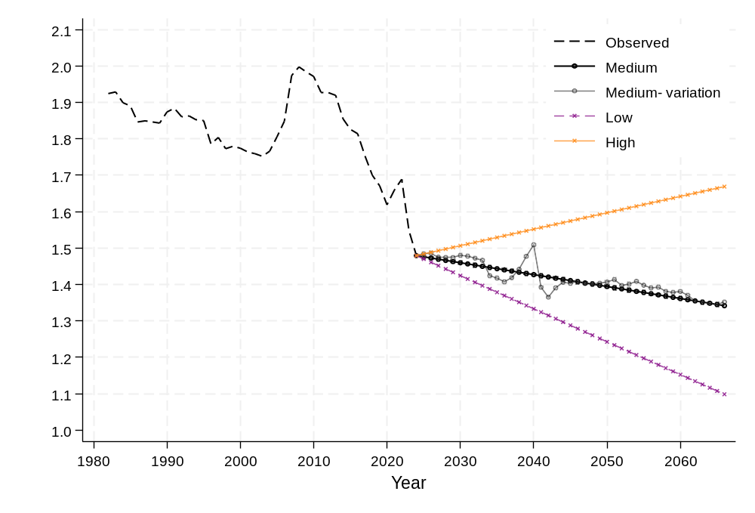

9. Probabilistic fertility forecast
This section provides fertility forecasts using probabilistic methods which include estimates of uncertainty.

Uncertainty
While all forecasts are uncertain, unlike in the deterministic projection shown earlier, when using stochastic methods for forecasting, this uncertainty can be quantified. Typically presented using prediction intervals around the point estimate. However, it is important to understand what uncertainty is being measured and quantified.
Many different sources of uncertainty may be present to varying degrees in fertility forecasting. The choice of time period for the base data is one good example of the inherent uncertainty of forecasting. Depending on what period is used, different base periods may lead to very different forecasts and uncertainty of future fertility as they capture different trends in the data (Rueda and Rodríguez 2010). The choice of period is often a difficult question for forecasters, and it necessarily involves a degree of subjective judgement (Alder et al. 2007).
More generally, in probabilistic forecasting the choice of model is a source of uncertainty. As noted earlier there is an abundance of methods available and there is no ‘best’ model (Ahlburg 2001). Throughout the forecasting process the forecaster has to make numerous decisions, each time faced with multiple options. There are numerous ways to attempt to select the best performing model, typically by ranking models based on some measure of their error (either in-sample or out-of-sample). But a forecast that has the lowest error on one error measure may perform worse on another measure. Similarly, a model that has higher accuracy for younger age groups, may perform worse when it comes to projecting the trend for older age groups. Or a model may do well in the short term but not the over a longer-term horizon; or for it may perform best for national series but not sub-national ones (Jiménez-Varóna, et al 2024).
Similarly, once a model is chosen there is uncertainty about the model parameters. Stochastic population forecasts typically only model parameter uncertainty. That is, it is assumed from the start that the model is correct (de Beer 2000) and the uncertainty being quantified in the intervals shown around the average values is only uncertainty of the model parameters. Another way to think about it is that they are probabilities that are conditional on the model (Lee 2024). It is taken for granted that the model being used is correct, and we calculate the uncertainty based on this assumption. This has been termed the ‘quiet scandal’ of statistics (Breiman 1992, cf Kabaila 2009). A Bayesian framework can potentially incorporate additional sources of uncertainty, including uncertainty in the model choice, underlying data, and expert judgements.
Only including parameter uncertainty tends to produce predictive intervals that are too narrow. On the other hand, application of time-series methods to forecast fertility can lead to excessively wide intervals as time-series methods are generally not developed for long-‍term forecasting (Keilman 2020).

Model combination and the Model Average approach
Given the large number of methods available to forecast fertility, a model average approach is used here which combines seven different forecasts. In fertility forecasting there is no ‘best’ model; different methods and models may be more accurate in the short or long-term, or over different ages or different segments of the population.
To deal with this uncertainty regarding model choice, a sensible option is to conduct several different forecasts and combine the results. Since the early work of Bates and Granger (1969), there has been strong evidence that combining forecasts can lead to improved accuracy, including recently in fertility forecasting (Shang and Booth 2020). Combining models is especially useful in situations such as fertility forecasting when there is high uncertainty regarding the ‘best’ method, as well as high uncertainty about the forecasting situation as in the case of long-range forecasts (Ahlburg 2001; Armstrong 2001). As Armstrong (2001) notes:
‘Instead of trying to choose the single best method, one frames the problem by asking which methods would help to improve accuracy, assuming that each has something to contribute. Many things affect the forecasts and these might be captured by using alternative approaches. Combining can reduce errors arising from faulty assumptions, bias, or mistakes in data.’
As an approach, it is most successful when the forecasts that are being combined are diverse so that their errors are not highly correlated (Petropoulos et al. 2022). This diversity can come from using different data, different methods, or both (Armstrong 2001). We introduce diversity by using several different models as well as time periods of data. Table 6 shows the seven models used, and further details about each model can be found in the Technical Appendix.
Table 6: Seven probabilistic methods conducted
No. | Model | Data | Time period | Model
1 | FDM | Period ASFRs | 1950–2024 | Exponential smoothing
2 | FDM | Period ASFRs | 1970–2024 | ARIMA (Model A)
3 | FDM | Period ASFRs | 1970–2024 | Exponential smoothing (Model B)
4 | FDM | Period ASFRs | 1970–2024 | Random walk with drift* (Model C)
5 | FDM | Cohort ASFRs | 1940+ birth cohort | ARIMA (Model A)
6 | FDM | Cohort ASFRs | 1940+ birth cohort | Random walk with drift* (Model B)
7 | APC | Period and cohort | 1980–2024 | Age, period and cohort effects
* Equivalent to ARIMA(0,1,0)
There are several ways in which different forecasts can be weighted and combined (see Wang et al. 2023). We take the simple average of the models as this strategy has been noted to work well. Some models did better at capturing changes in the peak, and others at younger or older ages.

Model results
Each component model contributing to the average captured different aspects of fertility trends, influenced by the time period of data used, the fitting method, and the approach to forecasting time series patterns. Some models projected significantly higher fertility rates at younger ages, while others predicted much lower rates. Additionally, there was considerable variation in both the overall level and the shape of the projected age-specific fertility rates.

Age-specific fertility rates

Figure 20: Age-specific fertility rates – Observed in 2023–24 and projection to 2065–66, model average and underlying models
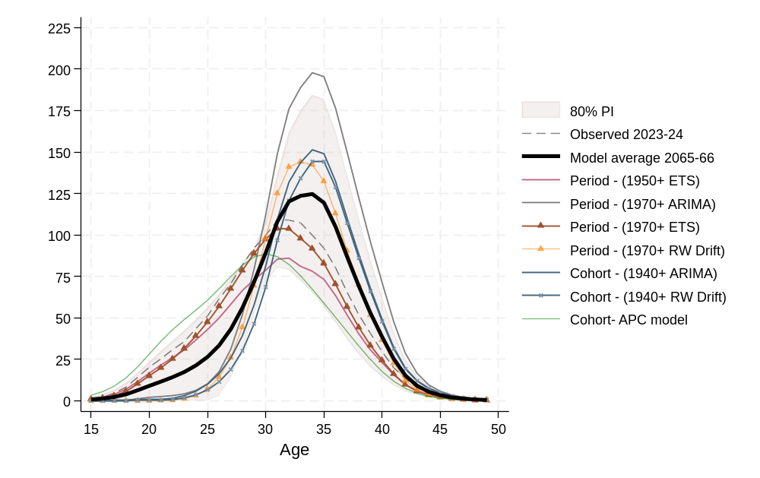
For the component model trained on data from 1950 onward, an exponential smoothing model with a damped trend function was used to ensure that trend rates became more tempered over longer forecast horizons. Additionally, the original functional data model incorporated a weight function that assigned greater importance to more recent trends. According to this model, which extrapolates trends from the 1950s, fertility is projected to decline across all ages.
In contrast, another model based on data from 1970 onward (Model A for 1970) produces a different projection. It forecasts very high overall fertility, with a decline at younger ages but an increase at older ages. This pattern reflects the model capturing the rising trend in fertility from age 30 onward that began in the 1970s.
The cohort models generally produced less extreme projections. However, when modelled to continue past trends (using a random walk with drift – Cohort 1940+ B), the cohort model followed a trajectory similar to that of the highest period model.
The prediction intervals highlight particularly high uncertainty regarding fertility levels at both under and over age 30. This wide uncertainty range reflects the significant changes and fluctuations in fertility rates both at younger and older ages in the past few decades. Additionally, variability around the peak fertility age is influenced by short-term delays in childbearing due to economic conditions or other external factors.
The high uncertainty surrounding younger age groups contrasts with the earlier deterministic projection, where future trends for these ages are considered more certain. Based on past trends and an understanding of the underlying drivers of changing childbearing patterns, it is assumed in the deterministic model that fertility at younger ages is unlikely to increase substantially in the future. This contrast highlights the difference between our largely expert judgment-based deterministic model and the probabilistic approach, which incorporates less expert judgment. While the deterministic model reflects informed expectations about future fertility trends, the probabilistic approach reflects a wider range of possible outcomes based on observed variability and statistical uncertainty.

Total fertility rate
The resulting TFR from the component models, as well as the final model average, is shown below in Figure 21, and Table 7. For the end year of 2065–66, the component projections varied between a TFR of 1.18 to 1.96. The combined forecast has a TFR of 1.43 for 2065–66. Several of the models, including the APC model and the 1970 (Model C) displayed trajectories which included declines as well as increases, leading to a somewhat oscillating pattern overall.
Figure 21: Total Fertility Rate – Historical trend and projection to 2065–66, model average and underlying models
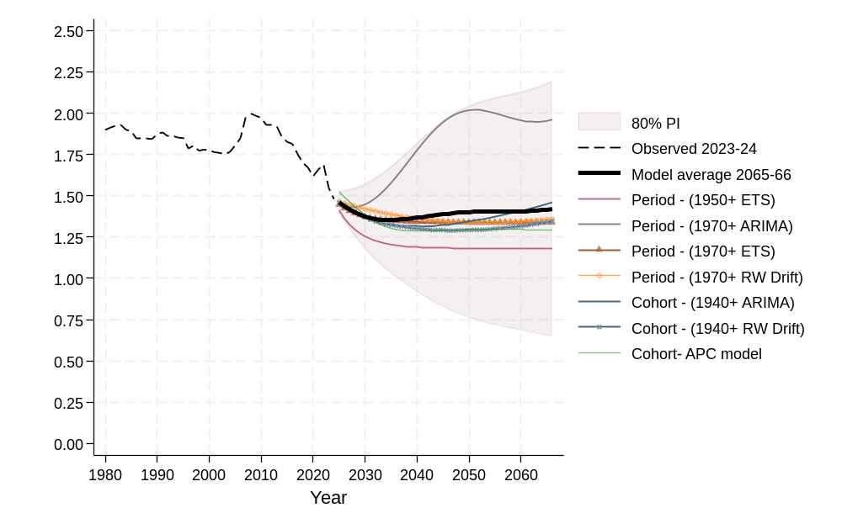
Note: Year refers to the end of a financial year
Table 7: Total Fertility Rate by selected year, combined forecast and component forecasts
Point forecasts | 2025–26 | 2035–36 | 2045–46 | 2055–56 | 2065–66
1950+ Model | 1.36 | 1.20 | 1.18 | 1.18 | 1.18
1970+ Model A (ARIMA) | 1.44 | 1.62 | 1.97 | 1.99 | 1.96
1970+ Model B (ETS) | 1.42 | 1.35 | 1.34 | 1.34 | 1.34
1970+ Model C (Random Walk with Drift) | 1.45 | 1.38 | 1.34 | 1.34 | 1.36
1940+ Cohort Model A (ARIMA) | 1.44 | 1.32 | 1.33 | 1.38 | 1.46
1940+ Cohort Model B (Random Walk with Drift) | 1.44 | 1.32 | 1.29 | 1.30 | 1.35
APC model | 1.52 | 1.34 | 1.35 | 1.36 | 1.35
Combined Forecast | 1.44 | 1.36 | 1.39 | 1.41 | 1.43
Prediction intervals for combined forecast
Lower 95% | 1.29 | 0.83 | 0.51 | 0.34 | 0.24
Upper 95% | 1.59 | 1.90 | 2.29 | 2.48 | 2.62
Lower 80% | 1.34 | 1.01 | 0.82 | 0.71 | 0.65
Upper 80% | 1.54 | 1.71 | 1.98 | 2.11 | 2.21

While we have captured some of the model uncertainty by using a combined forecast, the inclusion of different, or additional, models would lead to different point and interval results. As such the uncertainty reported here is based on the selection and weighting of the seven chosen models, and a different set of models would have led to different results.

10. Comparison of models
In this section, we compare the deterministic projection (medium variant) with the model average forecast from the probabilistic model. We also compare the results with the deterministic projection of McDonald (2020) which was based on fertility data up to 2017–‍18.

Comparison between deterministic and probabilistic projections
Starting with a comparison of the deterministic projection and the model-averaged probabilistic projection (Figure 22), the probabilistic model shows significantly higher overall fertility around the peak age. This reflects the continuation of historical trends, where fertility has increasingly concentrated in the 30s as childbearing shifts away from younger ages. The deterministic model’s medium scenario aligns with the probabilistic projection in terms of overall patterns for younger age groups, though, as noted earlier, the probabilistic exhibits relatively large uncertainty.
Figure 22: Age-specific fertility rates – Observed in 2023–24 and projected to 2065–66
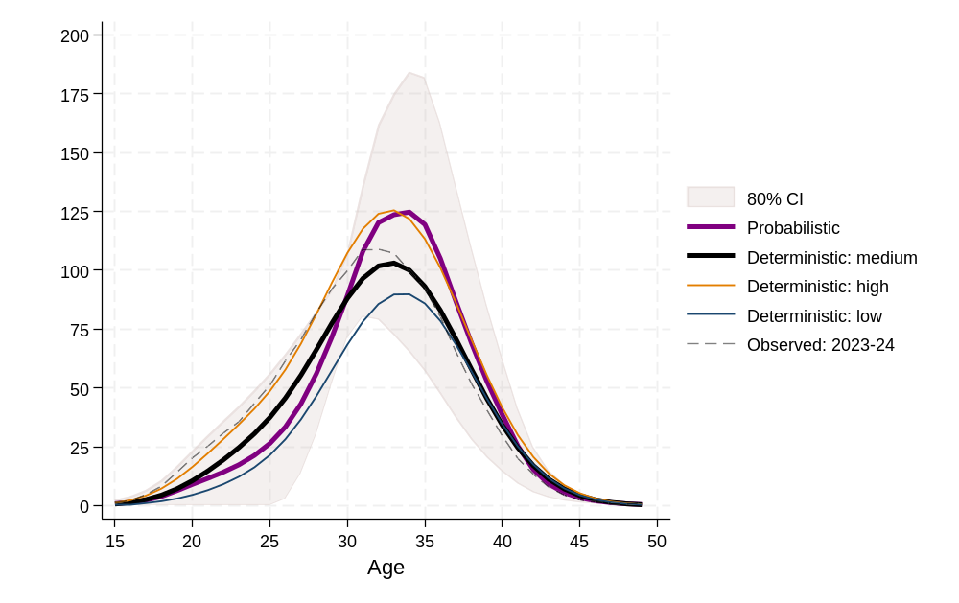

Next, for Australia as a whole, the observed total fertility rates are presented along with the corresponding projected and forecasted values. Figure 23 shows the model average forecast resulting from the probabilistic projections, and the medium variant deterministic projections. For the probabilistic projection, the upward trend is driven by the forecast increases in fertility rates for women in their 30s and early 40s. Here, we see a much greater uncertainty in the forecasts for TFR in 2065–66, with the 80% prediction interval ranging from approximately 0.65 to 2.21 children per woman, in comparison to the deterministic high and low variants, ranging from approximately 1.10 to 1.67.
Figure 23: Total Fertility Rate – Historical trend and projection to 2065–66, by model
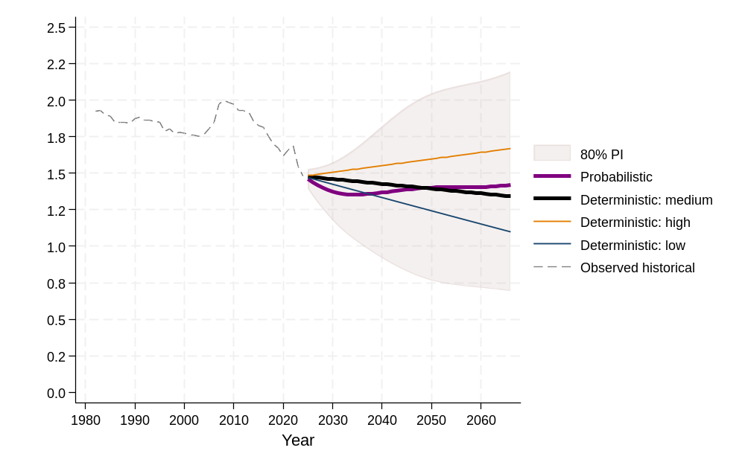
Note: Year refers to the end of a financial year

Comparison with McDonald (2020) projections
In 2020, McDonald produced a series of deterministic fertility projections based on the latest available data (2018–19). His projection horizon went to 2035–36. If we compare this to the current deterministic projection, we can see that the latest version has a lower projection of the future trajectory of fertility in Australia.
Under McDonald’s medium assumption, TFR was projected to fall to 1.62 by 2035–36, with a flattening off around 2031–32 to its final value of 1.62. For the same year, the medium fertility rate is 1.45 for our deterministic model, and the model average for the probabilistic is lower at 1.34.
As seen in the Figure 24, the McDonald (2020) high and low TFR projections were 1.7 and 1.5, respectively, for 2031–32. In contrast, our deterministic high variant is 1.5 and our low variant is 1.41 for the same period. Our medium deterministic forecast is similar to the latest National forecast by Wilson (2024b) which has an assumed TFR of around 1.4 for the mid-2030s. The probabilistic model is significantly lower in this time period as it trends down during the 2020s and 2030s, before increasing slightly again.
Figure 24: Total Fertility Rate – Historical trend and projection to 2031–32, comparison of deterministic model with McDonald (2020) projection
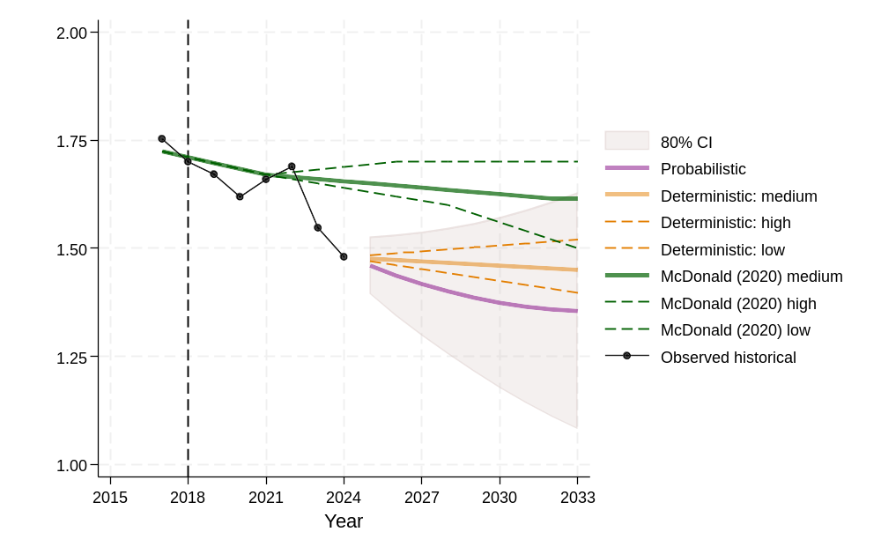

The shape of the ASFR curve also has some differences. Our projection assumption results in a greater decline at younger ages compared to what was forecasted by McDonald (2020) (Figure 25).
Figure 25: Age-specific fertility rate – Projection to 2031–32, comparison of deterministic model with McDonald (2020) projection
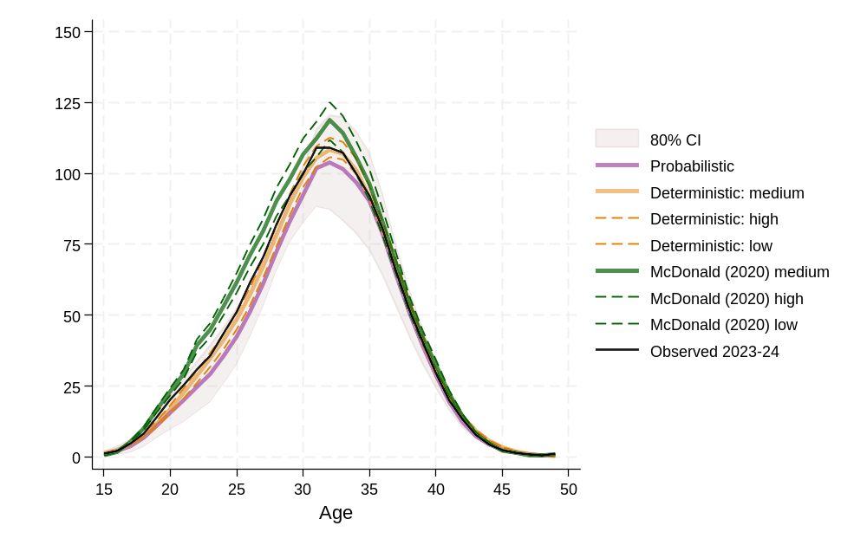

11. Conclusion
Since the 1960s, there have been profound changes in how people structure their lives, including shifting social norms around gender roles, increased female labour force participation, the widespread availability of safe contraception, and a significant rise in educational attainment, particularly at the tertiary level. These societal transformations have had a direct and lasting impact on both the timing and overall level of fertility, leading to delayed childbearing and smaller family sizes.
Looking ahead over the next 40 years, it is uncertain whether similarly transformative societal shifts will occur. However, more gradual trends – such as rising ages of home leaving and declining rates of partnering – are likely to continue exerting downward pressure on fertility. At the same time, policies that support childbearing, alongside favourable economic conditions, may help individuals realise their fertility intentions.
Fertility projections in this report are presented in two forms: deterministic and probabilistic. The deterministic projections are based on expert assessments informed by historical fertility trends in Australia and comparable high-income countries. The projections include low, medium and high scenarios. The medium scenario projects a total fertility rate (TFR) of 1.34 children per woman, while the low and high scenario project values of 1.10 and 1.67, respectively, reflecting the potential variability in future fertility rates.
Probabilistic projections are generated using multiple functional data models combined with an autoregressive time series framework, capturing both age-specific fertility patterns and time dynamics. To avoid reliance on a single model, forecasts are averaged across seven distinct models, including period, cohort, and age-period-cohort (APC) frameworks. This approach offers a more nuanced and data-driven outlook but introduces greater uncertainty than deterministic scenarios, as results vary by model and historical period used. The model-averaged projection yields a slightly higher and wider range of total fertility rates, with individual models projecting between 1.18 and 1.96 and a central estimate of 1.43. This higher projection reflects the probabilistic models’ emphasis on long-term trends over recent behavioural shifts.
The deterministic projection of a TFR of 1.34 (medium scenario) represents what the authors consider the most likely fertility trajectory. The deterministic projection most effectively incorporates recent trends such as the overall decline in fertility caused by a shift toward later ages of childbearing.
Projecting future fertility levels presents considerable challenges, particularly over extended time horizons. The assumptions underpinning these projections are grounded in a careful assessment of fertility theories and historical trends across Australia and comparable contexts. While all projections carry inherent uncertainty, the approach taken here aims to provide a well-informed and realistic basis to support future demographic planning and policy development.

Acknowledgements
We would like to thank The Australian Treasury Centre for Population for helpful comments on earlier versions of this report, Alex Shen for research assistance on this project, and Dr Tom Wilson for reviewer comments.
This paper uses unit record data from the Household, Income and Labour Dynamics in Australia (HILDA) Survey. The HILDA Project was initiated and is funded by the Australian Government Department of Social Services (DSS) and is managed by the Melbourne Institute of Applied Economic and Social Research (Melbourne Institute). The findings and views reported in this paper, however, are those of the author and should not be attributed to either DSS or the Melbourne Institute.

References
Ahlburg, D. A. (2001). Population forecasting. In J. S. Armstrong (Ed.), Principles of forecasting: A handbook for researchers and practitioners (pp. 557–575). Springer.
Ahmed, K. J., Tan, Y., and Rudd, D. (2024). Exploring the relationship between changes in fertility and disasters: a review of the literature. Journal of Population Research, 41(1):1–29.
Alders, M., Keilman, N., and Cruijsen, H. (2007). Assumptions for long-term stochastic population forecasts in 18 European countries: Hypothèses de projections stochastiques àlong terme des populations de 18 pays européens. European Journal of Population/Revue Européenne de Démographie, 23, 33–69.
Armstrong, J. S. (2001). Combining forecasts. In J. S. Armstrong (Ed.), Principles of forecasting: A handbook for researchers and practitioners (pp. 417–439). Springer.
Atalay, K., Silva-Goncalves, J., Stevens. K. and Whelan, S. (2022). ‘Housing and the transition into adulthood – Australian evidence’, Life Course Centre Working Paper Series, 2022–16. Institute for Social Science Research, The University of Queensland.
Australian Bureau of Statistics (1953). Demography Bulletin, 1951. Catalogue No. 3141.0
Australian Bureau of Statistics (1963). Demography Bulletin, 1961. Catalogue No. 3141.0
Australian Bureau of Statistics (1988). Transition from Education to Work, Australia, May 1987. Catalogue No 6227.0
Australian Bureau of Statistics (1992). Transition from Education to Work, Australia, May 1992. Catalogue No 6227.0
Australian Bureau of Statistics (1995). Births, Australia. 1995.
Australian Bureau of Statistics (1998). Transition from Education to Work, Australia, May 1998. Catalogue No 6227.0
Australian Bureau of Statistics (1998a). Births, Australia 1998. Catalogue No. 3301.0
Australian Bureau of Statistics (1998b). Population Projections, Australia, 1997 to 2051. Catalogue No. 3222.0
Australian Bureau of Statistics (2000). Population Projections, Australia, 1999 to 2101. Catalogue No. 3222.0
Australian Bureau of Statistics (2003). Population Projections, Australia, 2002 to 2101. Catalogue No. 3222.0
Australian Bureau of Statistics (2006). Population Projections, Australia, 2004 to 2101. Catalogue No. 3222.0
Australian Bureau of Statistics (2007). Population Projections, Australia, 2006 to 2101. Catalogue No. 3222.0
Australian Bureau of Statistics (2013). Population Projections, Australia, 2012 (base) to 2101. Catalogue No. 3222.0
Australian Bureau of Statistics (2015). Births, Australia 2014
Australian Bureau of Statistics (2018a). Transition from Education to Work, Australia, May 2018. Catalogue No 6227.0
Australian Bureau of Statistics (2018b). Population Projections, Australia, 2017 (base) to 2066.
Australian Bureau of Statistics (2020). Births, Australia 2019 methodology
Australian Bureau of Statistics (2021). Births, Australia 2020 methodology
Australian Bureau of Statistics (2023a). Census of Population and Housing, 2021. 5% sample Microdata. Accessed 10 November 2024
Australian Bureau of Statistics (2023b). Population Projections, Australia. 2022 (base)- 2071.
Australian Bureau of Statistics (2024a). Births 2023, Australia
Australian Bureau of Statistics (2024b). Historical Population.
Australian Bureau of Statistics (2024c). Births 2023, Australia Methodology. Accessed 20 October 2024
Australian Bureau of Statistics. (2024d). Education and Work, Australia. ABS.
Australian Bureau of Statistics (2024e). National, State, and Territory Population. March 2024. Methodology. Accessed 2 November 2024
Australian Bureau of Statistics (2024f). National, state and territory population, June 2024.
Australian Institute of Health and Welfare (1997). Australia’s Mothers and Babies 1995. AIHW National Perinatal Statistics Unit: Sydney
Australian Institute of Health and Welfare (2024). Australia's mothers and babies 2024.
Bacon, B. (2000). Projecting the decline in fertility. Paper presented at Workshop on Declining Fertility in Australia: Policy and Research Issues, Australian Institute of Family Studies, Melbourne, 30 May 2000.
Beaujouan, É., and Toulemon, L. (2021). European countries with delayed childbearing are not those with lower fertility. Genus, 77(1), 2.
Bell, M., Wilson, T., and Charles-Edwards,E. (2011). Australia's population future: Probabilistic forecasts incorporating expert judgement. Geographical Research, 49(3), 261–275.
Bohk-Ewald, C., Li, P., and Myrskylä, M. (2018). Forecast accuracy hardly improves with method complexity when completing cohort fertility. Proceedings of the National Academy of Sciences, 115(37), 9187–9192.
Bohk-Ewald, C., Li, P., and Myrskylä, M. (2019). Do top methods for cohort fertility completion also perform best when forecasting period fertility? Max Planck Institute for Demographic Research. 2019 Population Association of America Annual Meeting.
Booth, H. (2006). Demographic forecasting: 1980 to 2005 in review. International Journal of Forecasting, 22(3), 547–581.
Bongaarts, J., and Feeney, G. (1998). On the quantum and tempo of fertility. Population and Development Review, 24(2), 271–291.
Bryson, L, Stazzari, S, Brown, W. (1999). Shaping Families: women, control and contraception. Family Matters, (53), 31–38.
Brückner, H., and Mayer, K. U. (2005). De-standardization of the life course: What it might mean? And if it means anything, whether it actually took place?. Advances in Life Course Research, 9, 27–53.
Corr, P., and Kippen, R. (2006). The case for parity and birth-order statistics. Australian and New Zealand Journal of Statistics, 48(2), 171–200.
Ní Bhrolcháin, M., and Beaujouan, É. (2012). Fertility postponement is largely due to rising educational enrolment. Population studies, 66(3), 311–327.
Burkimsher, M. (2017). Evolution of the shape of the fertility curve: Why might some countries develop a bimodal curve?. Demographic Research, 37, 295–324.
Central Statistics Office (2024) [Ireland]. Vital Statistics Annual Report 2022.
Commonwealth of Australia (2023). Intergenerational Report 2023: Australia’s future to 2063.
Comolli, C. L. (2017). The fertility response to the Great Recession in Europe and the United States: Structural economic conditions and perceived economic uncertainty. Demographic Research, 36, 1549–1600.
Comolli, C. L., and Vignoli, D. (2021). Spreading uncertainty, shrinking birth rates: A natural experiment for Italy. European Sociological Review, 37(4), 555–570.
Costemalle, V. (2020). Bayesian Probabilistic Population Projections for France. Economie et Statistique / Economics and Statistics, 520–521, 29–47.
De Beer, J. (1985). A time series model for cohort data. Journal of the American Statistical Association, 80(391), 525–530.
De Beer, J. (1989). Projecting age-specific fertility rates by using time-series methods. European Journal of Population/Revue européenne de Démographie, 315–‍346.
De Beer, J. (2000). Dealing with uncertainty in population forecasting. Statistics Netherlands, Department of Population, Voorburg.
Dereuddre, R., Van de Putte, B., and Bracke, P. (2016). Ready, willing, and able: Contraceptive use patterns across Europe. European Journal of Population, 32, 543–‍573.
DeStasis (2023). Population Projection. [Bevölkerungsvorausberechnung]
Dunstan, K., and Ball, C. (2016). Demographic projections: User and producer experiences of adopting a stochastic approach. Journal of Official Statistics, 32(4), 947–962.
Ekert-Jaffé, O., Joshi, H., Lynch, K., Mougin, R., Rendall, M., and Shapiro, D. (2002). Fertility, timing of births and socio-economic status in France and Britain. Population, 57(3), 475–507.
Ellison, J., Berrington, A., Dodd, E., and Forster, J. J. (2024a). Combining individual-and population-level data to develop a Bayesian parity-specific fertility projection model. Journal of the Royal Statistical Society Series C: Applied Statistics, 73(2), 275–297.
Ellison, J., Bijak, J and E. Dodd (2024b) Can incorporating parity information improve the reliability of fertility projections? Insights from a Bayesian generalized additive model approach.
Esping‐Andersen, G., and Billari, F. C. (2015). Re‐theorizing family demographics. Population and Development Review, 41(1), 1–31.
Eurostat (2025). Fertility Indicators. Accessed 6th March 2025
Gatti, R., Lederman, D., Islam, A. M., Nguyen, H., Lotfi, R., and Mousa, M. E. (2024). Data transparency and GDP growth forecast errors. Journal of International Money and Finance, 140, 102991.
Gleditsch, R. F., Rogne, A. F., Syse, A., and Thomas, M. J. (2021). The accuracy of Statistics Norway's national population projections (No. 948). Discussion Papers.
Goldscheider, F., Bernhardt, E., and Lappegård, T. (2015). The gender revolution: A framework for understanding changing family and demographic behavior. Population and Development Review, 41(2), 207–239.
Goldstein, J. R., Rößger, F., Jaschinski, I., and Prskawetz, A. (2011). Fertility forecasting in the German-speaking world: Recent experience and opportunities for improvement. Comparative Population Studies, 36(2–3).
Graziani, R. (2020). Stochastic population forecasting: A Bayesian approach based on evaluation by experts. Pp 21–42 in Mazzuco, S., and N. Keilman [eds] Developments in Demographic Forecasting, 49. Cham: Springer.
Green, K. C., and Armstrong, J. S. (2015). Simple versus complex forecasting: The evidence. Journal of Business Research, 68(8), 1678–1685.
Hewitt, B., England, P., Baxter, J., and Shafer, E. F. (2010). Education and unintended pregnancies in Australia: do differences in relationship status and age at birth explain the education gradient? Population Review, 49(1).
Human Fertility Collection (2024). Max Planck Institute for Demographic Research (Germany) and Vienna Institute of Demography (Austria). Data downloaded on 24/09/2024.
Human Fertility Database (2024). Max Planck Institute for Demographic Research (Germany) and Vienna Institute of Demography (Austria). Data downloaded on 24/09/2024.
Hyndman, R. J., Booth, H., and Yasmeen, F. (2013). Coherent mortality forecasting: the product-ratio method with functional time series models. Demography, 50(1), 261–‍283.
Hyndman, R. J., and Ullah, M. S. (2007). Robust forecasting of mortality and fertility rates: A functional data approach. Computational Statistics and Data Analysis, 51(10), 4942-4956.
Jasilioniene, A., Jdanov, D. A., Sobotka, T., Andreev, E. M., Zeman, K., Shkolnikov, V. M., ... and Rodriguez, G. (2015). Methods protocol for the human fertility database. Rostock: Max Planck Institute for Demographic Research.
Jiménez-Varón, C. F., Sun, Y., and Shang, H. L. (2024). Forecasting High-Dimensional Functional Time Series: Application to Sub-National Age-Specific Mortality. Journal of Computational and Graphical Statistics, 33(4), 1160–1174.
Kabaila, P. (2009). The coverage properties of confidence regions after model selection. International Statistical Review, 77(3), 405–414.
Keilman, N. (2018). Probabilistic demographic forecasts. Vienna Yearbook of Population Research, 16, 25–36.
Keilman, N. (2020). Uncertainty in population forecasts for the twenty-first century. Annual Review of Resource Economics, 12(1), 449–470.
Kippen, R. (2003). Trends in age- and parity-specific fertility in Australia. Working Papers in Demography, No. 91
Kippen, R. (2003). Trends in age- and parity-specific fertility in Australia. Working Papers in Demography, No.91. Demography and Sociology Program, ANU.
Kosis (Korean Statistical Information Service)2024. Mean age of Mother by Birth Order for Provinces.
Lazzari, E., Gray, E., and Chambers, G. M. (2021). The contribution of assisted reproductive technology to fertility rates and parity transition. Demographic Research, 45, 1081–‍1096.
Lazzari, E., Compans, M. C., and Beaujouan, E. (2024). Change in the perceived reproductive age window and delayed fertility in Europe. Population Studies, 1–21.
Lee, R. (2024). Forecasting Population in an Uncertain World: Approaches, New Uses, and Troubling Limitations. Population and Development Review.
Lesthaeghe, R. (2010). The unfolding story of the second demographic transition. Population and Development Review, 36(2), 211–251.
Lesthaeghe, R. (2014). The Second Demographic Transition: A concise overview of its development. Proceedings of the National Academy of Sciences of the United States of America (PNAS), 111(51): 18112–18115.
Lesthaeghe, R. and Zeman, K. (2024). The new fertility postponement in Europe and North America and the East-West contrast, 2010–19.
Lutz, W., Sanderson, W. C., and Scherbov, S. (1996). Probabilistic world population projections based on expert opinion. IIASA Working Paper, WP-96-017
Lutz, W., Skirbekk, V., and Testa, M. R. (2006). The low-fertility trap hypothesis: Forces that may lead to further postponement and fewer births in Europe. Vienna Yearbook of Population Research, 167–192.
Lindberg, L. D., Firestein, L., and Beavin, C. (2021). Trends in US adolescent sexual behavior and contraceptive use, 2006–2019. Contraception: X, 3, 100064.
Mazza, D., Bateson, D., Frearson, M., Goldstone, P., Kovacs, G., and Baber, R. (2017). Current barriers and potential strategies to increase the use of long‐acting reversible contraception (LARC) to reduce the rate of unintended pregnancies in Australia: an expert roundtable discussion. Australian and New Zealand Journal of Obstetrics and Gynaecology, 57(2), 206–212.
Mazzuco, S., and Scarpa, B. (2015). Fitting age-specific fertility rates by a flexible generalized skew normal probability density function. Journal of the Royal Statistical Society Series A: Statistics in Society, 178(1), 187–203.
McDonald, P. (2020). A Projection of Australia’s Future Fertility Rates. Centre for Population Research Paper, The Australian Government, Canberra.
McDonald, P. (2000a). Gender equity, social institutions, and the future of fertility. Journal of the Australian Population Association, 17(1), 1–16.
McDonald, P. (2000b). Gender equity in theories of fertility transition. Population and Development Review, 26(3), 427–439.
McDonald, P., and Moyle, H. (2010). Why do English-speaking countries have relatively high fertility? Journal of Population Research, 27, 247–273.
McDonald, P., and Kippen, R. (2011). Forecasting Births.
Myrskylä, M., Goldstein, J. R., and Cheng, Y. H. A. (2013). New cohort fertility forecasts for the developed world: Rises, falls, and reversals. Population and Development Review, 39(1), 31–56.
Nardi, P. C. C., Ribeiro, E. M. S., Bueno, J. L. O., and Aggarwal, I. (2022). The influence of cognitive biases and financial factors on forecast accuracy of analysts. Frontiers in Psychology, 12, 773894.
Neels, K., Murphy, M., Bhrolcháin, M. N., and Beaujouan, É. (2017). Rising educational participation and the trend to later childbearing. Population and Development Review, 43(4), 667.
Nobles, J., Frankenberg, E., and Thomas, D. (2015). The effects of mortality on fertility: population dynamics after a natural disaster. Demography, 52, 15–38.
Northern Territory Government (2024). Northern Territory Projections 2024. 2024 Release. Department of Treasury and Finance.
OECD (2025). OECD Family Database. SF2.3 Age of mothers at childbirth and age-specific fertility. Accessed 10 March 2025
Office of National Statistics (2024). How is the fertility rate changing in England and Wales?
O’Neill, B., and Balk, D. (2001). World population futures. Population Bulletin, 56(3), 3–40. Washington: Population Reference Bureau.
Perera, H. N., Hurley, J., Fahimnia, B., and Reisi, M. (2019). The human factor in supply chain forecasting: A systematic review. European Journal of Operational Research, 274(2), 574–600.
Peristera, P., and Kostaki, A. (2007). Modeling fertility in modern populations. Demographic Research, 16, 141–194.
Petropoulos, F., Apiletti, D., Assimakopoulos, V., Babai, M. Z., Barrow, D. K., Taieb, S. B., ... and Ziel, F. (2022). Forecasting: theory and practice. International Journal of Forecasting, 38(3), 705–871.
Poler, R., and Mula, J. (2011). Forecasting model selection through out-of-sample rolling horizon weighted errors. Expert Systems with Applications, 38(12), 14778–14785.
Rassi, A., Wattimena, J., and Black, K. (2013). Pregnancy intention in an urban Australian antenatal population. Australian and New Zealand journal of public health, 37(6), 568–573.
Rendall, M., Aracil, E., Bagavos, C., Couet, C., DeRose, A., DiGiulio, P., ... and Verropoulou, G. (2010). Increasingly heterogeneous ages at first birth by education in Southern European and Anglo-American family-policy regimes: A seven-country comparison by birth cohort. Population Studies, 64(3), 209–227.
Rodin, J. (2011). Fertility intentions and risk management: Exploring the fertility decline in Eastern Europe during transition. Ambio, 40, 221–230.
Rueda, C., and Rodríguez, P. (2010). State space models for estimating and forecasting fertility. International Journal of Forecasting, 26(4), 712–724.
Ruzicka, L. and Caldwell, J. (1982), ‘Fertility’, pp. 199-229 in Population of Australia, Country Monograph Series No. 9, UN ESCAP, Bangkok.
Sasieni, P. D. (2012). Age–period–cohort models in Stata. The Stata Journal, 12(1), 45–60.
Schmertmann, C., Zagheni, E., Goldstein, J. R., and Myrskylä, M. (2014). Bayesian forecasting of cohort fertility. Journal of the American Statistical Association, 109(506), 500–513.
Scott, R. H., Wellings, K., and Lindberg, L. (2020). Adolescent sexual activity, contraceptive use, and pregnancy in Britain and the US: a multidecade comparison. Journal of Adolescent Health, 66(5), 582–588.
Ševčíková, H., Li, N., Kantorová, V., Gerland, P., and Raftery, A. E. (2016). Age-specific mortality and fertility rates for probabilistic population projections. In R. Schoen (Ed.), Dynamic Demographic Analysis (pp. 285–310). Springer.
Shang, H. L., and Booth, H. (2020). Synergy in fertility forecasting: improving forecast accuracy through model averaging. Genus, 76, 1–23.
Shankar, M., Hooker, L., Edvardsson, K., Norman, W. V., and Taft, A. J. (2023). The prevalence and variations in unintended pregnancy by socio-demographic and health-related factors in a population-based cohort of young Australian women. Australian and New Zealand Journal of Public Health, 47(3), 100046.
Sharot, T. (2011). The optimism bias. Current Biology, 21(23), R941-R945.
Sobotka, T., and Berghammer, C. (2021). Chapter 10. Demography of family change in Europe. Research handbook on the sociology of the family, 162.
Sobotka, T., Skirbekk, V., and Philipov, D. (2011). Economic Recession and Fertility in the Developed World. Population and Development Review, 37(2), 267–306.
Statistics Canada (2024a): Crude birth rate, age-specific fertility rates and total fertility rate (live births). Table: 13-10-0418-01
Statistics Canada (2024b). Population Projections for Canada (2023 to 2073), Provinces and Territories (2023 to 2048)
Statistics Korea (2024). Birth Statistics in 2023.
Stats NZ (2022). National Population projections: 2022 (base)– 2073.
Statistics Sweden (2024a). Total fertility rate by region and sex. Year 2000–2023
Statistics Sweden (2024b). Fertility rate by mother’s region of birth and age, Year 2024–‍2120
Sullivan, R. (2005). The age pattern of first-birth rates among US women: The bimodal 1990s. Demography, 42(2), 259–273.
Szreter, S. and Garrett, E. (2004), Reproduction, Compositional Demography, and Economic Growth: Family Planning in England Long Before the Fertility Decline. Population and Development Review, 26, 45–80.
Testa, M. R., and Basten, S. (2014). Certainty of meeting fertility intentions declines in Europe during the ‘Great Recession’. Demographic Research, 31, 687–734.
United Nations (2024). World Population Prospects.
Vanella, P. (2016). The total fertility rate in Germany until 2040: A stochastic principal components projection based on age-specific fertility rates (No. 579). Hannover Economic Papers (HEP).
Van de Kaa, D.J. (1999). Europe and its population: the long view. Pp. 1–194 in: D. J. van de Kaa. H. Leridon, G. Gesano and M. Okolski, European Populations: Unity in Diversity. Kluwer Academic Publishers: Dordrecht.
van Raalte, A. A., Basellini, U., Camarda, C. G., Nepomuceno, M. R., and Myrskylä, M. (2023). The dangers of drawing cohort profiles from period data: a research note. Demography, 60(6), 1689–1698.
Vashishtha, R., Pennay, A., Dietze, P. M., and Livingston, M. (2021). Trends in adolescent alcohol and other risky health‐and school‐related behaviours and outcomes in Australia. Drug and Alcohol Review, 40(6), 1071–1082.
Wang, X., Hyndman, R. J., Li, F., and Kang, Y. (2023). Forecast combinations: An over 50-‍year review. International Journal of Forecasting, 39(4), 1518–1547.
Wilson, T. (2005). Application of a probabilistic framework to New Zealand’s official national population projections. New Zealand Population Review, 31(1), 51–76.
Wilson, T. (2017). Comparing alternative statistics on recent fertility trends in Australia. Journal of Population Research, 34, 119–133.
Wilson, T. (2023). Demographic trends in South Australia and projection assumption suggestions. Report prepared for the Analytics and Forecasting section, Planning and Land Use Services, Department for Trade and Investment, South Australian Government.
Wilson, T. (2024a). Visualizing the shelf life of population forecasts: A simple approach to communicating forecast uncertainty. Journal of Official Statistics, 40(1): 38–56.
Wilson, T. (2024b) Australia’s Population Outlook: 2024-based Probabilistic Population Forecasts. Advanced Demographic Modelling, Melbourne.
Wilson, T., and Bell, M. (2004). Australia’s uncertain demographic future. Demographic Research, 11, 195–234.
Zeman, K., Beaujouan, É., Brzozowska, Z., and Sobotka, T. (2018). Cohort fertility decline in low fertility countries: Decomposition using parity progression ratios. Demographic research, 38, 651–690.
Zhao, Z., and Reimondos, A. (2012). The Demography of China’s 1958–61 Famine: A Closer Examination. Population (English Edition, 2002-), 67(2), 281–308.

Technical Appendix

National Data
For the probabilistic projections, a long time series of fertility rates by single year of age was required to have enough historical period to train the projection models and validate their accuracy on historical data. This time series was created by using data from a number of sources as shown in Table A1.
Table A1. Source of data used for probabilistic fertility projections
Year type | Time period | ASFR data | Source
Calendar | 1921 to 1974 | 5-year | ABS (2024b)
Calendar | 1975 to 1981 | Single year | ABS (2015) – Table 12
Financial | 1981–82 to 2023–24 | Single year | ABS via Centre for Population

1921–1974
Fertility rates from 1921 onwards are publicly available from the Australian Bureau of Statistics, Historical Population publication (ABS 2024b). These fertility data are aggregated into seven 5-year age groups, from 15–19 to 45–49. The abridged data was split into single years of age using interpolation with Sprague multipliers.
In some years the Sprague interpolation resulted in negative fertility rates for the youngest and oldest age groups (15–19 and 45–49). Therefore, for all years the ASFR was interpolated manually with each age being apportioned a proportion of the ASFR for their 5-year age group. For five ages between 15–19, an increasing percentage of the average ASFR was assumed increasing from 3%, 7%, 20% 30% and 39% respectively. For the last age group, the same proportions were used but in decreasing order.
To check the fit of our interpolated data, spot checks were conducted against known single-year ASFR for this historical period. For 1951 and 1961, births by single year of age of the mother were obtained from historical ABS publications (ABS 1953,1963). Births were calculated as confinements by age of mothers which were then multiplied to equal total births and then divided by historical ERP values. These differences between the series can be seen in Figure A1. The year 1981 was also included as an additional check, with a comparison made between interpolated values and historical single-year ASFRs from the ABS (2015). Overall, the interpolated values are somewhat lower at the peak ages in 1951 and 1961 however the overall fit is reasonable.
Figure A1: Comparison of abridged age-specific fertility rates interpolated with Sprague multipliers against historical records, 1951,1961 and 1981
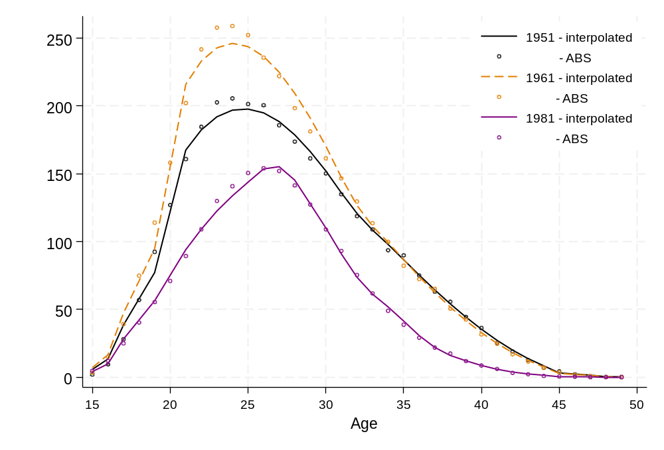
Source: Interpolated data using abridged ASFRs from ABS (2024b); 1951 check data from Australian Bureau of Statistics (1953), 1961 check data from Australian Bureau of Statistics (1963), 1981 check data from Australian Bureau of Statistics (2015).

1975–1981
For 1975 to 1981, a time series of national ASFRs by single year of age was available from the Australian Bureau of Statistics (2015). As this data was already in single years of age no further adjustments were needed.

1981–82 to 2023–2024
Data on births by financial year and Estimated Resident population (ERP) at 31st December of each year was provided at the National and State level from 1981–82 to 2023–2024.
Between 1981–82 to 1989–90 the total number of births across all States and Territories equalled the total for Australia. From 1990–91 onwards (except 1992–93) the State/Territory birth totals were lower than the National total. However, the discrepancy was minimal, ranging from 3 to 58 births across the years.
In 2023–24 births data, Nationally, there were 25 births with no age of mother listed. Across the States/Territories there were 31 births with no age of mother: 4 in the Northern Territory, 2 in Queensland, 5 in South Australia, 4 in Tasmania, 3 in Victoria, 13 in WA, and none in either the ACT or NSW. These births were distributed proportionally according to the 2023 fertility rates ABS (2024a).
To calculate fertility rates, births by age of mother and financial year were divided by the relevant ERP. For Greater Capital City Statistical Area (GCCSA) there were some minor discrepancies between births at this level and the total for the state. To ensure consistency, we based all calculations on state-level births, using the proportion of births provided in the GCCSA files (in terms of the proportion in Capital Cities compared to the total) as a guide to splitting the state-level births (for each age, year and state).

Calendar year to financial year conversion
For the projections data was required by financial year whereas fertility rates prior to 1981–82 were only available by calendar year. The financial year rates were approximated by taking the average of two consecutive calendar years. For example, to derive the 1980–‍81 ASFRs we took the average of the 1980 ASFRs and the 1981 ASFRs.

Period to cohort conversion
For some parts of the report, including the probabilistic modelling, there were instances where cohort fertility rates were required. As these were not directly available, they were approximated by taking the diagonals across calendar year or financial year, depending on the analysis. It is important to note that this method of deriving cohort data does involve approximations and assumptions.
Figure A2 shows how the different cohort, calendar and financial year periods relate on a Lexis diagram. On a Lexis diagram we can follow a true birth cohort of women, such as those born in 1989 and shown in the red parallelogram. These women turned 31 in 2020, however depending on what month they were born in, they may already they may have spent most of 2020 as a 30 year old or as a 31 year old.
Period data, such as ASFRs calculated for a year such as 2020, can be seen as squares on the diagram. When calculated by calendar year for any one age, they will capture two birth cohorts. When calculated using financial year they will capture three birth cohorts. In most cases this ‘synthetic’ cohort approach will not be significantly different to what is observed for the actual cohorts of women. However, there are two scenarios where there could be bias, as highlighted by van Raalte (2023). The first is if there are large differences in the size of cohorts across years and the second is if there are significant trends in period ASFRs trending up or down. In the latter case cohort rates may be overestimated when fertility is declining, and underestimated when fertility increases.
Figure A2: Illustration of cohort, calendar year and financial year for 1989 birth cohort
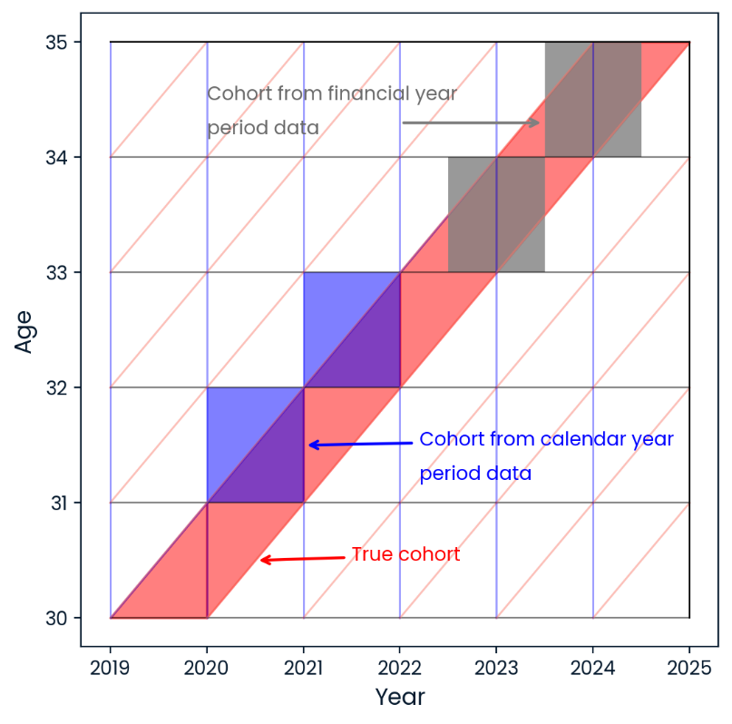
Note: Adapted from van Raalte (2023).

Apart from the issue of the period diagonals not representing true cohorts, reconstructing cohort rates in this way also assumes that migration and mortality are not selectively related to fertility (Jasilioniene et al. 2015), in other words that those who migrate or die have the same fertility rates.
Several checks were performed to assess whether the ‘cohort’ data taken as the diagonals from the period rates were suitable for further inclusion in our models. The completed cohort fertility rate for the diagonal cohorts was compared against other sources of data which had some information on total children by age/birth cohort. This included the Labour Force Survey (LFS), the Household Income and Labour Dynamics in Australia (HILDA) survey, and the Census. As shown in Figure A3, which plots an example for the 1960, 1970, 1980 and 1990 diagonal cohorts, the fertility rates indicated by the cohort rate calculations were close to those from the Census.
Figure A3: Data check for cohort diagonals from period data
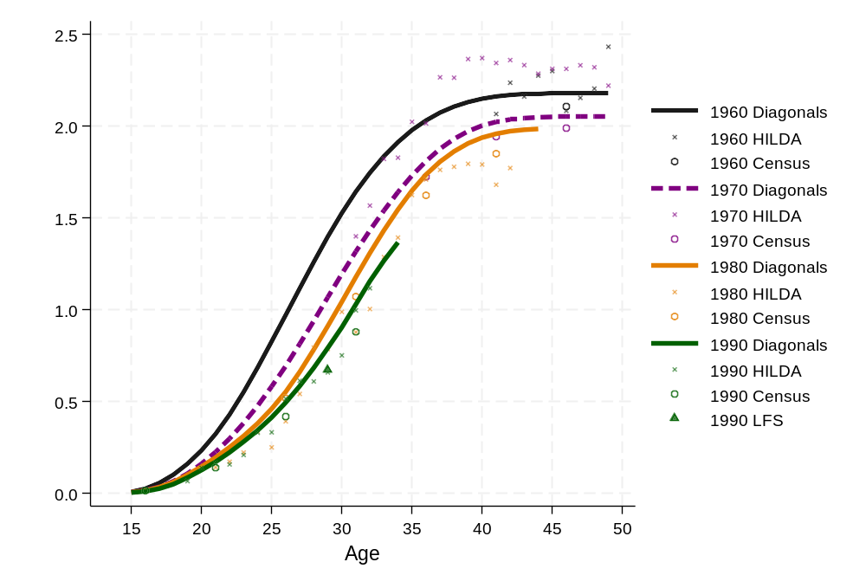
Source: Household Income and labour Dynamics in Australia (HILDA) survey, Australian Bureau of Statistics Labour Force Surveys.

Parity analysis – details of procedure
In the describing the background section of the report, the age-parity-specific fertility rates discussed and shown in Figure 11 were calculated using the own-child-method (OCM), based on a 5% sample of the 2021 Census. The OCM is an indirect fertility estimation method that relies on identifying children and linking them to mothers in the household. We restricted our analysis to children aged 0 or under, which we linked according to the relationship in household of the child under 0 as well as all women aged 15–49. In most cases of households containing only 1 family (e.g. 1 couple and their young children) it was easy to assign children to the most probable mothers. Where multiple women in the age 15–49 age range were living in a household the mother was found by examining additional information such as children ever born and family unit relationship variables. This method of indirect fertility estimation relies on most infants living with their mothers.

Deterministic projection – details of procedure
To model the distribution of future fertility across ages we used a parametric model which was flexible enough to handle the early-age fertility bulge present in some States and Territories of Australia. We chose the model formulated by Peristera and Kostaki (2007) as it is specifically designed to accommodate a bimodal fertility curve with a ‘bulge’ of fertility in younger ages.
The model has two terms which describe age-specific fertility in terms of parameters that are easily interpretable and capture the levels, mean ages, and variances of the two humps or peaks in populations with bimodal patterns. The formula is:
$$\text{ASFR(x)}\text{=}\text{C}\text{1}\text{ exp}{\left[-{\left(\frac{x-M_{1}}{S_{1}}\right)}^{2}\right]}^{ }+\text{C}\text{2}\text{ exp}{\left[-{\left(\frac{x-M_{2}}{S_{2}}\right)}^{2}\right]}^{ }$$
Where ASFR(x) is fertility rate at age X
C₁= Level of fertility for peak at younger ages
C₂= Level of fertility for peak at older ages (main peak)
S₁= Variance of fertility of peak at younger ages
S₂ = Variance of fertility of peak at older ages
M₁= Age of peak at younger ages
M₂ = Age of peak at older ages
As an example, Figure A4 shows the observed fertility schedule (shape of the ASFR curve) in Australia in 1999–2000 and 2023–2024 and the resulting fit from the Peristera-Kostaki model. The bulge at younger ages is particularly evident in 1999–2000, but then largely absent in the latest year. The values of the six Peristera-Kostaki parameters for each of the two years are given in the table under the graph.

Figure A4: Australia age-specific fertility rates in 1999–2000 and 2023–24 and curve fit using Peristera- Kostaki model
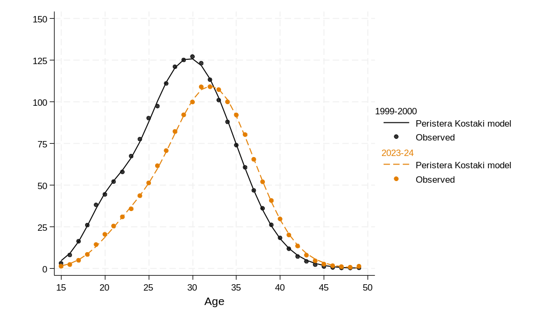
Source: Data provided by Centre for Population.
Parameters | 1999–2000 | 2023–2024
C₁= Level of fertility for peak at younger ages | 0.022 | 0.018
C₂= Level of fertility for peak at older ages | 0.126 | 0.109
S₁= Variance of fertility of peak at younger ages | 3.23 | 4.47
S₂ = Variance of fertility of peak at older ages | 7.42 | 6.89
M₁= Age of peak at younger ages | 20.0 | 22.4
M₂ = Age of peak at older ages | 29.6 | 32.1

In projecting future fertility, we first examined the historical trend in each of the key parameters. We used non-linear regression to solve for the six best-fitting parameters for the equation. This was done for each year from 1981–82 to 2023–24. Then based on our own judgement we determined the most likely trend into the future of each parameter.
For the two parameters capturing the overall level of fertility (C₁ and C₂) we predicted a slow decline at first which then increased in intensity. This was modelled using a logarithmic decay function. For the two parameters relating to peak ages (M₁ and M₂) we used a diminishing exponential growth function to model a rapid increase at first, which then decreased in intensity. For variance, we predicted an increase for the first peak (younger ages) and decrease for the second peak (older ages).
The trajectories of the parameters are shown in Figure A5. In some cases, the high and medium, or low and medium scenario had the same assumptions regarding a particular parameter.
For the variation of the medium scenario, we introduced random fluctuations to all the forecast for C1 and C2 , with a mean of zero and a standard deviation of 0.003 and 0.0007 respectively. These values are based on the variability in historical variability of C1 and C2.
The ‘bump’ was then introduced manually by setting an increasing trend for C₁ and C₂ peaking at 2040. The young age and older age levels were given slightly different trends with the younger ages having a dampened trend compared to the older age peak.
Figure A5: Trajectories of parameters modelled for the medium, low, and high scenario
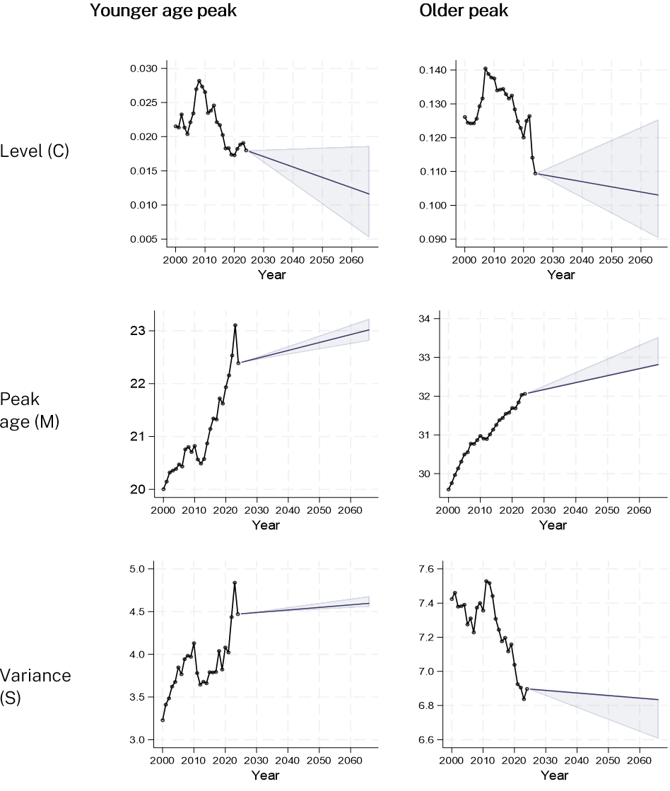

Probabilistic projections – details of procedure

Functional data models
For models 1–6 we used the functional data model developed by Hyndman and Ullah (2007) Functional Data Method (FDM). This is a robust estimation technique that combines nonparametric smoothing, principal component decomposition, and time series forecasting and is ideally suited for high-dimensional time series such as ASFRs. The FDM treats the ASFRs as smooth functions across age and time and decomposes the data into several principal components using functional principal component analysis (FPCA). The ASFR (f) at age a, and time t is decomposed into three main categories: It can be thought of as a method that reduces the complexity of the data by capturing the main trends or ‘stories’ that can be seen in the data, focusing first on the first major trend, then moving to the next. This method helps identify key trends, such as shifts in the timing of childbearing or overall increases or decreases in fertility, while filtering out random noise.
Several steps are involved in this method.
- ASFRs are smoothed to reduce noise
- The data is transformed using a Box-Cox transformation
- Functional principal component decomposition is used to extract components which describe the dominant trends in the age patterns of fertility over time.
$$f\left(α,t\right)=μ\left(a\right)+\sum_{k=1}^{K}{β_{k}\left(t\right)}{+ ϕ}_{k}\left(a\right)+ε\left(α,t\right)$$
$μ\left.\left(a\right.\right)$: The mean ASFR at age a and time t
$ϕ_{k​\left(a\right)}$: The k-th basis function representing age-specific variations (e.g. basis 1, basis 2)
$β_{k​\left(t\right)}$: Time-varying coefficients for each basis function (bottom row).
$ϵ\left.\left(a,t\right.\right)$: Residual error term
- The scores associated with these components are then forecast using time series methods (e.g., ARIMA)
- The forecasts are translated back to age-specific fertility rates
The functional data model uses the ‘demography’ and the ‘ftsa’ R code developed by Robert Hyndman and colleagues, and available on CRAN and Github.
We used different time periods, to ensure a variety of longer and shorter term trends. Using a longer period would highlight trends in lower fertility particularly at young ages and the shift in childbearing over time. Using a more recent window of time would emphasize fertility trends in the older age groups.
Time-series cross validation was also used to examine periods before 1940, however we found that the models using significantly older data had lower accuracy.

Model 1–4: Functional data model for period data (1950–2024 and 1970–‍2024)
The different patterns captured based on what time period of data is used can be seen in Figure A6 which is fitted on data from 1950 to 2024 (Model 1), and Figure A7 which shows the components from a model fitted from 1970 to 2024 which were used for Models 2–4.
In each case the top row this displays the average age pattern over the entire period (on a transformed scaled). As can be seen the average is similar across both times, as this is simple the main curve of fertility over age. This average is removed from the data and the data is then decomposed using principal components analysis. This results in two main ‘patterns’ which explain the majority of the variance in the remaining data. The first one explains the most and the second one less. Across our models the first two components typically explained over 95% of the variance and therefore we only used two components.
In the 1950 model, the first basis function (Basis Function 1) primarily describes fertility at younger ages. The coefficient of this function (Coefficient 1) displays how fertility at the younger ages has developed over time. We see an increase until the early 1960s, followed by a steady decline. The second basis function captures trends at the older ages. For this function we see a decline up until the early 1980s followed by a steady increase and then a period of stabilisation.
In contrast for the 1970 model, the first basis function, or the main story, is what has been happening for fertility levels after age 30. According to coefficient 1, which describes how Basis 1 has changed over time there has been a steady increase. The second component is harder to define but appears to capture all ages not around the peak, and Coefficient 1 shows a variable pattern which has been negative. This could be capturing a decline in the spread of the fertility curve with childbearing becoming less spread out over the reproductive ages and more concentrated in the peak ages.
For the 1970 data the coefficients from each model were fitted in a time-series framework using either an ARIMA or exponential smoothing function depending on the coefficient.
- An ARIMA model, using the auto.arima function in R. This resulted in a an ARIMA(1,1,0) with drift model for the first basis and ARIMA (3,0,0) with non-zero mean for the second basis
- An exponential smoothing model with damped trend.
- A random-walk-with drift model.
Figure A6: Fitted functional data model, for 1950–2024
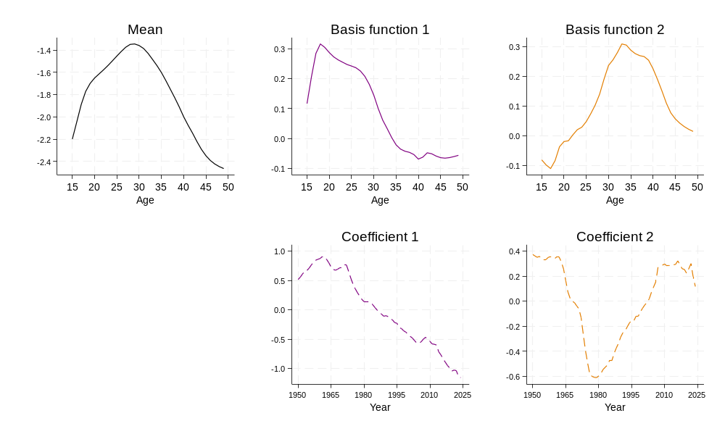
Figure A7: Fitted functional data model, for 1970–2024
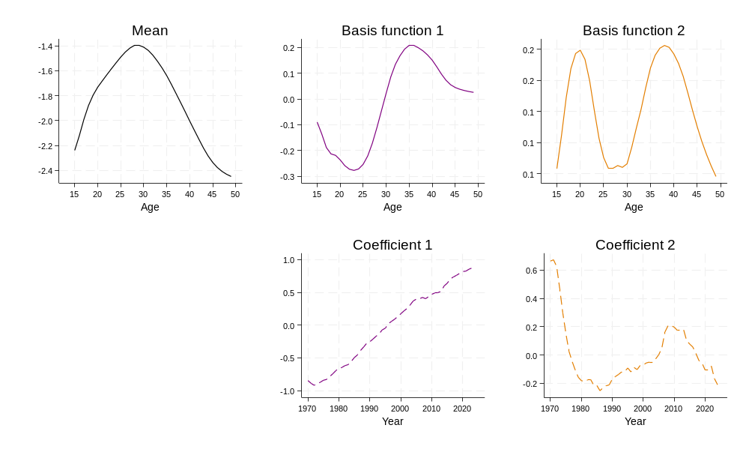

Model 5 and 6: Functional data model for cohort data (1940+ cohort )
Models 5–6 also used the Functional Data Model, but this time with a cohort perspective. Instead of looking at fertility rates over time we look at them across the generations. We chose the 1940 birth cohort as the starting point for these projections, as these women would have started childbearing around 1965. In deciding the starting point we examined how cohort fertility rates changed from year to year and cohort to cohort, by plotting the difference in cohort ASFR in Figure A8. This shows for example, whether the fertility rate at age 30, for a woman born in 1960 was higher or lower than the fertility rate age 30 for a woman who was 1 year older and born in 1959.
Figure A8: Heat plot of year-on-year difference in fertility rates by age and birth cohort
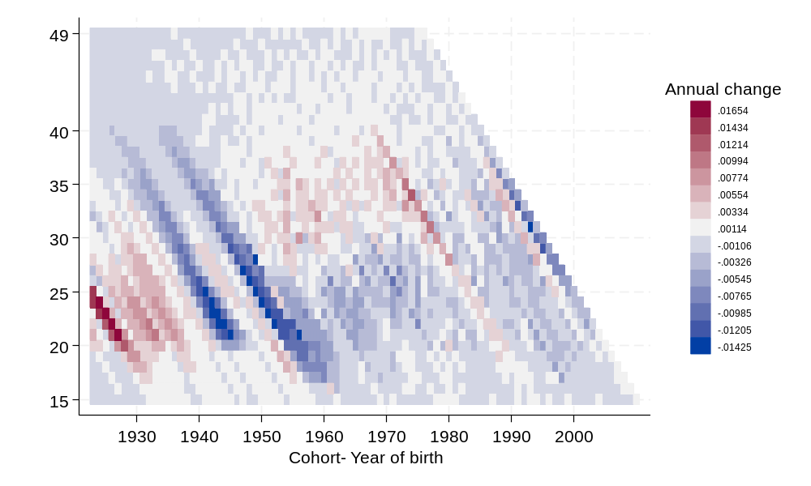
Source: Data from Australian Bureau of Statistics (2024b) and provided by Centre for Population.
In each model, women born in 1975 were the last to have a full observable reproductive span from ages 15 to 49. We used a rolling approach to first fill in ‘missing’ data for those women who have not yet finished childbearing. For example, we started with the 1940–‍1976 births cohorts and fit a functional model, projected 1 year forward, and filled in the missing age 49 for those born in 1975. This process was continued until the missing fertility rates for those born 1975–2009 were completed. This was used to forecast any of the 30–39 ASFRs that were missing from the 1986–1996 birth cohorts.
The main models were then fitted on these data, and again with the coefficient time-series modelled using ARIMA or exponential smoothing based on what provided the best fit.
For the 1940 cohort models, two variants were included.
- An ARIMA model, using the auto.arima function in R. This resulted in an ARIMA(0,2,2) model for the first basis and ARIMA (3,0,1) with non-zero mean for the second basis.
- A random-walk-with drift model.

Model 7: Age-Period-Cohort model
To introduce greater diversity in the projection approaches, a final model was developed using an age-period-cohort (APC) framework. APC models capture processes influenced by age, period, and cohort effects. However, a key challenge is the linear dependency among these three factors, making it impossible to estimate their independent effects directly. This issue can be addressed by applying additional assumptions and constraints, with various methodological approaches available to do so.
The model uses a Poisson regression framework, where births data are combined with ERP as the exposure variable to estimate the fertility rate. We use the apcspline program written by Sasieni (2012).
The forecasted values for the 1980, 1990 and 2000 cohort from the APC model are shown in Figure A9. Dashed lines indicate the forecasted values, and the solid line refers to observed ASFR values.
Figure A9: Age-specific fertility rates for 1980, 1990 and 2000 birth cohorts as fitted by APC model
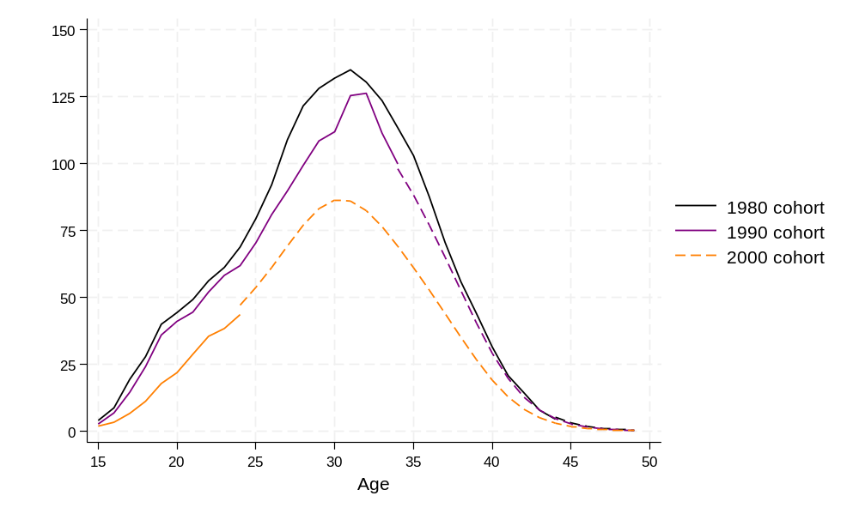
For the combined forecast, the prediction interval was constructed by calculating the variance with the following formula, as outlined in Wang, et al (2023). Here $σ_{i}^{2}$ refers to the variance for component model i, and ${\left(μ_{i}-\tilde{μ}\right)}^{2}$ captures how far each model is from the combined average.
$${\tilde{σ}}^{2}=\sum_{i=1}^{7}{ }\frac{1}{7}σ_{i}^{2}+\sum_{i=1}^{7}{ }{\frac{1}{7}}_{i}{\left(μ_{i}-\tilde{μ}\right)}^{2}$$
This approach does not consider the covariance of the component models, but further refinements could be made to more accurately capture the co-variance. In addition to create the point forecast with the combined model we used a simple average, with each model given an equal weight of 1/7. A different approach could consider other options for weighting including constrained regression, and to do so in a way that may give different important to different projections, across ages and across time.

Of women aged 15–49 in 2066, those aged 41 and over have already been born but those who will be aged 15–40 have yet to be born.
The term ‘Ready, Willing, and Able’ was used by Coale (1973: cf Dereuddre et al. 2016) to describe the macro-level population preconditions for fertility decline in a society. Here we apply the term at the micro-level for individual readiness to have children.
For a given year, the TFR measures the average number of children a woman would have if she survived through to the end of her reproductive years and experienced at each age the age-specific fertility rates of that year. See the Glossary of Terms for a more detailed definition of TFR and age-specific fertility rates.
The list of countries also includes Malta, Portugal, Slovakia, Serbia, Cyprus, Lithuania, Liechtenstein, Latvia, Czechia, Switzerland, and North Macedonia. This list is from the authors’ own calculations based on Eurostat (2025) data. Only countries which had a full time-series of data from 2000 to 2019 were included in the counts.
Detail on the calculation process for the Mean Age at Birth is available in the Technical Appendix.
Author’s calculations based on 2006, 2011, 2016, and 2021 Australian Census data retrieved from TableBuilder Pro.
Note: Australian Bureau of Statistics Population projection reports are typically published one or two years after the start of the jump-off year. For example, for projections starting in 1997, the report was published in 1998.
Calculated as the sum of the ASFRs weighted by the mid-point of each age, divided by the sum of the ASFRs.
The assumptions of McDonald (2020) and the medium deterministic projection are largely similar – both have fertility falling at ages 15–19, 20–24 and 25–29. McDonald has fertility stabilising in the 20s, which the medium projection does not. As such, fertility rates in the 20–29 year age range are lower for the medium projection compared to McDonald.
https://cran.r-project.org/web/packages/ftsa/index.html
https://github.com/robjhyndman/demography

