Past trends and potential futures – projecting Australian fertility
SUPPLEMENTARY REPORT

A research report prepared for the Centre for Population, Australian Treasury.
Authors: Edith Gray, Anna Reimondos, James Raymer and Natalie Nitsche
School of Demography
Research School of Social Sciences
Australian National University
© Australian National University 2026
ISBN: 978-1-923278-60-8
This publication is available for your use under a Creative Commons Attribution 4.0 International licence, with the exception of photographs, images, third party materials, materials protected by a trademark, signatures and where otherwise stated. The full licence terms are available from https://creativecommons.org/licenses/by/4.0/legalcode.

Use of Australian National University material under a Creative Commons Attribution 4.0 International licence requires you to attribute the work (but not in any way that suggests that the Australian National University endorses you or your use of the work).
Australian National University material used ‘as supplied’
Provided you have not modified or transformed Australian National University material in any way including, for example, by changing the Australian National University text; calculating percentage changes; graphing or charting data; or deriving new statistics from published Australian National University data – then the Australian National University prefers the following attribution:
Source: Gray, E., Reimondos, A., Raymer, J. & Nitsche, N. Past trends and potential futures – projecting Australian fertility: supplementary report, Australian National University.
Derivative material
If you have modified or transformed Australian National University material, or derived new material from those of the Australian National University in any way, then the Australian National University prefers the following attribution:
Based on Australian National University analysis.

Contents
S1. Introduction 1
S2. State/Territory and Greater Capital City Statistical Area 2
S3. Aboriginal and/or Torres Strait Islander fertility 8
S4. Country of birth fertility projections 11
References 15
Technical Appendix 17

S1. Introduction
This supplementary report complements the fertility projections provided in the main report. In the main report the fertility projections are at the national level. However, the national population can be disaggregated into groups based on different levels, such as the geographical location of where people live, or specific socio-demographic factors.
In this supplementary report we focus on four key disaggregations:
- States and Territories
- Greater Capital City Statistical Areas
- Aboriginal and/or Torres Strait Islander status
- Selected overseas-born populations.
Understanding the past trends and possible future trajectories of specific subgroups of the population is useful for giving context to the national projections and understanding the drivers of fertility change. If two groups of people have vastly different rates of fertility, isolating why and how their childbearing behaviour differs can help us to understand the factors that shape fertility behaviour. Fertility rate differentials can also be important for policy or planning purposes to ensure services to support parents and children are available, whether this is by geography or another socio-demographic characteristic.
It is important to note, however, that the contribution of any subgroup to the national total fertility rate (TFR) depends on two key components: 1) the fertility rate of the subgroup itself, and 2) the size of that subgroup within the national population of women of reproductive age. At the national level, the TFR can be understood as a weighted average of age-specific fertility rates (ASFRs) across all population subgroups, where the weights are determined by each subgroup's share of the population at each age. As a result, subgroups with higher fertility rates and larger shares of the population will contribute more to the overall national TFR. Conversely, subgroups with lower fertility or smaller population shares will contribute less.
This report focuses solely on the first component, the projected fertility rate differentials across subgroups. It does not attempt to estimate each subgroup’s future contribution to the national TFR, as this would require assumptions not only about fertility trends but also about the future population distribution across subgroups – information that is beyond the scope of this analysis. For example, changes in migration or regional population growth, could all substantially alter the relative population shares of different groups in the future. Therefore, while projected fertility differentials are useful for understanding trends and disparities within groups, it's important to remember that a subgroup’s share of the population – both now and in the future – can significantly influence how much that group’s fertility contributes to the national fertility rate, ranging from minimal to substantial.

S2. State/Territory and Greater Capital City Statistical Area
Fertility rates vary across geographic areas, including administrative boundaries such as states and territories. Several factors could contribute to these differences, including compositional differences, selection effects and contextual effects. Compositional differences arise because different states or areas have diverse populations, with varying characteristics (such as age, socioeconomic status, and cultural backgrounds) that may influence fertility rates. There may also be selection effects whereby some areas attract individuals specifically interested in having (or growing) their family because they are perceived as family-friendly or offering a good environment to raise children. This is less likely to be observed at the state level, however, they are noticeable at lower levels of geography (Evans and Gray 2018; Gray and Evans 2018). Certain features of a location, such as a strong labour market, favourable climate, or higher quality of life, may also have direct or indirect effects on the fertility levels of the people living there.
Given the variability in fertility levels by geographical location, the future of the national fertility rate will ultimately depend on the fertility rates that occur across different geographic areas. This section reports on a series of sub-national projections produced to complement the national predictions. Separate projections were created for two subnational geographical levels:
- State and Territory
- Greater Capital City Statistical Area (GCCSA)
To ensure consistency across geographical levels, the sub-national projections were reconciled with the national projections. Specifically, fertility rates for each GCCSA were adjusted to align with the overall state projections, and the state projections were, in turn, adjusted to sum to the national projection. This reconciliation was conducted using Estimated Resident Populations (ERPs) from the Australian Bureau of Statistics (ABS) to maintain accuracy and coherence across levels. Further detail on the reconciliation of the data to the national level is available in the Technical Appendix of this supplementary report.

States and Territories
Over the past four decades, the difference between each State or Territory’s fertility rates has remained relatively stable, but they have varied in terms of their population growth. As such it has primarily been their share of the national population that has driven any changes in their contribution to the national TFR. For example, the contribution of QLD to overall TFR has increased over time, and the contribution of NSW and SA has decreased. This is mostly due to changes in relative size rather than major changes in fertility within the states.
The relative stability of differences in fertility rates between States and Territories over time can be seen in Figure S1, which tracks the TFR of each State or Territory, as well as the national level, from 1981–82 to 2023–24. South Australia (SA), Victoria (VIC), and the Australian Capital Territory (ACT) have traditionally had lower levels of fertility than the national average. NSW has generally fluctuated just above the national average. NSW has a diverse population, with a mix of highly urbanised areas like Sydney as well as significant regional and rural communities. This mix has a balancing effect on the state’s fertility rate, as the lower fertility in urban areas is offset by higher fertility in regional areas. Queensland has also historically recorded fertility rates above the national average. This trend is partly due to Queensland's large regional and rural population, where fertility rates are typically higher.
The Northern Territory (NT) has consistently had the highest fertility rates among all Australian regions. This is largely influenced by the NT’s unique demographic profile, which includes a significant proportion of Indigenous Australians, who historically have had higher fertility than the non-Indigenous population. Recently, however, the TFR in the Northern Territory has declined and is now closer to the national average than in the past. Tasmania has also typically had a TFR that is higher than the national average. The TFR of Western Australia has varied over time, but has more often been above the national average than below it. Since 2010, there has been some convergence in the fertility rates of SA, TAS and NT towards the national TFR.
Each State and Territory also has varying fertility age patterns, as shown in Figure S2. Here, data from 2018–19 to 2023–24 have been averaged as some of the smaller States and Territories (that is, NT, TAS and ACT) exhibit fluctuations when looking at annual age patterns due to small numbers.
Figure S1: Total Fertility Rate by State/Territory, 1981–82 to 2023–24
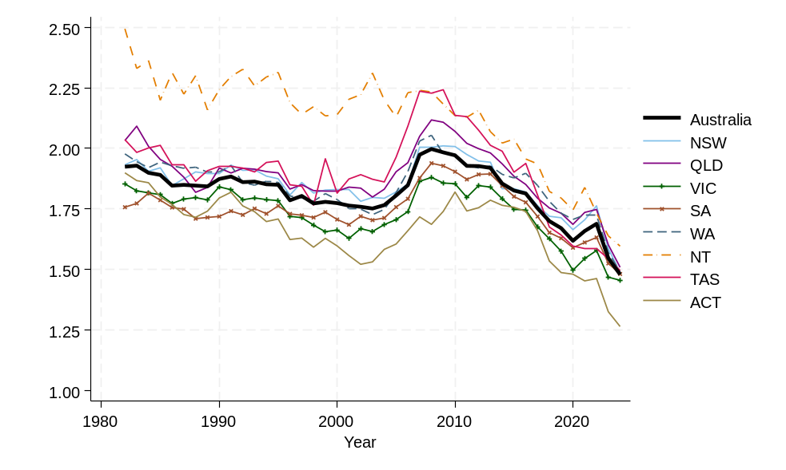
Source: Data supplied by Centre for Population.
Figure S2: Age-specific fertility rates (average over 2018–19 to 2023–24) by State/Territory
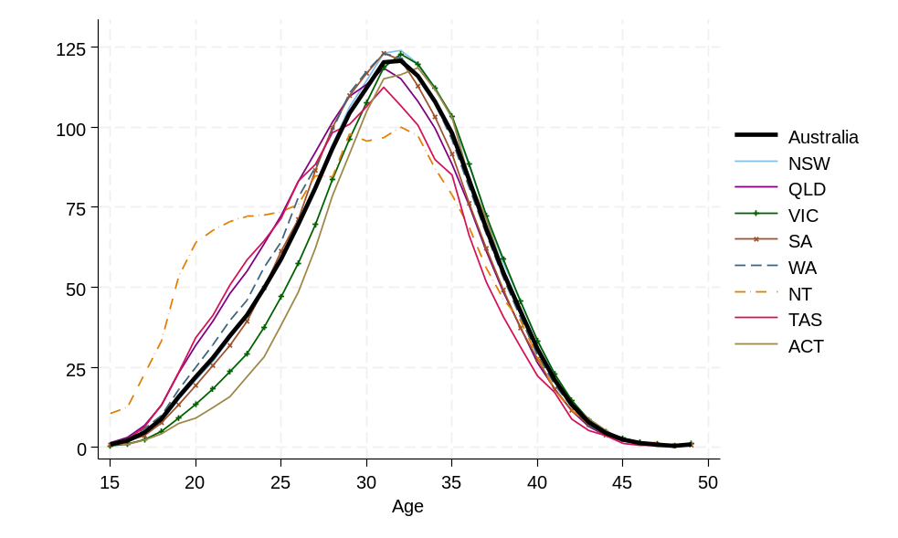
Source: Data supplied by Centre for Population.

Projected fertility
When projecting future fertility at the sub-national level, we assumed that all States and Territories would experience the overall trend of declining fertility. We assume that each State and Territory will retain some distinctive features in the age patterns of childbearing. However, over time, we expect a gradual convergence toward a more uniform national age distribution. For example, in the Northern Territory, we anticipate a significant reduction in the early-age fertility ‘hump’ (Figure S4).
Figure S3: Observed (2023–24) and projected fertility for the Northern Territory, high, medium and low scenario
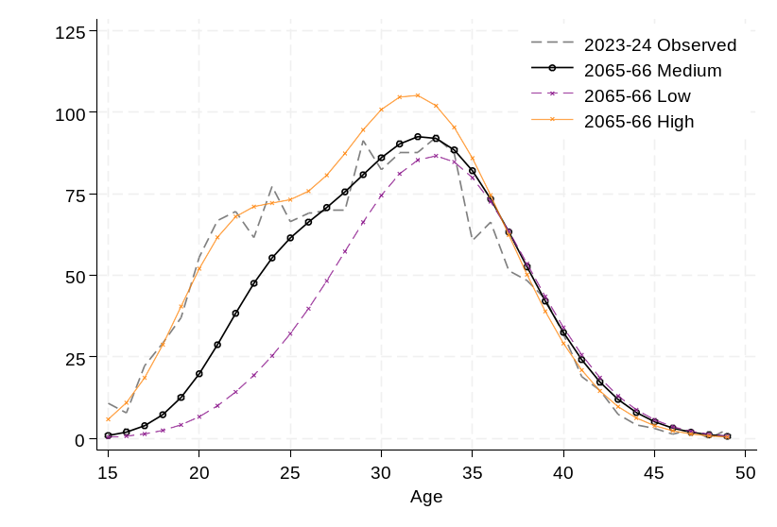
Source: Data for 2023–24 supplied by Centre for Population.
Trends toward the long-term ‘medium’ target TFRs for each state/territory can be seen in Figure S4. The medium value and low and high values for each state/territory are also shown in further detail in Table S1.
The ACT had a very low value of 1.26 in 2023–24. As such, its path to a future target of 1.23 was largely stable.
Figure S4: Total Fertility Rate – Historical trends and projected to 2065–66 by State/Territory
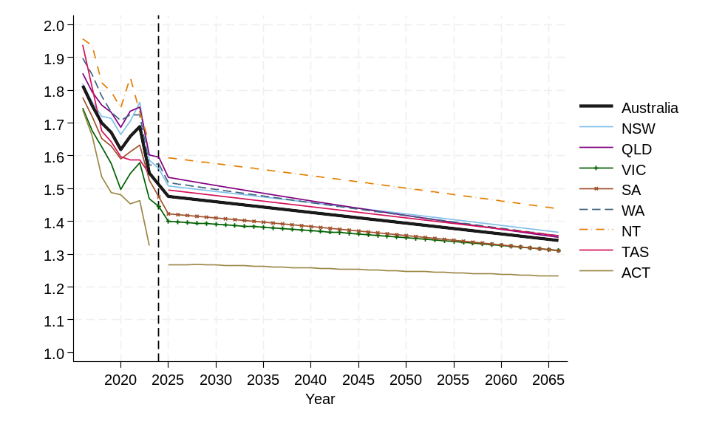
Source: Historical data up to 2023–24 supplied by Centre for Population.
Table S1: Observed (2023–24) and projected (2065–66) Total Fertility Rate by State/Territory under high, medium and low scenario
State/Territory | 2023–24 | 2065–66 Medium | 2065–66 Low | 2065–66 High
New South Wales | 1.49 | 1.37 | 1.12 | 1.70
Victoria | 1.46 | 1.31 | 1.09 | 1.63
Queensland | 1.51 | 1.35 | 1.09 | 1.69
South Australia | 1.55 | 1.31 | 1.07 | 1.65
Western Australia | 1.49 | 1.36 | 1.10 | 1.69
Tasmania | 1.50 | 1.36 | 1.09 | 1.69
Northern Territory | 1.60 | 1.44 | 1.17 | 1.75
Australian Capital Territory | 1.26 | 1.23 | 1.09 | 1.53
Source: Data for 2023–24 supplied by Centre for Population.

Greater Capital City Statistical Area
For each State/Territory, fertility was further projected by Greater Capital City Statistical Area (GCCSA). The GCCSA is a geographical boundary defined by the Australian Statistical Geography Standard (ASGS) that groups each State/Territory (except the Australian Capital Territory) into two areas: one that represents the greater capital city area and one that represents the rest of the State/Territory. The GCCSA is designed to capture not only the population living in the immediate city area, but also those who live in smaller towns or areas around a capital city but regularly visit the city for work or other reasons (Australian Bureau of Statistics 2021a).
Historically in all States and Territories, fertility rates have been higher outside of the Capital City Statistical Areas, although there are differences across States and Territories in the extent of the difference. For example, the difference between Melbourne and the rest of the Victoria has typically been significantly higher than the difference between Brisbane and the rest of Queensland, or Darwin and the rest of the Northern Territory.
Figure S6 shows the historical differentials in TFR for the Greater Capital City areas and the rest of state from 2002–03 through 2022–23 as well as the projections up to 2065–66. In most states, the historical lines have either shown a steady parallel trend for Capital City areas and the rest of state, or a slow convergence. An exception is Tasmania, where there is some evidence of a growing gap between the capital city and rest of state since 2016–17.
For the future we project that fertility rates by GCCSA will converge, but that in all states and territories, fertility rates in Greater Capital City areas will be lower than in the rest of the state. The only exception is the Northern Territory where fertility rates in Darwin were already similar to the rest of state in the base year.
Figure S5: Total Fertility Rate by Greater Capital City Statistical Area: historical trends and projections by State/Territory. 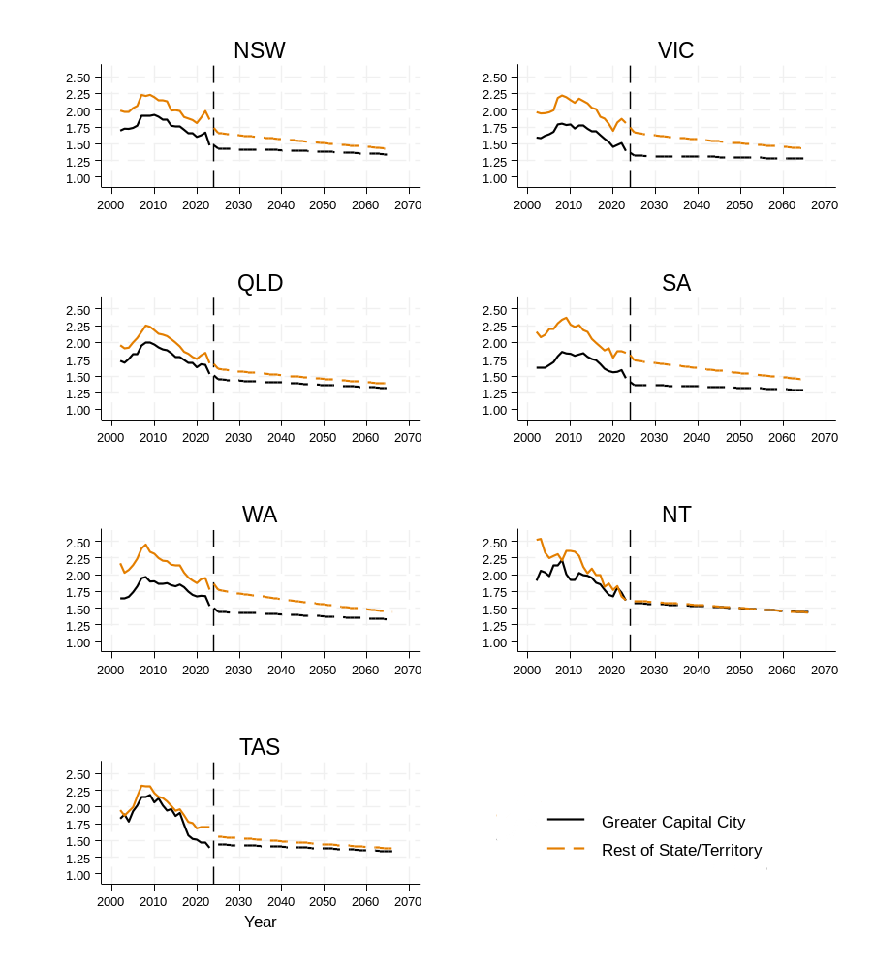
Source: Data supplied by Centre for Population.
Table S2: Observed (2022–23 a) and projected (2065–66) Total Fertility Rate by State/Territory and Greater Capital City Statistical Area
 | 2022–23 State | 2022–23 Greater Capital City | 2022–23 Rest of State/  Territory | 2065–66 State | 2065–66 Greater Capital City | 2065–66 Rest of State/ Territory
New South Wales | 1.59 | 1.48 | 1.86 | 1.37 | 1.34 | 1.42
Victoria | 1.47 | 1.40 | 1.53 | 1.31 | 1.27 | 1.42
Queensland | 1.60 | 1.53 | 1.69 | 1.35 | 1.32 | 1.38
South Australia | 1.53 | 1.47 | 1.84 | 1.31 | 1.29 | 1.44
Western Australia | 1.57 | 1.53 | 1.78 | 1.36 | 1.33 | 1.44
Tasmania | 1.55 | 1.39 | 1.70 | 1.36 | 1.34 | 1.38
Northern Territory^{b} | 1.64 | 1.62 | 1.62 | 1.44 | 1.44 | 1.43
Note:
- For GCCSA data was provided only up to 2022–23, so the State level values refer also to 2022–23 and therefore differ from Table S1 which refer to 2023–24.
- In 2022–23, the TFR calculated for Darwin was 1.617, and for the rest of the Northern Territory it was 1.622. Both these values are lower than the overall level for the Northern Territory at 1.64. This is an example of Simpson’s Paradox which is explained in the Technical Appendix.
Source: Data for 2022–23 based on data supplied by Centre for Population.

S3. Aboriginal and/or Torres Strait Islander fertility
Another important differential in fertility rates is by Aboriginal and/or Torres Strait Islander identification. According to last Census estimates, there were 984,000 Aboriginal and/or Torres Strait Islander peoples in Australia at 30 June 2021, making up 3.8% of the total population counted (ABS 2021b).
Unfortunately, it is not possible to build a reliable picture of recent historical trends in fertility rates of Aboriginal and/or Torres Strait Islander fertility rates due to data quality issues, which affect data for both births and the estimated resident population which represent the numerator and denominator, respectively, needed to calculate fertility rates. The data quality issues include undercounts, non-response, poor understanding of identification, and these elements vary in severity across indicators, over time, and across jurisdictions and data collection authorities (Johnstone 2010; Biddle & Johnstone 2014; Carmichael 2019).
According to the latest data from the Australian Bureau of Statistics, the Total Fertility Rate for Aboriginal and/or Torres Strait Islander women has increased from 2.04 children per woman in 2013, to 2.17 children per woman in 2023 (ABS 2024a). However, as the ABS cautions, this increase should be interpreted with caution as it is likely impacted by changes over time in the completeness and coverage of birth registration data.
In this report, the base historical fertility trends that informed the projections were constructed using birth data from the Australian Institute of Health and Welfare (AIHW) and Estimated Resident Population (ERP) data from the Australian Bureau of Statistics (ABS). The resulting fertility rates reported here are therefore not equivalent to, and should not be directly compared with, those published by other sources, including the ABS. Our TFR estimates are lower than those of the ABS in recent years. For example, for 2022 we calculate a TFR of 2.04, compared to 2.16 published by the ABS (2024a). Further details on the data used is available in the Technical Appendix.
While the overall trends may be difficult to ascertain with certainty, there is more confidence in other significant changes such as substantial declines in teenage fertility and a shift towards childbearing at older ages (Carmichael 2019; Venn & Dinku 2019). As shown in Figure S6. Aboriginal and/or Torres Strait Islander women tend to have children at younger ages compared to the broader Australian population. This represents a fundamental difference in childbearing patterns that has remained relatively consistent over recent years.
Figure S6: Age-specific fertility rates for total population and for Aboriginal and/or Torres Strait Islander women, 2006, 2016 and 2022.
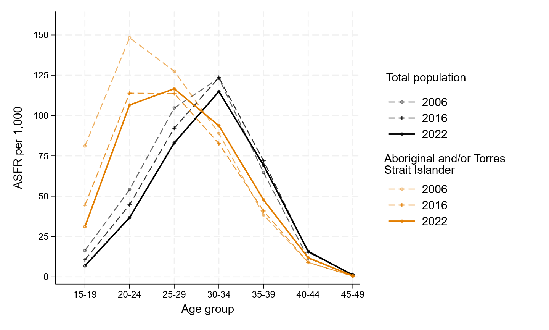
Source: Age-specific fertility rates for total population from Australian Bureau of Statistics (2024a). Age specific fertility rates for Aboriginal and/or Torres Strait Islander women from own calculations with births from AIHW (2023) and ERP from ABS (2024b).
Figure S7 also shows further detail on the trends in ASFR by 5-year age group, with data from 2006 to 2022, and projected trends to 2065–66.
As seen in both S6 and S7, the 2006 fertility rates appear, particularly for some age groups, to show a substantial divergent pattern from later years. The 2006 data is based on experimental population data from the 2006 Census (ABS 2008a). It is difficult to know if the trends from 2006 to 2011 are due to the difference in how the denominator (population ERP) was constructed or if they reflect real trends.
Due to this issue, for projecting the future we base our focus primarily on trends that have occurred between 2011 and 2022, which are all based on the same denominator. Over the last decade, there are some clear trends by age. The fertility rate of women aged 15–19 has dropped significantly from 57 births per 1,000 women aged 15–19 in 2011 to 31.1 births per 1,000 women in 2022. In the last decade, there has been a continuing trend of fertility shifting to later age groups, with the 30–34 age group experiencing a particularly strong positive trend in the birth rate.
We project that fertility rates will continue to decline at the younger ages, and while some of this early age childbearing will be shifted to older ages there will overall be a decline. We also assume that there may be an increase in identification rates, particularly in urban areas, as suggested by Taylor, et al (2020). Table S3 shows the resulting ASFR based on the assumptions about the shifting age-profile of childbearing. We estimate a decline in fertility of 0.40 children, from 2.04 in 2022 to 1.64 by 2065–66.
Figure S7: Observed and predicted ASFR for 5-year age groups, Aboriginal and/or Torres Strait Islander women
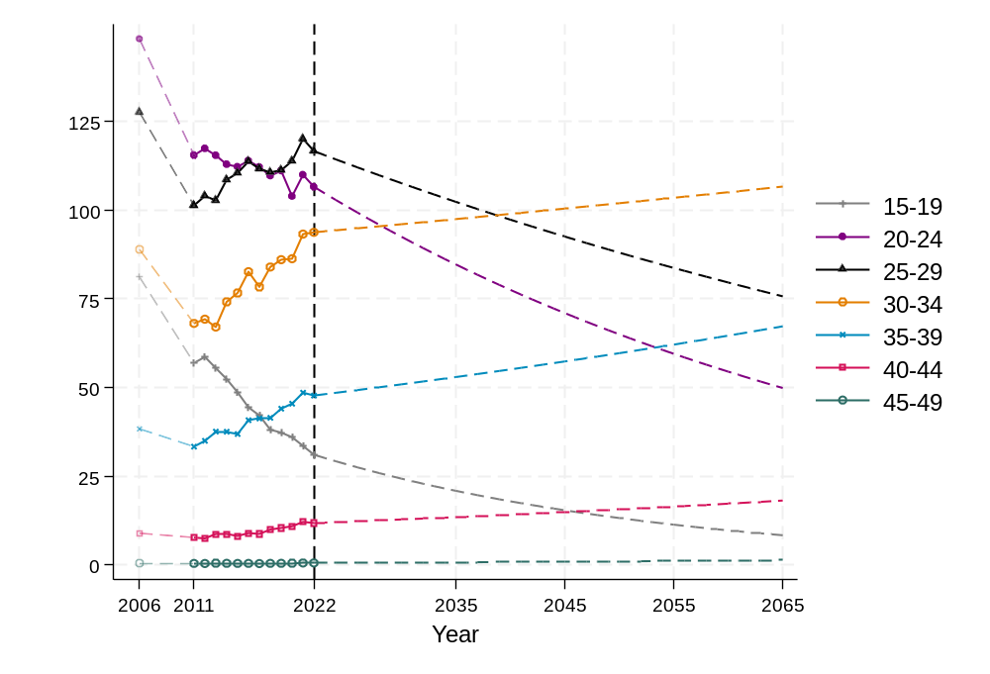
Source: Age-specific fertility rates for Aboriginal and/or Torres Strait Islander women based on own calculations with births from AIHW (2023) and ERP from ABS (2024b).
Table S3: Assumed annual change in ASFR (births per 1000), Aboriginal and/or Torres Strait Islander women by age and resulting projected rates
Age group | 2022 | 2065–66 (projected) | Annual % change
15–19 | 31.1 | 8.4 | -3.0 %
20–24 | 106.6 | 50.0 | -1.75 %
25–29 | 116.6 | 75.7 | -1.0 %
30–34 | 93.7 | 106.6 | 0.3 %
35–39 | 47.7 | 67.3 | 0.8 %
40–44 | 11.9 | 18.2 | 1 %
45–49 | 0.5 | 1.4 | 2 %
Total (TFR) | 2.04 | 1.64 | -0.5 %
Source: Age-specific fertility rates for Aboriginal and/or Torres Strait Islander women in 2022 based on own calculations with births from AIHW (2023) and ERP from ABS (2024b).
This projection is aligned with the trends in the ABS's most recent estimates and projections of Australia’s Aboriginal and/or Torres Strait Islander population (2024b). Additionally, the ABS fertility projections indicate a TFR decline of approximately 1.5% per year until 2031.

S4. Country of birth fertility projections
Australia has a high proportion of residents born overseas. In 2023, more than one-third (36%) of the estimated resident female population aged 15–49 was born overseas (ABS 2024a). Australia’s national fertility rate is therefore shaped by the fertility rates not only of the population born in Australia, but also of the migrant population. It is also important to acknowledge that the impact of migrant fertility on the TFR may be very different from the impact of migrant births on the overall number of births in a country (Bagavos 2019).
Over time, the nature of the migrant population in Australia has changed significantly, both in terms of its overall level and its composition by country of birth. Overall, the percentage of the population born overseas has increased, from 20% in 1971 to 28% in 2021 (Yusuf & Martin 2020; ABS 2022b). The migrant population has also become more heterogeneous and there has been a shift in migration intake from Europe to Asia. In 1971, 86% of migrants had been born in Europe (including the United Kingdom), but this decreased to just 31% by 2021 (Yusuf & Martin 2020; ABS 2022b). The composition of migrants has also changed over time within countries of birth.
At any one point in time, the current characteristics of the migrant population as defined by their country of origin, length of time since migration, and age at arrival in Australia are all determined by past migration trends. A migrant’s fertility and childbearing patterns will be influenced by these factors: how long they have been in Australia, age at arrival, which country they came from, and more generally by which specific migration pathway they took and whether they arrived as a student, as a skilled migrant, or for another reason.
Prior to the late 1990s, the fertility rate of migrants tended to be higher than that of the Australian born. For example, in 1981 the fertility rate of Australian born women was 1.99, whereas it was 2.14 for women born overseas (Martins & Yusuf 2020). Since 1998, the TFR of women born overseas has switched to being lower than that of women born in Australia (ABS 2002). This shift has been driven by two key factors: (1) declining fertility rates globally, particularly in Asia, and (2) Australia’s skilled migration policy, which prioritises migrants with higher education and specific occupational experience (Martins & Yusuf 2020; Baffour et al. 2023).
In this section, we examine the historical trends, and possible fertility futures, for the 10 largest overseas-born estimated resident female populations aged 15–49 in Australia in 2023. The size of each population is shown in Table S4. It is important to note that the top 10 countries ranked by the size of the female population aged 15–49 is not necessarily the same as the top 10 countries of birth that would be selected if the number of births were used as the ranking indicator instead.
It is also important to keep in mind that the ranking is dynamic with the ranking of the top 10 countries of birth shifting over time, reflecting changing immigration trends (Raymer et al. 2020). For example, in 2016, the three largest overseas-born groups were from the United Kingdom, New Zealand, and China, whereas by 2021, India had replaced New Zealand in the top three. As such, the top 10 countries projected may not all remain in the dominant positions in the future period for which fertility is being projected as rankings will be influenced by specific migration policies of the Australian Government, but also global and national factors in the sending countries. Moreover, the current age-sex compositions will change depending on the retention and ageing of current migrants and the levels of future immigration (Raymer et al. 2025).
We examine recent trends in the fertility rates of the top 10 overseas-born populations, focusing on the period between 2003 and 2023, using data on fertility rates by 5-year age group published by the ABS (2004, 2005, 2006, 2007, 2008b, 2009 ,2010, 2011, 2012, 2013, 2014, 2015 ,2016, 2017, 2018, 2019, 2020, 2021b, 2022a, 2023b, 2024a). The fertility rates of the specific overseas-born populations exhibited substantially higher variability than the corresponding rates for the Australian total population. This variability is likely due to their smaller population size, and because the size and age composition of the populations may change abruptly, due to immigration intakes. As such, projections should be used with caution.
As seen in Table S4, and in Figure S8 in over 2021–2023, the TFR of Australian born women was estimated to be 1.69, and this was significantly higher than most of the top 10 countries, except women born in New Zealand who had an estimated TFR of 1.83. Women born in the United Kingdom, and South Africa also recorded relatively high fertility rates of 1.63 and 1.52 children per woman, respectively. For all other countries, the values were significantly lower, and in the cases of China and Thailand reached under 1 child per woman.
These very low fertility levels can be attributed to the selective characteristics of migrants. For instance, in 2021, only 8% of Australian-born women aged 25–29 were full-‍time students, compared to 25% of women born in China and 23% of those born in India (ABS 2021c). The overseas-born population, particularly those who have arrived more recently, is highly selective, making it challenging to draw fair comparisons using indicators such as the total fertility rate (TFR).
Figure S8: Age-specific fertility rates by country of birth, 2021–2023 average
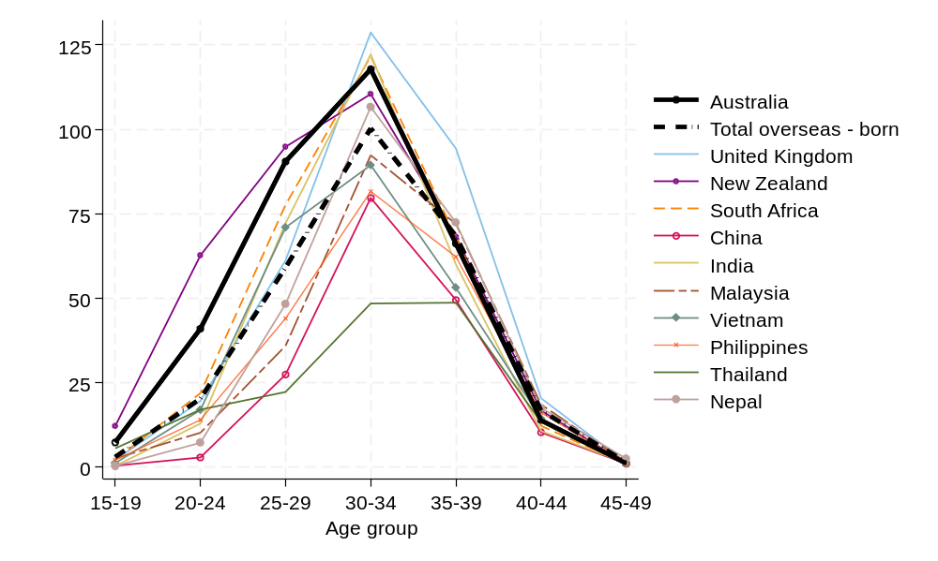
Source: Data from Australian Bureau of Statistics (2024a).
Given the ongoing importance of international migration in shaping Australia’s demographic landscape, examining the fertility patterns of different immigrant groups is essential. It is important however, to exercise caution in comparing the fertility rates of overseas-born and the Australian-born population, over time and across migrant groups, particularly when using synthetic fertility indicators such as TFR. The TFR is designed on the assumption that the same group of women are followed over a hypothetical life course. In the case of migrant women who may enter or exit the population at different ages, this brings up several conceptual and interpretative challenges.
Given these challenges of estimating future migrant fertility, in projecting the TFR by country of origin, we took a conservative approach and assumed that the overall trends of the last 20 years would continue, although at a slower or dampened rate. For each country and 5-year age group, we estimated the linear slope of changes in the fertility rate over time. The slope was then used to project the future values of the age-specific fertility rate using different damping levels depending on the level of fertility. The results are shown in Table S4 and Figure S9.
Table S4: Top 10 Countries of birth by size of estimated female resident population aged 15–49 in 2023, and projected TFR
Rank | Country of birth | 2023 Births | 2023 Female ERP 15–‍49 | 2023 Female ERP 15–‍49  as % of total population | TFR- Observed 2021–‍2023a | TFR  Projected 2065‍–‍66
1 | India | 16,593 | 300,348 | 4.8 | 1.39 | 1.32
2 | China  (excludes SARs and Taiwan) | 6,791 | 228,630 | 3.7 | 0.85 | 0.83
3 | United Kingdom | 6,986 | 162,217 | 2.6 | 1.63 | 1.56
4 | New Zealand | 7,420 | 147,704 | 2.4 | 1.83 | 1.74
5 | Philippines | 5,158 | 133,922 | 2.1 | 1.10 | 1.09
6 | Vietnam | 3,064 | 90,992 | 1.5 | 1.23 | 1.18
7 | Nepal | 4,159 | 76,896 | 1.2 | 1.27 | 1.20
8 | Thailand | 1,368 | 58,277 | 0.9 | 0.78 | 0.75
9 | South Africa | 2,451 | 56,789 | 0.9 | 1.52 | 1.45
10 | Malaysia | 1,902 | 54,005 | 0.9 | 1.16 | 1.15
- | Total overseas born | 100,011 | 2,265,551 | 36.2 | 1.34 | -
- | Australia | 186,811 | 3,990,308 | 63.8 | 1.69 | -
- | Total | 286,998 | 6,255,859 | 100 | 1.57 | -
Note: The TFR of 2021–2023 are based on rates calculated for every year and then averaged.
Source: Australian Bureau of Statistics (2024a, Table 6).
Figure S9: Historical (2003–2023) and projected fertility rates by 5-year age group, for women by top 10 countries of birth
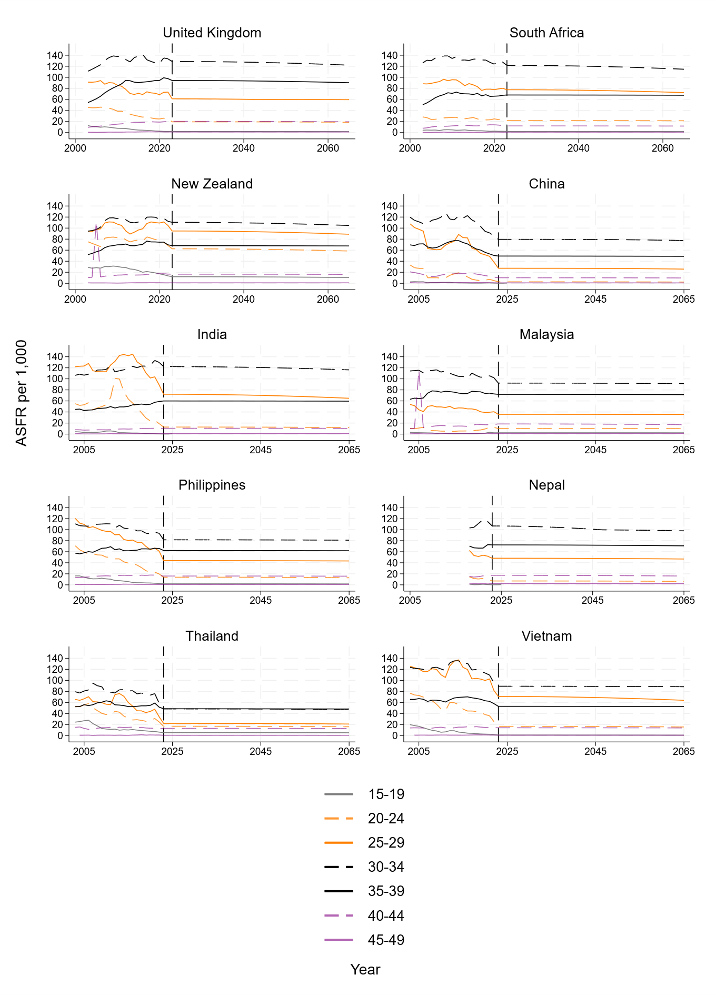
Note: Top 10 countries of birth as ranked by the size of the Estimated Resident Population of women aged 15–49 in 2023. There is no data for Nepal prior to 2018.
Source: Data up to and including 2023 from Australian Bureau of Statistics (2004, 2005, 2006, 2007, 2008b, 2009, 2010, 2011, 2012, 2013, 2014, 2015 ,2016, 2017, 2018, 2019, 2020, 2021b, 2023b, 2024a).

References
Australian Bureau of Statistics (2002). Births Australia, 2001. Catalogue Number 3301.0
Australian Bureau of Statistics (2004). Births Australia, 2003. Catalogue Number 3301.0
Australian Bureau of Statistics (2005). Births Australia, 2004. Catalogue Number 3301.0
Australian Bureau of Statistics (2006). Births Australia, 2005. Catalogue Number 3301.0
Australian Bureau of Statistics (2007). Births Australia, 2006. Catalogue Number 3301.0
Australian Bureau of Statistics (2008a). Experimental Estimates of Aboriginal and/or Torres Strait Islander Australians Catalogue No. 3238.0.55.001, Jun 2006
Australian Bureau of Statistics (2008b). Births Australia, 2007. Catalogue Number 3301.0
Australian Bureau of Statistics (2009). Births Australia, 2008. Catalogue Number 3301.0
Australian Bureau of Statistics (2010). Births Australia, 2009. Catalogue Number 3301.0
Australian Bureau of Statistics (2011). Births Australia, 2010. Catalogue Number 3301.0
Australian Bureau of Statistics (2012). Births Australia, 2011. Catalogue Number 3301.0
Australian Bureau of Statistics (2013). Births Australia, 2012. Catalogue Number 3301.0
Australian Bureau of Statistics (2014). Births Australia, 2013. Catalogue Number 3301.0
Australian Bureau of Statistics (2015). Births Australia, 2014. Catalogue Number 3301.0
Australian Bureau of Statistics (2016). Births Australia, 2015. Catalogue Number 3301.0
Australian Bureau of Statistics (2017). Births Australia, 2016. Catalogue Number 3301.0
Australian Bureau of Statistics (2018). Births Australia, 2017. Catalogue Number 3301.0
Australian Bureau of Statistics (2019). Births Australia, 2018.
Australian Bureau of Statistics (2020). Births Australia, 2019.
Australian Bureau of Statistics (2021a). Greater Capital City Statistical Areas, Australian Statistical Geography Standard (ASGS) Edition 3.
Australian Bureau of Statistics. (2021b). Estimates of Aboriginal and/or Torres Strait Islander Australians.
Australian Bureau of Statistics (2021b). Births Australia, 2020.
Australian Bureau of Statistics (2021c). Census 2001. Analysis using Table Builder, Persons enumerated by place of usual residence.
Australian Bureau of Statistics (2022a). Births Australia, 2021.
Australian Bureau of Statistics (2022b). Cultural Diversity: Census. Information on country of birth, year of arrival, ancestry, language and religion.
Australian Bureau of Statistics (2023). Population Projections, Australia. 2022 (base), 2071.
Australian Bureau of Statistics (2023b). Births Australia, 2022.
Australian Bureau of Statistics (2024a). Births 2023, Australia
Australian Bureau of Statistics (2024b). Estimates and Projections, Aboriginal and/or Torres Strait Islander Australians. Accessed 16 December 2024
Australian Bureau of Statistics (2025). Aboriginal and/or Torres Strait Islander births and confinements, summary, by state Retrieved from ABS Data Explorer, 10 March 2023
Australian Institute of Health and Welfare [AIHW] (2023). Aboriginal and/or Torres Strait Islander mothers and babies.
Baffour, B., Raymer, J., & Evans, A. (2023). Recent trends in immigrant fertility in Australia. Journal of International Migration and Integration, 24, 47-67.
Bagavos, C. (2019). On the multifaceted impact of migration on the fertility of receiving countries. Demographic research, 41, 1-36.
Biddle, N., & Johnstone, K. (2014). Indigenous family formation. In Family formation in 21st century Australia (pp. 197-224). Dordrecht: Springer Netherlands.
Carmichael, G. A. (2019). Indigenous fertility in Australia: updating Alan Gray. Journal of Population Research, 36, 283-317
Evans, A., & Gray, E. (2018). Modelling variation in fertility rates using geographically weighted regression. Spatial Demography, 6(2), 121-140.
Gray, E., & Evans, A. (2018). Geographic variation in parity progression in Australia. Population, Space and Place, 24(2), e2080.
Johnstone, K. (2010). Indigenous fertility in the Northern Territory of Australia: what do we know? (and what can we know?). Journal of Population Research, 27(3), 169-192.
Lei, L. (2012). On a special property of the Total Fertility Rate. Paper Presented at the 2012 Annual Meeting of the Population Association of America. San Francisco, May 3-5.
Martins, J. M., & Yusuf, F. (2020). Changes in Ethnic Composition and Fertility of the Australian Population. Population Change and Public Policy, 51-60.
Peristera, P., & Kostaki, A. (2007). Modeling fertility in modern populations. Demographic Research, 16, 141-194.
Raymer, J., Bai, X., and Liu, N. (2020). The dynamic complexity of Australia’s immigration and emigration flows from 1981 to 2016. Journal of Population Research, 37(3), 213-242.
Raymer, J., O’Donnell, J., and Guan, Q. (2025). The contributions of past immigration to current age-sex structures of immigrant populations in Australia. Vienna Yearbook of Population Research, 23, 1-17.
Taylor, A., Wilson, T., Temple, J., Kelaher, M., & Eades, S. (2021). The future growth and spatial shift of Australia's Aboriginal and/or Torres Strait Islander population, 2016–2051. Population, Space and Place, 27(4), e2401.
Yang, Y., Shang, H. L., & Raymer, J. (2022). Forecasting Australian fertility by age, region, and birthplace. International Journal of Forecasting.
Venn, D., & Dinku, Y. (2020). Can increased educational attainment explain declining Indigenous fertility? Australian Journal of Social Issues, 55(3), 339-353.

Technical Appendix

Reconciliation of sub-national projections
When conducting sub-national projections, an important restriction is that the sub-national rates must be consistent with the higher-level (national) rate (Yang et al. 2022). For the states’ fertility to reconcile to the national fertility level coherently, we conducted initial projections followed by small adjustments in some cases, so that the number of births across the States and Territories in any year matches the number of births in the National population. For this, and to predict what contribution each State/Territory would make to the National TFR, future estimates of the resident population are needed. These were sourced from the 2022–2071 Population Projections by state produced by the Australian Bureau of Statistics (2023).
For the state projections, a hybrid top-down, bottom-up approach was used. The Northern Territory, Tasmania, and the Australian Capital Territory are projected directly (bottom-up), while the larger states have a top-down projection applied. Within each state, the GCCSA fertility rates were projected using a top-down approach.
The projected population of women by single year of age are used up to the year 2035. From 2035 onwards, the population of women in their mid-teens would be born between now and the start of 2035. As such in the ABS population projections, these would be determined by projected fertility. To avoid this circularity, we keep the percentage distribution between states stable from 2035 onwards.
For NT, TAS and ACT, fertility is projected based on the assumption that these states may follow a slightly different trend from other states. The Peristera and Kostaki (2007) model was used to project fertility in each of the three smaller jurisdictions, as was done with the National projections. However, the values for the trajectories of these projections were different to the national parameters.
The historical and predicted contributions to fertility at different ages for these states/territories was calculated and subtracted from the National figures. For the remaining states, a ratio was calculated describing, for each age whether they were above or below the national average (minus NT, ACT, and TAS). A ratio above one for an age meant that for that age, the State was above average. This ratio for each of the large States was then used to distribute their relative ASFRs according to the projected alternative national ones. Due to fluctuations over time, the data was smoothed using locally weighted smoothing. After all of the larger states had been projected in the final stage, the fertility of the smaller states was added back in.
The ratio was then modelled to gradually stabilise using a damping function, where values under one were pulled up and values over one were pulled down. States which were further from the national pattern, had a higher dampening value applied. Victoria was given the highest value, whereas QLD and WA had a slightly lower one compared to NSW and SA. This method was used to ensure a trend towards convergence with the national age pattern. We can see this process in the example of the ratio of the QLD ASFR versus the (alternative) National one as observed in 2023–24 and the flattening towards one predicted by 2065–66 (Figure SA1).

Figure SA1: Observed and predicted ratio of fertility rates in Queensland compared to the national average by age, 2023–24 and 2065–66
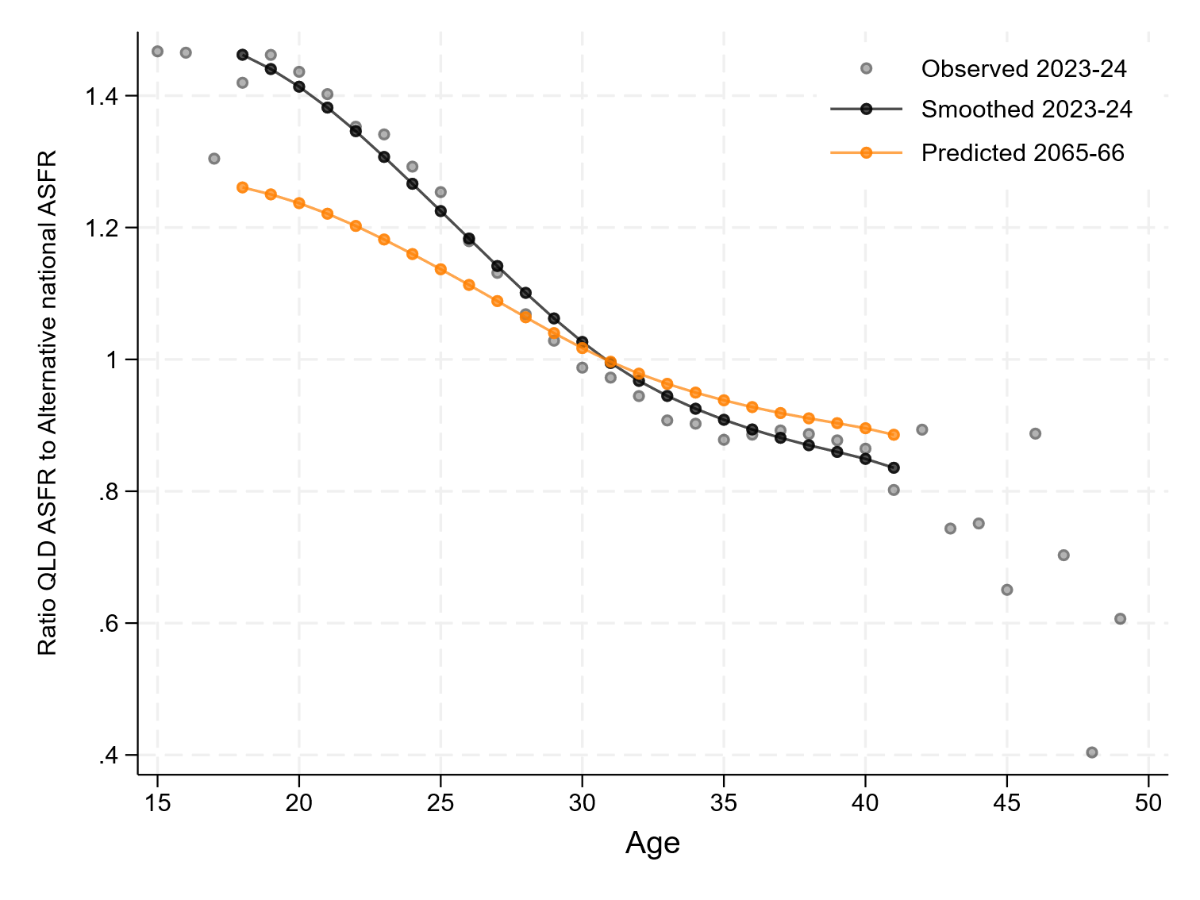

Simpson’s Paradox
In Table S2, it was noted that the TFR of the Northern Territory in 2022–23 was higher than the TFR of either sub-population of the Territory when split into the two Greater Capital Statistical Areas of: 1) Darwin; and, 2) Rest of the Northern Territory.
This is an example of Simpson’s Paradox, a statistical phenomenon in which trends observed within sub-groups reverse or disappear when the groups are combined. In the context of total fertility rate (TFR), the paradox occurs when the aggregate TFR is either higher or lower than the TFRs of the individual sub-populations. As outlined by Lei (2012), while the aggregate TFR of two sub-populations (TFR₁, TFR₂) is theoretically a weighted average, it can range from 0 to TFR₁ + TFR₂. Depending on the shape of the age-specific fertility rate (ASFR) curves for each sub-population, and the proportion of the population at each age, the combined TFR can fall outside the range of both individual TFRs. In the Northern Territory, we see a unique case where the aggregate TFR is lower than either sub-group defined by the Greater Capital City Statistical Area. This is due to the particular shape of the ASFR curves, as illustrated in Figure SA2.
Figure SA2: Comparison of age-specific fertility for Northern Territory, Darwin and Rest of NT (2022–2023)
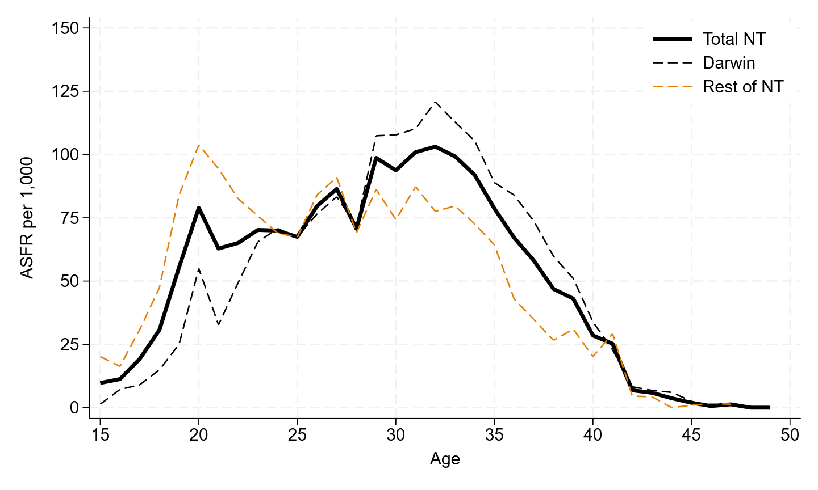
Source: Data provided by Centre for Population.

Calculation of fertility rates for Aboriginal and/or Torres Strait Islander women

Numerator: Births to women who identify as Aboriginal and/or Torres Strait Islander, by age group
Births to women who identify as Aboriginal and/or Torres Strait Islander were calculated based on 1) data of the number of mothers by age, and 2) the total number of births.
Data on the number of mothers who identify as Aboriginal or Torres Strait Islander was available from the AIHW (2023) in 5-year age groups for years up to and including 2022. The top age group in the AIHW data was coded as 40+ years of age. To maintain consistency with other areas of the report where the highest age group is calculated as 45–49, we separated the total mothers recorded at age 40 and over into 95.4% as aged 40–44 and 4.6% as aged 45–49. This ratio was derived from examining the ratio of births to mothers who identified as Aboriginal and/or Torres Strait Islander in the ABS birth registration data, averaged over the 2003 to 2023 period.
The number of mothers in any year is not the same as the number of births, as women can have multiple births. In 2012, 12,286 women who gave birth were Aboriginal or Torres Strait Islander. The total number of mothers in each group was then multiplied by the total number of babies born to mothers who were Aboriginal or Torres Strait Islander, assuming no age difference in plurality.
In the same year, there were 12,454 births recorded to mothers who were Aboriginal or Torres Strait Islander. This gives a ratio of births to mothers of 1.0137.
Using the simplifying assumption that this ratio is the same across all age groups, we apply the ratio to all age groups to derive the births by mothers' age. For example, in 2012, there were 4,037 mothers aged 20–24. The number of births at age 20–24 was calculated as 4,037*1.0137=4,456
For the denominator of the fertility rates – the number of women by age who identify as Aboriginal or Torres Strait Islander – we used the ERP estimates published by the ABS (2024b) which are based on the 2021 Census and back-cast annually from 2011 to 2021 and projected forward to 2031. The ABS ERP estimates give us a consistent denominator for 2011 to 2022, which is the last available year for which data on births from the AIHW was available. While a longer time series would have been advantageous, we prefer to keep the source of the denominator the same because as Carmichael (2019) noted, fertility levels for Aboriginal and/or Torres Strait Islander people often change significantly when the population is rebased to a different Census or when birth registrations are corrected for errors.
We chose to reconstruct historical fertility rates using these data rather than use the already calculated estimates of Aboriginal and/or Torres Strait Islander fertility rates published by the Australian Bureau of Statistics (ABS). This choice was made on the basis that fertility rates calculated by the ABS are based on birth registration data which historically have been affected by registration issues, including lags and subsequent catch-ups in registration, which have led to fluctuations in observed fertility patterns. The volatility of the ABS registration data compared to the data from the AIHW perinatal data is shown in Figure SA3. The AIHW perinatal data provided a more stable time series, and the ABS itself cautions against detailed comparisons of annual trends in births to Aboriginal and/or Torres Strait Islander women using registration data (ABS 2024a).
Figure SA3: Comparison of number of estimated births to Aboriginal or Torres Strait Islander mothers recorded by birth registration database (ABS) and perinatal statistics database (AIHW)
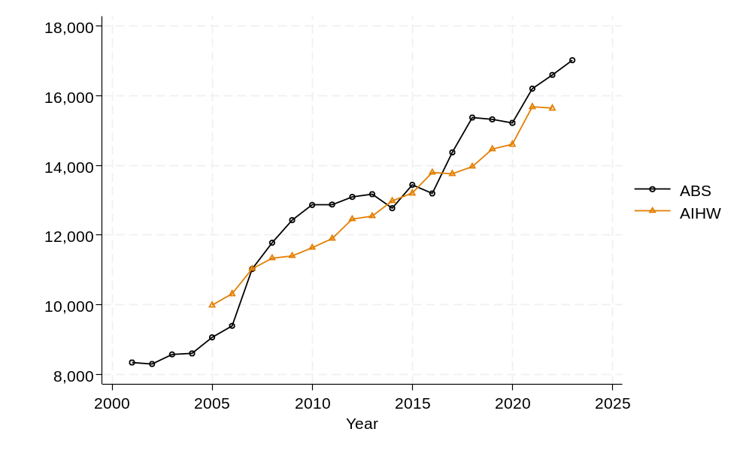
Source: Australian Bureau of Statistics (2025) and Australian Institute of Health and Welfare (2023).

Excluding persons where country of birth was not stated.

